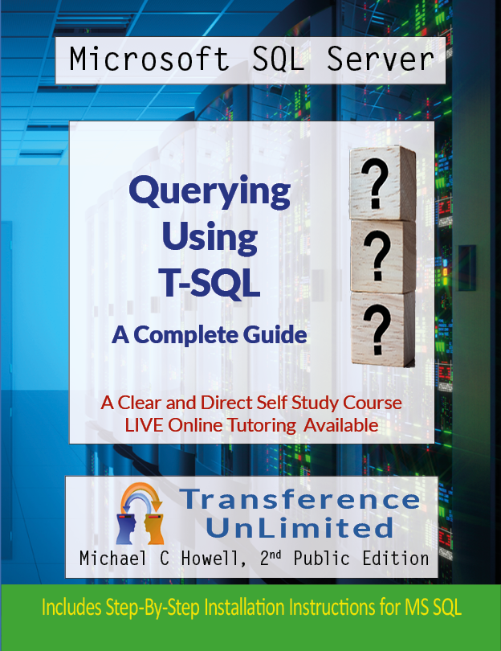


This course was written and independently published by:

Michael Howell
Transference UnLimited
London
United Kingdom

Mike.Howell@Transference-UnLimited.com

© Transference UnLimited 2020

I reserve all rights to this material. You have to have my permission to reproduce the content of this course, present it to an audience, store it or sell it in any form except for those images to which I do not hold the copyright.

The photograph of Dr Codd comes from Wikipedia (https://en.wikipedia.org/wiki/Edgar_F._Codd).
I have used two stocks images licenced from Adobe Stock Images and another licenced from Freepik.com.

I drew or edited all other images using Adobe Illustrator (2020), Adobe Photoshop (2020) and Adobe InDesign (2020).

The Kindle version was typeset with Microsoft Word.
I proofread the content with the help of Grammarly. Yes, I have still made mistakes.

I present the material as is. I do not take any responsibility for the consequences of using or misusing any of the course’s content. I do not offer any warranty regarding the accuracy of the material nor its applicability to a given purpose. I have designed this course to broaden your knowledge of T-SQL through study and practice. It does so with a sincere intent to educate and uses a splash of colour and an occasional dash of humour.

Any opinions expressed here are those of mine and are exactly that: my opinions.
Any humour expressed is precisely that: my sense of humour.

All trademarks mentioned belong to the respective trademark holder.

I would appreciate it if you bring my attention to any errors, omissions, unintentional copyright violations or suggestions for genuine improvement by contacting me via my email address provided above.

Table of Contents
Table of Contents 4
Preface 1
Dedication 3
About the Author 4
1. Getting Started with SQL 5
1.1. Where Did SQL Come From? 5
1.2. ANSI SQL Versus T-SQL Versus PL/SQL Versus... 6
1.3. What is a Relational Database? 7
1.4. Getting to Know What Dr Codd Invented 8
1.5. Why Normalisation Is Necessary 8
1.6. Normalising the Data 9
1.6. The Fundamentals of the Primary Key 10
1.7. The Allocation of Data Types 10
1.8. Code Pages 11
1.9. The Primary Key in More Detail 11
1.10. Foreign Keys 12
1.11. Time Anomalies 13
1.12. Other Examples of Time Anomalies 14
1.13. Many-to-Many Relationships 14
1.14. Learning Many-To-Many Relationships by Example 15
1.15. General Link Table Characteristics 16
1.16. A Bridging Table’s Primary Key 17
1.17. Enforced Relationships: An Occasionally Overlooked Design Feature 17
1.18. Other Types of Database 17
1.19. A Data Warehouse 18
1.20. An Analysis Services Database 18
1.21. Benefits of The Normalisation System 19
1.22. Drawbacks of Normalisation 20
1.23. A Note About the Exercise 21
Exercise 1: Getting Started with SQL Server Management Studio 22
Ex 1.1. Using SSMS 22
Ex 1.2. Putting a Query into SSMS 24
Ex 1.3. Saving your Work 28
Ex 1.4. Creating a Solution 28
Ex 1.5. Creating the Solution Itself 29
2. Finding Your Way Around a Database 33
2.1. Getting Online Help for MS SQL 33
2.2. Possible Formatting Styles for SQL Commands 34
2.3. The Object Naming System 36
2.4 A Database User 38
2.5. The Database Owner User (dbo) 38
2.6. How the dbo User Relates to the Schema dbo 38
2.7. The Fully Qualified Name of an Object 39
2.8. The SQL Database Objects 40
2.9. Scripting 44
2.10. Variables 44
2.11. The SET Statement 46
2.12. Introduction to SQL Batches 46
2.13. BEGIN and END 47
2.14. IF 47
2.15. WHILE 48
2.16. SQL Data Types 49
2.17. A Few Notes on Using Unicode 62
2.18. Why Some People Use ‘N’ When They Don’t “Need” to 64
2.19. Using SELECT to Load Data into a Variable 65
2.20. Categories of SQL Command 66
2.21. Drawing a Database Diagram 67
2.22. How to Draw a Diagram Using SSMS 68
2.23 Adding Comments Into Your SQL Scripts 71
2.24. What Comments Look Like 71
2.25. The Exercise 73
Exercise 2. Finding Your Way Around A Database 74
Ex 2.1. Vertical Bar Graph 74
Ex 2.2. Horizontal Bar Graph 75
Ex 2.3. Multiple Horizontal Bar Graphs 75
Ex 2.4. Using SELECT to Load variables 75
3. The SELECT Statement 76
3.1. The SELECT Statement’s Fundamental Syntax 76
3.2. More Detail on Case Sensitivity 77
3.3 Conservative Names 77
3.4. Avoiding Typing Long Names 79
3.5. The * 79
3.6. The TOP Clause 80
3.7. TOP WITH TIES 80
3.8. Column Aliases 82
3.9. The Exercise 83
Exercise 3. The Select Statement 84
Ex 3.1. Try Comments 84
Ex 3.2. Extracting Product Data 84
Ex 3.3. Using a TOP Clause 84
Ex 3.4. WITH TIES 85
Ex 3.5. Column Aliases 85
4. The WHERE Clause 86
4.1. Operators 86
4.2. The WHERE Clause’s Syntax 88
4.3. Many-to-Many Relationships Revisited 88
4.4. Using Range Operators (<=, =>) With Dates 89
4.5. Using the IN Operator to Replace OR 90
4.6. The LIKE Operator 90
4.7. The CASE Statement 93
4.8. The EXISTS Operator 96
4.9. The Database Catalogue: Sys.Objects 97
4.10. The Database’s Schema List 99
4.11. How The EXISTS Example Works 100
4.12. A Practical Example of Using EXISTS 100
4.13. The Exercise 102
Exercise 4. The WHERE Clause 103
Ex 4.1. Working With > and < etc. 103
Ex 4.2. Remove Duplicates 103
Ex 4.3. Working with IN 103
Ex 4.4. Working Without IN 103
Ex 4.5. Working with LIKE 103
Ex 4.6. Using the CASE Statement 104
5. The ORDER BY Clause 105
5.1. The Syntax of the ORDER BY Clause 105
5.2. Examples of Using ORDER BY 105
5.3. Using Column Aliases in the ORDER BY Clause 106
5.4. When You Can and Can’t Use Column Aliases 107
5.5. Using Ordinal Numbers Instead of Column Names 107
5.6. The Exercise 108
Exercise 5. The ORDER BY Clause 109
Ex 5.1. Ordering the Products by Category ID 109
Ex 5.2. Order the products by Subcategory ID 109
Ex 5.3. Order by Subcategory ID and then Product Name 109
Ex 5.4. Using Aliases with Order By 109
Ex 5.5. Using Ordinal Numbers 109
6. Joining Tables 110
6.1. Introducing the Sample Tables 110
6.2. Preparing to Visualise Joins 111
6.3. What a Fully Qualified Column’s Name Looks Like 111
6.4. Table Aliases 111
6.5. How SQL Implements a JOIN Operation 111
6.6. The Inner Join 112
6.7. A Colourful Analogy Describing Joining Multiple Tables 113
6.8. A Step-by-Step Example of an Inner Join 114
6.9. An Inner Join with Three Tables 115
6.10. Using Table Aliases 116
6.11. A Vital Consideration For the ON Clause 117
6.12. An Inner Join Example from Adventure Works 117
6.13. The Left Outer Join 119
6.14. A Left Outer Join with Adventure Works 121
6.15. Finding a Column to Use To Detect a No Match Situation 122
6.16. What NULL Means 123
6.17. How Null Differs from ‘’ 123
6.18. Why You Can’t Detect NULL With = 124
6.19. The Right Outer Join 124
6.20. Self Joins 124
6.21. The CROSS JOIN 127
6.22. The FULL JOIN 128
6.23. Outdated Syntaxes For Joins 129
6.24. The Effect of the WHERE Clause’s Condition in the ON Clause with a LEFT OUTER JOIN 131
6.25. Putting the WHERE Clause in the ON Clause with an INNER JOIN 132
6.26. The Ambiguity Caused by the Old Notation 132
6.27. Should You Rewrite Old Style Queries? 132
6.28. The Exercise 133
Exercise 6. Joining Tables 134
Ex 6.1. Obtain Sales Data 134
Ex 6.2. Adding More Tables to the Join 134
Ex 6.3. Add Yet Another Table 134
Ex 6.4. Outer Join 134
Ex 6.5. A Voluntarily Made Error 134
7. Grouping Data and the Aggregation Functions 135
7.1. A Grouping Example 135
7.2. Grouping Illustrated Visually 135
7.3. Grouping Data from Adventure Works 136
7.4. Using GROUP BY and a JOIN Operation Together 137
7.5. A Way to Understand the List of Columns in the GROUP BY Clause 138
7.6. Popular Aggregation Functions 139
7.7. Trying The Aggregation Functions 141
7.8. Putting A Condition on The Grouping’s Output by Using the HAVING Clause 142
Exercise 7. Grouping Data 144
Ex 7.1. Creating A Suitable Query 144
Ex 7.2. Removing Unwanted Columns 144
Ex 7.3. Writing the Grouping 144
Ex 7.4. Applying A Condition to Find Poorly Performing Categories 145
8. Subtleties of Aggregations 146
8.1. Uses for MAX and MIN 146
8.2. The Affect of NULL on Averages 146
8.3. Variations of COUNT 148
8.4. The Exercise 148
Exercise 8. Subtleties of Aggregations 149
Ex 8.1. Working Out Which Country Has The Highest Sales Tax 149
9. Conversion Functions 150
9.1. The CAST() Function 150
9.2. The CONVERT() Function 152
9.3. Removing Unwanted Digits From a Decimal Number 154
9.4. Automatic Type Conversions 154
9.5. SYSDATETIME() Versus GETDATE() 155
9.6. Converting NULL to Another Value 155
9.7. ISNULL() 155
9.8. COALESCE() 156
9.9. NULLIF() to Insert NULLS on the Fly 157
9.10. The Exercise 157
Exercise 9. Conversion Functions 158
9.1. Displaying People’s Names 158
9.2. Price List 158
10. Subqueries and Common Table Expressions (CTEs) 159
10.1. The Nested/Non-correlated Subquery 159
10.2. The Correlated Subquery 160
10.3. A Bizarre and Memorable Analogy 161
10.4. The Common Table Expression (CTE) 163
10.5. Benefits of using a CTE 163
10.6. The Syntax of a CTE 163
10.7. The Exercise 164
Exercise 10. Subqueries and CTE’s 165
Ex 10.1. Sales of Road Bikes with 58” Frames 165
Ex 10.2. Display the Average Price of Items Per Subcategory 165
Ex 10.3. Show the Prices Formatted using the EN-ZA Culture 165
Ex 10.4. Add Flexibility To Allow Varying Culture and Exchange Rates 165
11. Data Partitioning Using OVER 167
11.1. Partitioning Using Sample Data 167
11.2. The OVER Clause 168
11.3. Useful Functions that Come With Partitioning 169
11.4. RANK() 169
11.5. DENSE_RANK() 170
11.6. ROW_NUMBER() 171
11.7. Using Data Partitioning with a CTE 174
11.8. Unpacking the Meaning of The CTE 176
11.9. Using Aggregate Functions with Data Partitioning 177
11.10. More Functions To Explore 178
11.11. The Exercise 179
Exercise 11. Data Partitioning Using OVER 180
Ex 11.1. The Starting Query 180
Ex 11.2. Convert the Query into a CTE 180
Ex 11.3. Add Two ROWNUMBER() Columns 180
12. UNION, INTERSECT and EXCEPT 181
12.1. UNION 181
12.2. UNION ALL 184
12.3. INTERSECT 184
12.4. EXCEPT 184
12.5. The Exercise 185
Exercise 12. UNION, INTERSECT and EXCEPT 186
Ex 12.1. Write the First Query 186
Ex 12.2. Write a Second Query 186
Ex 12.3. Write the Union of the Above Queries 186
Ex 12.4. Write One Last Query 186
13. Dealing With Dates 187
13.1. What Do Dates Look Like? 187
13.2. How to Reformat Dates 188
13.3. An Old Fashioned Way to Convert Dates 188
13.4. Extracting Parts of Date (Method 1) 190
13.5. Extracting Parts of Date (Method 2) 191
13.6. Microsoft Specific Date Formatting Commands 191
13.7. Arithmetic With Dates and Time 192
13.8. DATEADD() 193
13.9. DATEDIFF() 193
13.10.EOMONTH () 193
13.11.The Exercise 194
Ex 13. Dealing With Dates 195
Ex 13.1. How many Days Until Your Birthday 195
Ex 13.2. Different Units 195
Ex 13.3. How Long Did Adventure Works Stay In Business? 195
Ex 13.4. List Orders Placed Close to the End of the Month 195
14. The Fundamentals of Creating Tables 196
14.1. Generating Practice Tables 196
14.2. The Primary Key Column 197
14.3. The Identity Column 197
14.4. Data Types 198
14.5. NULL or NOT NULL 198
14.6. Creating the Customer’s Table 198
14.7. Creating the Products Table 199
14.8. Creating the Sales Table 199
14.9. Copying A Table 200
14.10.Copying The Structure of a Table 202
14.11.DEFAULT and CHECK Constraints 203
14.12.What’s Coming Up In The Next 3 Chapters 203
14.13. The Exercise 203
Exercise 14. The Fundamentals of Creating Tables 205
Ex 14.1. Create a Pair of Tables To Store Car Warehouse and Car Sales Information 205
Ex 14.2. Copy a Table 205
15. Inserting Data 206
15.1. Inserting a Single Row 206
15.2. Implicitly Inserting a Default Value 207
15.3. Implicit Column Names 207
15.4. Explicitly Listing Default Values 208
15.5. What Your Customers Table Should Look Like 208
15.6. Inserting Multiple Rows With a Single INSERT 208
15.7. Inserting Faulty Data Into Sales: Testing the PK-FK Constraints 209
15.8. Violating the Constraints 210
15.9. Trying Out Computed Columns and DEFAULT, CHECK and NULL Constraints 210
15.10.Copying Rows Into An Existing Table 213
15.11.An Example of INSERT SELECT 214
15.13.A Comparison Between SELECT INTO and INSERT SELECT 218
15.14.The Exercise 218
Exercise 15. Inserting Data 219
Ex 15.1. Insert Data Into The Warehouse and Sales Table 219
Ex 15.2. Testing the Constraints 219
Ex 15.3. Insert Into 220
16. Deleting Data 221
16.1. The Delete Command’s Syntax 221
16.2. An Easy Mistake To Make 222
16.3. Beware The Heaps of March 223
16.4. Violating Constraints Using Delete 223
16.5. Deleting Data Based on Data in A Different Table 224
16.6. An Example Using DELETE FROM FROM 224
16.7. The Exercise 226
Exercise 16. Deleting Data 227
Ex 16.1. A Dealership Returns a Car 227
17. Updating Data 228
17.1. The Fundamentals of UPDATE 228
17.2. Updating To Test Violating a PK-FK Constraint 229
17.3. A Valid Update 230
17.4. Updating Data Based on Another Table 230
17.5. The Exercise 232
Exercise 17. Updating Data 233
Ex 17.1. Make Stock Level Adjustments to The Inventory 233
Ex 17.2. Update the Inventory Based on the Sales 233
18. Fundamentals of Explicit Transactions 235
18.1. A Transaction Begins 235
18.2. How Do Transactions Affect You? 236
18.3. Separate Transactions 238
18.4. Controlling The Transaction Yourself 239
18.5. A More Graceful Approach 241
18.6. How Transactions Affect Other Users 243
18.7. Pessimistic Locking 243
18.8. Optimistic Locking 244
18.9. The Purpose of Locking 244
18.10.Trying Out Pessimistic Locking 245
18.11.An Example of Pessimistic Locking 245
18.12.Options for Using a Table Despite it Being Locked 247
18.13. The NOLOCK Option 248
18.13.The READPAST Option 248
18.14.Consider a Staging Database or Data Warehouse in the Future 248
18.15.A Data Warehouse 249
18.6. The Exercise 250
Exercise 18. Transaction Fundamentals 251
Ex 18.1. Create a Clothing Inventory Table and Load it With Data 251
Ex 18.2. Keeping Track of Your Transactions 252
Ex 18.3. Locking Between Users 254
19. Error Control 256
19.1. Understanding What Is Inside A T-SQL Error 256
19.2. Demarcating Potentially Hazardous Code: The TRY…CATCH Block 258
19.3. The Error Handling Code in the BEGIN CATCH…END CATCH Block 261
19.4. Transaction State (XACT_STATE) 262
19.5. XACT_ABORT Mode Outside a TRY CATCH Block 263
19.6. XACT_ABORT Mode On in a TRY…CATCH Block 264
19.7. Summary of the TRY…CATCH Error Handling Technique 265
19.8. The Exercises 265
Exercise 19. Error Control Basics 266
Ex 19.1. Create a Set of Inserts 266
Ex 19.2. Controlling the Error 266
20. Writing Queries Using SSMS’s GUI 269
20.1. The Elements of the GUI Editor 269
20.2. Why Did I Leave Using the GUI Until Now? 273
20.3. How to Activate The Query Editor Tool 274
20.4. The Template Tool 276
20.5. The Exercise 279
Exercise 20. Querying Using SSMS’s GUI 280
Ex 20.1. Opening a Template to Write a Stored Procedure 280
21. Conclusion 284
21.1. Exploring More 284
21.2. Spreading the Good Word 284
Exercise 21. Conclusion 285
Appendix A. Installing Microsoft SQL and Adventure Works 2017 286
A.1. Introducing the Sample Database: Adventure Works 286
A.2. General Notes on Installing SQL Server 2017 286
A.3. Hardware Required 288
A.4. Understanding The MS SQL Naming System 289
A.5. Downloading the SQL Server Files 291
A.6. Installation Centre Options 293
A.7. The Install Rules Screen 297
A.8. The Feature Selection Screen 298
A.9. Instance Configuration or Installation Type 300
A.10. The Server Configuration Screen 301
A.11. Database Engine Configuration 303
A.12. The Ready to Install Screen 305
A.13. The Installation Progress Screen 305
A.14. Finding the Install Logs 306
A.15. Installing SQL Server Management Studio (SSMS) 308
A.16. Installing Adventure Works 2017 311
A.17. Performing the Restore Operation 313
Appendix B. SSMS Tips and Keys 320
B.1. Useful Shortcut Keys 320
B.2. What to Do if You Have Lost a Window or a Pane 321
B.3. How to Find Out What the Capabilities of an Icon/Heading Are 321
Appendix C. Useful Options 323
C.1. Line Numbers 323
C.2. Text Size 323
Appendix D. Data Type Precedence and Implicit Type Conversions 325
D.1. Data Type Precedence 325
D.2. Type Coercion 328
Appendix E. Backus-Naur Form 330
E.1. A Practical Example of Using BNF: Attaching a Database 331
E.2. Before You Try These Examples 332
E.3. Finding Where The Adventure Work’s Files Are 332
E.4. What you are About to See is Not a Backup Technique 332
E.5. Detach Adventure Works 333
E.6. Using BNF to Construct the CREATE DATABASE Command 333
Appendix F. Answers To The Exercises 336
Exercise 1. Getting Started With SQL 336
Exercise 2 - Finding Your Way Around a Database 338
Exercise 3 - The Select Statement 342
Exercise 4 - The Order By Clause 343
Exercise 5 - The Where Clause 345
Exercise 6 - Joining Tables 347
Exercise 7 - Grouping Data 350
Exercise 8 - Subtleties of Aggregations 353
Exercise 9 - Conversion Functions 354
Exercise 10 - Subqueries and CTE’s 355
Exercise 11 - Partitioning Functions 358
Exercise 12 - UNION, INTERSECT and EXCEPT 360
Exercise 13 - Dealing With Dates 362
Exercise 14 - Creating Tables 364
Exercise 15 - Inserting Data 366
Exercise 16 - Deleting Data 368
Exercise 17 - Updating Data 369
Exercise 18 - Transaction Fundamentals 370
Exercise 19 - Error Control Basics 373
Exercise 20 - Querying Using SSMS’s GUI 375

Preface

This self-study course aims itself at the person who wants to know what “those SQL commands” mean. The ones you are told to type in but have never had explained to you; the semi-meaningless commands that somehow get the data from the SQL database into your report.
I have written this course for those of you who find traditional official course material is not helpful enough. Especially if you aim to take a Microsoft exam. This course is short, sharp and waffle free. All you need to do is bring along an initial spark of enthusiasm. In completing the exercises at the end of each chapter, you will prove your new skills to yourself; okay, maybe not right away, but soon.
I’ve written this course to get you fluent in daily-use SQL and beyond: from displaying tables in your database, selecting rows of interest, the various ways of joining multiple tables, grouping rows right up to using data partitioning functions. I’ve thrown in subqueries and common table expressions (CTE’s) for good measure, you might find them very helpful.
Inserting, deleting and updating data are covered in here too. I introduce transaction management as well as error control. When you have finished working your way through this short course, you’ll be boasting about your SQL skills at the next Christmas staff party.
Each chapter ends with brief practical exercises that designed to make you think and possibly do a little bit of research. The exercises are answerable using the preceding sections of theory. The exercises are graduated and get more difficult as you work your way from the first to the last. You might occasionally have to google for help which makes the exercises more realistic. All the answers to all the exercises are in the back of the book.
Appendix A takes you through the steps to download and install MS SQL on your personal computer. Then you can practice at your own pace, in places I choose not to imagine.
Once you reach course completion, you will be well on your way to take one of the Microsoft SQL Querying exams–the exam that matches your version of SQL. Not all the exam topics are covered here; almost all of them are. The course leaves you with enough knowledge and skills to study and make sense of the official Microsoft exam kit on your own.

When you have completed this course, your SQL foundation skills should be rock solid. Whether you are going for the SQL 2019, 2017, 2016 or earlier exam, this course will take you much closer towards that goal.

I have been teaching Microsoft courses since 1998 and have taken the various exams since then. I know what you need to do to get there. You will need to put in practice on a SQL server. Please don’t think memorising brain dumps and their answers will help you. Without the SQL skills, you won’t be able to make sense of the questions and so not be able to remember them.
I am happy to present the entire or part of this course via virtual online training. Contact me for rates if you are interested in live tuition.

Best wishes in getting to meet your new friend: MS SQL is grinning and beckoning you over.
Mike Howell
Course author
Mike.Howell@Transference-UnLimited.com

Dedication

To my mum and dad:

“Wish you were here to see me fly.”

To Dr Jordan Peterson and the wisdom he unashamedly shares:

“Pick up the heaviest burden you can and carry it.”

“Whatever turns your crank, man!”

To my sister:

“I don’t know where to begin.”

About the Author

Mike Howell has taught MS SQL since 1998. He started working with Microsoft’s SQL 6.5 and used other SQL flavours before then. He has worked at company’s such as Volkswagen of South Africa and has consulted and developed applications for small, medium and large organisations from a steel foundry to financial institutions.
He believes in teaching people the skills to educate themselves and how to help themselves as much as possible once they leave the classroom environment. He develops programs, teaches and consults on the topics of Azure, C#, VB, MVC, Web Forms and various aspects of web development. He also works in none-Microsoft technologies.
He is a Microsoft Certified Trainer and holds post-graduate degrees in computer science, electronic engineering and a degree in physics. He is a freelance trainer and consultant and owns Transference UnLimited which he opened in 2018.



Getting Started with SQL

Welcome to the beginning of your journey; a journey that starts with the work of a genius. To this very day, we actively use his design in the computer industry: the relational database.

This chapter will teach you about:

- Who was involved in creating SQL
- Why relational databases and SQL were necessary
- The basics of how to turn data into tabular structures
- Primary keys
- Foreign keys
- Code pages
- Time anomalies
- Many-to-many relationships
- Techniques to maintain data integrity
- Where relational databases fit into the bigger picture of data warehouses and analysis services databases

1.1. Where Did SQL Come From?

The letters SQL (usually pronounced “sequel”) stand for Structured English Query Language. It is an industry-standard language for querying and inserting data into a relational database. Donald Chamberlin and Raymond Boyce created SQL at an IBM research laboratory. It became commercially available in 1979.
The language’s original name was SEQUEL but thanks to a company–Hawkey Siddeley in the UK– having trademarked the name, it was given the replacement name SQL.
However, SQL is less than half the story. Before SQL came to exist, in the late ‘60s, a now-famous and well-respected scientist, Dr Edgar Codd (Figure 1-1), created a new form of a database: a relational database. SQL became the language used to extract data from his design. Dr Codd was an Englishman working for IBM in America at the time.
IBM was slow to adopt his ideas and produce anything commercial from them. Instead, an independent company, the first to create a commercially successful relational database and SQL implementation, was Oracle (then known as Relational Software).



Figure 1-1. Dr Edgar Codd. We honour his genius by using his ideas to this very day.

1.2. ANSI SQL Versus T-SQL Versus PL/SQL Versus...

In 1986, the American National Standards Institute (ANSI) created a standard vocabulary of SQL commands and syntax. SQL had become a somewhat chaotic language; individual database server manufacturers had added many custom features and altered its syntax until implementations were confusingly inconsistent. The ANSI standard provided a core set of commands and syntax rules. Any SQL system declaring that it was SQL-86 compliant, included these standard commands and syntax at a minimum. A manufacturer was welcome to add features beyond the standard.
The ANSI standards do not affect how the commands are implemented internally by the SQL server: one brand of SQL server may use a completely different set of steps to execute a particular statement than another, both producing the same results. Tuning the internal steps to give you the most efficient output is known as query optimisation.

Efficiency is usually taken to mean “the least amount of time” but doesn’t have to be; memory usage, for instance, can be an alternative consideration. Tuning queries can be considered more art than science.
Initially, the ANSI standard was revised every three years. With each revision, ANSI added commands that became dismissed as unnecessary and obtuse. The frequency of updates slowed down at the time SQL-92 appeared.
SQL-99 is the most well-adopted standard across many SQL server implementations in 2020. SQL systems offer SQL-99 compliance only in part. However, this course will teach you enough standardised SQL for you to apply your knowledge to many popular SQL systems such as Microsoft SQL, Oracle and MySQL.
This course uses Microsoft’s variation of SQL (which includes SQL-99 “compliance”) called Transact SQL or T-SQL. Oracle’s version of SQL is called PL/SQL. Be sure to check your server’s manuals should you get syntax errors trying to use any of the commands listed in this course on a none T-SQL machine. You can frequently resolve issues via a minor change to the syntax. Or find the name of the equivalent command as is used by your server.

1.3. What is a Relational Database?

Dr Codd revolutionised the way data was stored in computers with his concept of a relational database. He designed his database based on a new set of ideas: to distribute data across tables that are linked together using a concept he named keys. Tables are two-dimensional structures consisting of rows and columns. They store data very similarly to how you store data in a spreadsheet.
Before we had rows and tables, a computer scientist would talk about records and fields. A customer’s details would be kept in a customer’s record. Each aspect of a customer would be associated with a field such as LastName or PostCode. Field names such as LastName–are examples of metadata–data about the data itself.

With Dr Codd’s ideas, each record now becomes a row in a table. You store the contents of each record’s fields in the cells of the table aligned on the same row. Each column of cells stores the same field for each row. Tables are rigidly structured.

You may hear computer folk use the term field when they are referring to a column’s name. They may use the term record when they “mean” a row. It’s okay to do that, its a sign of their experience using databases from the past. If you are new to databases, you should bear in mind that some previously precisely defined terms blur into each other over time and end up representing the same concept.

If you want a sneak preview of tables you’ll be using later, have a look at Figure 1-3. I shall describe the figure to you in more detail as we work through the text.

In summary: a table provides a regular and predictable structure for storing data in the computer.

1.4. Getting to Know What Dr Codd Invented

Dr Codd added a mechanism to tables to allow consistent, unique labelling of each row of data. This mechanism is known as the primary key. He then introduced techniques to avoid duplication (or redundancy) of information. These techniques reduced the frequency of spelling errors and the potentially disastrous consequences they might have.

Dr Codd developed a set of three steps that you apply to the original data to distribute the data over several tables methodically. These steps, when collectively applied, are known as normalising the data. He labelled each step as a numbered normalised form. We have 1st normalised form (1NF) for the first step, 2nd normalised form (2NF) for the second and 3rd normalised form (3NF) for the third.
There are at least six recognised normalised forms in total. The first three forms are the most significant in designing a relational database. I am not going to describe the fundamentals of normalisation. You can read up on the details of the normalisation process here https://en.wikipedia.org/wiki/Database_normalization.

1.5. Why Normalisation Is Necessary

Let’s look at some data as stored in a comma-separated value file (CSV file). People frequently use CSV files for exporting and moving data between applications and physical servers. They are not suitable for direct frequent or robust querying as we will see. Long before Dr Codd invented tables, we used CSV files as a data storage tool.

Have a look at the example in Figure 1-2. Imagine you are a machine. How many customers would this file reveal to you? How many products?

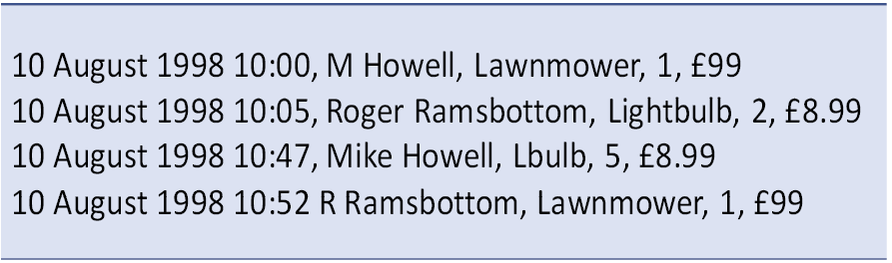
Figure 1-2 This is an example of data stored in a non-relational format: a CSV file.
A machine, being very literal, would not realise that M Howell and Mike Howell are the same people. Neither would the machine realise the same for R Ramsbottom and Roger Ramsbottom. A computer would interpret the file as containing four customers and not two as intended.

If you use the same approach to count the number of products, the machine would “see” three distinct products: lawnmower, lightbulb and lbulb. A human might assume that there are two products in total since besides lawnmower, surely Lbulb and Lightbulb are the same item? They aren’t to a computer. Can you imagine trying to sort out tens-of-thousands of such lines of potential confusion?

Normalising the Data

Let's have a look at the stages of normalising data. We will start with the data in Figure 1-2 and normalise it. In Figure 1-3, I have begun to divide the data across tables. The sales information isn’t captured at this stage, only the customer and product details.

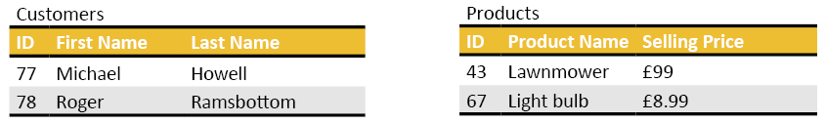
Figure 1-3. The beginnings of normalisation. I have turned the data from the .csv filed into first normal form except for the sales information, which we will analyse soon.
You can see there are two tables. I have broken each customer’s name into smaller components: their first name and their last name. This division of the customer’s name into what are called atomic units makes it easier to write SQL statements that can access the parts of a full name or even do the reverse, by combining the parts–concatenating them–together in arbitrary ways.

For instance, say you wanted to generate label’s for envelopes– Mr M Howell rather than Mr Michael Howell–having separate columns for first names and last names makes this a lot easier to do. The data is now in first normal form (1NF). 1NF has removed the duplicate customer and product names.

The Fundamentals of the Primary Key

I have assigned each product and customer a unique label: the primary key. In Figure 1-3, the two ID columns are the primary key columns. I have chosen random numbers for the primary keys to make a point. You usually should not mentally link a primary key value to specific data; it is a randomly chosen label SQL uses to find a row.

For instance: you may find the product carrots by using the primary key value 44 in your database, but in the database of your competitor, carrots are identified by the primary key 163. It would not be a good idea to assume that everyone on Earth refers to carrots as product 44.

For the reasons given above, some database designs use primary key values that are 32 digits long. They are so long you cannot remember them, and so you cannot link a primary key to a particular row using your human memory.

A primary key will identify a row for as long as that row is in the table. Once you delete a row, SQL does not reuse that primary key value in that table, unless you explicitly tell it to do so, which is rarely a good idea. You can confuse yourself given the data in other tables by reusing a deleted row’s primary key value.

The Allocation of Data Types
1NF requires you to assign a data type to each column. For instance: you might declare a first name’s datatype to be a variable-length character column that can be up to 30 characters long. SQL requires a user-specified limit on the size of a text-based column. An example of a suitable SQL type would be varchar(30).
You may see nvarchar(30) in a design rather than varchar(30). The ‘n’ stands for national. It implies that the field can contain any symbol of any language (Chinese, Japanese, Korean, and so on). A national character column uses a standardised system known as Unicode (Universal Code) to allow a massive range of possible symbols. If you drop the ‘n’ prefix on the data type specification, you are limited to choosing from one of at most 256 characters.

Code Pages
The set of 256 available characters in a non-Unicode character-based column is chosen by the database administrator when they create a database. This set of characters is known as the database’s code page. Code pages are predefined and known world-wide. They are used–or assumed based on the operating system–in text files, database tables and any other character storage technology.

Codepages have uninspiring names such as CP-1252 or CP-850. You must find out what code page your administrator is using in your database. Especially so should you need to mix character sets from various human languages in a database. You are welcome to mix varchar and nvarchar fields in the same database. Consistency in using one or the other is key to successful database design. American and UK based databases tend to default to CP-1252 or its other name: Latin1_General_CP1.

You may see the letters CS or CI attached to a code page’s name such as Latin1_General_CP1_CI_AS. CI means that the database is case insensitive. If it is CS, you must refer to every object in the database with the correct case. CI is the most commonly found option.

AI and AS after a code page’s name imply that sorting character data is accent sensitive (AS) or it isn’t (AI). Accents are what you find on letters like these: ë, è, é, ä, Ǟ. I have no idea where Ǟ comes from, but it looks like a fun character to me–okay. I’m joking; it's Finnish.

Accent insensitivity would mean that e regardless of the decorative accent (the diacritical mark) is treated as an e. Accent sensitivity implies that SQL will group words with the same initial diacritical marks together.

Now you know why it is best to ask your database administrator (DBA) what code page you are using in your work. When in doubt, if you are ln the UK or America, use Latin1_General_CI_AS. You can discover more about code pages here https://en.wikipedia.org/wiki/Code_page
Other data types include decimal, date, time, datetime and the seldom-used money type. If you hurry ahead to section 2.15, you can discover the available data type options and the ranges of values they support.

1.9. The Primary Key in More Detail

If you recall from Figure 1-3, the two columns named ID are the primary key columns; a label used to guarantee uniqueness between the rows in a table. In my example, this column contains a surrogate value. The term “surrogate” implies that I artificially introduced this value into the data. The number is arbitrary and has no direct bearing on the rest of the data that I want to store in a row.

You may find that amongst the existing data, before normalisation, a column can supply an adequate unique label for each row. You might have to achieve this by combining two or more column’s values per row, known as a compound key. You call such a key a natural key since it already exists in the data.

The use of an existing column or combination of columns as a primary key is okay if you are sure it is always going to be unique in value. The latter is often not straightforward to guarantee. For instance, you may think that combining a customer’s first name, middle name, and last name is an adequate natural primary key. Later, you realise, that isn’t going to work for when two customers with the same name need to go into your database.

Useful Tip:
It is best to avoid using natural keys since the rules that define them, or the context in which you use them ina table might change in the future. Surrogate keys are the safest option.

You may notice that one or more existing columns in a table may be possible candidate primary keys. You refer to these columns as alternate keys. For example, you may have stored a national insurance number in a column which you are sure is unique and would make an excellent natural primary key. It would be a good idea to use a surrogate integer primary key anyway–just in case the rules defining or re-using a national insurance number change in the future. In that situation, where you have chosen to use a surrogate key; the national insurance number becomes an alternate key.

Foreign Keys

You link rows between two tables by using foreign keys. You can think of them as a mechanism that associates foreign data with the current table’s rows. See Figure 1-4.

In a table, the column of foreign keys almost always links to the nominated primary key values in another table. It doesn’t have to, any column in another table with relevant meaning will suffice. A primary key column can act as a foreign key column as well.

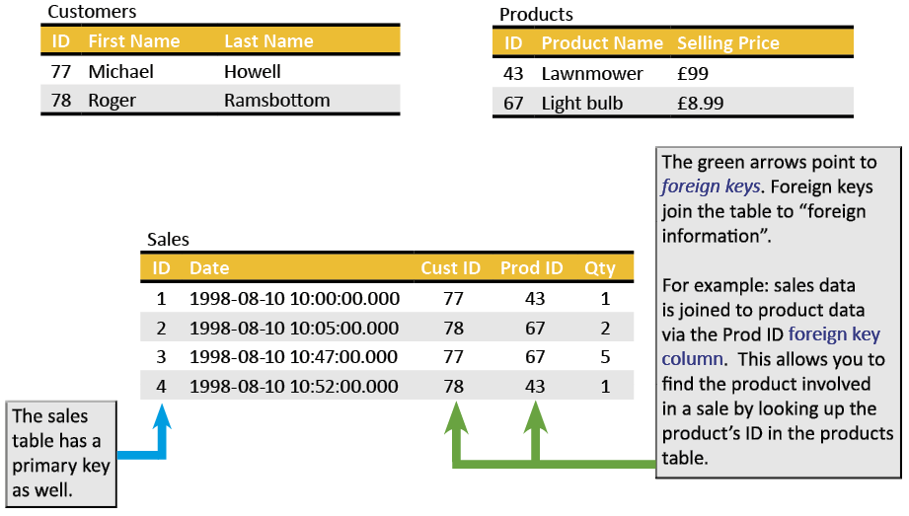
Figure 1-4 Here, you see examples of primary keys and foreign keys. This set of tables completes our database design as derived from the original data in Figure 1-2.
What you see in Figure 1-4 is the final design containing all the data from the CSV file in Figure 1-2. I have added a new table, the Sales table. The design is in 2NF (second normal form). The rules of the third normal form would not make any changes to this set of tables.

The Sales table has two foreign key columns–Cust ID and Prod ID, labelled with green arrows. Those column’s values connect you to the primary keys in the Customers and Products tables. If you go to a row in the Sales table, you can identify the customer and product that was involved in the sale by finding the matching foreign key value using the respective table’s primary key value. As an example: for row 2 in Sales, the customer is Roger Ramsbottom (78) and the product sold was a light bulb (67).

Time Anomalies

Beware the time anomaly. Look at the data once more in Figure 1-4 and think about what would happen if you were to zoom forward in time to 2030. If you pulled sales data from this database as it stands in the year 2030, it would quote prices for products as they are in 2030, not as they were in 1998. Oops!
This miss-pricing happens because the design does not record the selling price in the Sales table at the time of the purchase. We must do this in the real world. This situation is where we de-normalise (introduce data duplication) into the database for a good reason.

You must add a column to the Sales table that records the purchased product’s selling price at the time. A well-written application or the SQL server will do this for you to make sure you get the selling price correct in the Sales table. Such issues are best taken care of by the application or server within its code, and not done by a human; the risk of recording incorrect price information is too high.

Other Examples of Time Anomalies
Time anomalies can happen in all sorts of situations: you do not take into account fluctuation of exchange rates over time, you forget that VAT rates change and so on.
To solve exchange rate fluctuations, you might store the current exchange rate value in the sales table. Some database designs use a separate table to track exchange conversion rates over time for every currency of interest. You would then have to match the date of the sale to the corresponding entry in the rate tracking table.

That rate tracking table will keep a history of exchange rates for all the currencies used by the business. You would record a currency’s symbol, its rate and the date at the time. Perhaps you would do this once a day or at some other suitable interval. I used to do this at a steel foundry I worked at that sold goods globally daily. Back in the early ’90s, I would manually capture exchange the rates from the newspaper every morning. There were no fancy web services or even reliable Internet connections to help do that back then.
To solve the VAT rate issue, it is best to save the current VAT with the sales information.
It would be a really good idea if you spent time examining your database in your office to see what mechanisms are in place to avoid time anomalies.
In short, you can over-normalise a database by reducing redundancy to an excessive degree. In practice, the database’s design must not only return the required data, but the design of the database must also literally withstand the test of time.

Many-to-Many Relationships

Here is an essential idea. Let’s say we have a table of customers. My customers (resellers) may own several retail outlets around the country. I need to be able to send brochures and newsletters to a customer that might have several addresses. I need to express this real-life concept in SQL.

I also want to be able to reverse this process: I need to be able to take an address and find out who all the customers are at that address. I don’t want to solve this by retyping the same address over and over against a set of customer’s names. That approach opens you to errors. Furthermore, I don’t know how many possible addresses a customer may want to include. Many-to-many relationships solve this problem.

Learning Many-To-Many Relationships by Example
Jeronimo and Mark both work at the same retail outlet of Adventure Works. How can I express that idea in the database without typing the address of the outlet twice? “Hah!” you say, “easy with the rules of Dr Codd.”. Indeed, if only that solved the entire problem. Let’s make a start at a solution:
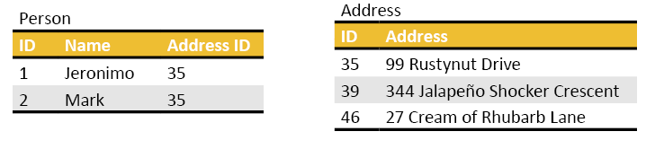
Figure 1-5 The first go at solving the many-to-many relationship problem.

Well, Figure 1-5 works if you want to show that Jeronimo and Mark both have offices at Rustynut Drive. It also works if you’re going to take an address and find out who works there. So-far-so-good. Now let’s tighten the thumbscrews.

What if Jeronimo wants his post from Adventure Works sent to both Rustynut Drive and Jalapeño Shocker Crescent? Oops! Each row in the Person table can only be linked to one address since there is only one Address ID column.

You could solve this by adding another address ID column to the Person table. But what if Jeronimo later stays at three addresses? Okay, so we add two address columns instead. As you can imagine, this is not a scalable way to solve the problem. At some stage, there will be some person who wants deliveries made to 5 address, and another person who will want deliveries to 7 addresses.

Adding columns to a table is not a realistic way to solve this. Especially if the majority of those columns will be unused for most of the rows in the table, such mostly empty columns form what is called a sparse table. We need a solution that works better, something that makes more efficient use of hard-drive space. Pause and think about how we can solve the problem. You are millimetres away from the solution, literally.

You solve this problem with a bridge table, also called a link table or a join table. The complete solution looks as in Figure 1-6.

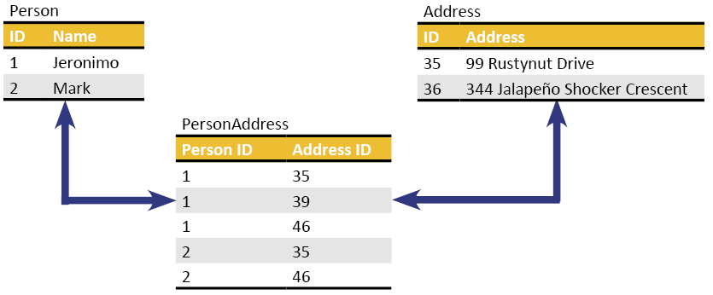
Figure 1-6 How to solve the many-to-many problem. The bridge table–PersonAddress–connects a given person by using their ID to all the addresses they stay at using the address ID and vice versa.
You can use the link table to connect a person via their person ID to all their addresses by the address ID’s given by the link table. You can use the bridging table in reverse: it can connect an address via its ID to all the people who are at that address.

You have to admit that a bridging table is a satisfying and smart solution. And it scales to any practical size you need. To get the data you need out of the three tables using SQL, you can have a sneak peek at Chapter 6.

General Link Table Characteristics

Usually, you name bridging tables by combining the names of the two tables that are linked together. Notice how I have used Pascal casing; in other words, I have written each table name concatenated without spaces against the other and each word in the table’s name starts with a capital letter. This naming system is a common practice in modern SQL systems.

Please avoid using spaces in table names as much as possible; they cause excessive use of []’s as you will find out later. If you consider ever-increasing screen resolutions, spaces tend to “go missing” when you try to read them, hence them losing favour.

Techniques for naming objects throughout computer science change with time. Don’t worry if you find your database doesn’t follow my suggestions. Whatever convention you find, It is best to keep consistency with it. Don’t be surprised to find an existing database is full naming inconsistencies caused by forgetfulness and the preferences of ex-staff members. Its all part of working with a real-world system.

A Bridging Table’s Primary Key

The link table may not appear to have an obvious primary key. If you look again through the table, you will see that the combination of all values in a row is unique. So, a link table uses both columns together to form a compound primary key.

Enforced Relationships: An Occasionally Overlooked Design Feature

The enforcement of values in a foreign key column to match a primary key column’s values in another is known as the preservation of referential integrity. As an example: this enforcement won’t allow you to sell a product if you haven’t put that product into the products table first. It is a rule that can be programmed between tables so that you cannot violate this rule.

The database’s programmer can enforce this rule, but they don’t have to for the database to work in general. The rule can be followed voluntarily without enforcement, with the risk that data may not be meaningful.

The designer does this by programming in a mechanism known as a primary-key-to-foreign-key constraint. This constraint can be called a referential constraint for short. Its abbreviated name is a PK-FK relationship. You will try them out yourself in Chapter 14 and onwards.
You do not have to have this constraint programmed into the database’s tables. You will still be able to join the various tables together, and the database will be usable. The tables, however, will be open to consistency errors. The omission of such a constraint can lead to disasters with queries producing meaningless output. You will be able to refer to rows from one table to rows in another table that don’t exist, without receiving explicit errors.

You should investigate the implementation of where these rules have and haven’t been applied in your real-world database(s). Without PK-FK constraints explicitly programmed, you must be cautious when inserting, modifying or even reading existing data; you risk using invalid foreign key values.

Other Types of Database

Relational databases are only one form of a database. As time has progressed and needs have evolved, various other database systems have become more common in the workplace.

A Data Warehouse

A data warehouse optimises the storage of huge volumes –terabytes, even petabytes– of archived intentionally (computer-controlled) de-normalised data. A data warehouse is kept on a SQL server as you would a relational database. Its internal structure is a specialised form of a relational database. It features specialised table configurations. Its tables are structured to simplify queries and to view the data at different levels of scale.

For example, you asked to know all the sales of tins of tuna in Leeds (a city in Yorkshire, UK) in January 2017. You also want to know the sales of all tinned fish (inclusive of tuna) in the whole of Yorkshire in the first quarter of 2017. There are three values of interest here: location, product and time. The structure of a data warehouse simplifies finding such answers.

We refer to these three values as attributes. Attributes have dimensions. This concept is analogous to measuring the attribute of length using a dimension such as millimetres, centimetres, metres, the attribute of time using the dimension of years, months, days the attribute of geography using the dimension of country, city, postcode and so on. The value you wish to extract—the quantity of sales—is known as the measure.

By supplying a query that makes use of three values such as:

- the city of Leeds
- the month of January 2017
- the subcategory of tins of tuna

You can find and calculate the quantity of sales.

An Analysis Services Database

You can preprogram combinations of frequently accessed dimensions and measures using an analysis services database. You can pre-compute the measures associated with the various combinations of possible dimension values–usually overnight–to form a multidimensional table called a cube. The next day, when a user supplies the lookup criteria, the cube answers immediately with the value of the pre-calculated measure versus triggering a possibly lengthy calculation against the raw data.

By using a bit of your imagination, given that my example uses three dimensions (city, product subcategory and date) you can visualise the cube as being a three-dimensional structure; each axis ticked off with the corresponding dimensions possible values.

The dimensions allow you to adjust the degree of detail along each axis. At the intersection of three imaginary lines projecting from the axes, you will find a pre-calculated totalled quantity. A cube is not limited to three axes, but we still call them cubes. They are effectively multi-dimensional tables.

You query cubes using “multi-dimensional SQL”. This multi-dimensional SQL comes in various flavours such as Multi-Dimensional eXpressions (MDX), or you can express the query using Data Analysis Expressions (DAX). Many database manufacturers have adopted MDX and subsequently customised its syntax. You can find DAX (Data Analysis Expressions) in Analysis Services, Power BI and Power Pivot (which is a part of Excel). You will find both MDX and DAX used in Analysis Services.

We are going to keep our SQL well within two dimensions in this course; tables made up of rows and columns.

Benefits of The Normalisation System

To end off the chapter, here is a list of the benefits of normalising data:

Benefits:
You avoid data duplication.

For example, a product once entered in the Products table, will be referred to by its ID in the future rather than duplicating its name against each sale’s table’s entry.
There is one place to go to make corrections. For example, changing a customer’s mobile phone number can be done by editing a single row in a single table versus every occurrence of data that involves that customer.
You can help protect the data’s integrity by enforcing that a foreign key value first has a matching primary key value.

For example, you can’t sell a product by using a product ID that doesn’t exist.
As long as you know the foreign key values required for a new row in a table–such as the Sales table example–you can insert data very quickly.

Usually, an application looks up the possible foreign key values required for a new row in advance and then presents them to the user, typically using a dropdown list. Letting a computer do the insert makes the content of a row containing foreign key references far less abstract. For instance, you choose a product from a dropdown list, and the application sends the product ID to the database instead.

Tabular structures generally suit an application’s internal architecture and workings beautifully. For humans, inserting data by hand can be rather tedious and error-prone.

Because of the speed at which applications can insert data, relational databases are often called Online Transaction Processing (OLTP) databases. They can hoover up new data—the occurrence of a transaction—very efficiently.

Drawbacks of Normalisation

And here are some “gotchas” when dealing with normalised data and tables:

Drawbacks:
It takes time to get to know the tables in a database to understand which tables contain what data. Use a diagram to help you. I discuss how to draw one using automated tools in Chapter 2.
Linking, or more correctly, joining the tables together can result in a rather long SQL command.

I’ll teach you how to break a long join in a query into manageable pieces as you work through this course.
Getting data out of a relational database can be a long-winded process involving many join operations and having an in-depth knowledge of the tables involved.

That may influence you to invest in a data warehouse. The latter is “easier” to query as they contain de-normalised data. The denormalization is controlled by the computer to minimise chances of error.
Many-to-many relationships require bridging tables.
The design needs to take time anomalies into account.

A Note About the Exercise

To do this exercise, you will need access to a SQL server running the Adventure Works sample database. If you want to install the necessary software on your machine for you to practice on, Appendix A will show you what to do.

The exercise for this chapter will introduce how to use SQL Server Management Studio (SSMS) and Solutions to you. Solutions are a device SSMS uses to keep track of collections of .sql files.

A Solution contains “folders” called projects. Each project is a collection of SQL scripts saved as .sql files. You name the Solution and the included projects to reflect their purpose.

You must do this exercise so that you can learn how to use SSMS and Solutions before you go onto the other chapters. All further exercises in this course refer to the same Solution that you will begin constructing in this exercise.

However, it strictly speaking is not necessary to create a Solution to do any of the other exercises. If you are new to SSMS, I would suggest sticking to using the Solution I describe in this first exercise. Once you are confident enough to know what a Solution does and how to use one, you can stop using it and create query files as you please wherever you want to store them.

You can find the answers to the exercises in Appendix F. Try to using the answers only when you feel you are stuck, and you need a hint here-and-there.

You can download a .pdf containing the answers from my web site for easier reference. You can download my completed Solution containing all the answers to all the exercise at the same address:

https://transference-unlimited.com/Downloads.php

Exercise 1: Getting Started with SQL Server Management Studio

Feel free to experiment and explore as you are doing this and any exercise in this course. If you feel stuck at any point, please refer to the answers in Appendix F.

The more you give yourself time to think and work on a solution of your own, the more “natural” and automatic thinking as a SQL expert will become. It takes time and practice for everyone to get to that stage. Take it easy on yourself.

Ex 1.1. Using SSMS

- Start SSMS by clicking on the Windows logo and type ssms. Click on the Management Studio Icon. If you find typing ssms doesn’t work for you, go to Windows logo=>#=>M=>Microsoft SQL Server Tools=>Microsoft SQL Server Management Studio Vx. If you are running on Windows Server rather than Windows 10, skip clicking the ‘#’ and M.

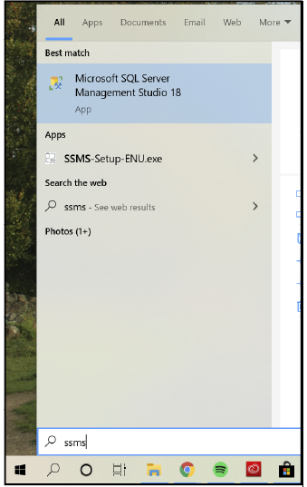

Figure ex1- 1. This figure shows what the SSMS icon looks like.

- Once SSMS has loaded, you will see a screen to log into your SQL server. The name of the server will vary; it won’t be MIKES-STARLORD. The name will be your computer’s name plus possibly a SQL instance name. See Appendix A if you are not sure how to work out what your SQL server’s name is.

If you are unsure of your server’s name, try using a ‘.’ (a period) which is an alias for your local computer name. The security mode should be set to Windows Authentication. This mode tells SSMS to log into the SQL server as the user currently logged into the workstation. See Figure ex1- 2 for guidance.

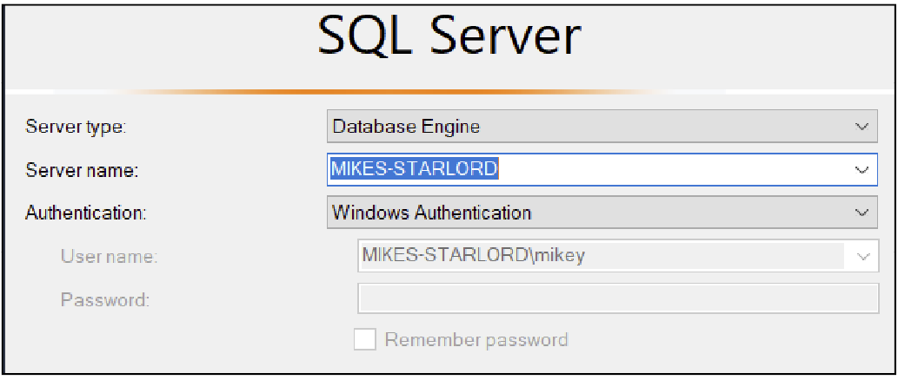
Figure ex1- 2. The login authentication dialogue. Your server name will be that of your machine. You can try using a . instead of typing in your computer’s name.
Have a look at the Object Explorer down the left.

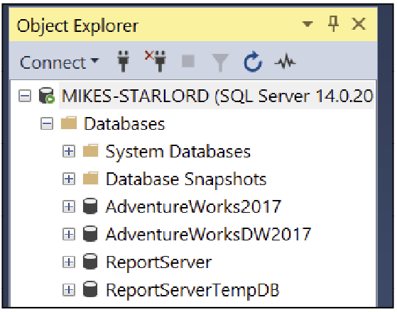
Figure ex1- 3. A screenshot of the Object Explorer’s general appearance.

Please explore Object Explorer by expanding the different sections. Please concentrate mostly on the AdventureWorks2017 database. Open folders as you wish but please don’t take any options that would edit a setting. Feel free to research on the Internet what is within these different folders.

Expand Databases=>AdventureWorks2017=>Tables.

Which table lists the products?

Which table lists the contacts of the company (that table includes customers, employees and suppliers)? If you are unsure, use the column list displayed under a chosen table in the Object Explorer to help you find the relevant table. Take your time exploring.

List any four of the column names and their data type belonging to the Sales.SalesOrderDetail table. You might want to try out the sp_help system (built-in) stored procedure to help you automate the process. You can read up about it here: https://docs.microsoft.com/sql/relational-databases/system-stored-procedures/sp-help-transact-sql?view=sql-server-ver15

Ex 1.2. Putting a Query into SSMS

Right-click on AdventureWorks2017=>New Query in the Object Explorer. A blank notepad like space will appear on the right. I like to call this area the “psychedelic notepad”, and you will soon find out why.

Observe the value in the drop-down box in the top left corner shown in Figure ex1- 4.


Figure ex1- 4. The database context selection box.
Have a look at what other choices are in the dropdown list. You will recognise what they are; they are the other databases on your system. Be sure to leave the box set to AdventureWorks2017.

Go into the script editor pane (the large blank area on the right) and type in the code in Figure ex1- 5. The case of the letters you use is irrelevant.

use AdventureWorks 2017
go

select user_name()
GO
Figure ex1- 5. A short test script for you to try out.
Useful Tip:

An excellent way to start a script file is with the use chosenDatabase statement followed by GO.
This instruction will make sure the SQL commands that follow later in the script will run against a chosen database.

Following this practice makes it clear to the reader which database the script was intended for.

Your screen should contain what you see in Figure ex1- 6.
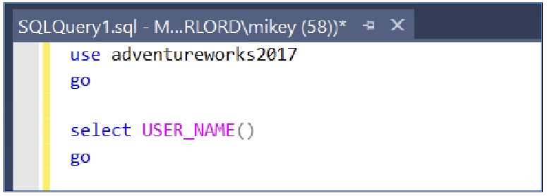
Figure ex1- 6. What you should have so far.

Now press F5 and the server will execute your script. At the bottom, in the results grid, you will see :

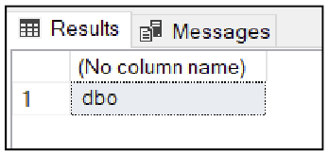
Figure ex1- 7. This screenshot shows your database username when you are in the context of the Adventure Works database. This name is not the same as your Windows login ID.

What you have done is told the machine to switch the database context to the Adventureworks2017 database and then print out your database username as it is in the current database.

Your user identity will very likely be the database owner (dbo); unless you are working on a system shared with other users where your database administrator (dba) has restricted your access to Adventure Works to some other user account. Being dbo means you have full control over the database that you are currently using. This user name will probably not be dbo for all databases unless you are the server’s system administrator (SA).

Now underneath the word GO, type in

select firstname, lastname from person.person
Figure ex1- 8. A SELECT command to access the person.person table in the current database.
And press F5.

You will see Figure ex1- 9.
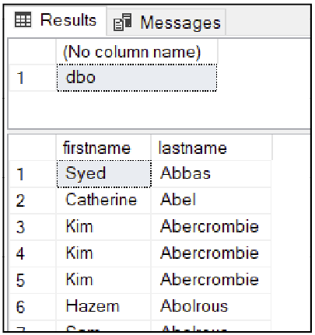
Figure ex1- 9. A partial output of the SELECT statement from the previous figure.
Try scrolling each of the two grids up and down independently. You are looking at two sets of results shown simultaneously.

You can run as many SQL statements at once as you wish by listing them in a script file; in a .sql file. You can highlight the statements you want to run with the mouse and then push F5. If you don’t highlight any section of the script, the entire script will run from top to bottom.

Highlight either the top or bottom select statement. Select only one of the commands; you can choose either one, highlight the command in its entirety and then press F5. The machine will execute the command you have highlighted.

This way you can choose which commands in a script file you want to run. Running part of a script is usually a better choice than having a lot of separate script files in different tabbed windows.

Play around by selecting and running any of your three commands–don’t forget the USE plus the GO is a valid statement pair as well.

Try changing the database in the drop-down box and then rerun your commands. One of the statements will fail if you don’t have the database set to AdventureWorks2017.

Why did it fail? What has your SELECT statement assumed?

Ex 1.3. Saving your Work

Go to File=>Save xxx As where xxx is your current file name. Change the name to My Query.sql but before you save it, write down the path to the file:

Close SSMS. Now reopen SSMS and work out how to reload the script that you have saved.

You might think to use the File=>recent files option in the future, but not this time, please! Work out which File option you need and write it down (hint: it isn’t the first option under File):

Ex 1.4. Creating a Solution

A Solution is a file management system. It consists of a Solution name and a set of one or more projects.

Each project can contain SQL scripts and other file types of your choosing. You could, for example, name a Solution after a department–Marketing–and then put two projects into it; Advertising and another project called Sales. You could then create or place existing SQL scripts relevant to advertising into the Advertising project. You would, unsurprisingly, put Sales related scripts and files into the Sales Project.

At a time in the future, when you sit down at your computer, and you want to find your SQL scripts, you reload the Solution. It will appear in the Solution Explorer tool. That tool then lists all the projects and scripts within your projects for you.

You can click on the script you want in the Solution Explorer. The script will open in the editor, and you can then execute it as you wish.

A Solution is, to use an analogy, a bookshelf loaded with books (projects) and the pages in the book are the script files. Let’s try it out.

Ex 1.5. Creating the Solution Itself

Go to File=>New=>Project. This option will detect that you don’t have a Solution at present and so it will offer to create a project and Solution simultaneously as in Figure ex1- 10.

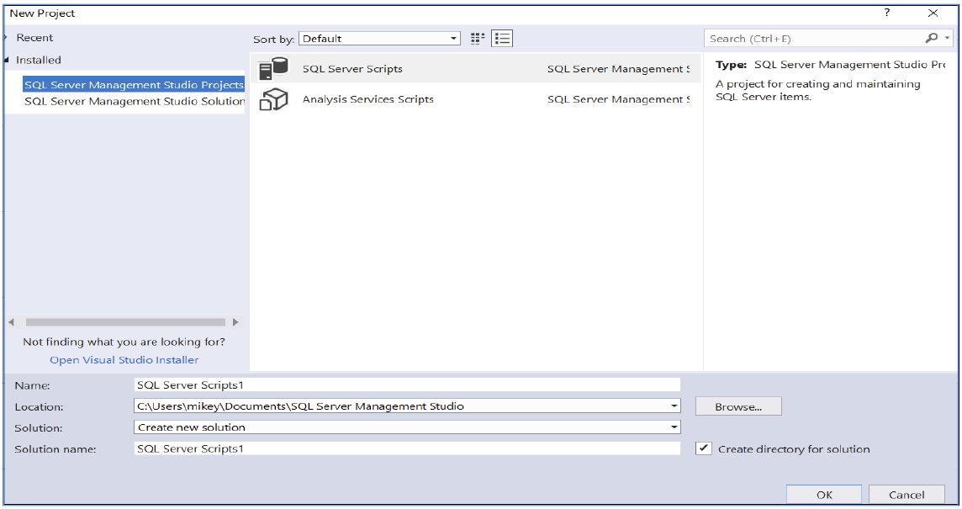
Figure ex1- 10. The dialogue that sets up a new project and if you don’t have one already also creates a Solution. IN other words, to create a Solution, you create the first project in a none-existent Solution.
Change the Name (this is the project’s name) to Ex1 Getting Started and the Solution’s name to Intro To SQL Class.

Write down where the path will be (the Location textbox):

Click OK. If SSMS asks you to save the files, do so.

Find the Solution Explorer down the right-hand side (Figure ex1- 11).

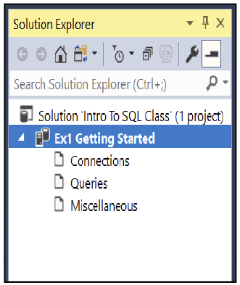
Figure ex1- 11. The Solution Explorer for the exercise so far.
Right-click on Queries=>New Query and you will get a query file called SqlQuery1.sql. Right-click the file and change its name to Test Query 1.sql. Be sure to keep the .sql extension.

Now right-click on the Queries option again, you will get a SQL Query x.sql file. Change its name to Test Query 2.sql.

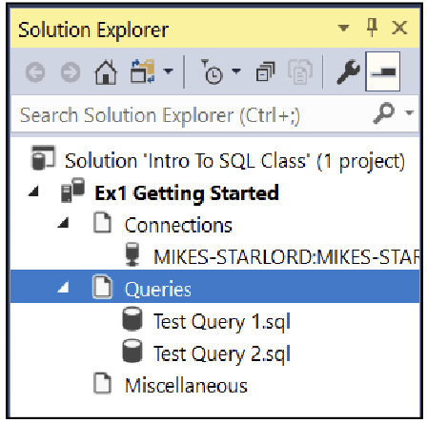
Figure ex1- 12. The Solution Explorer populated with two “Test Query” files.
If you ever close or lose your Solution Explorer pane, you can use SSMS’s main menu’s View=>Solution Explorer to reopen it. Right-click your project’s title of Ex1 Getting Started and take the Add=>Existing item option.

Browse to the SQL file you saved earlier—My Query.SQL. The machine will then copy the file and put it into the current Solution. This way, you can put copies of all your .sql script files you might have randomly scattered about your local hard-drive, network drives and so on into one convenient place.

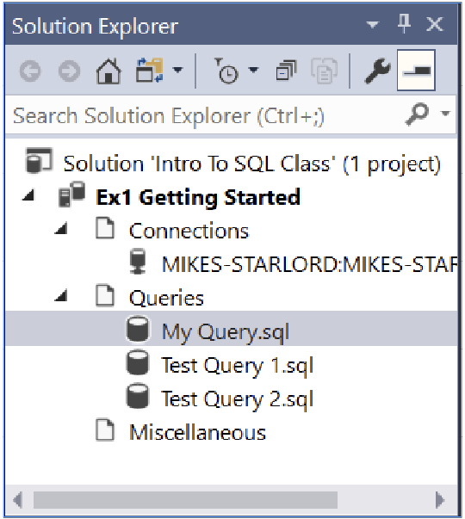
Figure ex1- 13. The Solution Explorer with the project “Ex1 Getting Started” loaded up with three .sql script files.
Now close SSMS.

Find the path to where you saved the Solution by using the File Explorer. In that location is a folder named after your Solution. Open that folder. In that folder, you will find a file named after the Solution Intro To SQL Class.ssmssln.

You might have to turn on the showing of file extensions in File Explorer to see the extension. You can do the latter by clicking File Explorer’s View=>Options=>Change Folder and search options=>View menu options and then click the radio button next to Hide extensions for known file types.
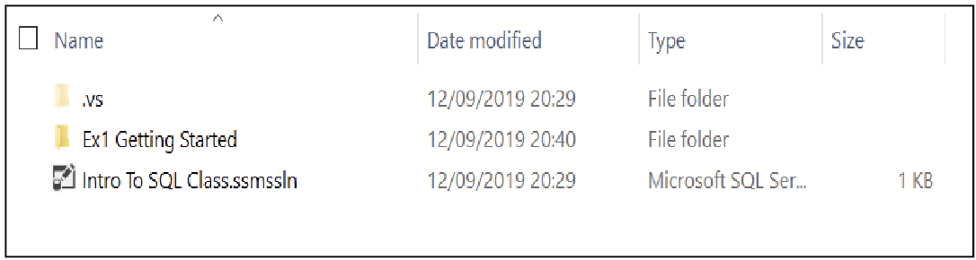 Figure ex1- 14. This figure shows the folder where the “Intro To SQL Class.ssmssln” file is. You might find this figure helpful if you are trying to find the file on your machine.

Double click the Intro To SQL Class.ssmssln file and sit back and watch as SSMS reloads and puts the entire Solution back together on to the screen as you left it.

Use the Solution Explorer to click on the various files under Queries to be able to open, edit and execute them. I know, two of them are empty, you can put some text into them if you like.

You now have a convenient library-like system that you can use to keep track of your SQL scripts.

Explore these skills on your own:
- Add a second project to the solution.
- Add some randomly named scripts to your second project.
- Work out what you can do to the items in a Solutions by right-clicking on its various items such as the Solution’s title, the various Project folders and the Queries folders.
- Try changing a file extension from .sql to .txt and then later set it back to .sql again. Note where the renamed file moves to within the Solution. You can use this facility to add documentation in the form of .txt files to your Solution.
Have fun.

Finding Your Way Around a Database

This chapter blends several different fundamental topics into one chapter:

- Where to go to find T-SQL’s documentation and online help
- Styling your SQL text
- What database objects are
- Naming conventions used to identify objects
- Script commands for programming repeated SQL statements and making programmatic decisions
- The complete list of types of data you can store
- The categories of SQL commands
- Drawing database diagrams using SSMS

2.1. Getting Online Help for MS SQL

If you need to find the syntax of a SQL statement, want to look through a range of useful examples or want to understand the inner workings of SQL better, an excellent place to start that quest is to read the official SQL manual. You can find it by visiting the SQL documentation site of Microsoft:

https://docs.microsoft.com/sql

For Microsoft’s more general documentation library, visit the link below:

https://docs.microsoft.com/

Microsoft’s SQL manuals, on the whole, are examples of some of the best IT manuals I have read. They not only explain the commands but give graded examples of their use, usually.

To discover how to write the syntax of a SQL command, you will ideally have to know how to read Backus-Naur Form (BNF) notation. This wonderfully simple notation explains the [ ] { } [,..n] and so on used to describe a command’s syntax in the documentation.

BNF is used throughout the IT industry to describe the syntax of commands in programming languages in general; for that reason, it is well worth your time to learn it. It takes 5 minutes to master. See Appendix E, which is about BNF.

Another good SQL site to visit is:

https://www.sqlservercentral.com/

If you like detail or are after insight into how MS SQL works internally, you have to visit the inimitable Paul Randal at:

https://www.sqlskills.com/

If you are after serious and truly useful SQL tools, pay a visit to Red-Gate. They have a product called SQL Prompt, which is fantastic as a supplement to SSMS. Also, have a look at Quest software (SpotLight is an especially highly regarded monitoring application) and the visually spectacular monitoring tools of Idera (some are free).
https://redgate.com
https://quest.com
https://idera.com

You can find many other supplemental applications on the Internet. If you are going to be involved with DBA work in the future, I would highly recommend visiting for useful database maintenance management stored procedures:

https://ola.hallengren.com/

2.2. Possible Formatting Styles for SQL Commands

When you type in SQL, there are many possible layouts you can use. There is no particular requirement as to how you format the text. You can insert whitespace (tabs, spaces, line breaks etc.) wherever you please if you feel it adds clarity to your command. As long as you don’t break a single word with whitespaces, SQL will accept it.

2.2.1. Some Formatting Examples

As examples of formatting for you to choose from, you might like this layout:

select LastName, FirstName from Person.Person
Figure 2- 1. A style suitable for a short command

Or you might like:

select
LastName,
FirstName
from
Person.Person
Figure 2- 2. A spacious style I use when I intend to save the query for re-use in the long-term via a .sql file.

or even:

select
LastName, FirstName
from
Person.Person
Figure 2- 3. A style that is useful for clarity when the column list is “long”.

or you might prefer:

select
ProductID, P.Name, PSC.Name, UnitPrice
from
Production.Product P
join
Production.ProductSubcategory PSC
on P.ProductID = PSC.ProductID
join
Production.productCategory PC
on PSC.CategoryID = PC.CategoryID
Figure 2- 4. A style I use when I want to emphasise the various parts of the SQL command such as the JOIN and ON clauses.

I will explain the purpose of these commands to you later. The SQL commands are not case sensitive, so you don’t need to type them in upper case. I have done so in my examples to make them stand out to you.

The names of objects in the database may be case sensitive (see “Code Pages” in the previous chapter). I will explain what objects are shortly but for now, consider them to be the names of tables. Your preferred layout and style for typing commands will become your signature; it will identify to readers that you wrote the SQL code.

I prefer the layout in Figure 2- 4 for more lengthy SQL commands. I have followed this layout throughout this book. For shorter scripts, I use Figure 2- 3’s layout. Consistency in your choices of formatting is vital both for your sanity and that of other reader’s.

2.3. The Object Naming System

You will use the object naming system to specify the location of an object in your SQL environment. I used the word “environment” because you can write a single query that uses multiple SQL servers and databases across the network while you are operating from a default database (or database context). At this point, please think of an object as a table. Later I will show you what all the SQL database objects are (section 2.6).

Let’s set the scene: you realise, to reduce typing, that it is best to set an assumed default database SQL Management Studio (SSMS). SSMS will understand to use this database for future SQL commands that don’t name a database explicitly.

You have learned, via the previous exercise, that you can set a database context by typing in the commands in Figure 2- 5.

As a small sidenote: you may see a ‘;’ appended to SQL statements in some versions of SQL. The ‘;’ is used to clearly demarcate the end of a complete SQL statement. Without it, you could argue that it is difficult for you to see where one SQL statement ends, and the next begins. T-SQL works out where a statement ends for itself and does so successfully 99.9% of the time. Some variations of SQL, like MySQL, require you to use the ‘;’ consistently at the end of each statement. Microsoft’s T-SQL almost always does not require semi-colons. You can use them at the end of your statements if you feel more comfortable doing so.

USE AdventureWorks2017
GO
Figure 2- 5. A sequence of two instructions to set your SSMS’s session’s database context.
Useful Information:
Neither USE nor GO are SQL commands. They are instructions to the software controlling the communication to the SQL server known as the provider. The provider is on the client’s machine. SSMS (or any client application) sends commands to the provider which in turn packages them and sends them to the SQL server.
The SQL server passes the results of your query back to the provider, which then relays them to the client application. You can relate this concept to using a hardware driver to allow the OS to talk to a hardware device. The provider simplifies the process of enabling a client to talk to many different makes of SQL server.

Or you can use the drop-down box in the top left-hand corner to select a database (Figure 2- 6).

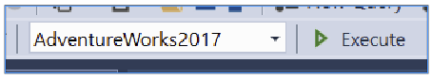
Figure 2- 6. The database context selection drop-down in SSMS.
Once you have selected a context, you can refer to objects within the database using the notation:

Schema name.Object name

For example, you have the course’s text refer to the table containing the Adventure Works’s products list. This table is called Production.Product. Production is the schema name and Product is the object name.

You can think of a schema as being similar to a folder for files in Windows. They are used to group the database’s objects under a common name. You can use schemas to implement security mechanisms, but I shall not cover that in this course.

In Figure 2- 7, you can see sample tables (from Adventure Works) grouped into schemas such as dbo, HumanResources, Person and Production.

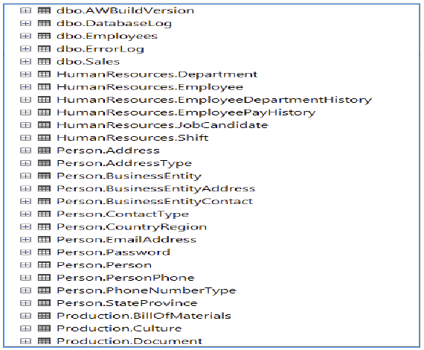
Figure 2- 7. A list of tables in their respective schemas. You can see this list by expanding the AdventureWorks2017 folder. The schemas are dbo, HumanResources, Person, and so on.
You must register possible schema names before using them in a database in advance. They are specific to a database. You can reuse a schema name in other databases, but the repeated names are not related to each other from an administrative point of view.
If you register a new schema name, you have to allocate an owner to it. Whoever owns the schema name, has total control over any objects that carry that schema’s name. The level of control the owner has includes editing the object’s contents, modify its definition and to be able to delete the object itself. The owner of a new schema will default to the database owner (dbo).

2.4 A Database User

When you log into the SQL server, you use your login credential (think of your Windows login ID as an example of a login credential) to establish a connection with the server. When you access a database, SQL maps your login credential onto a database user account that is database specific. It is almost as if you log in twice: once into the SQL server and then again into a database.

Your database user is what grants you access to the objects in the database. Not your login credential. If your database user account doesn’t have access to a table, you can’t access that table.

The database’s owner (the dbo) will have mapped your login credential onto a suitable user account in the database. The dbo will very likely have created that database user account for you. The system administrator, who has total control over the entire server including all its databases, can also set this mapping up for you.

2.5. The Database Owner User (dbo)
dbo is a database user account with unusual privileges. If your system administrator has mapped your login credential onto the dbo user account, you have complete control over all objects in that database. Each database has a dbo account. The separation of database users per database means that you may have dbo privileges over one database but no or ordinary user privileges in a different database.

2.6. How the dbo User Relates to the Schema dbo
The dbo user account owns the schema name dbo. This dual usage of the label dbo has a beneficial side effect: any object prefixed with the name dbo (the schema name) is owned by the user dbo.

Some databases use the dbo schema name exclusively rather than customising the schema names. Some designers feel this reduces design complexity. Some designers do not know that you can vary the schema name.
If the dbo creates an object without specifying a schema name, SQL assumes the intended schema to be dbo and will name the object with dbo as a prefix. If you type in a table’s name without a schema prefix, the machine assumes you meant the prefix dbo. The latter behaviour can be changed.

Because of the assumed automatic usage of dbo as a prefix, you can usually get away with referring to the name of that object without prefixing it with dbo. Assumptions can be dangerous: the default schema name for a given database user account can be changed.

For commercial-grade scripts that you intend to keep for a long time, be they .sql files or the contents of a stored procedure and so on, type the schema name in front of an object name. Do so even if the prefix is dbo. This explicit labelling of the schema protects you in case someone has changed a user’s default schema. Besides, doing so is considered polite, correct and good practice.

For throw-away scripts and ad hoc queries, you can assume that dbo is the default schema name. However, if you are going to keep “it”, put a schema name in front of it.
You can access objects that are owned by someone else. You can do so as long as the object’s owner has permitted you to do so. Unless you are the dbo, in which case you will automatically override all privileges assigned to an object.

The dbo’s job typically includes assigning users and roles (a superset of a windows group) permissions to objects in the database to enable users to access them.

Here is a “for instance” showing an assumed schema name of dbo:

select PostCode from Addresses
Figure 2- 8. An example of a query that doesn’t explicitly use a schema name. The machine will assume that you mean dbo.Addresses unless you have altered the user’s default schema.

The above (Figure 2- 8) assumes you want to access dbo.Addresses

2.7. The Fully Qualified Name of an Object

The fully qualified name–the FQN–used to label an object categorically looks as you see in Figure 2- 9.

Server name.Database name.Schema name.Object name
Figure 2- 9. The parts that make up an arbitrary database object’s fully qualified name
It is rare to see the server name in front of an object’s name. This ability allows you to access a table on a different server via your network. The system administrator must preconfigure this facility; otherwise, folk could try to read all sorts of tables from all sorts of random servers in your company. Naughty users. You can find out more here: https://docs.microsoft.com/sql/relational-databases/linked-servers/create-linked-servers-sql-server-database-engine?view=sql-server-ver15.

You can specify a different database name to that of your current database context by putting the database name in front of the schema and object name. You can use ”..” if you wish to imply the default schema (usually dbo). I have some examples in Figure 2- 10.

1) select * from SalesDB.Marketing.RegionalSales

2) select * from CanadaServer.Engineering.Products.Tolerances

3) select * from PartsDB..Stock
Figure 2- 10. Examples of using various components of an FQN to access objects.
Example 1 starts with a database name: SalesDB. The currently used SQL server name is assumed. The schema name is Marketing, and the table name is RegionalSales.
Example 2 is an example of a fully qualified name. This query connects to a server called CanadaServer, the database name is Engineering, the schema name is Products, and the table’s name is Tolerances.
In example 3, you are accessing the PartsDB database, explicitly using the default schema name (via the ‘..’. The user’s default schema name is very likely dbo) and then it accesses the Stock table.

2.8. The SQL Database Objects

Not everything in a SQL server or database is an object. What constitutes an“object” is precisely defined. A database user, for instance, is not an object; they are a database user. A database is itself not an object; it is a database.

I have listed the available database objects in T-SQL and a summary of their purpose in Table 2- 1. We will not be creating nor working with all these kinds of objects in this course.

Object: | Purpose:
Table | Tables are used to store data.
View | Views contain a preprogrammed query. You can use a view as if it were a table.  They are used to limit the rows and columns you can see in a table. In other words, they provide a view of a table or a query’s output.  They can be used to store complex and long-winded queries, providing a means to access that query using a convenient meaningful name.  You can think of them as preprogrammed SELECT statements.  You can edit data via a view under the right circumstances.
Index | You would use an Index to speed up the process of finding data in a table. They are analogous to using an index to find a topic in a book.  There are various kinds of index in T-SQL. In this course, I will touch upon clustered and standard (non-clustered) indexes.  A clustered index is the technical name for what we have so far referred to as a table. Not all tables are clustered indexes, but the reverse is true. A table that is not a clustered index is called a heap. Chapter 14 talks more about these ideas.  Standard indexes are the most popular index type in a database. They are used to search specific columns within a clustered index. I am simplifying a tad as I have discounted discussing heaps.  A programming or administration course would describe these various aspects in more detail.
Stored procedure  (affectionately called a “sproc”) | A stored procedure is a sequence (a script) of SQL commands executed (run) by typing in EXEC procedureName. EXEC is short for the word execute.  They are handy for running a set of SQL commands consistently or for avoiding remembering and typing in a sequence of commands, particularly long-winded ones.  Sprocs are stored within the database itself rather than stored as .sql files. This ability removes the step of you having to find the .sql file when you want to run a sequence of SQL commands.  They can accept parameters. You enter parameters after the procedure’s name when you want to execute them. These parameters are available to the stored procedure’s script contents as variables. I will explain variables to you later in this chapter.  Parameters make the stored procedure’s script more flexible for a variety of uses without you having to edit the text in the script.  As a short example: EXEC AddCustomer 67, ’Peter’ might add the customer Peter with a customer id of 67.
Function | There are two categories of functions:  1. Table-valued functions are effectively stored procedures that output a table. Unlike a stored procedure, you can use them where ever you would place a table name. They have a considerable advantage over views in that you can parameterise them for flexibility. Views do not accept parameters.  2. Scalar functions contain a SQL script that returns a scalar value. A scalar value (a one-dimensional value) represents the single value that you would find in a table’s cell, the single numerical or character-based output of a calculation.  You may see scalar-valued functions specified in the column list of a SELECT statement or used in a WHERE clause’s conditional expression. An example would be the built-in function COUNT(*), which returns the number of rows in a table or group of rows.
Synonym | You use synonyms to give aliases (false) names to objects in the database.  They are sometimes used to provide abbreviated alternative names to objects with very long names.  Often these aliases are used to create short names for long FQNs (server.database.schema.object name style names).  You can use synonyms to help ease migrating objects to a new schema or database. They can helpfully disguise the source of the data to ease the process of moving that data elsewhere in the future.
Trigger | These are stored procedures that execute (fire) when you insert, delete or update a row in a table. You can use triggers to implement auditing, versioning systems and “complex” data validation rules.  A trigger’s script has access to the original column values as well as the proposed replacement values. They can be used to implement SQL script to validate new row data that requires looking up rows across different databases—an advanced form of referential integrity check.  They can abort proposed alterations to a row.
Rule | You can use rules to specify the format of text in a field or match proposed data against acceptable ranges of values.  Rules are considered defunct, and they are non-ANSI standard compliant. Backwards compatibility is the only reason they are still supported.  Rules have an equivalent constraint type called a check constraint, which is an ANSI standard. These constraints are implemented directly in a table’s definition, unlike a rule which is a separate object applied to a table.  You will still find rules used in older database designs (pre-2000’s).  Don’t replace them. If you try to replace them, you will create a lot of work for yourself. Don’t use rules in future designs.
Default | They supply a default value should a column’s content be unsupplied.  They are, like the rule, defunct and non-ANSI compliant.  In an ANSI compliant system, they are implemented directly in a table’s definition.  As for the rule, please don’t try to replace them but don’t use them in the future.
Type  (also known as a user-defined type or UDT) | User-defined types–UDTs–create alternative friendlier names for existing data types. For instance, the PhoneType in Adventure Works is the same as the nvarchar(30) type.  They can be used to create entirely new data SQL types with the help of programming languages such as C#. Examples of the latter would be the geography data types for managing the storage of longitude and latitude coordinates on the Earth’s surface in your tables.  I don’t recommend creating user-defined types as aliases to SQL types. The intention of using them is to attempt to provide consistency for column definitions. For example, PhoneType may be used in 3 different tables to define the home phone, mobile phone and office phone columns in each of the tables identically.  Why don’t I recommend them? Once you have allocated a type to a column’s definition, you can’t edit the type’s definition. You have to replace each column’s definition that uses the UDT with the non-aliased equivalent. Then you will be able to edit the UDT’s definition. Then you can reapply the now edited type definition to each column.  Types used as aliases for standard SQL types are usually more trouble to maintain than their usage is worth.  Instead, rather document what SQL types you want to use for what purposes in a text file. In the future, consult that file to find out what SQL type to use for a specific column’s purpose.
Table 2- 1 The various objects you can find in a database. I have listed them here for completeness. This course will not cover using all of them.
If you are unsure if you are dealing with a SQL object, a simple test is that if you can put a schema name in front of its name, it’s a SQL object.

2.9. Scripting

When you create a script (a .sql file), you are typing in a sequence of SQL statements that you want to execute together. Sometimes you will execute a part of the script. You do that by highlighting the relevant sections of the script with the mouse then executing it using F5.

You would use such partial script execution for testing purposes. Once you are happy with the sections of the script, the general idea is that you would run the completed script from top to bottom.

You don’t have to execute the final script all in one go. If your intention is for the script to execute in sections, insert comments to explain to the reader where the sections are.
SQL statements work independently of each other. One SQL statement may create a table, the next may insert data into it, and the next read the table. SQL statements are rarely directly connected. The statements in a script arguably communicate via the changes they make to the database’s tables and the script’s variables. Exceptions are the case of correlated subqueries and common table expressions (CTEs). I teach these in chapter 10.
You must execute the sequence of statements in a script in a meaningful order; you wouldn’t insert data into a table that doesn’t exist yet: you would put the statements to create the table earlier in the script than the statements that insert data into it.

2.10. Variables
If you need to pass information/data from one SQL statement to another (such as a customer’s id), an option you can consider is to put the piece of information into a variable.
A variable is available for each command in a script to read and set.
As an alternative, you can pass large amounts of data between commands via tables. Let’s focus on small amounts of data first, and so variables are where we begin.

You create a variable by giving it a name–up to 256 characters long, no spaces, no leading numbers–and then you specify the type of data it will store. I provide a list of data types in section 2.15.

Almost all the data types you can choose from will only store one item of data at a time; a number, a sequence of characters (called a string) and so on. Being able to store a single value means that a variable only posses a single dimension. Such values are called scalar values. Compare that to a SQL table which has two dimensions (rows and columns). There are exceptions such as variables of type table.
I will begin by using some basic types so that you can develop a general understanding of variables and data types. I will start with the integer and nvarchar types. Integers are whole numbers between approximately -2000,000,000 and +2000,000,000. Nvarchars are strings of up to 4000 characters. Their content can include that of any symbol used by any language, including Chinese, Japanese, Korean, and so on. I explain the various data types in detail in section 2.15.

You create a variable by using the DECLARE statement as you can see Figure 2- 11.

1) DECLARE @x INT

2) DECLARE @x INT, @y INT

3) DECLARE @x INT=100
Figure 2- 11. Three examples of declaring variables. The variables are @x. @y and @z
Example 1 declares a variable and implicitly leaves its content set to null (computer speak for unknown). The intent would be to load data into it later. You can declare multiple variables on the same line (example 2). You can both declare and load an initial value into a variable (example 3).

The @ symbol prefixes a variable’s name. The @ prefix is so that SQL recognises the adjacent name as a variable rather than as a database’s object’s name or SQL statement.

Useful Tip:

Any SQL I show via an SSMS screenshot (for example, Figure 2- 12), you can try for yourself on your computer. Any SQL presented in a rectangular block (Figure 2- 11) is unlikely to work as-is. Such SQL is presented as part of my discussion and is a guide to syntax rather than necessarily be a functioning standalone example.

Figure 2- 12 shows you some SQL you can try out. The NULLS indicate that the variables have no content, null means unknown. The SELECT statement has projected the variables onto a single row 4 column table. SELECT is a command used to output a table, whether it is a copy of an existing table or one created on the fly as you see here.

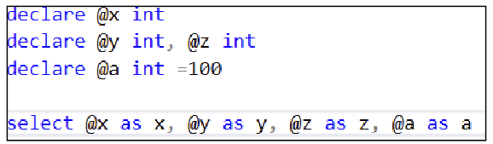
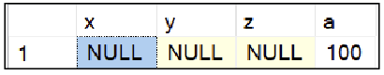
Figure 2- 12. A pair of screenshots showing a group of DECLARE statements and the resultant output of the SELECT statement. SELECT projects the variables onto a single row of a table.
You must run all the statements in Figure 2- 12 simultaneously, or you will receive errors. You might like to try highlighting and executing the SELECT statement without the DECLAREs and see what happens. I explain the reason for the error you will get (“must declare the scalar variable…”) in 2.10.

2.11. The SET Statement

You can load data into an existing variable any time you like using the SET statement (Figure 2- 13).

DECLARE @x INT
SET @x = 100
Figure 2- 13. Loading data into a variable with SET. You must execute both statements simultaneously
You must run the DECLARE and SET statements together. If you run the, declare by highlighting it and pushing F5, then run the SET in the same separate way, your SET statement will tell you that the variable, @x, no longer exists.

2.12. Introduction to SQL Batches
SQL runs statements in units of execution called batches. When you run a script in its entirety or highlight a section of the script and push F5 that set of commands forms a batch.

You can explicitly break your script up into smaller batches by using the word GO. SQL processes each batch of commands separately from the others. They can communicate through modifying data in tables which the next batch can read. Variables, however, cannot cross from one batch to another. If you create a variable in batch #1, the SQL in batch #2 cannot read it.

An important rule is that if one batch contains create commands such as CREATE TABLE, the same batch cannot insert data into that table. You must detach the batch with the CREATE statements by typing in an explicit GO placed at the batch’s end. You thereby separate the first batch that creates the tables from the second batch that contains the insert statements.

It is as if you use the batch demarcator (GO) to tell SQL that it must finish executing the batch that creates the tables before it can run the next batch that uses the tables. I find that using that reasoning helps me understand where to put the word GO.

2.13. BEGIN and END

You use the keywords BEGIN and END to enclose a set of statements that you wish to treat as if they were a single statement. These keywords don’t have an apparent visible effect. I will use examples throughout the remainder of this section that will illustrate what BEGIN and END do.
BEGIN, and END are significant to statements such as IF or WHILE. IF and WHILE only apply to the single SQL statement that immediately follows them. By grouping several SQL statements between BEGIN and END, the enclosed statements are seen by IF and WHILE as if they were a single statement. All of the bracketed statements, therefore, are now controlled by the preceding IF or WHILE.

The examples below will illustrate the usage of BEGIN and END.

2.14. IF

You can execute a section of script based on a decision. You write the decision in the form of a Boolean expression; an expression that yields either true or false. I explain Boolean expressions in far more detail in chapter 4, which is about the WHERE clause.

If the boolean expression after IF is true (any non-0 value) the very next statement is executed. Otherwise, if the expression is false; SQL ignores the next statement.

You can supply an optional ELSE keyword. The statement after ELSE executes if the Boolean expression in the IF statement yields false (0 in value).

Figure 2- 14 shows the syntax of IF using code that has a very predictable outcome (Figure 2- 15). We will use IF in more elaborate scenarios later in the course. Feel free to try this code and experiment with it.

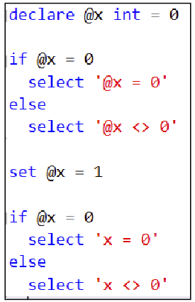
Figure 2- 14. This code shows the fundamentals of how to use IF and ELSE.

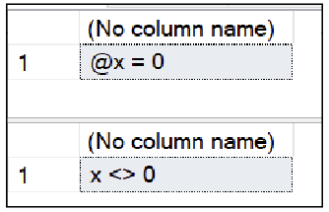
Figure 2- 15. The output from the two select statements.

2.15. WHILE

WHILE is used to code a conditional loop, it used to express that you want a conditionally repeated SQL statement. The statement after WHILE repeatedly executes as long as the Boolean expression associated with WHILE remains true.

Figure 2- 16 shows the fundamentals of how to use a WHILE loop. If you run it, you will have to open the SSMS’s Messages pane to see the output.

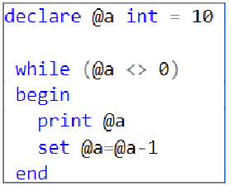
Figure 2- 16. An example of a while loop that counts from 10 down to 0.

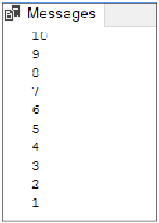
Figure 2- 17. The output of the WHILE loop.

The BEGIN and END keywords are required. Without them, only the PRINT statement will run and so @a would never decrement in value. This situation would cause an infinite loop.

You can try running the script after removing the BEGIN and END. If you do, you will need to click the red stop symbol in the toolbar once you have started it and realised what is going on; the script will never stop running. At any stage, during or after execution, click on the SSMS’s Messages tab to confirm what is happening.

2.16. SQL Data Types

Both variables and columns in a table must be assigned a data type. These types determine the range of values you can store in the variable or column.

The data types belong to categories such as whole numbers, fixed-point numbers (numbers with a given number of digits after the decimal point), floating-point numbers (numbers with a decimal point in any position), dates, time, combinations of dates and time as well as ranges of character symbols (from English, German, French, Chinese, Korean, Japanese etc.).

2.16.1 Whole Numbers

Type name: | Range:
bigint | -9,223,372,036,854,775,808 to 9,223,372,036,854,775,807
int | -2,147,483,648 to 2,147,483,647
smallint | -32,768 to 32,767
tinyint | 0 to 255

2.16.2. Decimal/Numeric

This type has two names: decimal or numeric. You usually specify it by following the type name followed by two numbers in parenthesis. These numbers are the precision and the scale and are each optional.

In Figure 2- 18, there is an example of using this type to declare a variable:

DECLARE @price DECIMAL(10,2)
Figure 2- 18. This figure shows you an example of how to declare a variable of type decimal. The variable will have a precision of 10 and a scale of 2. This precision and scale mean that you will have two digits after the decimal point and up to eight in front.

Type name: | Range:
decimal(p,s)  or  numeric(p,s) | p determines the maximum number of digits in the number.  p includes the number of digits both before and after the decimal point.  p must be a value between 1 and 38.  s is the number of digits after the decimal point.  0 ≤ s ≤ p (s can have a value of 0 up to and including p).  p defaults to 18.  s defaults to 0.

You can read more about precision and scale here: https://docs.microsoft.com/sql/t-sql/data-types/precision-scale-and-length-transact-sql?view=sql-server-ver15.

You can store a number such as 12345678.12 in @price. There are ten digits in total, eight digits in front of the decimal point and two digits after. 8 digits + 2 digits = 10 digits. Be aware of mistakenly thinking that you will get ten digits in front of the decimal point and two digits after.

In short, this type offers you up to 38 digits to play with, and you can insert a decimal point somewhere within those 38 digits. Your choice of scale will affect how many digits after the decimal point are stored. A scale of 0 means you can’t insert a decimal point, making your variable or column a whole number.

2.16.3. Money/SmallMoney

Type name: | Range:
money | -922,337,203,685,477.5808 to 922,337,203,685,477.5807
smallmoney | -214,748.3648 to 214,748.3647

These are old data types. As far as I know, they date back to the ’70s. They are not very useful for storing money values despite their name. That is because they have far too few digits after the decimal point (4 digits).

The lack of digits after the decimal means that if you do division or multiplication with values of these types, your calculation will rapidly begin suffering from rounding errors. Addition and subtraction are much safer to do. I would suggest using the decimal type with 6 to 8 digits after the decimal point for money instead.

Smallmoney is too small a range to be of much use in a business environment. It exists for backwards compatibility with older SQL scripts.

2.16.4. Approximate Numerics

Type name: | Range:
float(n) | -1.79*10³⁰⁸ to -2.23*10⁻³⁰⁸ if 25 ≤ n ≤ 53  Or  2.23*10⁻³⁰⁸ to 1.79*10³⁰⁸ if 1 ≤ n ≤ 24
real | Can be considered the equivalent to float(24) in a modern machine.

You would use this pair of types to store very large or very small numbers. n determines one of two ranges of values for float. The real type, like smallmoney is rarely used and kept for backwards compatibility.

These types are used to capture numbers using scientific notation for example: 1,000,000,000,000,000 is written as 1E+15 which is a shorthand for writing 1×10¹⁵. 0.000,000,000,1 is written as 1E-10 or 1×10⁻¹⁰.

If 25 ≤ n ≤ 53, the float type stores fifteen digits and then rounds any remaining digits to 0. You express this behaviour by saying that float stores fifteen significant digits.

If 1 ≤ n ≤ 24, float records seven digits significantly and rounds any further digits to 0.

2.16.5. Dates and Times

Type name: | Range:
datetime | Date part: 1753-01-01 to 9999-12-31.  Time part: 00:00:00 to 23:59:59.997
datetime2 | Date part: 0001-01-01 to 9999-12-31.  Time part: 00:00:00 to 23.59.59.9999999
smalldatetime | Date part: 1900-01-01 to 2079-06-06.  Time part: 00:00:00 to 23:59:59
date | 0001-01-01 to 9999-12-31
time | 00:00:00.0000000 to 23.59.59.9999999
datetimeoffset | Date part: 0001-01-01 to 9999-12-31.  Time Part: 00:00:00 to 23:50:59.9999999 with support for a time-zone offset of -14:00 to +14:00 from Greenwich Mean Time.  Regardless of whether daylight savings applies or not, SQL will return the time stored as fixed. It is for you to adjust the time during daylight savings time, not SQL. To put this another way, SQL stores UTC which is independent of a countries choice of daylight’s savings.

datetime is the oldest of the date and time storing types harking from the ’70s. It stores a date and time together regardless of if you only want to save only the time or the date. If you only want to store a date, the tradition is to set the time part to 0:0:0 (midnight). If you only want to use the time part, the tradition is to set the date part to the 1st January 1900.

We still use this type a great deal even in the year 2020 because of its familiarity. It is, however, best to use the more accurate datetime2 type for future date and time storing columns. Microsoft added Datetime2 to SQL 2008 onwards.

Don’t go through your database replacing datetime columns with datetime2 columns unless you know what you are doing. I have known SQL code using datetime to rely on the rounding behaviour of the time part of datetime, and so I would suggest leaving such older code as-is.

The ability to store date information without time information and time information without date information is something relatively new to the world of SQL. You can do that with the date and time type. Microsoft added these industry-standard types in 2008.

2.16.6. Character Types

Type name: | Range:
char(n) | Char stores a fixed number of characters, n of them.  The range of available characters is dependent on your database’s code page setting.  n has a maximum value of 8000.
nchar(n) | nchar stores a fixed number of Unicode (national) characters, n of them.  National characters can come from any language on Earth and include various other symbols as well, such as smileys and musical notation.  n has a maximum value of 4000.
varchar(n) | varchar(n) stores a variable number of characters, up to n of them.  The range of available characters is dependent on your database’s code page setting.  n has a maximum value of 8000.
nvarchar(n) | nvarchar(n) stores a variable number of Unicvode (national) characters, up to n of them.  n has a maximum value of 4000.
varchar(max) | varchar(max) stores a variable number of characters up to a maximum of 2,147,483,647 characters (2GB worth) can be stored.  The characters available are code-page dependent.  Varchar(max) is the “more modern” version of the text data type and supports additional commands to manipulate its content.  Favour the varchar(n) type if you know what n should be. Varchar(max) is suited to storing text documents of varying length such as text-based cv’s, job descriptions where you can’t predict the ultimate length of the datum.
nvarchar(max) | nvarchar(max) stores a variable number of Unicode characters from any language on Earth.  A maximum of 1,073,741,823 of characters (1GB worth) can be stored.  Nvarchar(max) is the “modern” version of the ntext data type and supports additional commands to manipulate its contents.
text | text stores a variable number of characters.  A maximum of 2,147,483,647 characters (2GB worth) can be stored.  The range of characters available is code page dependent.  This type is still popular and seen in many older database designs. You should not use it in future designs. Replace it with varchar(max).
ntext | ntext stores a variable number of Unicode characters taken from any language on Earth.  A maximum of 1,073,741,823 characters (1GB worth) can be stored.  This type is still popular and seen in many database designs. You should not use it in future designs. Replace it with varchar(max).

Character types can accommodate fixed-length character fields and variable-length character fields. The latter carries the prefix var. I will show you the practical differences a little further down in the text.

If you put ‘n’ in front of a character type, you can use the Unicode UTF-16 character encoding format. This format gives you access to symbols from Chinese, Japanese, and so on. I have been a little grandiose in saying that UTF-16 (Unicode Transformation Format) can store any symbol of any language on Earth. For that ability, you need to use Unicode's UTF-32 format, which MS SQL does not support. There are very few language symbols that UTF-16 doesn’t offer, but I have encountered some Thai symbols that don’t work. Visit https://home.unicode.org/ for more information on Unicode.

The value of n is limited to 8000 for non-Unicode character storage. It is limited to 4000 for Unicode storage. The exceptions are the varchar(max), nvarchar(max), text and ntext which allow 1GB of more’s worth of characters. Because they are stored using a different format in the database to the other char(n) types and work less efficiently, you should not use them if you know you can predict the value of n.

Non-Unicode character processing relies on the database administrator’s deliberate choice of code page as described in “Code Pages” 1.9. The choice of code page affects the set of characters you can use in non-Unicode fields.

2.16.7. Comparing VARCHAR to CHAR Data

A fixed-length character field fills any unused character positions with spaces. A variable-length character field records exactly how many characters there are in the string of characters.

If you have a char(8) field and use the first three characters, you have stored three characters plus five spaces in the remaining character slots. If you have a varchar(8) field, if you store three characters, you will have used 3 bytes of storage plus an additional 2 bytes SQL uses to count the length of the string; in this case, it stores the number 3. varchar remembers the exact length of the string. Char pads the string by filling unused character slots with spaces.

Varchar fields make sense for storing text whose length will genuinely vary, such as a short description of someone’s skill set; a length of characters that may vary widely in amount. Char is excellent for a fixed-length field such as a product’s serial code which will always have the same number of characters.

Be wary of comparing variable-length character fields against fixed-length fields.

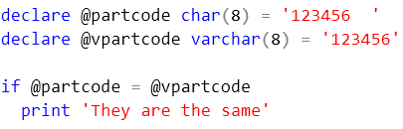
Figure 2- 19. This script helps towards answering the question “are char and varchar fields stored the same way?“ This example’s results (Figure 2- 20) may bamboozle you until you read the text.

Given my description before this example, you may be surprised to find that T-SQL returns:

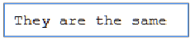
Figure 2- 20. The query in Figure 2- 19 reveals that @partcode and @vpartcode are identical.
Strictly speaking, @partcode and @vpartcode are not the same in content. If you put the two spaces in the front of @partcode’s content (that is the fixed-length char variable) rather than at the end, SQL will no longer tell you that both variable’s content is the same.

The “secret” is that T-SQL removes whitespaces from the end of character fields when it compares them. It does not do that to leading whitespaces

You might find it best to write a comparison between char and varchar types as:

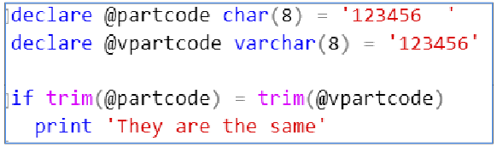
Figure 2- 21. You can use the TRIM() function to alleviate confusion over whitespaces in front of or at the end of character strings, be they char or varchar.

The TRIM() function used in on both sides of the equals sign removes the whitespaces from the front and the end of each string.

If you are beginning to wonder if there is a difference between char and varchar at all, let’s get SQL to do the talking:

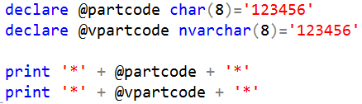
Figure 2- 22. How to prove that char and varchar are different in behaviour.

Figure 2- 22 produces:

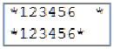
Figure 2- 23. You can see the spaces in the char field now.
The extra spaces you see before the “*” in the char field (Figure 2- 23) show you that char and varchar fields do not store data the same way.

There are various comprises made internally by SQL that causes fixed-length fields to be more efficient in terms of processing time required because of their predictable space usage in the database file.

Use a fixed char types if the number of characters you want to store is the same amount (or very close to the same amount) every time.

If you need to store more than 8000 bytes of character data, you have to use the varchar(max), varchar(max), text and ntext types. Only use them under the circumstances when a standard character field won’t do. These types create specialised structures in the database for them to work. Their content is less efficient to manipulate and store for that reason. They are not a group of types to avoid but don’t use them unnecessarily.

2.16.8. Binary Types

Type name: | Range:
varbinary(n) | Varbinary(n) stores binary data such a file or picture.  However, this type is limited to storing 8000 bytes at most.
varbinary(max) | Varbinary(max) stores binary data as for the previous data type but up to 2GB worth of data.  Varbinary(max) is the “modern” version of the image data type and supports additional commands to manipulate its contents.
image | An older data type that stores up to 2GB worth of data.  Like the text type, it is considered defunct. You should not use it in future designs. Rather use varbinary(max).

If you need to upload files that are not text-based (.mp3, .pdf and the like) into your database’s tables, these are the types to use.

You will rarely see the varbinary(n) in use as it is limited to storing up to 8000 bytes. You may find, for example, that the data for a web site user’s avatar’s image can fit into 8000 bytes. Maybe want to store a binary checksum value to allow checking that someone hasn’t tampered with a downloadable file’s. You could store the file itself elsewhere such as on the hard drive (keeping the path to the file in a text column) or in a varbinary(max) column.

If you are going to store a binary file in a table, use the type varbinary(max).

You may find the image type used in older tables; it is considered outdated.

Don’t try to convert image to varbinary(max) columns. Likewise, neither convert text to varchar(max) columns. You may break a client application. The newer versions of the old types support new commands within SQL as well as within various programming languages. These new commands allow you to perform partial edits of the content of such a column. The older types do not have this support; you had to download, edit and then replace the entire column’s contents.

If you are curious as to know how you can upload binary files into a SQL table using a SQL command, do some research on T-SQL’s powerful OPENROWSET command (https://docs.microsoft.com/sql/t-sql/functions/openrowset-transact-sql?view=sql-server-ver15).

2.16.9. Other Types

Type name: | Purpose:
Cursor  (used for declaring variables) | You use a variable of type cursor to access the rows in a table either one-by-one or by specifying a row’s number.  You use SQL cursors, for example, when a script needs to choose to execute one of several different sets of SQL statements based on the contents of a row in a table.  A further example: if a column in the current row in the employee's table indicates that the employee is a salesman, SQL must execute the code that works out their commission. SQL then moves to the next employee row. If that next row indicates that the employee is a project manager, SQL will execute the code that works out a bonus based on the number of projects they have completed. Slowly but surely the cursor will work its way through all the rows one at a time running various bonus calculations appropriate for each row.  Contrast this to a SELECT statement; it returns an entire table at a time.  The name “cursor” comes from a dedicated computer terminal’s cursor: a flashing block on a screen highlighting the last typed character on the terminal’s keyboard. In this case, the cursor “flashes” on the current row.  See https://docs.microsoft.com/sql/relational-databases/cursors for more information.  You use this type to declare variables but not columns.  A course oriented towards programming would cover the cursor in detail.
hierarchyid | You would use this type to indicate a row’s position in a hierarchical structure.  Think of the hierarchy of folders on your hard drive. They form a hierarchical tree-like structure. All the folders within a given folder are on the same hierarchical level.  Think of the various levels of management in an organisation; they too form a hierarchy.  See https://docs.microsoft.com/sql/relational-databases/hierarchical-data-sql-server if you wish to learn more.  This type is a Microsoft specialised type.
sql_variant | You use this type to declare variables.  The resultant variable is compatible with a variety of existing SQL data types rather than being compatible with only a single data type.  Such a variable can contain a character string one second and an integer the next.  You will very rarely see such variables used in SQL code. Programmers use such variables more often in languages such as C#, VB .NET, Python and JavaScript, amongst others.
spatial geometry types | You use these data types and associated commands to manipulate maps of 2D objects such as a map of the underground or a subway system.  These are specialised Microsoft types although they exist in other forms in other makes of SQL server.
spatial geography types | You use these data types and associated commands to manipulate geographical coordinates using the system of longitude and latitude.  They too are specialised Microsoft types with variations of them available in other SQL systems.
Table  (used for declaring variables) | You use this type to declare variables.  The resultant variable can, to a large degree, mimic the behaviour of a table. When you create a variable of this type, you must specify column names and their types as if it were an ordinary table.  They are commonly used in functions to create temporary tables used to output the result of the function’s execution. A function uses such a variable to capture its cumulatively generated output during the execution of its script.  They provide a means to store multiple values in a single variable.
rowversion | rowversion creates a specialised column in a table. SQL automatically updates the contents of that column for each row that you edit or each new row that you insert. The last row edited or added will have the highest rowversion value of all the other rows across all the tables in the database.  It is fundamentally a steadily increasing high capacity integer value. It is used by comparing a given row’s rowversion value against other rowversion values in the other rows. The row with the highest version number in the table is the last edited or newest row.  SQL uses this type to help replicate data across databases, usually databases kept on different machines. Humans very rarely use it.
timestamp | The type timestamp is the older original name for what is now the rowversion type. They are aliases for each other.  I mention it here to tell you that you shouldn’t use it anymore. Microsoft encourages you to use the ANSI compliant rowversion name instead.  You can find out more about rowversion/timestamp here: https://docs.microsoft.com/en-us/sql/t-sql/data-types/rowversion-transact-sql
uniqueidentifier | You use this type to define a column or variable that can store a globally unique identifier (GUID).  A GUID is a huge random number written as a sequence of 32 hexadecimal digits (0-9, A-F). They look something like this: D7452FD0-5854-4FC8-A20A-371B3DF298CF.  They are sometimes used as primary keys since it is statistically improbable that the same machine (arguably any machine on Earth) would choose the same number. Even if two machines did choose the same number, it is mind-blowingly unlikely those machines would ever share their data. Hence they are theoretically guaranteed to be unique.  That is because the number is simply massive in size. Your chance of guessing a GUID’s value is very near 1 in 300,000,000,000,000 (that’s 15 0’s). For comparison: your chance of winning the UK lottery’s jackpot is as good as 1 in 30,000,000,000 (that’s 10 0’s). How many times have you won the lottery’s jackpot?
XML | You use the XML type to store XML data. This type supports searching as well as editing an XML document’s content. It also supports various types of specialised indexes. SQL has commands to convert XML data to tabular data and vice versa.  You can learn more here https://docs.microsoft.com/sql/t-sql/xml/xml-transact-sql
JSON | You can use this type to store, search and modify JSON documents. This type supports various means of searching and converting JSON into conventional tables and vice versa.  You can learn more here https://docs.microsoft.com/sql/relational-databases/json/json-data-sql-server

2.17. A Few Notes on Using Unicode

You will sometimes see a portion of a script that puts a capital N in front of a character string. The N must be in capital letters, or you will get a syntax error. Let’s try this. Figure 2- 24 creates a table that has Chinese symbols in its name (you don’t have to try this one, really).

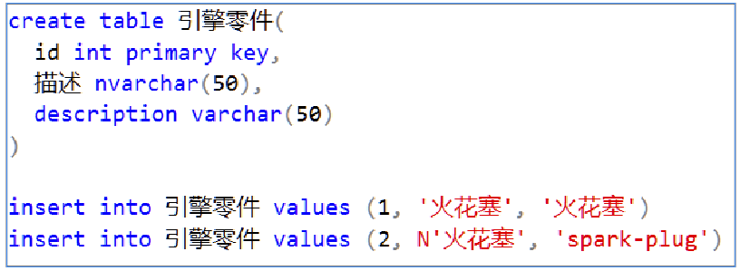
Figure 2- 24. Creating a table that uses Unicode symbols in its name.
SQL has no problem creating a table whose name is made up of Unicode symbols because the columns in a database’s system tables that store a table’s name are themselves Unicode enabled. That is not so for the data you store in a table, hence this discussion.
The content of the rows that are affected by your use of either Unicode enabled columns or columns that obey the current code page’s character set. SQL keep the names of your tables in a Unicode column in a system table I will introduce to you in section 4.8.
Figure 2- 24 inserts two rows; the first insert puts Chinese characters into a nvarchar column and the same characters into a none-Unicode column. SQL bravely accepts the data without complaint.

The second insert put an N in front of the data going into the Unicode column and English symbols taken from the current code page going into the second none-Unicode column.

Selecting the entire table produces Figure 2- 25:

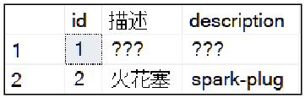
Figure 2- 25. The result of the inserts made in Figure 2- 24 obtained with a straightforward SELECT statement. The table’s name does not influence the results.
You can see in the first cell of the table that you get junk data even though that column is a nvarchar column. This behaviour happened because SQL implicitly tried to convert the Chinese characters into the available characters offered by the database’s code page. This conversion failed since the code page (CP-1252 in my case) doesn’t offer Chinese symbols.

SQL then stores the failed conversion result in the Unicode enabled column. This conversion to code-page data happens because code-page based text data takes precedence over Unicode based data. Appendix D will explain why this ordering of conversion occurs in detail; in short, the conversion order is done this way for backwards compatibility with code that pre-dates Unicode.

The second cell stands no chance of correctly storing the data. The system converted the Unicode data to code-page compatible data, which is, again, a failed conversion SQL stores the result of the failed conversion.

The first cell of the second row has valid data because the capital N in front of the Chinese symbols told SQL that you want to treat the literal characters in the string as Unicode data, so it stored the Unicode data as instructed. No conversion involving a code-page occurred.

The N stopped the implicit conversion of the Chinese into the local code page’s symbol set (or lack thereof). Code pages are a much much older idea than Unicode, and so they take precedence over Unicode processing for compatibility with older SQL code.

And if you are wondering what I inserted:  is Chinese for engine parts,  stands for description and is a spark-plug. Well, it is according to Google Translate; otherwise, I do apologise.

If you want to try the above fun exercise for yourself, do what I did: stick English words into Google Translator’s web page, translate them to Chinese or whatever language you fancy and copy and paste the symbols into SSMS. I have worked on a Chinese SQL system before. Um, I neither speak nor read Mandarin, so it was a very interesting experience.

2.18. Why Some People Use ‘N’ When They Don’t “Need” to

You will see in some scripts that ‘N’ appears before a character string. The ‘N’ is the only SQL element that is always case sensitive. Using it is unnecessary if you use symbols from your code-page in a character string. It is used by some folk even if it is superfluous for two reasons:

- If a command’s parameter is expecting Unicode data (such as of type nvarchar), you arguably avoid an extra data type conversion step from non-Unicode to Unicode data by putting ‘N’ in front of the string. If you supply a character string without the leading ‘N’, you invoke a pointless type conversion. The example I gave earlier, however, shows you the results of implicit type conversions going wrong. Remember that Unicode contains every symbol in your code page, but not the other way around.
- It is arguably “more” correct and polite if you acknowledge that a parameter or command is expecting Unicode even if you don’t need to use Unicode characters.

A reminder: you might find “Data Type Precedence and Implicit Type Conversions” in Appendix D interesting reading if this kind of detail floats your boat. You should at least be aware that implicit conversions do happen and develop a feel for the side-effects they can cause.

2.19. Using SELECT to Load Data into a Variable

You will, on occasion, want to be able to access the data in a row by loading its column values into a set of variables. Let’s see how you can do this, as shown in Figure 2- 26. I will explain the SELECT statement in great detail over the remainder of the course, but for now, please bear with me in using it at the moment.

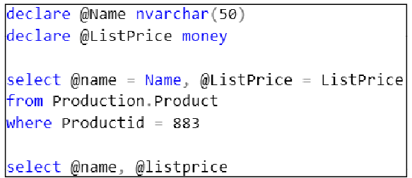
Figure 2- 26. This script introduces how to use a SELECT statement to load data into variables.

This example creates two variables: one to store a product’s name and the other the price. I chose the respective variable’s data type by looking at the column definitions of Name and ListPrice using the Object Explorer to examine the Production.Product table. Confirming the data types to use is a very good practice compared to guessing what you think the data types of the variables should be.
The SELECT statement takes a single row from the product’s table (for product 883) and loads the name of the product into the @Name variable and the list price into the @ListPrice variable. I then use a SELECT statement to print the contents of the variables. Figure 2- 26 produces the output you see in Figure 2- 27.

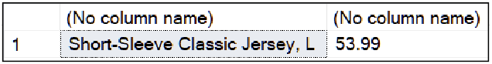
Figure 2- 27. The result contained in each variable.

Once you have taken from a row and transferred it into a set of variables, you can use those variables in an expression. That expression could be part of an IF statement or a WHILE statement. IF and WHILE cannot access the contents of a row directly. Variables create a mechanism that allows you to do that.

If you like, come back to this section later, once you have got to know the SELECT statement better.

2.20. Categories of SQL Command

You can divide SQL statements into five categories:

- data definition language statements (DDL)
- data manipulation language statements(DML)
- data query language statements (DQL)
- data control language statements (DCL)
- transaction control language statements (TCL)

2.20.1. Data Definition Language Statements

You use these statements to create, edit and delete database objects. These are SQL statements that start with CREATE, ALTER(edit while preserving assigned permissions) and DROP such as CREATE TABLE, ALTER TABLE, DROP TABLE.

2.20.2. Data Manipulation Language Statements

These commands include INSERT, DELETE and UPDATE for manipulating the contents of rows.

2.20.3. Data Query Language Statements

This category is a recent addition to the other older categories. This category contains the SELECT statement and nothing else.

In the past, folk classified SELECT as a DML statement because it manipulates an input table (s) to produce an output table. This process is known as projecting the data onto an output table. Directly copying the input table to an identical output table is a form of manipulating the data even though it may not be a very interesting 1-to-1 projection. The output table is a new table, albeit a short-lived one.

2.20.4. Data Control Language Statements

You will use these statements to control who has access to the data in a table. They also control access to other database objects. They include commands that start with GRANT, REVOKE and DENY.

2.20.5. Transaction Control Language

If you need to control if a set of DML statements should succeed as a unit or fail as a unit, you make use of the commands from the TCL category. BEGIN TRANSACTION, ROLLBACK TRANSACTION and COMMIT TRANSACTION are examples of these statements. In SQL, you will often see TRANSACTION abbreviated to TRAN to save typing. You will learn about these commands and how they protect you from faulty data changes in chapter 18 onwards.

2.21. Drawing a Database Diagram

You are going to want to write statements that involve joining several tables together. It will help you if you can get a diagram of the database’s tables that you use most often. SSMS can draw a diagram for you.

You can put all the tables in a database onto one diagram, but such a diagram can quickly become too large to be practical. How about if you could draw several diagrams of the same database? Each diagram can contain the groups of tables you use most frequently together. Of course, you can.

SSMS stores the diagrams in the database itself. There is a catch; you have to have database owner (dbo) rights on the database. If you don’t have these rights, ask the dbo to create and print some diagrams for you.
You can use third-party tools to help you. Third-party tools are unlikely to be able to automate the diagramming process entirely, but a diagram is better than no diagram at all.
You can find a free diagramming tool as an alternative to using SSMS by following this link: https://www.draw.io

Without dbo access, you will have to draw the diagrams manually if the dbo won’t draw them for you. You can gather all the information (table names, column names, data types, and so on) that you need by using the tables folder in Object Explorer.

If you are using Draw.IO, you can take a set of SQL CREATE TABLE statements, that you write, and it will use them to build the basics of your diagram. You will have to write the CREATE TABLE statements yourself, which is quite an educational exercise. See “Chapter 14: Creating Tables Used in Later Chapters” for assistance. SSMS’s automated scripting tools will not be available to you if you are not the dbo.

2.22. How to Draw a Diagram Using SSMS

If you look under the databases tab on the Object Explorer, you will see a folder labelled Database Diagrams (Figure 2- 28). Right-click it and select New Database Diagram. If you don’t see the tab, I’m afraid you don’t have dbo privileges on that database.

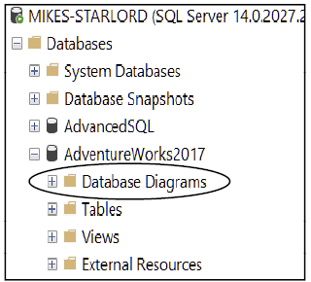
Figure 2- 28. A screenshot that shows where to find the Database Diagrams folder.

2.22.1. Oh! It Broke!

If you receive the message in Figure 2- 29, don’t panic. It’s quite “normal” to get this error when you try to add a diagram to a database restored from another company’s network.

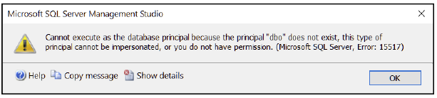
Figure 2- 29. A message you might get when you try to draw a diagram for the first time on a database.

What the message is saying is that your machine does not recognise the Windows user account of the person who created the database. In the case of Adventure Works, the creator is presumably someone at Microsoft. You need to claim responsibility as the databases creator and owner before you can continue.

To correct this, click OK to get rid of the message. Right-click the database’s name (Adventureworks2017) and take the properties option on the menu. Then select the Files blade (Figure 2- 30).

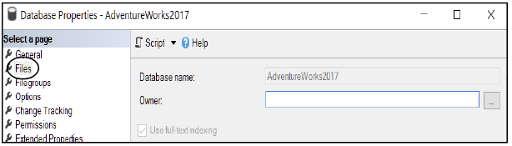
Figure 2- 30. An owner-less database which Is the cause of the message in Figure 2- 29.

Note the empty text box next to Owner. If you are using an earlier version of SQL, you will see the user account of the creator of the database in the text box, although your computer does not recognise them. SQL 2017 blanks the name out.
The easiest way to fix this situation is type SA (just the two letters which stand for System Administrator) into the blank box and press OK. If you prefer, you can type in your full windows user name–using the format computer name\windows user name–into the box.

You are now in complete control of the Adventure Works database.

2.22.2. Continuing to Drawing the Diagram
If necessary, repeat the steps of right-clicking Database Diagrams and selecting New Database Diagram. This time you will be offered a list of tables (Figure 2- 31). You can choose them all if you like and click OK. If you select a lot of the tables in Adventure Works, you will wait a fair while for the diagram to complete. Wait until you can click Close. In the meantime, SSMS will auto-arrange the tables on the work surface. You will see a diagram similar to Figure 2- 32.
Move around the diagram with the mouse. Please familiarise yourself with the general content of it. Try using the “cross-hairs” in the bottom right-hand corner (click and hold on the ) to get a bird’s-eye view of the picture and then move the mouse around while using the “cross-hairs”.
You will see your diagram has the rather uninteresting name of “Diagram_0”–the name is shown to you in the tab label at the top of the drawing editor. You change the name by saving the diagram. Push ctrl+s to save the diagram. The machine will ask you to choose a name for the diagram; type in a name that tickles your fancy such as “My Diagram” and then click OK.
If you want another diagram using a different set of tables, repeat the steps described before: right-click the database’s name, click New Database Diagram and so on.
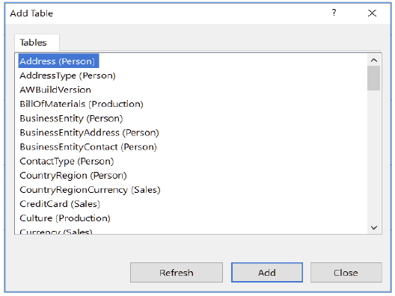
Figure 2- 31. This dialogue lets you choose the tables you want on the diagram. You can select them all if you like by using either the shift or ctrl key to help you choose the tables that you want.

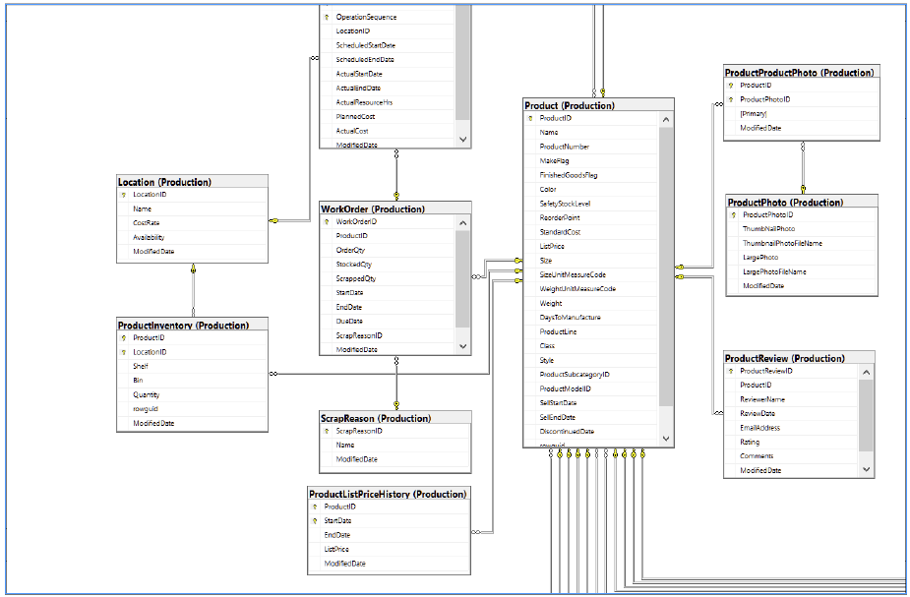
Figure 2- 32. A screenshot of a section of a database diagram.
Try right-clicking on a table in the diagram and experiment with the various viewing options. The “pipes” you see are the primary-key-to-foreign-key constraints that have been programmed into the database to ensure database integrity. I will elaborate on and demonstrate these constraints later the course.

2.23 Adding Comments Into Your SQL Scripts

I highly recommended that you put commentary into your .sql files. I make this recommendation for several reasons:

- You ideally need an opening set of comments that identify the purpose of the SQL script, its author, its date of creation and a version number. Some folk take pride in drawing a pretty box-like effect using ‘=’ or ‘*’ characters around the details I’ve described. Heck, be creative, have some fun. Be consistent.

- Put comments explaining the purpose of the various commands in the script. Not necessarily after every command–you will irritate your audience and yourself. At the very least, use them to clarify complicated statements or code that involves obscurely named table and columns.

- You want a way to remember what your code does, including how it works. You will forget such details after a few hours, let alone days. You are human, after all. Write the comments so they would be helpful to a reasonably knowledgeable stranger.

- Consider that colleagues, current or those newly appointed in the future, will need to modify and therefore clearly understand your code.

If you have to be ISO compliant, best check up on what documentation and standards you must create. Find this information out either from the ISO, an experienced colleague, a consultant or your manager.

2.24. What Comments Look Like

There are two kinds of comments. The “dash-dash” and the “slash-splat, splat-slash”. As a challenge and right-of-passage, I would like you to say the last comments name out loud five times in a row without getting tongue-tied. I’m kidding.

2.24.1. The -- (dash dash)

The “—" symbol pair disables or “knocks-out” the remainder of the line. Everything on the line after the "—" in SSMS will turn a lovely shade of fresh minty green and SQL will ignore it.

All the lines after the line containing the “—" will be processed. The return of multiple colours to those remaining lines will make that clear to you.

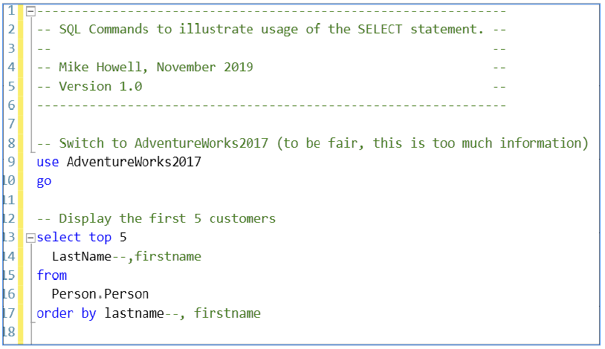
Figure 2- 33. An example of commenting that starts with a “pretty” header.

I wouldn’t put a comment above USE clauses in general. I have done so in this example to show you how to use the “—” symbol. Note how I have temporarily disabled the displaying of first names (line 14) and the ordering by first names (line 17); the ‘,’ must be “knocked out” too.

2.24.2. The /* */ (slash splat-splat slash)

This comment notation is a two purpose device. Whatever is between the ‘/*’ and the ‘*/’ will be knocked out. That can include many lines of code. The ‘/*’ and the ‘*/’ can also do what I like to call “keyhole surgery” by letting you knock out a section of a line. Figure 2- 34 illustrates the various uses.

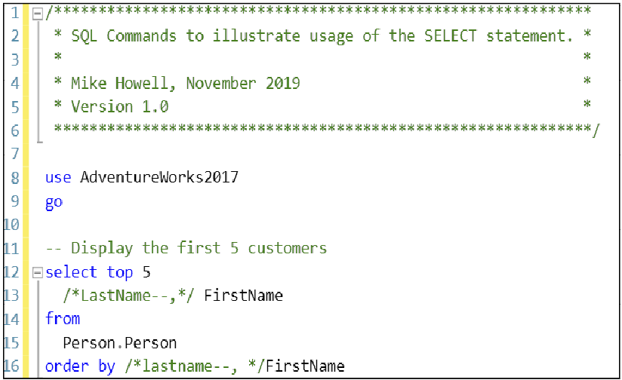
Figure 2- 34. An example of how to use the /* and */ to implement comments. /* */ can disable a section of a line (as I have done on line 16).

The Exercise

You will add another .sql file to the Solution you began in the previous chapter. If you don’t have a Solution from doing the last chapter’s exercise, you can use any blank open query window you like.

The exercises will put you through your paces, trying out variables in various ways. The exercises get more and more tricky as you work your way through them. Use this chapter’s content for clues and templates of script that will help you.

Exercise 2.3 is more challenging and illustrates issues caused by the limitations of scripting languages in general: they are not programming languages and so can be challenging to use to express yourself efficiently. Ok, exercise 2.3 is somewhat cruel; I’ve put it in for those who have found this section to be familiar and rather dull. If you have worked out a clever way to solve it, please let me know how you did it in an email.

Don’t forget; you can look at the answers in Appendix F.
You can download a .pdf containing the answers from my web site. You can download my completed Solution containing all the answers to all the exercise at the same address.

https://www.Transference-UnLimited.com

Exercise 2. Finding Your Way Around A Database

Open SSMS if you don’t have it open already and then open the Solution from the previous exercise (“Intro To SQL Class”). You can use a blank query window instead.
Add a new project to your Solution called “My Class Queries”. Inside that project, create a new .sql file called “Scripting Techniques”.
Your Solution Explorer should look similar to this:

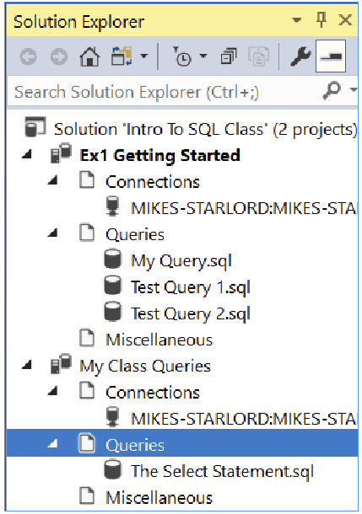

Ex 2.1. Vertical Bar Graph

Write a script that contains a WHILE loop. The script must have a variable called Length.
Depending on the value of Length, you must print a vertical line of ‘*’s that match the value of length.
If Length is 10, you must draw 10 ‘*’s one underneath each other.
If Length is 3, you must draw 3 ‘*’s one underneath each other.

For example, if Length is 4 you should produce something like this:
*
*
*
*

Ex 2.2. Horizontal Bar Graph

This exercise is the same as the previous one except see if you can work out how to convert the vertical line into a horizontal one.
If Length is four your script should produce:
****

Ex 2.3. Multiple Horizontal Bar Graphs

Create a variable called Numbers which is going to be a character variable. If you set it to ‘5, 20, 8, 10’ you will get the following output from your script.
5 :*****
20 :********************
8 :********
10 :**********

This exercise can be quite tricky. This one will require research to complete, but you will learn a great deal from researching an answer on your own. If you want to learn more from the other chapters in the course first before you come back and tackle this one, good for you, feel free to.
Some hints should you need them: look up how to use the functions CHARINDEX(), SUBSTRING() and CAST() using the Microsoft documentation.

Ex 2.4. Using SELECT to Load variables

Write a select statement that loads the title, first name, middle name and last name of business entity id number 5 from the Person.Person table into four separate variables.
Then print the four variables using the print command in this format:

Title : tttt
First Name : xxxx
Middle Name : yyyy
Last Name : zzzz

The SELECT Statement

You will use the SELECT statement to display data contained within your tables. I will start explaining its fundamental syntax. I will then build up your knowledge of its various components chapter by chapter.
The SELECT statement projects data onto an output table which it then presents to you or an application. The application may manipulate the data further.
The data usually comes from a table in the database; as you have seen in Chapter 2, the data can also come from variables or even literal text. The SELECT statement has the power to reshape the input data to form an output table formatted to your choosing.

3.1. The SELECT Statement’s Fundamental Syntax

Figure 3-1 shows a starting syntax to begin your understanding of the select statement. The order of the sections of the statement must appear as shown; you cannot put the word FROM in front of select.

select column1, column2, column3,... from table
Figure 3-1. The basic syntax of the select statement.

You can put spaces and line-feeds wherever you wish within the SELECT statement as I have shown in section 2.2. The commands are not case sensitive; I have written them in uppercase to make them stand out. Any text in lowercase represents text you will replace with actual values.
Do not put a space in the middle of a SQL command. For example: if you type “SEL ECT” the machine will think you want to run a command called “SEL” and then pass the value “ECT” to that command. You will get an error message in the messages pane located near the bottom of SSMS.

Useful Tip: Dealing with Errors

If you double-click the red error in the messages pane, the cursor will jump to where the error is in your SQL script.

You will notice red squiggles appearing in your text as you type. If you find these squiggles remain after you have typed in your full command, move the mouse over them and SSMS will tell you why they are there.

SSMS’s editor continuously reads your script from top to bottom to detect certain errors as early as possible before you run your script. Sometimes a squiggle appears when SSMS processes your script from the first line to the last, and your commands do not make sense in the order you have specified them. If you intend to run the script peace-meal by highlighting sections of it at a time, you can ignore these errors; your highlighted script will run.

The red squiggle may appear because you have an incorrectly formed a SQL batch. If necessary, put the GO keyword, where appropriate, between your commands (see Section 2.12).

You might find SSMS’s Error List useful. It will summarise all the errors identified by red squiggles in a single pane. If you go to View=>Error List, SSMS will list all the errors along the bottom of the screen. You can then double-click on an error in the list, and the editor’s cursor will jump to the error in your script (Figure 3-2).

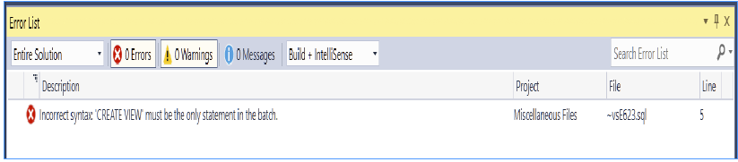
Figure 3-2. An example of an Error List window showing a random error. Clicking on an error will take you to the relevant line in the script file.

Useful Tip: Dealing with Style

There are no single styles used for laying out your SQL commands. One tends to favour a spacing and indentation choice by experimenting and seeing what “works for you”. The trick is to be consistent.
As long as your command is as legible as you can make it, that should be fine.

By contrast, in a programming language such as C# or Python, the rules for formatting are stricter. If you are used to strictly formatted languages, you will find that SQL is quite different.

3.2. More Detail on Case Sensitivity

SQL’s commands are not case sensitive. The names of the objects in the database may be. Case sensitivity for object names depends on the code-page settings the database designer chose. You will find that most databases do not have case-sensitive names. If yours does use case sensitivity, you will have to spell an objects name correctly and make sure the casing of the letters matches what you see the name to be in the Object Explorer. Adventure Works is not case sensitive.
It can be challenging to work in a case-sensitive database as an error telling you that an object doesn’t exist could be the result of you incorrectly specifying the case of the name.
The only exception to case-sensitivity is the usage of the single capital letter ‘N’ in front of a character string to specify that you want that string processed as a sequence of Unicode characters such as N’My Unicode data’. The N must be in uppercase no matter if the database’s object names are case sensitive or not.

3.3 Conservative Names

If you put yourself into the Adventure Works database (use the drop-down box in the top left corner of SSMS) and type in the script in Figure 3-3, you will get the result in Figure 3-4.

Figure 3-3. This script shows a SQL command written in a “conservative style”.
Figure 3-3 shows a script that expressed in a conservative style. “Conservative“ implies that the script is overly cautious; the square brackets aren’t necessary in this case. I explain what purpose they serve in the next section.

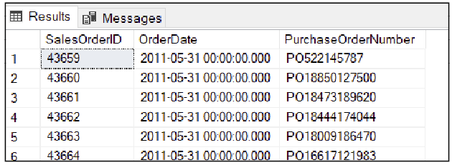
Figure 3-4. The a partial result of the query in Figure 3-3
Figure 3-4 shows the sales order id’s, order dates and the various customers purchase order numbers. Adventure Works keeps these details in Sales.SalesOrderHeader table.
You could have typed in:
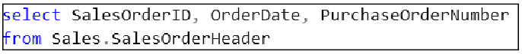
Figure 3-5. Column and table names specified without using brackets.
What is the story with the brackets?

3.3.1 The Meaning of []

The square brackets have two purposes:
- They indicate that the SQL server must treat two or more words as a single word. For example, if you type Customer number as a column’s name, SQL will see that as a pair of column names. So you would type [Customer number] instead.
- The [] indicate that a symbol such as ‘-’ or ‘+’ within a name should be taken literally and not cause SQL to attempt to perform a mathematical operation. For example, if you type Product-ID the SQL will read that as an instruction to subtract id from product. That will likely be a meaningless request and cause an error. If you type [Product-ID] SQL ignores the ‘-‘ as a mathematical operator.
You can place brackets around any name whether it has spaces or special symbols in it or not. An automated script generating tool will almost always use a conservative syntax whether it needs to or not for consistency’s sake. It is unusual for a manually typed in script to do so.
You can use double quotes (“ “) around the name of an object rather than brackets. Using double-quotes is the ANSI standard convention and works across many makes of SQL. Despite double quotes being the official standard, people like using [ ].
I suggest sticking to [ ]. And they look good.
Out of interests sake, the symbol used for object name demarcation varies from one SQL manufacturer to another. MySQL’s InnoDB engine uses ` `–grave accents or back-ticks– around names with spaces in them.

3.4. Avoiding Typing Long Names

You can save yourself having to type in column and table names by using the Object Explorer to help you. You can drag the names of columns and tables from the Object Explorer over into the script window. SSMS will always put the brackets in because it is conservative and consistent.
You can drag the word columns over if you like and SSMS will type all the column names out for you. This ability is handy if you want most of the columns’ names typed out except for one or two of them. You can then delete the columns you don’t need from the list

3.5. The *

You may see SQL that looks like this:
select * from sales.salesorderheader

The star implies that you want all the columns to be displayed. Using a ‘*’ is fine if you are performing an ad hoc query, but do not rely on this in a production-quality script as explained below.
The order of the columns in a table are, over time, unpredictable. Even the order of the rows is not guaranteed. The row order can be affected by a DBA adding or removing indexes on a table as well as the algorithm chosen by SQL’s internal query optimiser.
An administrator can change the column order in a table, they can delete columns, and they can add columns to the table between existing columns.
You could get a nasty shock casually using a * and new columns “surprisingly” pop up that you haven’t seen before. An existing report using such a query could fail since the query would return unexpected/missing columns.
The safest way to use the SELECT statement is to specify the columns you want in the order you want them. In such a case, if the database administrator (DBA) removes a column, SQL will tell you which column has been removed by naming it. If the DBA adds columns, they won’t affect your output because you haven’t asked for them to be displayed.
The order of the returned rows is not guaranteed with time either. You can ensure row order by using an ORDER BY clause that you will meet later in the course in Chapter 5.
Feel free to use the * when you want to check that your SQL statement is otherwise okay before eventually replacing it with a column list. Don’t leave it there. And always use an ORDER BY clause.

3.6. The TOP Clause

Let’s say you want to view the first 100 rows of a query’s output. You do this with the TOP clause.
This ability is convenient when you want to check that a query “works” and you don’t want to wait for all the data to arrive at the client and be displayed. It is a great trick to use when you are composing the appearance of a report: you won’t have to wait for the data to download in full every time you make a change to the report’s layout. Once you are done testing the report, you then remove the TOP clauses restriction.
You use the TOP clause like this:
select top 100 * from Production.Products

Since we are testing the syntax, I have used a *. Later I would replace the * with the column names I want.
Here is a variation of the top clause that lets you specify how many rows you want using a percentile:

select top 25 percent * from Sales.SalesOrderHeader

If you want a random set of rows for statistical sampling purposes, you can use write this:

select * from person.person tablesample (10 percent) order by title

You can follow TABLESAMPLE with x ROWS where x is the number of rows you want to see.

3.7. TOP WITH TIES

If you try the standard TOP clause in Figure 3-6, you will get the output shown in Figure 3-8.

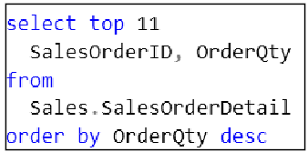
Figure 3-6. This script shows a conventional TOP clause. I will use this to illustrate the point of “WITH TIES”. Note the ORDER BY clause which is required when you use WITH TIES.

SalesOrderID OrderQty

50270 44
67266 41
51783 40
57186 40
48089 39
67266 38
51783 36
51109 36
46610 35
46673 35
46647 34

(11 rows affected)
Figure 3-7 The result of the WITH TIES clause. Note that the query returns 11 rows.

Useful Tip: Reformatting and Exporting Data from the Results Grid

I created Figure 3-7 by pressing Ctrl+T before I executed the query. This key sequence puts SSMS’s Results pane into text mode. This style output looks very familiar if you have used other text-based SQL execution tools. If you press Ctrl+D, SSMS returns to grid output mode.
You can highlight rows in the output grid and export them as a .csv file. If you click the top left-hand corner of the grid, you will select all of its content. You can then right-click the grid to export the data as a .csv text file. This ability is a convenient way to get the query’s results into a spreadsheet.
Now, let’s compare the output to the same statement with the with tieS option:
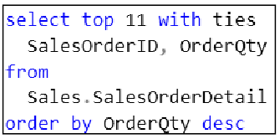
Figure 3-8. The SELECT statement using WITH TIES.

SalesOrderID OrderQty

50270 44
67266 41
51783 40
57186 40
48089 39
67266 38
51109 36
51783 36
46610 35
46673 35
46647 34
47065 34
46611 34

(13 rows affected)
Figure 3-9. The result of with ties. There are two extra rows this time even though the TOP clause says 11 as it did before.
Two additional rows appear in Figure 3-9 compared to Figure 3-7. These extra rows appear because there are other order quantities of 34. They are associated not only with order 46647 but also 47065 and 46611. With WITH TIES the machine checks the last entry see if any further entries have an equal value.
For the TOP clause to work, you do need an ORDER BY clause so that SQL can identify what you regard as the criteria for a row to be on top.

3.8. Column Aliases

At times, you will want to display a column that has an unsuitable name when the name is displayed. The name might contain abbreviations, the table’s designer may have chosen a meaningless column name, or the name simply doesn’t read very well when displayed because of spacing or punctuation issues.
You can temporarily rename a column so that its displayed name is more meaningful. Do this by putting the new name–called the column alias or alias for short–next to the column name in the select statement. You can optionally put the word AS between the column name and the aliased name.
The syntax looks like this:

select column1 alias1, column2 alias2, ...
from table

or

select column1 as alias1, column2 as alias2, ...
from table
Figure 3-10. The general syntax for using column aliases.

Figure 3-11 shows a script that uses aliases with spaces in them, hence the [].
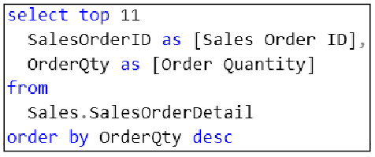
Figure 3-11. This figure shows an executable command that uses column aliases.

The result is in Figure 3-12.

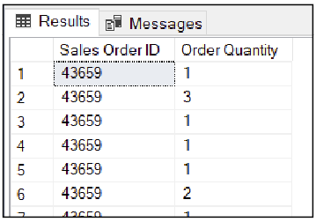
Figure 3-12. This figure shows the renamed column names at the top of the grid.
I find that using the AS in the column list helps me distinguish between the real column names and the aliased names more easily. Furthermore, SSMS colours the AS blue, so it stands out as a separator between the real and aliased names.

3.9. The Exercise

This exercise continues to add files to the Solution from previous exercises. You don’t need to have an SSMS Solution if you haven’t done the earlier exercises; any blank query window will do. Remember, if you get stuck, the answers–Ahem! Hints–are in Appendix F.
I have written the exercise so that there are no explicit table or column names mentioned. I only refer to the data that you want to use in your query.
That will give you a feel for what it is like to deal with real-world questions that users will ask you. You will have to turn a user’s English question into a working SQL statement
In your office, you will have to find your way around the tables and columns through investigation and practice. The Object Explorer and database diagrams are beneficial when it comes to learning the contents of a new database.

Exercise 3. The Select Statement

Open SSMS if you don’t have it open already and open the Solution that you created in the previous exercise.
In your Solutions project, “My Class Queries”, add a .sql query file called “The Select Statement”. Please work inside that file for this exercise.
In the SQL editor pane, type in “USE AdventureWorks2017” and on the next line type in “GO” and execute the script. Your current database context should then show AdventureWorks2017 as you see in Figure ex 3- 1.

Figure ex 3- 1. What your database context should be before going onto Ex 3.1.

Ex 3.1. Try Comments

Above the USE statement type in the following practice comment:
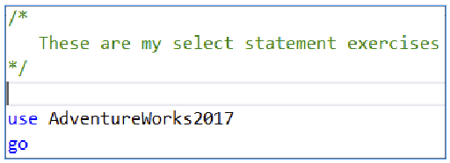
Figure ex 3- 2. How the opening of your script should look appear.
SQL will ignore the fresh minty green text between the /* and */. It is helpful to insert comments amongst the lines of your SQL scripts so that you can remember why you created the script, who created it, the date of creation, a version number and so on.
I will leave you to add whatever details you like to your comment.

Ex 3.2. Extracting Product Data

Write a SELECT statement that displays all the product ids, all the products names and all the list prices.
Work out which is the best table to use for this information by looking at the available table names in the Object Explorer.
If you need time to work out the details, be patient with yourself. You will get faster and faster and working your way around a database with practice.
A hint (but only if you need it): Look for a table with Product in the name.

Ex 3.3. Using a TOP Clause

Use a TOP clause to restrict the output of the select statement from the previous exercise to so that it displays the first ten products.
You might find it helpful to copy and paste the SELECT statement from Ex 3.2 and then edit the copy. That way, you can compare the new SELECT statement to the previous one. Put a comment above each copy of your SELECT statement that explains what each SELECT statement does.

Ex 3.4. WITH TIES

You are going to use the with ties clause and gradually increase the number of returned rows until you can see the effect of the with ties. Take the list price as the criteria for what qualifies as the top item (use ORDER BY ListPrice DESC). Begin by displaying the top five products, then try six products and then seven and so on.
Keep increasing the number of items until you see the effect that WITH TIES has.

Ex 3.5. Column Aliases

Display the first ten rows of the sales order header table. Show the columns SalesOrderID, OrderDate and TotalDue. Use column aliases to rename the columns to Sales Order ID, Order Date and Total Due.

4. The WHERE Clause

The WHERE clause allows you to pick specific rows that you want the SELECT clause to output. The WHERE clause checks each row one at a time against a condition of your choice. The condition can only make a decision based on a single row at a time–it cannot compare a value in two or more rows simultaneously.

What you will learn in this chapter:

- The comparison operators you can apply to data in a row
- The BETWEEN, IN and LIKE operators
- Difficulties and solutions in using ranges of dates in the WHERE clause
- The CASE statement
- The EXISTS operator
- Where to find and how to use the database’s catalogue

Operators

The WHERE clause uses a boolean expression to determine what rows you want to output. You construct your boolean expression by combining comparison operators with zero or more logical operators. Here is a table of the most commonly used comparison operators:

Comparison Operators: | Purpose:
x = y | Compare x to y for equality.
x <> y or use x != y | Compare x to y for inequality (checking if x is different to y)
x > y | Compare if x is greater than y.
x < y | Compare if x is less than y.
x >= y | Compare if x is greater than or equal to y.
x <= y | Compare if x is less than or equal to y.
z BETWEEN x AND y | Check if z is between x and y (including the value of x and y).
z IN (x,y,z) | Check if z is a value in the bracketed list.  The () are required.
z LIKE p | Implements a check to see if z fits the pattern p.  Section 4.6 explains the meaning of p.
Table 4- 1. A list of both well known and SQL specific comparison operators. x, y and z can be numeric, datetime or alphanumeric character strings except for the LIKE operator where z and p are alphanumeric character strings only.

You can join these operators together with boolean logical operators:

Logical operator: | Purpose:
x AND y | Combines x and y so that both must be true for the combination to be true.
x OR y | Combines x and y so that if either x is true or y is true, the combined expression is true.
NOT x | Takes the expression immediately following NOT and negates it.  In other words, if x is true, it is converted to false and vice versa.
Table 4- 2. The logical operators.
Knowing the order of the operator’s evaluation is essential. You can alter the default order of evaluation with parentheses–(). The default order of the operators is in the table below:

Operator Precedence:
*, /, % (modulus or remainder)
+(positive number), -(negative number), + (addition), -(subtraction)
=, >, <, <=, >=, <>
NOT
AND
BETWEEN, IN, OR
= (assignment)
Table 4- 3. The order in which SQL performs the operators in an expression. Operators on the same line have equal precedence. The first line’s operators have the highest precedence; the bottom line’s operators have the lowest.
Here is an example of how important understanding precedence is:
Calculating the amount to pay after a discount:

Amount = £20.00
Discount = 5%
Quantity = 10

Total = Amount * Quantity * 1 - Discount
= 20 * 10 * 1 - 0.05
= 200 - 0.05
= £199.95 WRONG ANSWER

Total = Amount * Quantity * (1 - Discount)
= 20 * 10 * 0.95
= 200 * 0.95
= £190 CORRECT ANSWER

The first total is incorrect because SQL applies the default rules of operator precedence. Referring to Table 4- 3, you will see that multiplication evaluates before subtraction. We need to override these rules to calculate the subtraction before the multiplication occurs. I have done so by using parenthesis.

The WHERE Clause’s Syntax

Here is a general syntax for the WHERE clause:
select column1, column2, column3,...
from table
WHERE booleanExpression
Figure 4- 1. This figure shows the SELECT statement with a WHERE clause appended to it.
Let’s say you want to see all the addresses that are in Leeds.
You could write the SQL statement in Figure 4- 1 to do that.
Figure 4- 2. This figure shows a query that finds all the address in Leeds, Alabama.
The WHERE clause must appear after the FROM clause. Text comparisons are not case sensitive unless someone has set the database’s code page to be so.
You can use the COLLATE clause on an individual query to override this if you need to. You can find a bit more about COLLATE here: https://docs.microsoft.com/sql/t-sql/statements/collations?view=sql-server-ver15
You might have noticed that the address table doesn’t contain any names of people. Let’s briefly think about why that is so. It is a brief and important diversion about a concept you met in section 1.14.

Many-to-Many Relationships Revisited

In Adventure Works, a person is contactable at multiple addresses. Likewise, many people can use the same address. Database designers specifically call this a many-to-many relationship. SQL does not directly support such relationships. It can do so with the help of a bridge table.
To find out what addresses a given person uses, you must use the bridge table called Person.BusinessEntityAddress. This table takes a person’s business entity ID–the person’s ID from the person.person table–and then reveals the matching address ID(s) that go with it. You will find those address IDs in the Person.Address table.
You would then use two JOIN operation on the three tables to find which person has which addresses. You will meet JOINS in chapter 6.

Using Range Operators (<=, =>) With Dates

Let’s say you want to find all orders placed in February 2014. You can write this query in one of several ways as I have shown in Figure 4- 2, Figure 4- 3 and Figure 4- 4:

Figure 4- 3. Using the AND operator to select a date range with >= and <.
Figure 4- 4. Using the and operator with the year and month function.
Figure 4- 5. Using BETWEEN as a replacement for AND.
These queries all return the same results sets (I’ve checked, I promise). Yet when you study the code inFigure 4- 3, Figure 4- 4 and Figure 4- 5 you might experience a range of emotions that vary from “yeah okay” (Figure 4- 2) to “oh, I quite like that one” (Figure 4- 3) to “what is going on?” (Figure 4- 4).
Figure 4- 3 is a reliable way of finding rows that fall within a date range. I have avoided worrying about how many days there are in February by using the less-than-sign operator applied to the 1st of March. The WHERE clause will include orders placed at 23:59 on the last day and millisecond of February up to just before midnight.

Figure 4- 4 is quite readable. I would recommend using it. However, this approach cannot use an index that you might have on a DateTime column. An index is a device that speeds up searching on a given column dramatically if the context justifies it.
Indexes are created manually by the database administrator, and it could be a shame not to use them if they are present. Depending on the volume of rows a query needs to search through, an index can be justifiable. They come at a price: upkeep effort and the disk space used to store them. Your DBA can help you find out if a column either has an index assigned to it or if the creation of one could be of help to you.
Figure 4- 4 illustrates the general compromise of readability over speed. In practice, you would try the query in both Figure 4- 3 and Figure 4- 4 to see which one gives you the performance level you like.
I show you Figure 4- 5 as a caution about using BETWEEN with dates. It would be a passable example if the BETWEEN operator didn’t include the end date. SQL treats the end date as if it were after a <= operator. Hence my having to specify the end time of 23:59:59. But what about the 999 milliseconds between 23:59:59 and 00:00:00? That 999 millisecond period may or may not be a detail that troubles you. Best not to risk that confusion.
Why did I not specify ‘23:59:59.999’ as the end time instead? That is because SQL would round the .999 up to the 1st of March. Now your query would include the 1st of March “by accident”. For that reason, I do not recommend using the BETWEEN operator for dates.

4.5. Using the IN Operator to Replace OR

IN is a useful operator for reducing a potentially large amount of typing. It is handy when you need to find if a column’s value matches a long list of possible values.
Let’s say you wanted to know all addresses that are in the cities Leeds, Birmingham, Houston and Nashville. You could type:
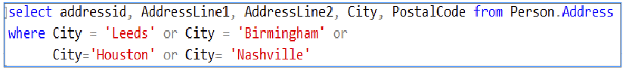
Figure 4- 6. An example of using the OR operator; to excess.
But why would you? You can rather type:
Figure 4- 7. Using the IN operator to save you typing a lot of ORs.
An error to watch out for is to forget to type in the (). You must have the parenthesis around the list for IN to work.

4.6. The LIKE Operator

LIKE allows you to do partial matches within a text field. And text fields only.

Think of it as a drop-in replacement for the ‘=’ sign, but it has interesting additional abilities. ‘=’ is for finding exact matches between two items, the LIKE operator is fuzzier. LIKE takes a column’s value and searches through it to find a pattern of characters.

If you set the pattern to a literal value such as ‘banana’, LIKE will only find those column values that are exactly ‘banana’. It is when you insert certain symbols into the pattern that LIKE becomes a lot more interesting.

If I set the pattern to ‘banana%’, LIKE will return all the column values that start with the word ‘banana’ such as ‘banana split’, ‘banana sundae’, ‘banana’ but not ‘chocolate-dipped bananas’. Table 4- 4. A list of symbols that LIKE interprets to have a special meaning and what those meanings are.

Symbol: | Meaning:
% | This symbol Matches any set of alphanumeric characters, including no character at all.
_ | _ matches any single character. There must be a character at the chosen location.
[x-y] | This range operator matches any single character in the specified range of characters. The range includes x and y.  For example:  ‘ [a-h]’ would match ‘A’ through to ‘H’ and ‘a’ through to ‘h’,’f’,’ ‘b’ but not ‘l’ or ‘i’ (assuming your database is not case sensitive)  ‘[0-9]’ matches the single characters ‘0’ through ‘9’. It can only match one digit at a time. For two digits use ‘[0-9][0-9]’.  You can put a comma-separated list of values and or ranges between the brackets such as ‘[a-f, k, l]’.
^ | The caret is the NOT operator.  You use it like this ‘^[a, b, x-z]’ which would match any single character other than a, b, x, y or z.

Table 4- 4. A list of symbols that LIKE interprets to have a special meaning and what those meanings are.
If you wish to see more examples go to https://docs.microsoft.com/sql/t-sql/language-elements/like-transact-sql.

4.6.1. Examples of Using LIKE

Let’s say you wanted to locate all customers whose last name starts with the letter F. You can write:

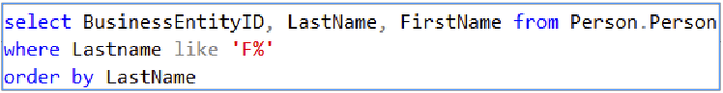
Figure 4- 8. Find all customers whose last name begins with the letter F.

If you need to find specific letters at the end of a character column, Figure 4- 8 shows you how. It finds all the last names that end on ‘son’:

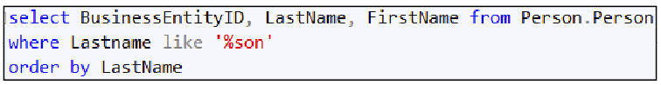
Figure 4- 9. Finding the last names that end with ‘son’.
The following examples won’t work with Adventure Works. I have typed them out so that you can see more examples of LIKE’s syntax.

Example 1:

select BinNumber, PartCode from WareHouseInventory
where BinNumber like ‘___999’

Example 2:

select BinNumber, PartCode from WareHouseInventory
where BinNumber like ‘[A-G][A-X][A-Z][0-9][0-9][0-9]’

Example 3:

select SupplierID, SupplierName, PhoneNumber from Suppliers
where SupplierName like ‘%Electronic Components%’

Example 4:

select SupplierID, SupplierName, PhoneNumber from Suppliers
where SupplierName like ‘_____%’

In example 1, a row will display if the bin number has three characters followed by the digits 999. The bin number must have exactly six characters in total, and the last three characters must be 999.
In example 2, a row will display if the bin number has the characters A-G as the first letter, followed by the characters A-X, then A-Z. Then the literal digits 0-9, then 0-9, then 0-9 must be the last three characters.
The ‘_’ matches any single symbol, including non-alphanumeric symbols. There must be a symbol for the ‘_’ to find. ‘%’, on the other hand, will match against nothing.
Example 3 will display any row where the supplier’s name has the words ‘Electronic Components’ anywhere in it. That is because I added the % to the front and the end of the pattern. There don’t have to be any characters after the final ‘s’ nor before the initial ‘E’. There must be a single space between ‘Electronic’ and ‘Components’.
Example 4 will find suppliers whose name has at least five characters in it.

4.7. The CASE Statement

The CASE statement substitutes the contents of a column with the result of one of a set of possible expressions. CASE chooses one of the available expressions based on one of a sequence of boolean expressions evaluating to true.

If CASE sounds like a souped-up version of an IF statement, you are right. It is a “space-saving” form of the IF statement. Unlike the IF statement, you can use CASE where you would put a column’s name. Have a quick look at the example in Figure 4- 9 to see what I mean.
The replacement expression can include literal values (such as ‘Billing Address’). That ability is handy, for example, when you want to perform a substitution for a relatively obscure code that is in one of the columns: in Figure 4- 9 CASE replaces the AddressTypeID value of 1 with ‘Billing Address’, 2 is replaced with ‘Home Address’ and so on. If the value of AddressTypeID isn’t explicitly listed, the ELSE replaces the unlisted value with ‘Uncertain’. ELSE, in other words, captures any unspecified value.
There is nothing to stop you from displaying the unmodified column as well as the CASE substituted version (Figure 4- 9 shows both the AddressTypeID and the substituted value).
I find it helps to think of the entire CASE statement, as long as it may be, as a single column amongst the other columns in your SELECT statement’s column list.
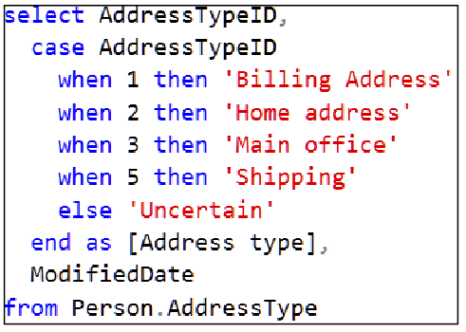
Figure 4- 10. This figure shows the fundamental syntax of the CASE statement.
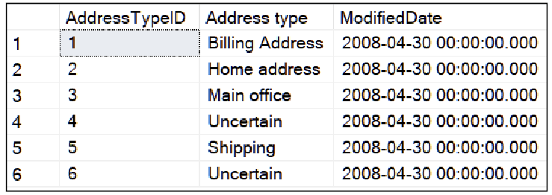
Figure 4- 11. The output of the above statement. The CASE clause has generated the Address type column.

4.7.1 CASE in Detail (Syntax 1)

The CASE statement has two possible syntaxes. I’ll explain the simpler syntax, the example in Figure 4- 9, first.
The CASE statement takes a column’s value and compares it against a variety of conditions known as cases. Each case is specified after the keyword WHEN. If a condition is satisfied, SQL substitutes the column’s value with the result of a given expression. If you meet one of the conditions, no further options in the CASE statement are processed. You can specify a default case after ELSE that fires if none of the preceding conditions match.
For example, Let’s say you sell theatre tickets. You have a column in a sales table that contains a code for a reason for a discounted sale. You want to create a printable report for an audience of users for who the codes would mean nothing. You want to show a description for each code instead.
If the value in the discount reason column is a ‘C’ you want to display an amount for a theatre ticket that has a concessionary discount applied, if it contains ‘S’, a student discount is applied and so on. If there is no value in the column, the default of the full price is displayed. Unlike the query in Figure 4- 9, the output is the result of a calculation rather than literal text. The CASE statement is quite happy to oblige you in doing this.
Figure 4- 11 shows a complete script that you can use to emulate the scenario above. It creates a simplified TicketSales table, inserts some made-up ticket sales (they are all broadway hits,…just kidding), and the SELECT statement shows you how to use CASE to display a discounted selling price. You can run this script inside Adventure Works if you would like to try it.

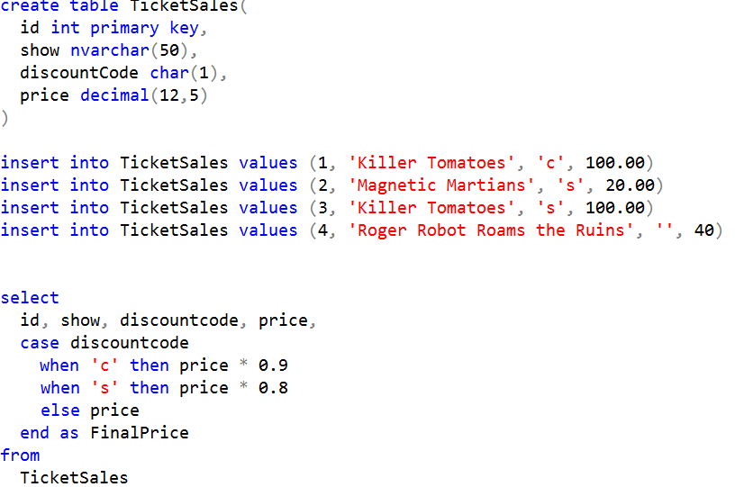
Figure 4- 12. A complete script demonstrating how CASE can return the result of a calculation.

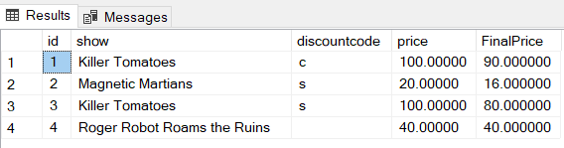
Figure 4- 13. The output from the SELECT in Figure 4- 11.

4.7.2 CASE in Detail (Syntax 2)

The other syntax variation of CASE has an explicit boolean test for each WHEN clause. There is an example of using it in Figure 4- 13.
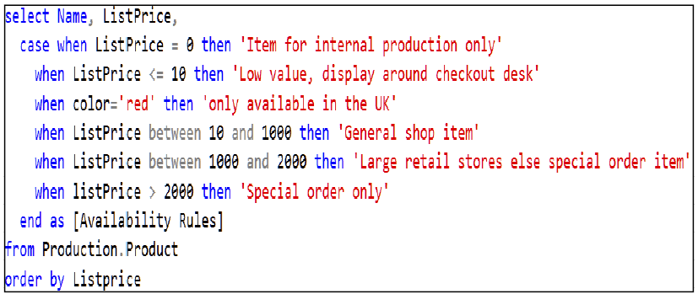
Figure 4- 14. An example of the more elaborate syntax for CASE. Each WHEN clause performs a boolean test.
If a WHEN’s test succeeds, CASE once again substitutes the output with the result of some other expression. This syntax allows you to write a sophisticated set of test conditions. As for the syntax in Figure 4- 9, once a case fires, SQL stop considering the remaining WHEN conditions.

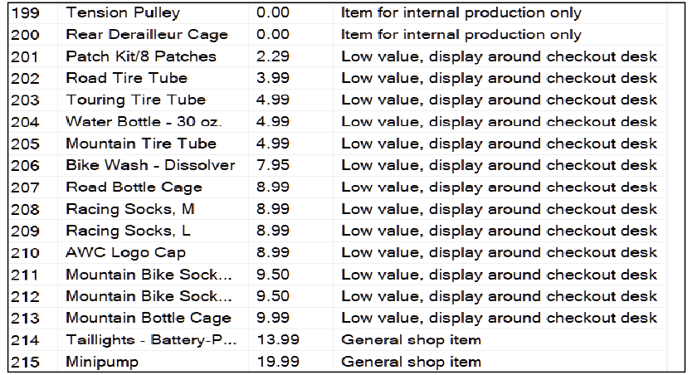
Figure 4- 15. A snapshot of some of the rows from the output generated by the SQL statement in Figure 4- 13.
The CASE statement can appear anywhere in a SELECT statement’s column list or the WHERE clause. In a WHERE clause, the CASE statement changes the condition used based on the value of another column’s content. In this situation CASE effectively replaces a possibly untidy sequence of AND operators in the WHERE clause.

4.8. The EXISTS Operator

EXISTS takes a select statement as a parameter. If the select statement returns one or more rows, the EXIST operator returns true; otherwise, it returns false.

Let’s say you want to know if a table exists in a database. You can ask that question using a script like that in Figure 4- 15.

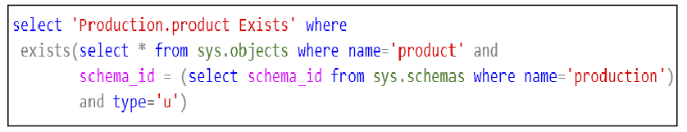
Figure 4- 16. A query that tests if the Production.Product table exists. You can stylise this query to check for any object in a database.
Whoa! What is going on here?! Don’t worry, lots of good things.

If you run this query with the Adventure Works database as the current connection’s context, you will see the output in Figure 4- 16. If you run it from within a different database that does not have a Production.Product table, such as TempDB, you will not get any output (Figure 4- 17).

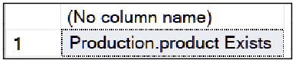
Figure 4- 17. This output confirms that the query in Figure 4- 15 found the Production.Product table.

If it doesn’t exist, you will get Figure 4- 17. If you toggle between Adventure Works and another database as your context, rerunning the query each time, you will be able to alternate between the outputs. Be sure to put yourself back into Adventure Works before carrying on.

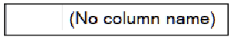
Figure 4- 18. The output if the EXISTS statement in Figure 4- 15 can’t find the Production.Product table.
To understand how the SELECT statement embedded in the EXISTS clause works, you need to know about the database’s catalogue.

4.9. The Database Catalogue: Sys.Objects

There is no harm in showing you a few database administrator’s “secrets” to stretch your skills towards “power user” status. Let's get to know what a database’s catalogue is.

Sys.Objects is a system table in each database. It contains a row that describes every object in a given database, otherwise known as a database’s catalogue. Refer to section 2.8 if you want to go over the possible objects you will find listed in Sys.Objects.

Once you have set the database context to the database you want to investigate, you can find out what objects are available by typing in the script shown in Figure 4- 18.

Figure 4- 19. A query to put the database’s catalogue–list of objects– on the screen.

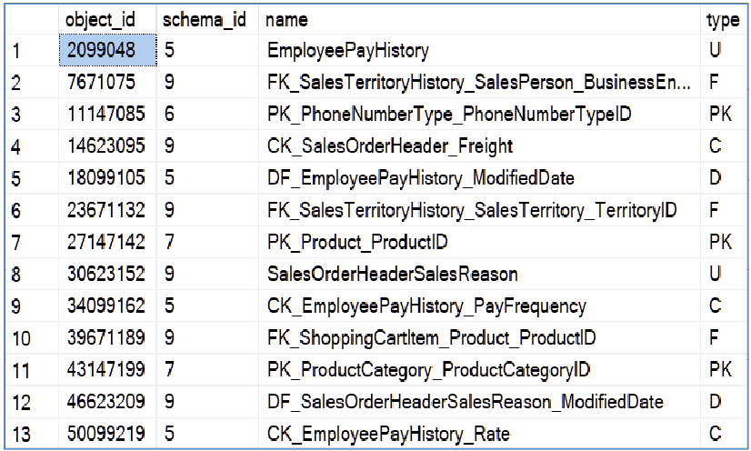
Figure 4- 20. A partial output of Sys.Objects for Adventure Works.
You will see an output similar to Figure 4- 19. The “WHERE TYPE<>’S’” in the script in Figure 4- 18 prevents the script from listing internal database system tables. SQL places a number of these system tables (including sys.objects itself) into every database that tracks low-level settings about what is in the database. You can remove the WHERE clause to see these table’s names, but they are of no interest to us in general.
Referring to Figure 4- 19, the object_id column is an object’s real name. Objects are known internally by this numerical id since this is fast and easier for SQL to keep track of a number. The name column shows an object’s friendly human-readable name. Next to object_id is the schema the object belongs to identified by an ID number. The type column contains a two-character code telling you what the type of the object is (see Table 4- 5).
This database catalogue is a convenient tool when you want to get a list of all or specific types of objects in a database. You must have selected the database you want to catalogue first as the current context. Otherwise, you will get the catalogue of whatever the current database is in the current context–and the resulting incorrect result set may prove a complete surprise until you realise your mistake.

Type Code: | Type:
C | A check constraint.
D | A default constraint.
F | A PK-FK constraint.
PK | A primary key constraint.  SQL uses this entry to acknowledge which column(s) is the primary key in a table.
S | A system table.
U | A user table.
V | A view.
P | A stored procedure.
CK | A check constraint.
D | A default constraint.
F | A foreign key (PK-FK) constraint.
TR | A trigger.
FN | A function.
IT | An internal table used to track row edits you have made to a different table.
Table 4- 5. A list of the type codes you will see in Sys.Objects. Microsoft adds new codes as SQL evolves.

These codes are useful when you want to list all objects of a specific type. Add a WHERE clause to your SELECT statement that specifies the type code of the object you want.

4.10. The Database’s Schema List

Sys.objects refers to an object’s schema name via an ID number. You can run the script in Figure 4- 20 to get a list of schemas in the current database.


Figure 4- 21. A query to list the schemas in a database and their id’s. Sys.Schemas is one of the system tables.

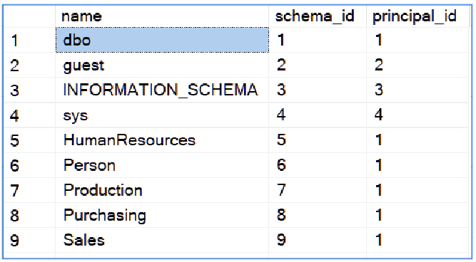
Figure 4- 22. An example of the contents of sys.schemas.

4.11. How The EXISTS Example Works

Have a look at Figure 4- 15 again and perhaps see if you can make complete sense of how it works now that you know what sys.objects and sys.schemas are: the query will display ‘Production.Product exists’ if it can find a table (the type=’u’ part in the WHERE clause), a human-readable name of ‘product’ and if the object belongs to the schema ‘production’.

Useful Tip:

The second SELECT statement (the one after “schema_id=”) is there to find the schema id that belongs to the “production” schema while explicitly avoiding coding a schema’s ID number into the query. Avoiding coding specific IDs, ultimately, makes the query far more reusable and general purpose. This style of the query, avoiding hard-coding numbers, is a good practice to apply in the real world.

The structure of the entire query makes use of a pair of queries, one nested inside the other. This nested query structure is called a non-correlated subquery or subquery for short. You will meet them and their partner, the correlated subquery, in Chapter 10.

It is best not to hard code an object’s ID number or schema ID into a query. A good reason to avoid hard coding ID numbers is that you can’t predict what they will be nor assume they will be constant. You may find your chosen human-readable table name, schema name and other object names in several different databases, but they will have different IDs in each database. In short, the ID that identifies the schema “Production” could change depending on which database you are using.

4.12. A Practical Example of Using EXISTS

Before you issue a CREATE TABLE command that you intend to deploy to several SQL servers, you ideally need to check if the table already exists. Maybe you want to prepare for accidentally executing that script twice on the same machine and possibly abort the script if so (use the RETURN command to do so). You could choose to either skip the CREATE command or possibly delete and recreate the table depending on if it exists on the destination machine.

Figure 4- 22 shows you how to implement one possible approach. The ‘*’ in the first SELECT statement doesn’t cause the downloading of column data when you use SELECT in this context. EXISTS does not “download” the table or its columns. Because of you using SELECT within an EXISTS operator, SQL knows that you are hunting for the existence of a row. It knows that you aren’t interested in the details of what the table contains. SQL will do the minimum amount of data loading required to satisfy your EXIST operator.

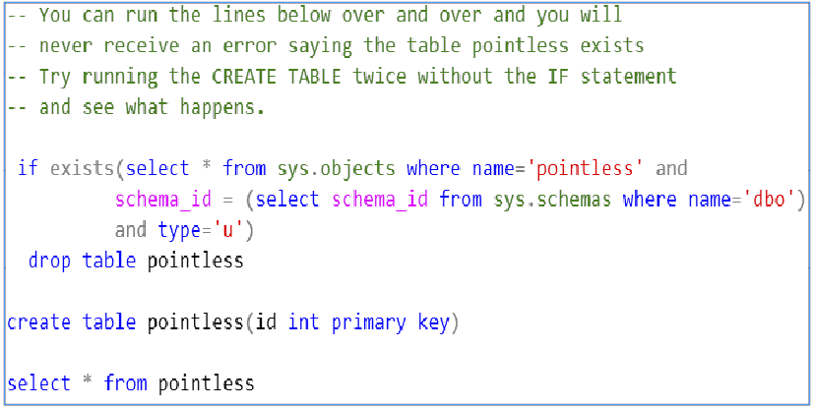
Figure 4- 23. A script that will create an empty, table called “pointless” and not produce an error if the table already exists. The script destroys the existing table, should it be there, and puts a new one in its place.

Let’s say you wanted to take the approach of keeping the pointless table if it was already in the database.

With slight changes to the IF statement, you can use the script in Figure 4- 23. This query uses NOT EXISTS which tests for the opposite condition for which EXISTS checks.

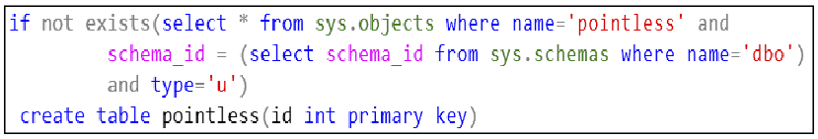
Figure 4- 24. How to create the pointless table if it doesn’t exist already using NOT EXISTS.

I discuss creating tables in some detail in Chapter 14.

4.13. The Exercise

The exercise will ask you to try various operators out such as IN and LIKE. You will get a chance to practice using the CASE statement.

Don’t forget; you can look at the answers in Appendix F.
You can download a .pdf containing the answers from my web site. You can download my completed Solution containing all the answers to all the exercise at the same address:

https://www.Transference-UnLimited.com

Exercise 4. The WHERE Clause

You will now use various WHERE clause variations. Add a new query file to your “My Class Queries” project and name it “The Where Clause”.
Put a descriptive comment at the top of the script and follow it with a suitable USE clause that accesses the AdventureWorks2017 database. Try using the -- symbol to create your comments instead of /* */ and see how it differs.

Ex 4.1. Working With > and < etc.

Write a select statement to display the sales order IDs for July 2012. Use the Sales.SalesOrderHeader table. The answer should have 385 rows using Adventure Works 2017. If you are using a different version of the Adventure Works database, you may need to change the year to an earlier one.

Ex 4.2. Remove Duplicates

Use the Sales.SalesOrderDetail table to display the sales order IDs. A sale will usually contain multiple different products for each order ID. That is why the same sales order ID appears in multiple rows. Find out using the Internet how to use the DISTINCT keyword to get rid of the duplicate rows. Try adding an extra column–anyone you like–to the query. What happens? Can you explain why?
If you display the sales order IDs using the Sales.SalesOrderHeader table you should get the same number of rows as by using Sales.SalesOrderDetail with the DISTINCT clause.

Ex 4.3. Working with IN

Write a SELECT statement to display the product IDs, the product names and the product colour for those products whose colour is red, black or yellow. Please use the IN operator to answer this. For Adventure Works 2017 I get 167 rows.

Ex 4.4. Working Without IN

Rewrite the query so that it offers the same functionality as above but uses the OR operator instead. Check that your new query returns the same number of rows as the previous query.
You should still get 167 rows.

Ex 4.5. Working with LIKE

Write a query that returns all products that have ‘ball’ somewhere in their name.
Display the product’s id and its name.
I get 3 rows returned.

Ex 4.6. Using the CASE Statement

Add a column to your query that displays ‘limited stock’ if the product’s colour is yellow, ‘in demand’ if the colour is silver and ‘Plenty of stock’ if the colour is black. If a product does not have a colour display ‘* NA *’.
Name the column Stock Status.

5. The ORDER BY Clause

The ORDER BY clause does what it says: it orders the rows according to a specified column or set of columns. It is an easy command to use bar one or two minor quirks.

The Syntax of the ORDER BY Clause

Here are examples of the syntax variations of the ORDER BY clause.

Example 1:

select col1, col2, col3, …
from table
order by col1,col2,col3, ...

Example 2:

select col1 as alias1, col2 as alias2, col3 as alias3, …
from table
order by alias1, alias2, alias3, …

Example 3:

select col1, col2, col3, …
from table
order by 1, 2, 3, …
Figure 5- 1. The three variations of the ORDER BY clause. You can append DESC to a column’s name to sort that column in descending order.
There are three syntax variations of the ORDER BY clause (Figure 5- 1). In example 1, the ORDER BY clause has column names taken from the column list in the SELECT statement. Example 2 uses column aliases rather than the column names. Example 3 specifies the ordering using column ordinal (position) numbers.
SQL orders the data by the first column and then within that ordered column, ORDER BY then sorts by the second column and so on. For example ORDER BY lastname, firstname will order the last names first and then within a duplicated last name it will order by first names. You can type DESC after a column’s name to sort that column in descending (reverse) order. The default order is ASC (ascending).
You can have some columns sorted in ascending order and some in descending. Please don’t forget to explicitly label all the columns that you want in reverse order with DESC.
You can order by columns that are not displayed via the SELECT statements columns list, as long as the columns are available in the table(s) you use. Although you will rarely see that done.

Examples of Using ORDER BY

The order by clause happily works with numeric, character and date types. Let’s say you wanted to see the last ten orders placed into the Adventure Works using the date as the criteria and then sort them by value within each date. You want to see the most valuable order within each date first. Figure 5- 2 shows you how, and Figure 5- 3 shows you the result.

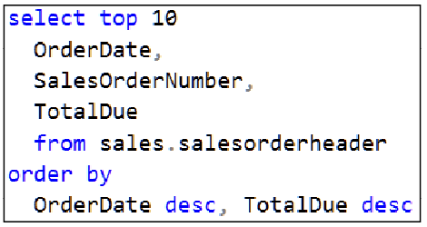
Figure 5- 2. A query to display the last ten orders recorded by Adventure Works. SQL sorts the sales orders in descending date order, within a given date it sorts them by placing the most valuable order at the top.

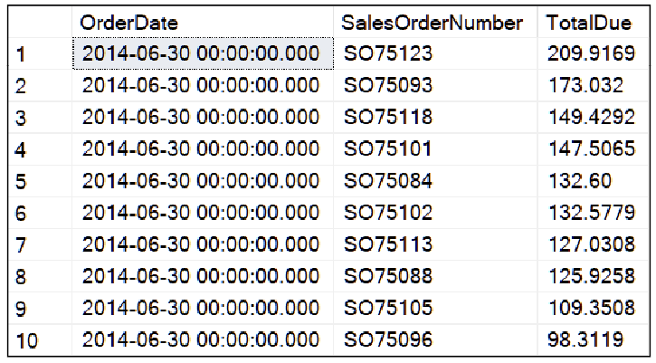
Figure 5- 3. The output of the query in Figure 5- 2. You can increase the number of rows to see a larger variety of dates.

Using Column Aliases in the ORDER BY Clause

You could express the same query in Figure 5- 2 as I have in Figure 5- 4. This example uses the aliased names for the columns.

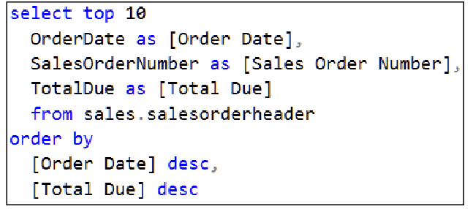
Figure 5- 4. Expressing the same requirement in the example but by using column aliases rather than column names.

In Figure 5-4, I have placed column aliases in the order by clause. You might say this adds clarity to the overall SQL statement.

When You Can and Can’t Use Column Aliases

The ORDER BY clause is the only part of a T-SQL statement than can use column aliases. You cannot use a column’s aliased name in any other part of a SELECT statement. That restriction includes the WHERE clause, the GROUP BY clause and other sections you will meet later in the course.
This is the explanation of why:
- The execution step that matches the column aliases to actual column names happens immediately before the ORDER BY clause executes.
- The ORDER BY clause is the last step SQL performs before outputting the result. That means any intermediary steps, such as processing the WHERE clause, do not have access to the alias definitions.
Immediately after the ORDER BY processing completes, SQL turns the requested data into an output table complete with column aliases replacing the actual column names. Only then is the result presented to you.
If you use a column alias in a WHERE clause, GROUP BY clause or anywhere other than in the ORDER BY clause, SQL will tell you that you are trying to access a column that doesn’t exist. You will have to replace the alias with the actual column’s name or calculation you have used to create that column.

Using Ordinal Numbers Instead of Column Names

The last way you can use the ORDER BY clause is by specifying the columns by using ordinal numbers. I have shown this in Figure 5- 5.

You will rarely see this ability used as it is a little risky. Why? Ordinal numbers could lead to confusion in the future if you edit the query’s column list and forget to update the ORDER BY clause.
Some automated tools, such as some report builders, put ordinal numbers into a query and adjust them automatically for you as you edit the column list. That is reliable as long as the machine works the ordinal numbers out for you.
I find ordinal numbers for testing a query until I like the ordering. When I finalise the SELECT statement, I replace the ordinal numbers with the real column names or aliases.
A Useful Tip:
Even if the column names or aliases are long, copy and paste them into the ORDER BY’s column list for your final query.
Rather don’t leave a reader to work out to which columns the ordinal numbers belong in your final query. That can be difficult for the reader to do if your query is many lines long.

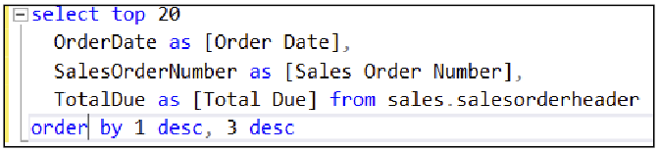
Figure 5- 5. This example uses column numbers (or ordinal position numbers) of the columns in the column list. You will rarely see this syntax in production quality code for reasons outlined in my text.

The Exercise

This exercise covers the various syntax variations of the ORDER BY clause.
The answers are available in Appendix F.
You can download the complete set of answers for all the exercises from my web site (https://www.transference-unlimited.com).

Exercise 5. The ORDER BY Clause

We will now use various syntax options of the order by clause. Add a new query to your “My Class Queries” project and name it “The Order By Clause”.

Put a descriptive comment at the top of the script and follow it with a suitable use clause that accesses the AdventureWorks2017 database.

Ex 5.1. Ordering the Products by Category ID

Write a select statement that displays the subcategory ID of each product, followed by the product’s name.
You should get 504 rows. Not all products will have a product subcategory id; such products will show NULL (unknown) in the subcategory id column.

Ex 5.2. Order the products by Subcategory ID

Modify the statement so that it orders the rows by the subcategory ID.

Ex 5.3. Order by Subcategory ID and then Product Name

Modify the statement to order first by the rows by subcategory ID and then by the product’s name.

Ex 5.4. Using Aliases with Order By

Create meaningful column aliases for the two columns: the subcategory ID and the product name.
Adjust your ORDER BY clause to use the aliases and check that it works as you would expect.

Ex 5.5. Using Ordinal Numbers

Replace the aliases with ordinal numbers and verify that the result is the same as before.

6. Joining Tables

The process of normalisation carries many benefits, as you have seen in Chapter 1. One of the normalisation processes’ characteristics is that it distributes data across many tables.
You are now at the stage where you ready to learn how to reverse the distribution of the data. You do this through the process of joining the tables together.
What this chapter covers:
- What is involved in constructing a join
- The inner join
- The meaning of NULL
- The left and right outer join
- The self join
- The cross join
- Older notations for doing joins and why you shouldn’t use them
- A caution about using the ON clause as a replacement to the WHERE clause

Introducing the Sample Tables

Here are three tables (from Chapter 1) and some data that I will use to explain the different types of join operation.

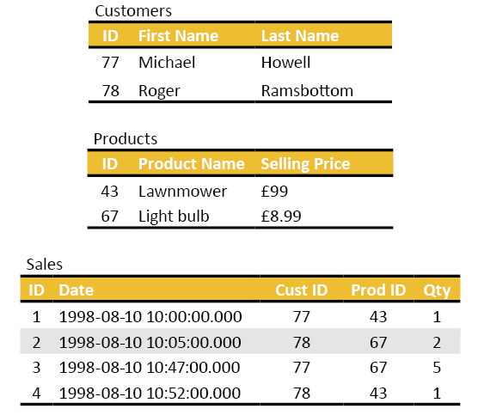
Figure 6- 1. The tables that I will use to describe the theory of joins.

Preparing to Visualise Joins

Keep the concepts that I am about to explain to you in the back of your mind before getting into joining tables using formal SQL. You will find that they help to make joining tables easier to understand.

What a Fully Qualified Column’s Name Looks Like

So far, the format we have used to specify a column’s name has been a shortened form. Figure 6-2 shows you what a column’s fully qualified name looks like.

Figure 6- 2. A query that shows a column’s full name, it has a table name in front of it.

Without the table name in front of a column name, SQL server works out to which table the column belongs implicitly. The match is reliable if the column names are unique. If you are joining two or more tables that result in two or more columns with the same name, you have to tell SQL which of the columns you want explicitly. You do that by putting the table name in front of the column’s name.

Table Aliases

Typing in a long table name in front of a column name can be tedious. To get around all the clutter, you can use a table alias. These temporary names are usually one, two or three characters long. You then use the table’s alias as a prefix in front of a column’s name.

The table aliases last as long as the current query is executing. The next query cannot use those of the previous query; you have to redefine your chosen aliases in each query.

Table aliases are assigned to the table names as soon as the server begins processing the FROM clause in a SELECT statement. The FROM clause is the first part of the SELECT statement that SQL processes. That means you can use table aliases right away; anywhere you would put a table name in a SELECT statement. Compare this to the behaviour of column aliases; because of their late assignment, column aliases can only be used in the ORDER BY clause.

How SQL Implements a JOIN Operation

When you join two tables together, bear in mind that the result is a single table. If you then join another table onto that joined pair, visualise the third table as if you were joining it to a single table. If you think of your query as if it joins the third table onto a second table onto the first table, you will likely confuse yourself very quickly.

Bear in mind that as long as you are referring to a column whose short name doesn’t match another's, you don’t need to use the fully qualified form of the column’s name. If two column names are ambiguous, you will need to identify from which table the column you want comes. Use a table alias to help you.
Every join operation widens (adds columns) to the previous table. Every column from the newly joined table will be available to you in your query. Your choice from the different types of join operations will determine the number of rows in the result.
You need to specify what qualifies a row from one table to join onto a row from the other. You do that by using the ON clause. The ON clause specifies which column(s) in a row from one table must match whichever column(s) in a row from the other table. You repeat the ON clause for each table that you join.
The output of the JOIN operation(s) you see using SELECT is an entirely newly formed table. Once SQL sends the spontaneously generated output table to the client, that table ceases to exist. That is how SELECT behaves in general: it takes input data and projects it onto an output table.

Now that you have the fundamental ideas of what a join entails, I am going to explain the various types of joins to you.

The Inner Join

The inner join–or ‘a join’ as many refer to it–is used to link two tables together to return the rows that the tables have in common. You need to define what “in common” means using the ON clause.
The first table is called the left-hand table and the second is the right-hand table. This convention presumably comes about because, in the West, we read from left to right. The right-hand table appears after the JOIN keyword. If you join a third table, the third table is on the right. The previous two tables (now regarded as a single table) are on the left.
You follow the right-hand tables name with an ON clause. The ON clause contains a boolean expression. That expression is evaluated for each row from the left-hand table against each row in the right-hand table.
The ON clause’s boolean expression will compare one or more columns from the left-hand table against one or more columns in the right-hand table. You separate multiple column comparisons using the AND Boolean operator.

If the ON clause’s expression evaluates to true, SQL considers the rows to be a match. SQL takes the matching rows and concatenates them to form a new row made of the columns from each table. SQL puts this row into the output table.

The order of the columns, despite any incidental appearance, is not predictable. It is for you to specify the column order in the SELECT’s column list. You must control the ordering of the rows in the output by using an ORDER BY clause. Otherwise, the row order is as good as random and can change in the future.

A Colourful Analogy Describing Joining Multiple Tables

Here is an analogy to explain the process of joining three tables: think of joining tables as if you were blowing air into a party-balloon. Every time you execute a JOIN–and you can have as many JOINs as you like–that is the same as you blowing air into a balloon, making it bigger each time. However, instead of blowing air into your ever-enlarging balloon, you are blowing columns and rows taken from other balloons into your new big balloon.

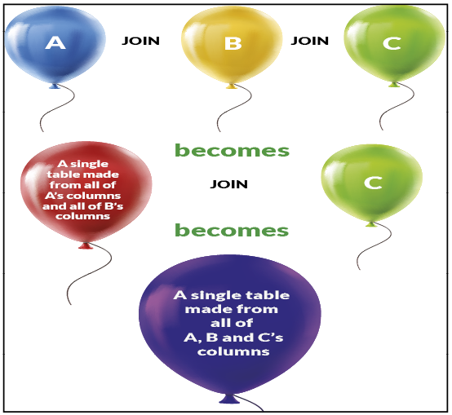
Figure 6- 3. A way to visualise joining three tables as SQL progressively evaluates them. The joins produce a single table as the output.
Figure 6- 3 illustrates how the left-hand table represented by ballon A expands in size, join by join until you have a single balloon that contains instances of all the columns from the other tables.

The number of columns in the final result is the sum of the number of columns in each table. The number of rows in the result depends on the type of join and the ON clause’s expression.

A Step-by-Step Example of an Inner Join

Let’s use the sample tables in Figure 6- 1.

select * from
Customers
inner join
Sales
on Customers.ID = Sales.[Cust ID]
Figure 6- 4. An example inner join written using the sample tables. You don’t have to specify INNER since it is the default join type.
The left-hand table, Customers, is going to be the probe table. The machine will take each row of the Customers table–one by one– and compare it against all the rows in the Sales table–the probed table. SQL will repeatedly cycle through the Sales table for each row in the Customers table.

SQL applies the ON clause condition to each tentative row pairing. If the ON clauses condition is true, SQL concatenates the pair of rows from Customers and Sales together to form a single row and sends that row to the output table. If false, SQL discards the row pairing and moves onto the next row in the Sales (the probed) table. When there are no more rows left in the Sales table, SQL takes the next row from the Customers table and repeats the scan through Sales looking for matches.

The JOIN is complete when SQL has checked all the rows from the Customers table (the probe) against Sales. If the probe table has 2 rows and the probed table has 4 rows, SQL will scan the probed table 2 x 4=8 times to supply the final answer.

The algorithm (the set of steps) that I have described to you is called the nested loop join. The algorithm is not a type of join; it is a way to perform a join. There are other algorithms that SQL can choose from: the merge join and the hash join (once known as the hash-match lookup join). I will leave you to research the alternative algorithms yourself if you are keen here: https://docs.microsoft.com/sql/relational-databases/performance/joins?view=sql-server-ver15.

If you are need to or more columns from each table to match simultaneously, you name these several columns together by using AND clauses in the boolean expression (in the style Table1.Column1 = Table2.Column1 AND Table1.Column2 = Table2.Column2). The ON clause should only contain = or <> comparison operators and the AND Boolean operator, nothing else.

You must only refer to columns in the ON clause to compare rows between the tables. Never use the ON clause to mimic a WHERE clause. Arbitrary comparisons in the ON clause, such as LastName=’Gogwobble’ will break certain types of joins. Why that is so is explained in section 6.22.

The order in which you specify the tables for an inner join doesn’t make any difference to the result. SQL’s optimiser will dynamically decide which table will make the best probe table and which table will be the probed. The probed table is almost always the table with the fewest number of rows.

In Figure 6-4, the ON clause dictates that for a given row from the Sales table to match a row in the Customers table, the CustID column from Sales must match the ID column in the Customers table.

The query will produce this output:

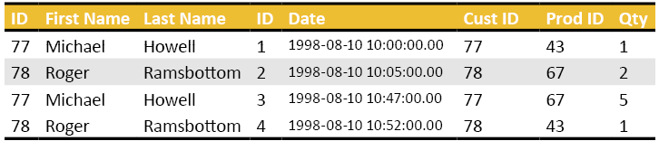
Figure 6- 5. The result of joining Sales to Customers (see Figure 6- 4).
Note the duplicated column name: ID. SQL, as usual, shows column names without the corresponding table name as a prefix. The first ID column’s full name is Customers.ID and the second ID column’s full name is Sales.ID.
The outputted table does not have a name. You can give it a name. How to do that will be shown to you in “Chapter 10: Subqueries and Common Table Expressions (CTE’s)”.
The resultant output table has as many columns as the sum of the number of columns of each joined table (3 from customers + 5 from sales = 8). The number of rows in the output depends on how many rows match according to the ON clause. Unmatched rows do not appear.

An Inner Join with Three Tables

Let’s see how to add a third table—Products—to the join operation. Think of the output of the previous example (Figure 6- 5 and Figure 6- 4) as a single table onto which you want to join the Products table. You will then write this:

select * from
Customers
join
Sales
on Customers.ID = Sales.[Cust ID]
join
Products
on Sales.[Prod ID] = Products.ID
Figure 6- 6. The syntax for joining the three example tables together. I have not used the word INNER so that you can compare the aesthetics of doing so by looking at Figure 6- 4.

The query above produces the output in Figure 6- 7.
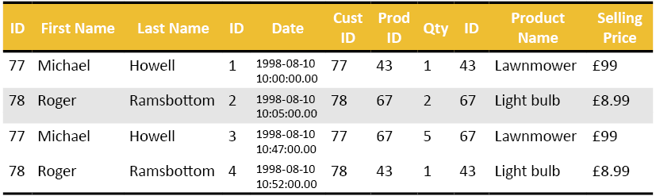

Figure 6- 7. The output of the join operation shows in Figure 6- 6 involving three tables.
You could continue adding join instructions for as many tables as you like.
Figure 6- 7 shows 11 columns; 3 from Customers, 5 from Sales and 3 from Products.

Using Table Aliases

To see how to use table aliases to make a query easier to read, have a look at Figure 6- 8.

select
C.ID as [Customer ID],
[First Name],
[Last Name],
S.ID as [Sales ID],
[Product Name],
Qty as [Quantity]
from
Customers C
join
Sales S
on C.ID = S.[Cust ID]
join
Products P
on S.[Prod ID] = P.ID
Figure 6- 8. This example shows how to use table aliases to reduce clutter in the column list and the ON clause.
Next to the table names, you can see the letters C, S and P. These are the table alias. C stands for Customers, S for Sales and P for Products.

If you look at the SELECT’s column list, I have used column aliases for clarity. I have removed any ambiguity concerning the ID columns by putting a table alias in front of them. Without the table aliases in front of ID, I would not be able to display either ID column; SQL would produce an error saying that ID is an ambiguous column name.
Table aliases do not influence the performance of the query. They do make life easier for us from a visual point of view.
From a reader’s point of view, they tend to look at the column list of a SELECT statement first. Once the reader realises that table aliases are prefixing the columns, they then read the various tables listed after the FROM clause to resolve them then return to the column list. As one of my students put it: “It is as if SQL can see into the future”. No, SQL reads the FROM clause first, computes the table aliases then looks at the rest of the SELECT statement’s content.

A Vital Consideration For the ON Clause

You can join any two columns together as long as their data type is compatible or SQL can make them compatible (See Appendix D). What that means is that you can accidentally compare an invoice number column to a customer id column in your ON clause and the statement will execute.

Such a query won’t produce meaningful output, but it will run. To SQL, invoice ID’s and customer ID’s are simply numbers. The machine cannot understand the column’s inherent meaning.

Useful Tip: Sample A Few Rows To Manually Check The Join Makes Sense

It is an excellent idea to sample a few rows from your query using TOP to see if the result makes sense before unleashing your SELECT statement on all the rows of all the tables involved.

An Inner Join Example from Adventure Works

You want to get a list of product ids, the product’s name, the product’s category name and the subcategory name.
First, you must find the tables that supply the columns you are after. Once you have identified the tables, you then look through each table’s column list to work out which columns are foreign key columns and which are the primary key columns. A diagram of the database or going through the tables with the Object Explorer will help you work out what columns must match to other columns.

You might have to include tables in your list of JOINS from which you don’t want to display data. You need these intermediate table in order so that you can form a “path” between the tables that have the columns you want.

For instance, you cannot join the Product table to the ProductCategory table without also joining in the ProductSubcategory table. This intermediary join is needed even though you don’t want to display anything from the subcategory table. Otherwise neither you nor SQL can work out how to get from a given product to its category.

Ideally, a database diagram (or the Object Explorer) will make this easier to follow. If you like, look at the relevant tables’ definitions and try to work out how to get from a product to a category without using the subcategory information. You can’t.
It may take a moment or two to realise that a product has to reveal the subcategory it belongs to before you can work out to which category to which it belongs. If a product gave you its category first, you wouldn’t be able to find out its subcategory. That is because a category contains many subcategories.
Let’s write this query in stages (Figure 6- 9). First, join Production.Product to Production.ProductSubcategories:

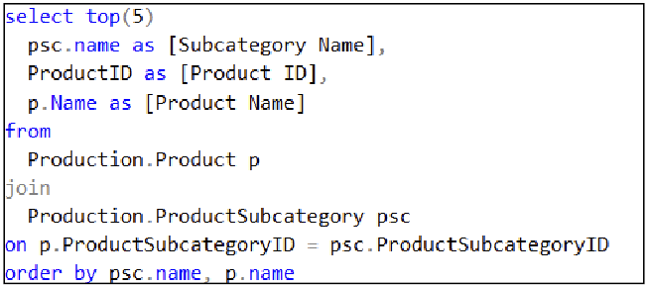
Figure 6- 9. How to do a JOIN using SQL and using real data.

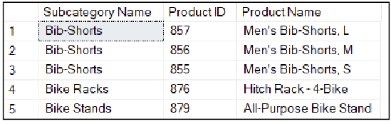
Figure 6- 10. The output of the query in Figure 6- 9.

P and PSC are the aliases. If you like, you can put AS between the table’s name and the alias you have chosen.
In Figure 6- 9, you can not refer to the column called name without using an alias. That is because name is a column in both the Product and ProductSubcategory table.
Now let’s join category information onto the query from above (Figure 6- 9):
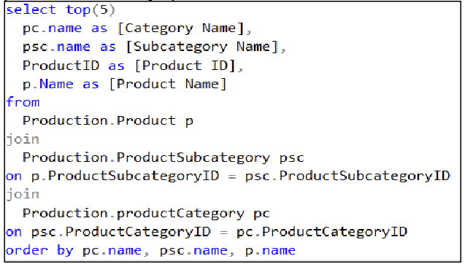
Figure 6- 11. An executable query that joins three tables together.

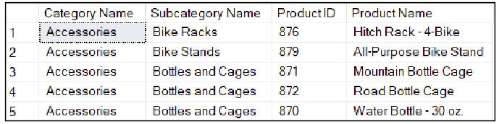
Figure 6- 12. The result of joining the three tables together in Figure 6- 11.

The Left Outer Join

The INNER JOIN outputs those rows that match given the condition in the ON clause. You may want to see the rows that do and the rows that don’t match. You also want a clear means to distinguish the two cases.
This task is where the LEFT OUTER JOIN comes in. The LEFT OUTER JOIN behaves the same way as an INNER JOIN plus it reveals all the rows in the left table (the first table) that don’t have a match in the right-hand table (the second table). For the rows from the left table that don’t have a matching partner in the right-hand table, SQL takes the row from the left table and concatenates it with a row with the same column headings that the right table has, but SQL sets all the values to NULL.
Let’s modify the customer’s sample table so that it has an extra customer (Figure 6- 13). There will be no sales recorded for this customer. You want to write a query that displays the customers that have not placed any orders.
Here is the amended Customers table:
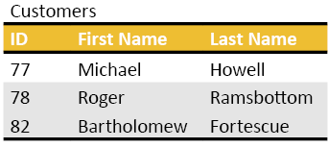
Figure 6- 13. The customers table with a new row; Bartholomew who hasn’t bought anything.

To write the required join, you would write the script in Figure 6- 14:

select * from
Customers C
left outer join
Sales S
on C.ID = S.[Cust ID]
join
Products P
on S.[Prod ID] = P.ID

Figure 6- 14. An example query for a LEFT OUTER JOIN. You can replace the LEFT OUTER JOIN with LEFT JOIN if you prefer.
And you will get Figure 6- 15 as a result. Some folk prefer to use the statement LEFT JOIN rather than type LEFT OUTER JOIN.

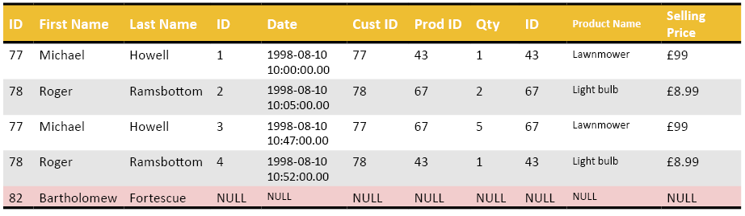
Figure 6- 15. The result of the LEFT OUTER JOIN query. Bartholomew’s row shows NULLs everywhere a value from the Sales table would have been. Likewise, that row’s product data is NULL too.

You can see that the row for Bartholomew contains NULL where the sales and product information would have appeared if he had bought anything.

The left outer join reveals both those rows from the left-hand table that match as well as those rows that don’t. According to the original question, you only want to see Bartholomew in the output.

We need a reliable method that will allow you to detect the unmatched row. To see how to do that, let’s switch to using real tables.

Useful Tip: Ordering the Tables Correctly
Be sure to specify the tables in the correct order for a LEFT OUTER JOIN.
SQL uses the left-hand table (the first table) to find matches in the right-hand table. Every row in the left-hand table will display whether it matches it not. Rows in the right-hand table that don’t match a row in the left-hand table won’t appear in the output.
If you list the tables in the wrong order around the keyword LEFT OUTER JOIN, you will get a result, but not the one you are expecting. Swapping the terms in the ON clause’s expression will not make a difference.
Swapping terms around an equal sign, when you are using it for comparison purposes, makes no difference. If you ask “is A=B?” or “is B=A?” you are asking the same question.

A Left Outer Join with Adventure Works

Let’s say you want to find those products that do not have a subcategory allocated to them.
First, write a suitable left outer join, as I’ve shown in Figure 6- 16. The LEFT OUTER JOIN query that will let you see which products both have and don’t have a subcategory. This query is the first step to achieving the goal of finding those products that don’t have a subcategory. The result is in Figure 6- 17. The outer join will find rows that both have and don’t have a match. You need to filter the unmatched rows out with a WHERE clause.

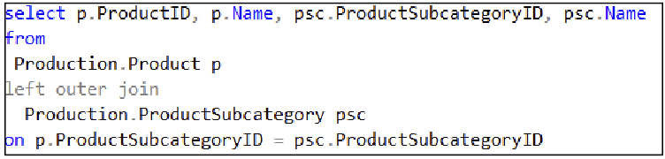
Figure 6- 16. The LEFT OUTER JOIN query that will let you see which products both have and don’t have a subcategory. This query is the first step to achieving the goal of finding those products that don’t have a subcategory.

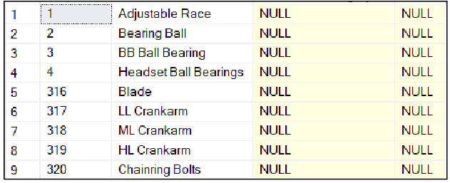
. .
. .
. .
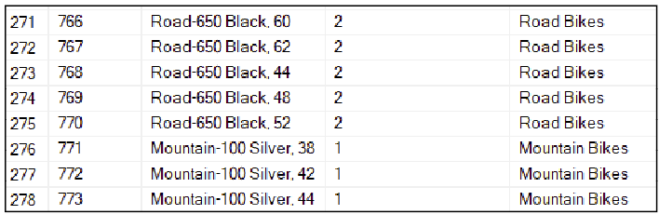
Figure 6- 17. The results of Figure 6- 16 showing the unmatched and matched subcategories.

Finding a Column to Use To Detect a No Match Situation

You need to work out which column you can use to indicate that there isn’t a match in the right-hand table.
The column to use in your test is the column from the right-hand table that you are referring to in the ON clause. If that column is NULL, there are no matches with any rows in the right-hand table. If you use any other column from the right-hand table, you risk mistaking a legitimate NULL value for a mismatched row.

I have seen folk choose a random column from the right-hand table to test for a mismatch. Choosing a column at random is definitely not a good idea. One day, the NULL value in that random column will be a legitimate NULL value in the data causing you to see a false supposedly mismatched row
To detect NULL, you must use the IS NULL comparison operator. You can not use ‘=’ to find a NULL. So your query must be written as in Figure 6- 18:
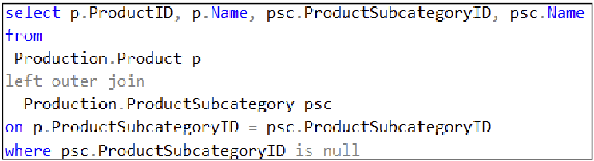
Figure 6- 18. This query finds those products that don’t belong to a subcategory.

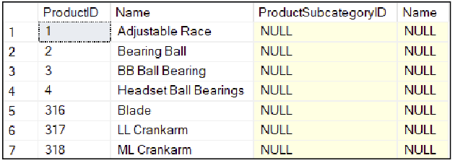
. . . . .
. . . . .
. . . . .
. . . . .
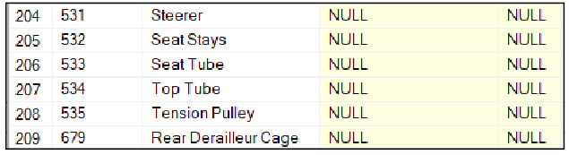
Figure 6- 19. The result of the query in Figure 6- 18. 209 products don’t have a subcategory.

The result is 209 rows long. You can see that the output has NULLs in all the columns potentially derived from ProductSubcategory. psc.productsubcategoryID is the right-hand table’s column to use to perform a check for a match/mismatch as it is the column used in the ON clause.

What NULL Means

When you work with a WHERE clause such as “WHERE LastName = ‘Blanderbobble’ “ you may expect that it would return one of two states: true or false. There is a third state: unknown. In computer science, NULL effectively means you don’t know what the answer is.

How Null Differs from ‘’

Here is an example that explains how they differ: If I had a middle name column for a customer, I would set it to NULL to indicate that I hadn’t asked the customer for their middle name; I don’t know if they have a middle name or not.

If I asked them for their middle name, and they don’t have one, I would set their middle name value to empty. An empty blank value is represented by ‘’ which is a pair of adjacent single quotes.

Why You Can’t Detect NULL With =

The ‘=’ sign implies that you have two known quantities that you wish to compare for equality. If I asked you is “3=x?” and you don’t know what the value of x is, you have to reply “I don’t know the answer”. SQL responds to such a question by returning NULL.

You can write a test to see if a variable or column’s value is unknown by using the IS NULL comparison operator. The test for the opposite condition is IS NOT NULL, or you can write the same test as NOT IS NULL.

You will find that the ability to express an unknown value using NULL is important when you meet the aggregation functions later in this course in “Chapter 7: Grouping Data and the Aggregation Functions”.

The Right Outer Join

If you can write a left outer join, surely, you can write a right outer join? And you can. This join swaps the purposes of the tables compared to the LEFT OUTER join; the RIGHT OUTER JOIN uses the right-hand table to find matches in the left-hand table, the opposite way around to the LEFT OUTER join.

You will very rarely see the RIGHT OUTER join used. I would cheekily venture that the only people who do use it are those people who feel the right outer join is somewhat neglected, and they want to give its existence some acknowledgement. Or they want to play silly buggers and annoy a colleague.

The same query, as seen in Figure 6- 20 written as a right outer join looks like this:

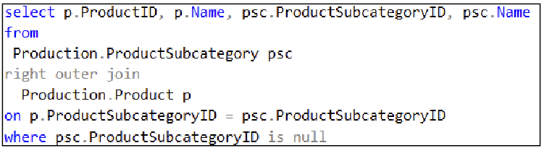
Figure 6- 20. This query is the same as the previous query except it I have written it as a right outer join.
The only difference in Figure 6- 20 compared to Figure 6- 18 is that I have written the table names in a different order and used the words RIGHT OUTER JOIN. It produces the equivalent output as Figure 6- 19’s query except that it lists the columns of the ProductSubcategory table first.
You can rewrite any right outer join as a left outer join.

Self Joins

You use a self-join when a table embeds a hierarchy of some sort. That description sounds rather abstract so let’s use an example. Have a look at the Employees table in Figure 6- 21.
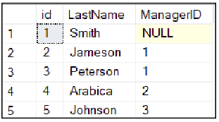
Figure 6- 21. An Employees table that contains a self-referencing column–ManagerID. This table shows that a staff member has a manager who is themselves a staff member.
You can reproduce the above table by running the script in Figure 6- 22.
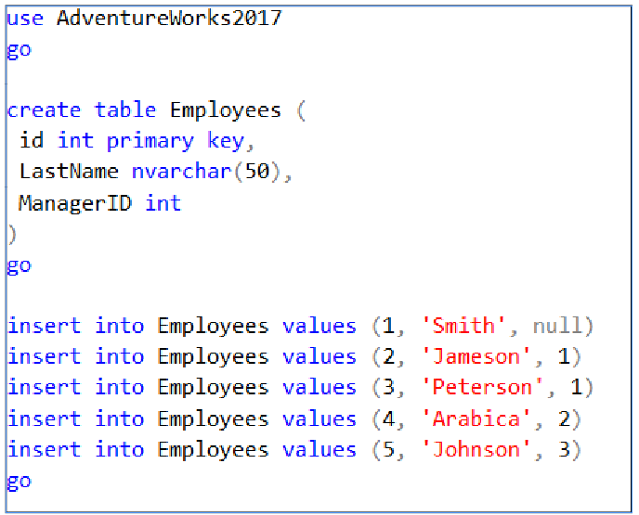
Figure 6- 22. The script to create the self-referencing Employees table.
In this table, the column for the manager ID is another employee. How could you get a list of employee’ s last names and their immediate manager’s last name?
Picture two tables in your mind. One called Employees and the other called Managers. You would take an employee’s row and their manager’s id and then find the manager’s details by looking up the manager id in the Managers table. Now, what if I told you that the Managers table was the same as the Employees table? Aaah! The self-join should all makes sense now.
There is no need to copy the Employees table into another table called Managers. Instead, you can join the Employees table to itself. To make the join clearer, use an alias for the “copy” of the Employees table and call the alias Managers.
The query would look like that in Figure 6- 23, executing it produces the result in Figure 6- 24.
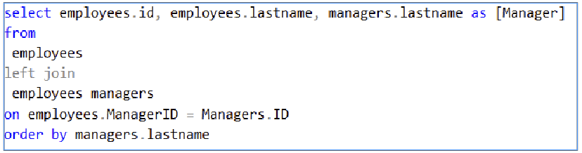
Figure 6- 23. Using a self join to determine an employee’s manager’s details. The self-join is much easier to follow if you use a well-chosen alias name to pretend you have a copy of the single table that is involved.

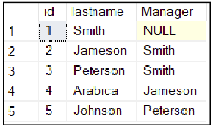
Figure 6- 24. The result of executing Figure 6- 23.
Figure 6- 23 uses a left outer join so that you can see the row for the employee who doesn’t have a manager, presumably the business’s owner. An inner join would not show that row.

The query in Figure 6- 23 answers the original goal, but by adding a bit of polish (Figure 6- 25) the output looks better by displaying the managers first and then their respective employees.

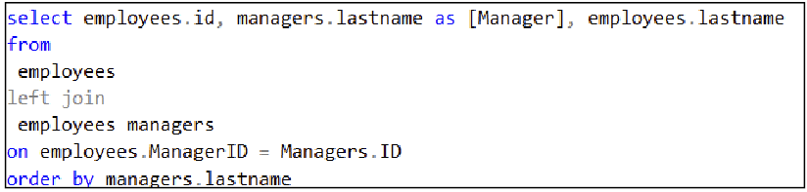
Figure 6- 25. A slightly modified version of the query in Figure 6- 23. This query produces a list of alphabetised manager’s last names. A useful addition would be to sort the employee’s last name’s within each manager’s last name.
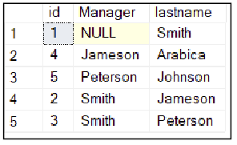
Figure 6- 26. The output of the query in Figure 6- 25.

Useful Tip: Improving a Self-Joins Readability

Self-joins can become much easier to understand if you use nicely chosen alias names.

The CROSS JOIN

You can use a cross join to display every row in one table placed next to every row in another. It can be useful from a combinatoric perspective.
Let’s look at an example of a CROSS JOIN statement. You have a table of teachers and a table of subjects they can teach. You want to calculate a matrix that shows all teachers listed next to all subjects, perhaps so that the result can be printed out and handed to the teachers. A teacher can then tick off the subjects they want to teach.
Figure 6- 27 shows a script to create the scenario described above.
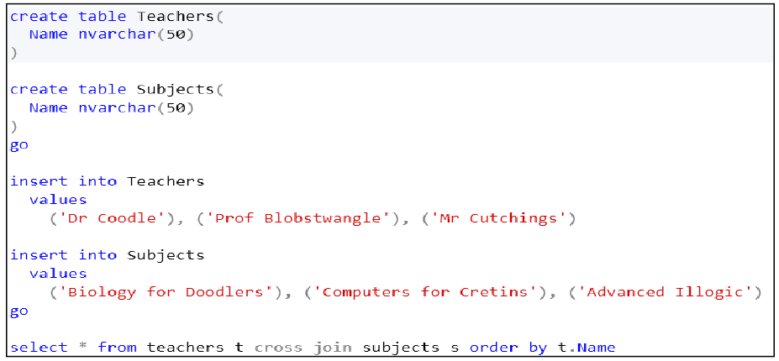
Figure 6- 27. A set of commands to create demonstration tables, insert data and then do a CROSS JOIN.
This query produces:

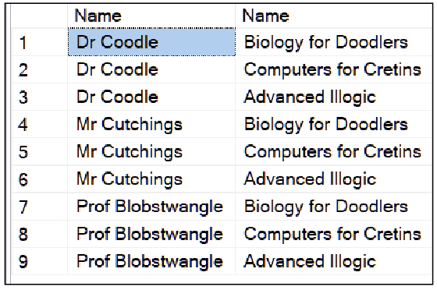
Figure 6- 28. Every teacher is listed next to every subject.

The CROSS JOIN is a hard-sell. Its inclusion in SQL is academic. See what I did there? Teachers, subjects, academic?

The FULL JOIN

If a left outer join tells you what rows in the left-hand table have and don’t have a match in the right-hand table, surely there is a join that shows you the rows that are in the right-hand table that aren’t in the left-hand table all in a single query?
That is what the FULL JOIN does. Let’s have a look at an example (Figure 6- 29).

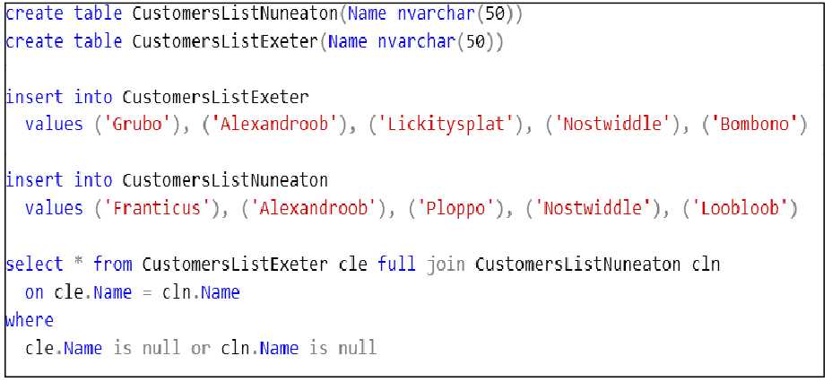
Figure 6- 29. An example of a FULL JOIN complete with a script to create sample tables. The FULL JOIN is at the very bottom. Note the use of checks for NULL; otherwise, the join will reveal matching rows as well as non-matching rows.
The result is in (Figure 6- 30).

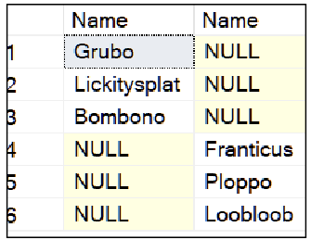

Figure 6- 30. This FULL JOIN result shows you those rows that are in one table but not the other.

You could use the FULL JOIN to see a report comparing two tables to see how different they are from each other.
If the synchronisation of data between two tables interests you, you might want to have a look at the SQL MERGE statement. You can read up on it here: https://docs.microsoft.com/sql/t-sql/statements/merge-transact-sql.

Outdated Syntaxes For Joins

Let’s look at a syntax for joining tables that pre-dates the SQL ANSI standard. You can still find it in use. I advise you to avoid using it in the future, and I will show you why.
To help put the age of this notation into perspective, I learned how to do joins this way in 1991 when I learned SQL using Oracle on Xenix 386. I suspect the notation is older than that. The reason why you should avoid this notation is that it is ambiguous when used to express outer joins. With the more recent implementations of SQL servers, you cannot do outer joins using this syntax anymore, only inner joins.
There is nothing wrong using this notation to do an inner join. However, it is best not to mix the old and new notations for the sake of consistency.
The syntax looks like this:
SELECT * FROM table1 T1, table2 T2 WHERE table T1.col = T2.col
Figure 6- 31. The pre-ANSI inner join syntax. The table aliases are used for clarity and make no difference to the result.
Figure 6- 32 shows an example that works correctly (an inner join).

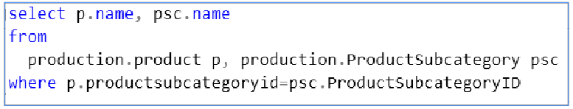
Figure 6- 32. This script shows how to do an INNER JOIN using the pre-ANSI syntax.
The syntax requires you to type the tables you want to join in a comma-separated list after the word FROM. You don’t have an ON clause; instead, you embed the join condition into the WHERE statement. The problem is that you can’t tell which parts of the WHERE clause are mean to be used to join the tables and which sections you mean to perform the function of a regular WHERE clause. It turns out that SQL can’t work it that out either. The notation works by coincidence for inner joins.

For LEFT OUTER JOINS you would replace = in the WHERE clause with *=. For RIGHT OUTER JOINS, you would use =*. The reason why this notation is defunct is important; it points out a mistake that has trickled over into using ANSI’s notation. It turns out that the error is easy to spot and correct with ANSI notation but indiscernible with the old notation.

The mechanism that causes the issue is quite fun to understand. Work out what the script in Figure 6- 33 does.

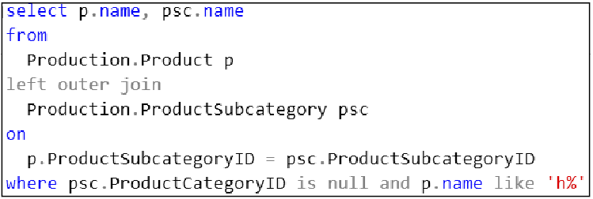
Figure 6- 33. This figure shows a query that is the first step to understanding why the old notation doesn’t work for outer joins.
It displays all those products that don’t have a subcategory, and their product name starts with the letter ‘h’.

The output looks like this:

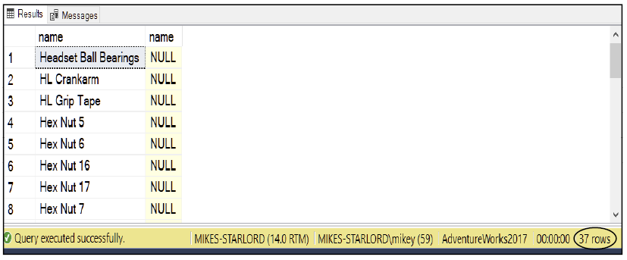
Figure 6- 34. The result of the query in Figure 6- 33. There are no surprises so far. There are 37 rows in the output.

Now, look at the query in Figure 6- 35. Compare it to the query in Figure 6- 33. Look carefully at the ON clauses. Are the queries functionally the same?

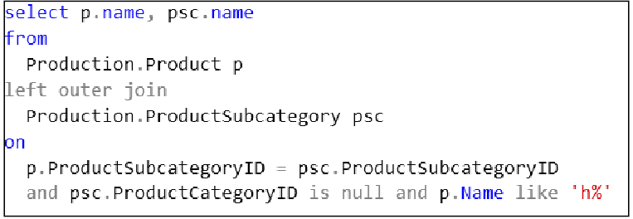
Figure 6- 35. The query in Figure 6- 33 modified by putting what was in the WHERE clause into the ON clause. Does this query behave the same way?
Now, look at the resultant output of Figure 6- 35, shown in Figure 6- 36. The result has 504 rows instead of 37.

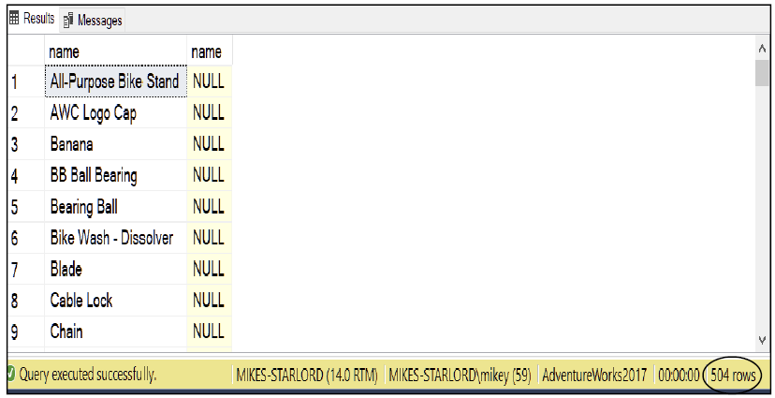
Figure 6- 36. The output from the query in Figure 6- 35. 504 rows compared to 37.

The Effect of the WHERE Clause’s Condition in the ON Clause with a LEFT OUTER JOIN

In either example (Figure 6- 33 or Figure 6- 35) the left outer join operation outputs all of the rows in the left-hand table. The WHERE clause in Figure 6- 33 filters out the rows you don’t want yielding the result in Figure 6- 34. The WHERE clause results in the reduction from 504 rows down to the 37 you expect.

An ON clause determines which rows you want to join. If you put the condition “psc.ProductCategoryID is null AND p.name LIKE ‘h%’” in an ON clause, you are asking SQL to join those rows where the ProductCategoryID is null, and the product’s name starts with the letter ‘H’. SQL will not perform the join on any other rows. Since you are using an outer join, any rows that don’t match according to the ON clause’s criteria, are displayed. Hence the entire left-hand table is in the result.
Some of the rows from the left-hand table will be joined to some of the rows in the right-hand table as per the ON clause. The other rows won’t be. Those rows that don’t satisfy the ON clause’s condition will be displayed.

Putting the WHERE Clause in the ON Clause with an INNER JOIN

An inner join displays a row if the ON clause returns true. This behaviour is not the same as the left outer join, which always output’s the left-hand table’s row to the next step involved in processing a SELECT statement, which is the WHERE clause. In Figure 6- 33, the WHERE clause removes the unwanted rows produced by the outer join.
An inner join using an ON clause that has been partially misused as a WHERE clause works because an inner join does not show the unmatched rows.

6.26. The Ambiguity Caused by the Old Notation

Let’s see how these ideas relate to the ambiguity caused by the non-ANSI syntax:

select p.name, psc.name from
production.Product p, Production.ProductSubcategory psc
where
p.ProductSubCategoryID *= psc.ProductSubCategoryID
and
psc.ProductCategoryID is null
and
p.name like ‘h%’
Figure 6- 37. An example of pre-ANSI notation to perform a left outer join. T-SQL will not let you use this notation anymore because it is ambiguous and produces nonsense output.
Do you see the ambiguity? SQL can’t work out if you mean for the AND clause to be part of the WHERE clause or if you mean for SQL to read it as if it were part of a modern-day ON clause. You can’t specify how you want SQL to treat the AND in the WHERE clause.

Because of the confusion, Microsoft and other SQL server implementors dropped the ‘*=’ and ‘=*’ as a means to express left and right outer joins. You can get around this problem by using a nested query (a query inside a query). You would use the inner query to perform the outer join and then use the outer query to filter out the unwanted rows. In this case, a nested query is a clumsy fix for a relatively simple problem. A problem that arguably should never have occurred in the first place.

Should You Rewrite Old Style Queries?

No. If it isn’t broken, don’t fix it. You will spend hours of your time replacing the old syntax with a functionally equivalent ANSI JOIN syntax. And you risk accidentally breaking working code.
In the future:
- Don’t use the old syntax for creating joins.
- Don’t put an expression that should be in a WHERE clause into an ON clause.

The Exercise

In this exercise, you continue to add .sql files to your Solution.
You will create a join that involves adding more and more tables.
You will try an outer join.
As usual, the answers are in Appendix F.
You can download the answers from my website at https://www.transference-unlimited.com.

Exercise 6. Joining Tables

You will now join tables together to extract columns from multiple tables in a single query.
Add a new query to your “My Class Queries” project and name it “Joining Tables”. Put a descriptive comment at the top of the script and follow it with a suitable USE clause that accesses the AdventureWorks2017 database.

Ex 6.1. Obtain Sales Data

Write a query to join the Sales.SalesOrderDetail table to the Production.Product table. Display the columns that contain the sales order id, the products name, the quantity ordered and the line total. Show the first 50 rows.

Ex 6.2. Adding More Tables to the Join

Join the Production.ProductSubcategory table onto the above query. Display the subcategory name before the product’s name in the result.

Ex 6.3. Add Yet Another Table

Add the Production.ProductCategory table onto the above query and display the category name before the subcategory name.
Be sure to save this query as we will use it in a later exercise.

Ex 6.4. Outer Join

Note that this exercise has nothing to do with the previous exercise. It is an entirely new scenario.
Write a query to show all those products–by name and ID–that nobody has ever ordered. Do not include those that have a list price of 0. You should get 38 rows. You will have to write a WHERE clause to do this.

Ex 6.5. A Voluntarily Made Error

Copy the query from Ex 6.4. Edit the copy so that it the condition in the WHERE clause is now in the ON clause. Have a look at the output. What has happened?

Grouping Data and the Aggregation Functions

When you group data in SQL, you specify one or more columns in a table that contain repeated values, group all the rows with the same values together, then apply a mathematical aggregation function on the rows within each group. SQL then sends the result of each aggregated group to the output table.

A Grouping Example

Let’s say you have a products table that has a product name, category name and a column containing the quantity of each item in stock. You want to see the total amount of stock in each category. You would do this by telling SQL to group the rows by category name and then sum up the quantities in each group. You would use the SUM() aggregation function to do this.

7.2. Grouping Illustrated Visually

Have a look at the table in Figure 7- 1. You want to work out the total quantity of products within each category name.

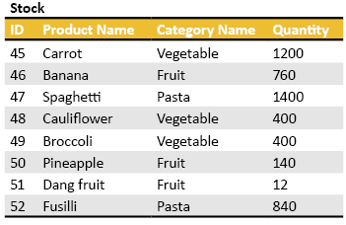
Figure 7- 1. The raw data that you are about to group by category name.
So you group the items by category name as in Figure 7-2.

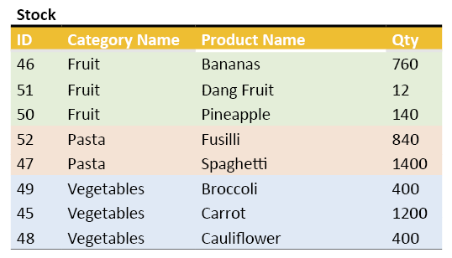
Figure 7- 2. The data after you have grouped it by category. Each colour represents a category.

Now you apply the SUM() aggregation function, and you get:
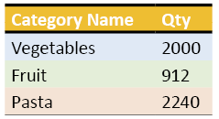
Figure 7- 3. The result after applying the SUM aggregation function to each grouping.

Useful Tip:

I would strongly suggest that you use an ORDER BY clause whenever you use a GROUP BY clause.
Don’t be tempted to think that SQL will order the outputted rows according to the columns in the GROUP BY clause.
Figure 7- 4 is what the SQL code would look like for our theory-based example:
select [Category Name], sum(qty)
from Stock
group by [Category Name]
Figure 7- 4. The grouping I have described expressed as SQL.

Enough theory. Smile. We are about to see how to do grouping in real life.

7.3. Grouping Data from Adventure Works

Let’s say you want to see the value of the first five orders placed into the Adventure Works database. You do that with the SQL statement in Figure 7- 5.

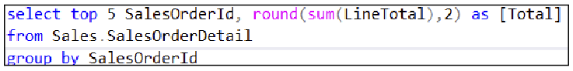
Figure 7- 5. An example of how to do a group operation. This query will display the value of the first five sales. The values are rounded off to two digits after the decimal point using the ROUND() function.

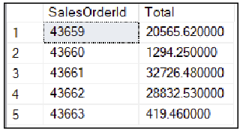
Figure 7- 6. The result of the script in Figure 7- 5.
The ROUND() function takes a value and rounds it off at the number of digits you want. It does not remove the extra digits. The number of trailing zeroes in Figure 7- 6 is decided by the DBA’s choice of the scale for the decimal data type. See 2.15.2 for an explanation of scale.

Useful Tip: Be Aware of Rounding Errors
It is essential to keep the SUM() function within the ROUND() function as you see in Figure 7- 5. Do not write what you see in Figure 7- 7. This script sums the individual rounded values from the LineTotal column. This premature rounding can result in a misleading total thanks to summing up individually rounded values rather than rounding total.
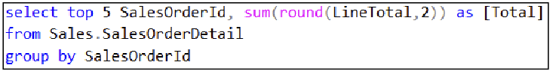
Figure 7- 7. How not to use the ROUND() function.
Realistic grouping operations will almost always involve joins since a single table in an online transaction processing (OLTP) database rarely has enough information to contain enough useful data.

7.4. Using GROUP BY and a JOIN Operation Together

Let’s say you want to see the first five sales orders, the corresponding order dates and the total value of each of those sales orders. Figure 7- 8 shows a way to answer the requirement. The result is in Figure 7- 9.

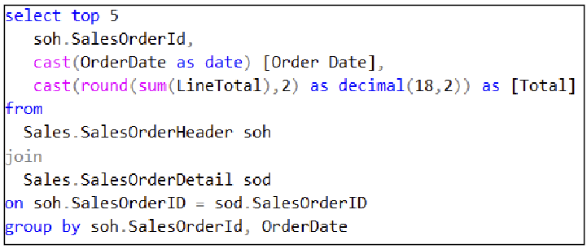
Figure 7- 8. A GROUP BY example that involves a JOIN operation.

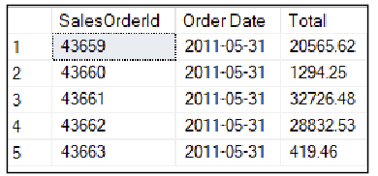
Figure 7- 9. The output of a more realistic example of how to do a grouping.
In Figure 7- 8, you see an example usage of the CAST() function. You use CAST() to change the data type of a column–assuming it is possible to do so. I have used CAST() to remove the third digit onwards from the Total column. It works by converting the data type of the sum of the LineTotal from numeric(38,6) to a decimal(18,2). decimal(18,2) allows up 16 digits in front of the decimal point and two digits after it (by setting the scale to 2). If you use SSMS’s Object Explorer to examine the SalesOrderDetail table, you will see that the LineTotal column’s type is a Numeric(38,6) column. SUM() applied to LineTotal will have the same data type.
You need the table join so that you can access both the date of the order (from Sales.SalesOrderHeader) and the line details (from Sales.SalesOrderDetail) of each order. The line details are what supply the columns giving the product id sold, the quantity sold, and so on.
The join operation does not influence how the grouping operation works. You might find it helpful to visualise all the script from “Sales.SalesOrderHeader” up until the “GROUP BY” as if you had replaced it with the name of a single table (call this imaginary table SalesData for instance).

7.5. A Way to Understand the List of Columns in the GROUP BY Clause

You will see that there are two columns listed in the GROUP BY clause in Figure 7- 8. The first column– soh.SalesOrderId–is there because you want to group all the rows with the same order id into an imaginary little box explicitly labelled for that order id. Then you want to apply the SUM function to the rows in each labelled “box” and display the result for each box.
Why is the OrderDate column in the GROUP BY clause? It has to be there. If you try to run the query and purposefully remove OrderDate from the GROUP BY clause, you will get the error in Figure 7- 10.

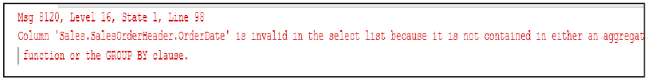
Figure 7- 10. The error message returned if you leave out the OrderDate column from the query in Figure 7- 8.

The SELECT list displays the sales order ID and the order date in the column list. Ask yourself, “what would happen if the same sales order id appeared on two different dates?”. “That’s impossible!” you cry.
You may know that you can’t have two order ID’s spread across two different dates, but SQL doesn’t know that. SQL needs to know what to do should it encounter the same order ID on two or more different dates. It needs to know that because you have asked it to display both the order ID and the date.
Which column must SQL group by first? The date or the order id? According to my query, if you had two different dates for the same order ID, SQL would display two totals for that ID, one for each date.
If that explanation needs a little time to settle down in your mind perhaps try this train of thought: You want to display people’s last names and first names ordered by their last names. What do you want to happen if several people have the same last name? Well, you would then order the first names within the same last name. Grouping data by columns has the same issue.
Sometimes you find yourself in a situation where you want to display several columns amongst those that you want to aggregate. All the none-aggregated columns must be listed in the GROUP BY clause in case any of them has a repeating value as explained above. If you know for sure that some of those columns will not repeat in value, you can simply tack them onto the end of the GROUP BY list in any order. These columns are referred to as trailing columns in the group by clause. If you want to be as scientific about it as you can: order the trailing columns from left to right ordering them from the most likely to have a repeating value to the least likely.

Useful Tip: How to Deal With Many Displayed (none-Aggregated) Columns in a GROUP BY Clause

You should hedge your bets when considering the ordering of the seemingly “unwanted” columns in the GROUP BY CLAUSE. In the future, there may be repeated values amongst those remaining columns even if today it seems a logical impossibility. Apply a strategy by listing the remaining columns in the order of the one whose contents is most likely to repeat–even if you have to stretch your imagination to work out which one–to the column whose content is least likely to repeat.

This approach will produce the most meaningful possible sub-groupings should they occur. If you are 100% certain a column’s value will never repeat within a group, tack them onto the end of the GROUP BY clause in random order (that last piece of advice is “off the record” as they say).

7.6. Popular Aggregation Functions

Here is a list of aggregation functions that you will see fairly often:

Function: | Purpose:
Avg(column name) | This function averages the numeric values in a column.  A NULL value in the averaged column does not increase the count of the number of rows.  If SQL finds the value of 0 in a row, this value’s occurrence does increase the row count as one would expect.  The average of a NULL filled column is NULL.  See Chapter 8: Subtleties of Aggregations.
Count(column name) | Count the number of rows in a table but ignore the rows where there is a NULL in the given column’s value.
Count(*) | Count the number of rows in a table.  Any NULL values anywhere in the table do not affect the outcome.
Count (DISTINCT column name) | Count the number of rows in a table but ignore duplicate values in the given column. A duplicated value counts as 1.
Count_big  (all the syntaxes variations as for count) | Used as a replacement to COUNT. COUNT can return an answer whose value ranges up to about 2,000,000,000 (2-thousand-million).  If you need to count up to about 9,000,000,000,000,000,000 (9 million-million-million) rows use COUNT_BIG instead.  You would use COUNT_BIG on the huge tables you are more likely to find in a data warehouse.
Max(column name) | MAX() finds the highest value in a column.  The column can be alphanumeric, a date, time or any numerical type.
Min(column name) | MIN() finds the lowest value in a column.  The column can be alphanumeric, a date, time or any numerical type.
StdDev(column name) | This function calculates the standard deviation measured over the given numeric column’s content. SQL adjusts the result for you assuming you used a subset of a population’s data–a sample of the data.
StdDevP(column name) | This function calculates the standard deviation measured over the given numeric column’s content. SQL calculates the result assuming you have an entire population’s data.
Sum(column name) | SUM calculates the total of the values contained in a numeric column.  NULLs are treated as 0’s unless the entire column contains NULLs in which case the answer returned is NULL.
Table 7- 1. A table of popular aggregations functions. There are others available, but they tend to be very technical and too specialised to list here.

7.7. Trying The Aggregation Functions

Let’s look at a few examples of how to use the aggregate functions.
I want to know how many rows there are in Sales.SalesOrderDetail table:

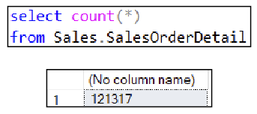
Figure 7- 11. How to count the number of rows in the Sales.SalesOrderDetail table.
You would like to know how many different products you have sold in the year 2013 (Figure 7- 12):

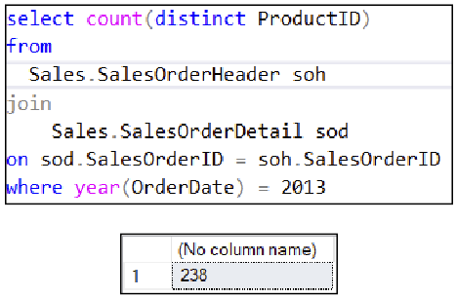
Figure 7- 12. Counting the number of different products Adventure Works sold in 2013.
You want to know what the average value of an order in May 2014 was. You want to see an indicator to show how meaningful the returned average is:
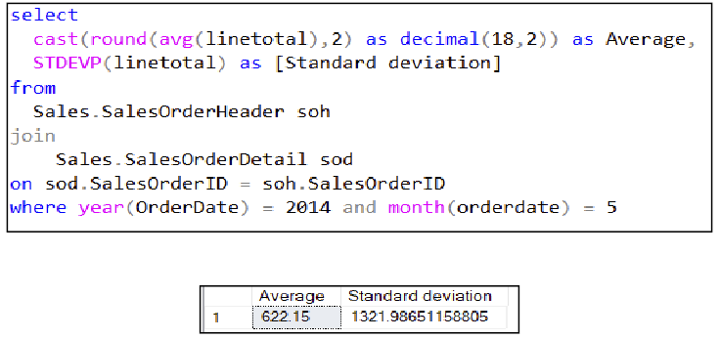
Figure 7- 13. A script to calculate the average value of an order in May 2014. The standard deviation shows the spread of the about the average (the mean).
That standard deviation is very far away from 0. That reveals that displayed average is a meaningless number. There are too many outliers away from the average for the average to be meaningful.
I hope that gives you food for thought when you see an average in the future. Averages without a quoted standard deviation are usually as meaningless a statistic as a percentage someone has quoted without showing the numbers used to calculate it.
What the very high value of the standard deviation is telling you is that if you picked up an order at random during May 2014, the chance of its value being near the calculated average is remarkably slim indeed. That shouldn’t surprise you given the range of prices of items that Adventure Works offers.

7.8. Putting A Condition on The Grouping’s Output by Using the HAVING Clause

You might want to display the results of a grouping whose value meets a criterion. You can choose which grouped results you want to display using the HAVING clause.
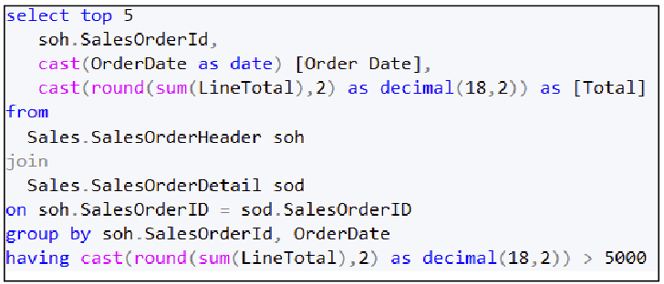
Figure 7- 14. This figure shows you how to filter rows after SQL has grouped the data using the HAVING clause.
In Figure 7- 8, I showed you a query that displayed the total value of the first five sales orders. But what if you wanted to see the first five sales orders that have a value of over $5000? Figure 7- 14 shows you a script that will do that for you. It uses the HAVING clause after the GROUP BY clause.
SQL applied the HAVING condition to the rows once it has grouped them. HAVING is different from the WHERE clause, which filters the rows that go into the grouping operation, not those that come out of the grouping operation.
HAVING cannot use column aliases (remember, only the ORDER BY clause can use column aliases, see section 5.4). That is why you have to repeat the entire “CAST(ROUND(…” in the HAVING clauses condition.
Despite the repeated definition of the Total column in the HAVING clause, SQL does not repeat the calculation involved. SELECT’s syntax requires its repetition, but SQL evaluates the expression once and reuses the result twice; once in the column list and again in the HAVING clause.
You can use cut and paste to duplicate the definition of Total, but be sure to reproduce edits of the Total column in the HAVING clause or the output of your results may be very unexpected indeed, without SQL reporting an error, of course.

Exercise 7. Grouping Data

You will now use grouping to obtain subtotals from the Adventure Works data. Add a new query to your “My Class Queries” project and name it “Grouping Data”. Put a descriptive comment at the top of the script and follow it with a suitable USE clause that accesses the AdventureWorks2017 database.

Ex 7.1. Creating A Suitable Query

At the end of exercise 7.3, you will display the following details: the total quantity of each product sold within a category name and the subcategory name to which it belongs.
This exercise will build a query to which you will add grouping.
You might find copying the answer to the previous exercise helpful (Exercise 6.3). You can start by writing a fresh query instead.
Begin by writing down the names of the tables you will need. Find the tables by identifying which ones contain the columns you need. Use a database diagram or the Object Explorer if you haven’t memorised the names of the tables yet.
Include tables in the list that you need to use, even if you don’t need to display columns from them. Note down the relevant column names from the tables if you feel that adds clarity:

Write a query that displays the required columns–the category name, the subcategory name, and the quantity sold–and include the sales order ID and product name columns for each sale in the output table. Satisfy yourself that your query does what you want and check that you are happy with the results. I get 121 317 rows.

Ex 7.2. Removing Unwanted Columns

Remove the columns of data you don’t want to see in the final result. That would be the order ID and the product’s name. Those two columns helped you validate that you were extracting the data you needed in exercise 7.1. They will not appear in the final results.

Ex 7.3. Writing the Grouping

For reference's sake, make a copy of your query and proceed by editing the copy.
Modify your copied query so that it displays the total quantity sold within each subcategory within each category. You will need the ORDER BY clause to make sense of the output. Why?
If you aren’t sure why you need the ORDER BY, run the query without it and study the output. It will be technically correct but hard to follow.
You should get 35 rows.

Ex 7.4. Applying A Condition to Find Poorly Performing Categories

Edit your query so that it shows those categories and subcategories where the quantity sold is less than 1000 units. The result should contain four rows.

Subtleties of Aggregations

The aggregation functions have useful abilities that are worth highlighting. Some unusual use cases for aggregation functions are listed here together with some additional functions that you will very likely find helpful.
In this chapter, you will see:
- Using MAX() and MIN() on dates and alphanumeric data
- How NULL affects averages
- Variations of the COUNT() function.

Uses for MAX and MIN

MAX() and MIN() are usable on dates and alphanumeric fields. Let’s use that knowledge to find the first and last date of trade for Adventure Works (Figure 8- 1):
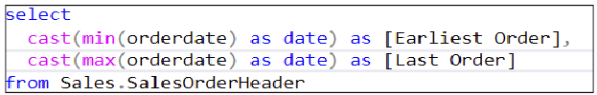
Figure 8- 1. Using MIN() and MAX() to find the earliest and last dates that Adventure Works processed an order.

The CAST function discussed thoroughly in chapter 9, removes the time component from the date.
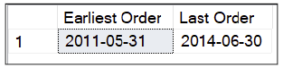
Figure 8- 2. The results of the script in Figure 8- 1.
Let’s find the first and last products by their name.

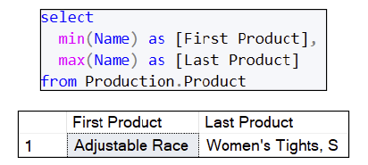
Figure 8- 3. The first and last product sold by Adventure Works by name.

The Affect of NULL on Averages

Let’s examine how NULL affects the AVG() aggregation function. You are going to create a scenario where you are going to record the marks from a test given to a set of students. The script in Figure 8- 4 will create a table to contain the student’s names and test results.
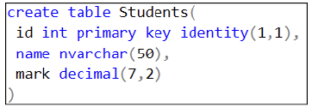
Figure 8- 4. A script to generate a table to illustrate the effect of NULLs on the AVG() function.
Now you want to load some students and marks into the table. Inserting data is covered in detail in Chapter 15.
Figure 8- 5. A command to insert three rows into the Student’s table. The mark they achieved for the test is next to their names.

Figure 8- 6. A query that displays the average mark across all the rows in the Students table.

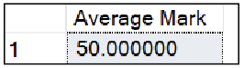
Figure 8- 7. The average mark for the class.

SQL calculated 50 by adding 90 + 60 + 0 and then dividing by 3. Peter was ill and did not write the test, which is why he received 0 as a mark. That has consequences to the class average.
A day-or-two later, Peter hands in a sick note. Now you don’t want his mark to affect the average anymore. To show this, you replace the 0 with NULL.:
Figure 8- 8. This script contains an update statement that will replace Peter’s mark with NULL.

Let’s recalculate the average using Figure 8- 6:

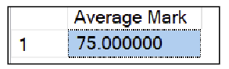
Figure 8- 9. The amended class average, given that Peter’s mark is NULL rather than 0.
SQL calculated 75 by taking 90 + 60 and dividing by 2. A NULL value encountered during an average aggregation causes SQL to ignore that row and not count it.

Variations of COUNT

Let’s look at the three versions of count that may intrigue you (Figure 8- 10).
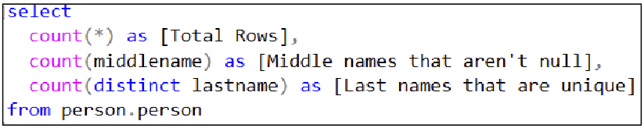
Figure 8- 10. This script shows three variations of the COUNT function.
Figure 8- 10 yields the results in Figure 8- 11.

Figure 8- 11. The result of applying three forms of the COUNT() function the Person.Person table.
In Figure 8- 11 you can see that if you name a column in the COUNT function’s parenthesis, SQL counts all the rows in the table that do not have null values in that column hence there being 11 473 middle names.
If you use the DISTINCT keyword in the parenthesis, the machine counts repeated values in a given column as a single entry; hence the result shows there are 1206 last names.

The Exercise

The exercise is a short one when expressed in words, but perhaps a little trickier to work out when it comes to writing the SQL.
The answers are in Appendix F.
You can get the complete Solution with my answers from my website:
https://www.Transference-UnLimited.com

Exercise 8. Subtleties of Aggregations

Add a new query to your “My Class Queries” project and name it “Subtleties of Aggregation”.
Put a descriptive comment at the top of the script and follow it with a suitable use clause that accesses the AdventureWorks2017 database.

Ex 8.1. Working Out Which Country Has The Highest Sales Tax

Use the Sales.SalesTaxRate table to display the tax rates and the names of the corresponding countries. You want to see the countries that have the highest and lowest tax rates.
Please solve this exercise with a single SELECT statement.

Conversion Functions

In this chapter, you are going to meet the functions that convert one data type to another. Data type conversion is a technique you will frequently use to reformat your data.

In this chapter, you will see how to:
- Use CAST() to change a data type
- Use CONVERT() change a data type and to apply a style to reformat a date
- Remove unwanted digits after a decimal point
- Use SYSDATETIME() versus GETDATE()
- Use COALESCE() on sparse tables
- Swap NULL with an alternative value and vice versa on the fly

The CAST() Function

CAST() is one of two functions that you can to change a column or variables data type to another type. The other popular type conversion function is CONVERT(). This function is almost identical to CAST, but it has a different syntax. You can regard the functionality of CAST() and CONVERT() as identical until I discuss the differences in section 9.2; whatever I tell you about CAST(), CONVERT() can do the same.

You can use CAST() to convert an integer to a decimal type to ensure you don’t lose digits after the decimal point in a larger calculation. You can convert a character string such as nvarchar(50) to nvarchar(20) which will keep the first 20 characters in the string. Using CAST() is one way to extract the first 20 characters from a string, although for the sake of aesthetics and clarity I would suggest you use the LEFT function instead. You can change a date type to a character type to convert the date to chosen character format, although CONVERT() has a little more flexibility for manipulating dates.

CAST() has the syntax I’ve shown in Figure 9- 1:

CAST (col or variable AS newType)
Figure 9- 1. The syntax of CAST()
In use, CAST() has a straightforward, easy to read syntax. Figure 9- 2 shows an example of how to convert a number into a character string. If you change a numeric type to a character type, you can append symbols to either end of the newly created string, which can be very handy for formatting a number as you please.

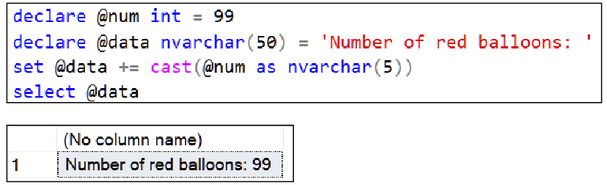
Figure 9- 2. This example shows how you can use CAST() to concatenate characters and a number together to form a new string. You can see the result at the bottom of the figure.
Figure 9- 2 converts the integer (99) into a 5 character long character string. 5 characters was an arbitrary choice that I made. Perhaps you would like to try converting it to nvarchar(1) to see what happens? Once SQL “sees” the integer 99 as the pair of symbols ‘9’ and ‘9’, you can concatenate addition text onto it.

You might be intrigued by the ‘+=’ symbol. “SET @data += CAST(@num AS nvarchar(5))” is the shorter equivalent of writing “SET @data = @data + CAST(@num AS nvarchar(5))”.

You could use columns from a table instead of variables to achieve the same end. For example: if you read through Figure 9- 3, you will see how to use the CAST function to manipulate a column.

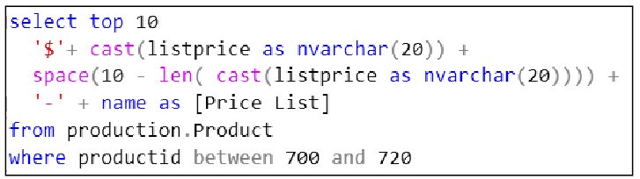
Figure 9- 3. You can use CAST in SELECT’s column list. This query aligns the product’s name so that it is ten characters away from the ‘$’ sign.
The script in Figure 9- 3 uses the SPACE() and LEN() function. The SPACE(n) function returns n x space characters, so SPACE(5) returns ‘ ‘ (5 spaces). The LEN() function calculates the number of characters in a string. LEN(‘hello’) returns 5.

“CAST(listprice as NVARCHAR(20))” takes a numeric list price and converts it into a string. The NVARCHAR makes sure the resultant character string has as many characters as there are digits in the number. For example, the list price of 500.86 after the cast operation would give a 6 character string containing ‘500.86’. The choice of 20 used in the NVARCHAR is an arbitrary one.

By subtracting the length of this string from 10, I can work out how many spaces to use to place the prefix ‘-‘ a constant distance from the end of the list price. The result is in Figure 9- 4.
The results grid uses a variable width front which is why the vertical column of ‘-‘ symbols don’t align perfectly under each other. If you rerun the query using text output mode (press ctrl+t) the ‘-‘ symbols will align one under the other (press ctrl+g to return to grid output mode). Figure 9- 5 shows the result in text mode.
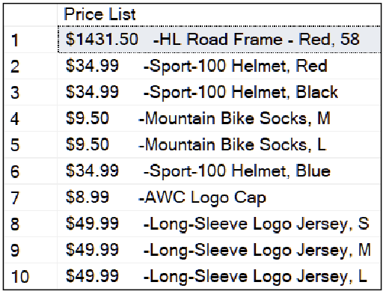
Figure 9- 4. The output from the query in Figure 9- 3. You might want to try this using SSMS’s text output mode to see the ‘-‘ symbols aligned under one another perfectly.

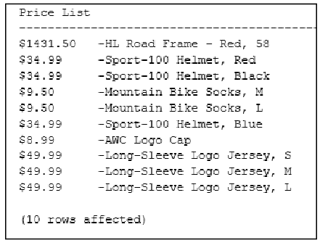
Figure 9- 5. The output of Figure 9- 3 using a monospaced typeface. By inserting a variable number of spaces after the price, you create a pleasing visual effect.

The CONVERT() Function

The CAST() function has a close relative called CONVERT(). CONVERT() has a different syntax to CAST(), which you may prefer. The most prominent difference is that it can perform a limited set of date formatting. CONVERT() reformats dates using a style parameter which CAST() lacks.
The syntax of CONVERT() is in Figure 9- 6.

CONVERT(newtype, column or variable, optional style number)
Figure 9- 6. The general syntax of CONVERT().
Figure 9- 7 shows an example of how to use CONVERT() to reformat 12.55555 as a two-digit number.
Figure 9- 7. An example of CONVERT() ‘s syntax.
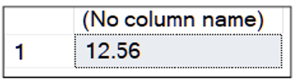
Figure 9- 8. The output of the type conversion done in Figure 9- 7.
In Figure 9- 9, you can see how to use CONVERT’s third parameter, the style, to change the format of the date.

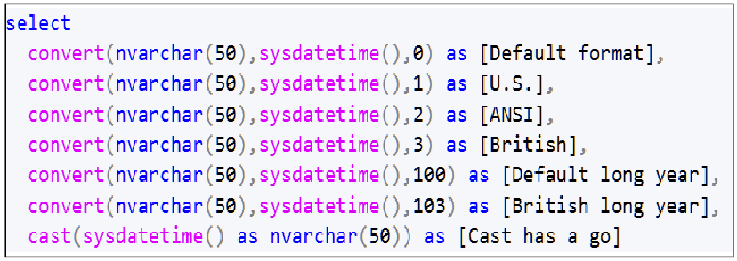
Figure 9- 9. This SELECT statement shows how to use CONVERT()’s style parameter to reformat dates. You can use GETDATE() rather than SYSDATETIME() if you like.
The SELECT statement in Figure 9- 9 produces the output in Figure 9- 10. The last column shows you what happens if you ask CAST() to convert the date. CAST() does not have a style parameter.

Figure 9- 10. This output shows some of the formattings that CONVERT() can do to a date. The last column shows how CAST() converts a date to a character string.
The third parameter in CONVERTS()’s parenthesis specifies the style of the date that you want. The style is a numeric parameter. You can find out what style numbers match which formats here https://docs.microsoft.com/sql/t-sql/functions/cast-and-convert-transact-sql.

I have used a few of the available styles in the example above. I have given their readable names to you as column aliases. The last column allows you to compare CONVERT to CAST reduces the date down to how you usually see it in a column.

Removing Unwanted Digits From a Decimal Number

In section Chapter 7 (Grouping Data), I touched on how to use the CAST function as a way to remove excess digits in a decimal number. Removing unwanted digits is a popular requirement in SQL, and so I am reproducing how to do that here.

You remove the excess digits after the decimal point by casting the original data type to one that has a smaller scale.
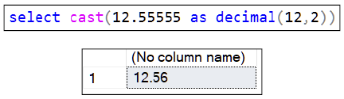
Figure 9- 11. An explicit type cast used to remove unwanted digits.
You can use CONVERT() if you prefer, to do the same task.

Automatic Type Conversions

Sometimes SQL will convert a character string into a number for you implicitly. You can see this happening in Figure 9- 12. You can rely on that implicit ability with caution. You may forget that you are using numbers expressed as character symbols in a given column and one day accidentally put a letter of the alphabet into one the rows. A client or query expecting only numeric data may then crash. Automatic type conversion isn’t always a good thing.

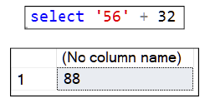

Figure 9- 12. An implicit cast showing how SQL assumes you meant the symbols ‘5’ and ‘6’ to be interpreted as the number 56. If you put a letter amongst the numeric symbols, you will get an error as you can see in Figure 9- 13.
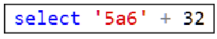

Figure 9- 13. A failed attempt at an implicit type conversion.

These errors occur in the real world over time: someone told the original table’s designer that there would be characters and digits in a given column, so they chose a character type. As time went by, it turned out that only numbers were stored. Tables added much later to the database switched to storing the same data in numeric columns. SQL tries to help out by automatically converting the character data type to a numeric type when you, for example, join the columns using the ON clause. This implicit conversion works fine until someone unthinkingly puts a character into the character typed column.

SYSDATETIME() Versus GETDATE()

SYSDATETIME() returns DateTime2 and GETDATE() returns DateTime. DateTime2 is the more recently added data type. GETDATE() is the original T-SQL function to retrieve the server’s date and time. SYSDATETIME is its more accurate replacement.

SYSDATETIME() gives seconds to 7 digits of resolution after the decimal point. GETDATE() is accurate to 0.001 of a second. You can decide which one of the two you want to use. Unless you need that level of accuracy in the seconds' portion, it makes no difference which one you use. SQL will implicitly convert the two data types as necessary. However, if you convert DateTime2 to DateTime and vice versa, bear in mind that you will lose the extra digits in the seconds part, should that trouble you.

Converting NULL to Another Value

You might find it helpful to revise section 8.2, which discusses how NULL can affect aggregation functions.
You may want to tentatively replace any NULLs in a column with a different value and vice versa. I am going to show you how to do this.

ISNULL()

ISNULL() lets you replace NULL with another value. Its syntax is in Figure 9- 14.

ISNULL(column containing null, replacement value)
Figure 9- 14. The syntax of ISNULL().
You can see a simple demonstration of using it in Figure 9- 15. In the demonstration, ISNULL() replaces the NULL stored in @value with a 0.

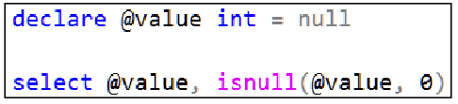
Figure 9- 15. An example that highlights how ISNULL() works.
Which produces Figure 9- 16.
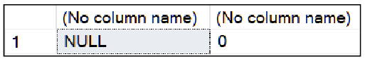
Figure 9- 16. The result of ISNULL swapping the NULL for a 0.

ISNULL() is convenient to use if you want to replace NULL in a column used by an aggregation function. You could do that by following the style used in this example: AVG(ISNULL(data column, 0) as opposed to using AVG(data column). You might want to experiment with ISNULL() by revisiting the example in 8.2.

COALESCE()

The COALESCE() function helps deal with sparsely populated tables. Sparsely populated tables are those that have groups of columns where only one–or very few–of those columns have a value per row. Refer to section 1.15 on many-to-many relationships to see a way to avoid creating sparse tables.

COALESCE’s syntax is in Figure 9- 17:

COALESCE(col 1, col 2, col 3, ..., col n)
Figure 9- 17. The syntax of COALESCE.
COALESCE returns the first non-null valued column in the list of columns passed to it as parameters. The column list can be as long as you want.

Let’s say you have a sparse table like the one in Figure 9- 18.

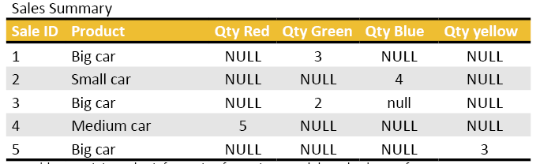
Figure 9- 18. A sparse table containing sales information for various models and colours of cars. I have distributed the quantity of sales of the different colours across multiple columns.
Your goal is to display the total quantity of sales of all the cars. You want a single result, not four totals representing each colour. You could write a suitable query as in Figure 9- 19.

select sum(coalesce([qty red], [qty green], [qty blue], [qty yellow]) FROM [Sales Summary]
Figure 9- 19. How to use COALESCE() to combine the sparsely populated columns in Figure 9- 18.
The query will give you a total of 17.
Of course, you could write:
select sum([qty red]+[qty green],+[qty blue]+[qty yellow]) FROM [Sales Summary]
Figure 9- 20. Using SUM() as another way to achieve the goal of wanting a grand total of all car sales.
You would definitely use SUM() if you had more than one non-zero value per row. If you use COALESCE() rather than SUM(), SQL returns the first none-NULL column’s value and ignores any other columns in its parameter list.

NULLIF() to Insert NULLS on the Fly

Turning a known value into NULL is the purpose of the NULLIF() function.

NULLIF() takes two values as parameters. If the parameters are equal, NULLIF returns NULL. If not, it returns the first parameter’s value. The syntax is in Figure 9- 21.

NULLIF(first column or variable to compare, second column or variable to compare)
Figure 9- 21. The syntax of NULLIF(). If the parameters have equal value, NULLIF returns NULL; otherwise, it returns the first parameter’s value.
If you to the demonstration in section 8.2 in the previous chapter, you will see that Peter initially scored a test mark of 0.

If you had 0 recorded for Peter’s mark in the Students table and you yearned to see the class average as if he scored NULL instead, you can use the query in Figure 9- 22.

Figure 9- 22. A SELECT statement that converts a mark of 0 to NULL before using it to calculate the average.

The query reveals the class average to be 75 (Figure 9- 23) versus 50.

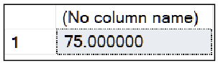
Figure 9- 23. The class average given that you have replaced Peter’s mark of 0 with NULL.

The Exercise

A gentle set of questions to get you used to the syntax of CAST() or CONVERT() with a little bit of NULL thrown in for good measure.
The answers are in Appendix F.
You can download my SSMS Solution via my website at https://www.transference-unlimited.com.

Exercise 9. Conversion Functions

Now is your opportunity to get to know more about type conversions and their related functions.
Add a new query to your “My Class Queries” project and name it “Conversion Functions”.
Put a descriptive comment at the top of the script and follow it with a suitable use clause that accesses the AdventureWorks2017 database.

9.1. Displaying People’s Names

Write a SELECT statement that displays three columns: the first name, the middle name and the last name of the first 20 people in the Person.Person table.
When you are happy with your query, add a column which contains the concatenation of the first name, and last name. Call the new column Name. Remember to put spaces between the parts of the name. Try your query to check that it works.
Now add people’s middle name into the new column you have just added. Run the query now. What happened?
What you are seeing is what happens if you concatenate NULL (unknown) onto a string of characters. The result is itself unknown, so whenever you have a middle name that is NULL, the result is NULL.
Fix the query so that the new column displays correctly. Be sure that if someone doesn’t have a middle name, you don’t have two adjacent spaces in the output.

9.2. Price List

You have been asked to create a price list that looks like this:
Product1 - $3.88
Product2 - $49.99
Product3 - $100.34

This output is a single column so it can be easily copied and pasted into a document.
Write a query that generates the price list as formatted above. Don’t include items that have a price of $0.00.
View the output by putting SSMS’s into text mode. Do this by pressing ctrl+t. If you view the output in grid mode, the variable width font used in the grid will distort the gap between the name and the price.
Once you have finished the exercise, push ctrl+g to put SSMS back into grid mode.

Subqueries and Common Table Expressions (CTEs)

You can use subqueries to break a complex query into two or more smaller queries. The smaller queries become components that modularise a complex query into easier to understand parts.

You can use subqueries as an alternative to writing a JOIN or a HAVING clause. You might find that writing a query in this way makes it easier to read and understand.
There are two forms for writing a subquery: nested and correlated.

The Nested/Non-correlated Subquery

The structure of a nested (or non-correlated) query works like this: you have an inner query–the nested query–whose output feeds results into an outer query. The inner query executes entirely as a single unit. It provides a subset of the data to the outer query.

You place the inner query in the outer query’s FROM clause. In other words, you put the inner query where you would ordinarily have put a table’s name. The inner query, after all, returns a table.

You have to give a table alias name to the inner query so that the outer query can refer to it. An example of such a query is in Figure 10- 1.

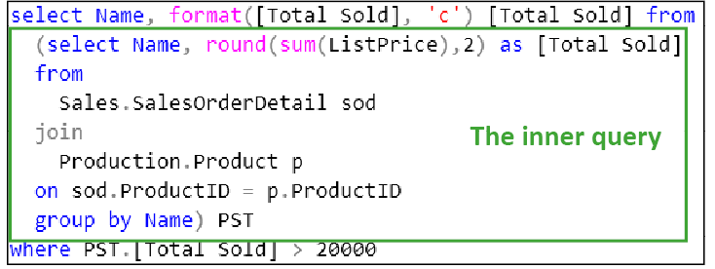
Figure 10- 1. An example of a nested query. You place the inner query (shown in the green box) inside the outer query. The position of the inner query is where you would usually put the name of a table.
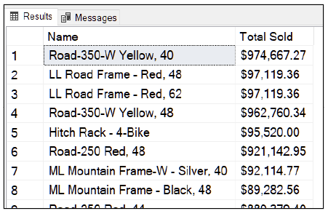
Figure 10- 2. The output of the nested query. It shows those products of which Adventure Works have sold more than 20,000. This query mimics a HAVING clause.
Let’s break the query (Figure 10- 1) into its components. The inner query (in the green box) supplies data to the outer query. The inner query totals the amount of each product that Adventure Works has sold. You can run the inner query as is; you can type the contents of the inner query into SSMS, and it will execute.
The outer query formats the data from the inner query by taking the product names and totals from the inner query and reformats the totals using the currency symbol of the local server. It does this by using SQL’s FORMAT() function using ‘c’ (currency) as the format specifier. The outer query has a WHERE clause that only displays the rows where the total sales of a product exceeds $20,000.
The query in does the equivalent of a HAVING clause. Many people consider the script in Figure 10- 1 to be easier to understand than a HAVING clause with a JOIN. Internally, SQL converts the nested query into an INNER JOIN even though you have written a nested query. You must decide for yourself if you feel the query is easier to read and understand than the equivalent single query that would combine a JOIN, GROUP BY and HAVING.

An essential characteristic of a non-correlated query–or nested query for short–is that the inner query can run on its own. You can take the SELECT statement that is the inner query and run it as is.

Now is possibly a good time to take a break and grab a strong cup of coffee before going onto the next section.

The Correlated Subquery

When you are dealing with a correlated subquery, you actually have two queries that at first appear to be a single query until you study it more carefully. The two queries run simultaneously. However, there is a dependency between the two queries which operates like this:
- The first query retrieves a row and then supplies that row to the second query
- The second query executes based on the contents of the row from the first query
- The first query retrieves a result from the second query and then decides if it will output a row based on the second query’s response
- The first query fetches another row of data and then steps 2-4 repeat until there are no more rows left for the first query to send to the second query.
Another way to put it is that the first query decides if the second query will display each row that the first query retrieves. The second query effectively considers each row from the first query one row at a time.

A Bizarre and Memorable Analogy

Aphids–a tiny insect usually found sucking the life out of your rose bushes–suck nectar from the stalks of plants. They collect it in their now swollen bulbous bodies. Ants keep aphids as if they were cows. They round up the aphids and stroke them with their antennae. The stroking causes the aphids involuntarily to release a drop of nectar which the ant drinks; the ants milk the aphids. Another ant comes along and then strokes the aphid some more until eventually, all the ants are satisfied.

Think of the ant as the first query and the aphid as the second query. The ant strokes the aphid–the first query feeds a row to the inner query–the aphid releases a sweet globule of nectar–the second query executes and returns data with the help of the row fed into it by the first query. The ant drinks the nectar–the first query takes the data from the second query. Another ant comes along and strokes the same aphid–the first query gives a different row to the second query–until there are no ants left. And everyone is happy.

Now you’ll remember how correlated subqueries work for the rest of your life.


Figure 10- 3. Hmm. Yummy! Aphid juice. And you thought I was kidding.

In Figure 10- 4, the first query retrieves a row of order detail information joined with the matching row from the product table. The first query then feeds the product id into the second query (it is in the WHERE clause). The second query then looks up the average value of sales for that product. The first query then compares the line total of the currently retrieved order to the average value of sales of that product as supplied by the second query.

If the row from the first query has a value that exceeds the average value of a sale of the same product, the first query displays the row.

The overall result: the query displays an order id, a products name and the value of the sale of that product if, for that product’s order, the line total exceeds the average value of sales of that product.

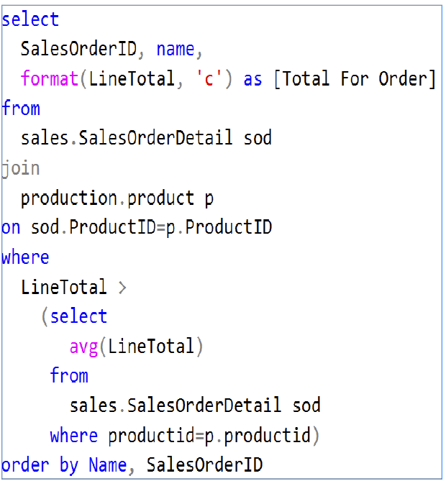
Figure 10- 4. A correlated subquery.

Useful TIP for Writing Correlated Subqueries

It is easier to write a correlated subquery by writing the second query first. Test the second query by replacing the columns that it will eventually refer to from the first query with literal values.
For example: to work out the query in Figure 10- 4, I began by starting with: SELECT AVG(LineTotal) FROM Sales.SalesorderDetail sod where productid=768 as an example.
Once I had checked that this second query returns the information I needed the first query to use, I replaced the literal value in the second query with the column(s) that supply the same data from the first query. I then built the outer query around the inner query.

With practice, nested queries and correlated subqueries can become startlingly intuitive to read compared to writing joins. If you are finding them tricky to understand at the moment, be patient with yourself and persist with them. They are worth the effort.

The Common Table Expression (CTE)

A common table expression allows you to structure nested subqueries into an easier to read layered format. You cannot write a correlated subquery with a CTE. Common Table expressions appeared for the first time in MS SQL in 2005.

Benefits of using a CTE

The CTE’s structure offers four benefits over nested subquery’s structure:

- It allows you to make a clear distinction between the inner subquery and the outer query. It does this by requiring you to specify the subquery first and the outer query second, one underneath the other.
- It allows you to give the subquery a meaningful, clear name that describes its purpose
- It has an easy to read syntax that allows you to rename the columns that the subquery produces. You can use the standard AS keyword to demarcate the column aliases if you prefer.
- It makes it easy for you to package multiple subqueries into a structure which SQL expresses as a single query.
You can have multiple subqueries using a CTE or otherwise. There is no reason why the outermost query can’t trigger a subquery which triggers a subquery which triggers a… and so on. You can do the same without using a CTE; however, using a CTE makes the query much easier to read. I will show you such a CTE in Chapter 11, but for now, I will start with a single subquery.

The Syntax of a CTE

The CTE starts with the keyword WITH. The word WITH implies that you are going to run the outer query using the subquery(ies) that follow WITH.

You follow WITH by the name you choose to give to the subquery. You can follow the name with an optional parenthesis enclosed list of column aliases for each of the columns the subquery produces. You can, If you prefer, put the aliases into the subquery’s column list using AS as usual.

After the subquery, you can write another, or you can write the final outer query. You write each additional subquery after the previous one by putting it inside parentheses. You must separate each subquery and the enclosing parentheses with a comma.

If you are familiar with SQL views, you might like to think of the subqueries as temporary, short-lived views. Once the entire CTE has executed to completion, the “views” effectively self-destruct and disappear.

You cannot access a subquery defined in your CTE in a different query. The CTE acts as a self-contained unit. You would have to repeat the subquery’s definition in each query that needs it.

Figure 10-1 produces the same output as you saw in Figure 10- 1.
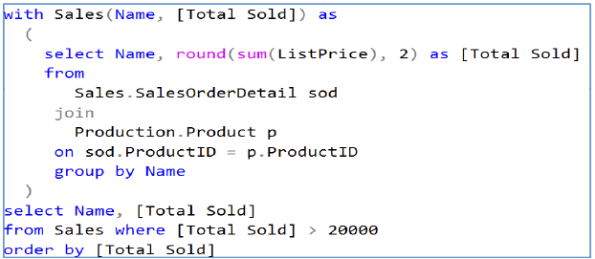
Figure 10- 5. The query in Figure 10- 1 rewritten as a CTE. The CTE separates the subquery from the query that uses it. You cannot write a correlated subquery using a CTE.

The Exercise

The exercise will take you step-by-step through the process of building a CTE.
Don’t forget the answers, should you need to refer to them for tips and help, are in Appendix F.
You can download my Solution that contains all the answers from
https://www.Transference-UnLimited.com.

Exercise 10. Subqueries and CTE’s

Add a new query to your “My Class Queries” project and name it “Subqueries and CTE’s”. Put a descriptive comment at the top of the script and follow it with a suitable USE clause that accesses the AdventureWorks2017 database.

Ex 10.1. Sales of Road Bikes with 58” Frames

Write a query that displays all the sales order id’s in which Adventure Works have sold a product named the “Road-450 Red, 58”. Take the approach that you don’t know the product id of “Road-450 Red, 58” neither do you want to know the product’s id.

To put the requirement slightly differently: embed a query into the query of the sales orders that looks up the required product id for the red bike. Note: don’t use an explicit join and this exercise doesn’t require a CTE at this point.

You should get 226 rows.

Ex 10.2. Display the Average Price of Items Per Subcategory

Create a CTE using the above query that displays the average price of an item in each subcategory.

Ex 10.3. Show the Prices Formatted using the EN-ZA Culture

Use the FORMAT() function to display the prices using the EN-ZA culture (South African English). Don’t worry about converting the currency exchange rate from $ to ZAR unless you want to.

You can find more about the FORMAT() function here:
https://docs.microsoft.com/sql/t-sql/functions/format-transact-sql?view=sql-server-ver15

Ex 10.4. Add Flexibility To Allow Varying Culture and Exchange Rates

Create a variable called Culture and a variable called ExchangeRate. You will have to work out the data types of the variables yourself.

Look up the language and country code of a country you find interesting on Wikipedia. Set the Culture to that value.

You can find country codes here: https://en.wikipedia.org/wiki/ISO_3166-1

You can find language codes here:https://en.wikipedia.org/wiki/List_of_ISO_639-1_codes

Google the exchange rate for that currency.

Set ExchangeRate to convert the Dollar price in the Production.Product to your chosen country’s rate.

Use these variables in your query in ex 10.3.

Try another country and exchange rate or two.

Data Partitioning Using OVER

Partition data using the OVER clause is useful when you want the query results to show both the subtotals from a grouping operation as well as the data that produces the subtotals. By contrast, If you write a query using GROUP BY, it displays the results of the aggregate functions alone.

Grouping data is a general concept; you don’t have to group data by using GROUP BY. You can group data by sorting it: if you sort people by their last names and then first names, you are grouping people by their last name then their first name without using the GROUP BY clause. Partition functions offer you another way to group your data.

With the OVER clause, the aggregated result displays as a repeated value in a new column added to the output table. This effect creates dedicated columns that display your subtotals.

The alternative to adding columns would be for SQL to insert spurious rows, containing subtotals, amongst the data rows in the output table. There are commands in T-SQL, such as ROLLUP and CUBE, that do just that. The difficulty with using them is that it is a cumbersome process to tell which rows contain subtotals and which rows contain real data. There are functions such as GROUPING() that allow you to determine which rows are data rows and which rows are synthetic and contain subtotals. For that reason, the ROLLUP and CUBE commands have fallen by the wayside. Please don’t use them, use the OVER clause instead. If you CUBE and ROLLUP, you can read more about them here: https://docs.microsoft.com/sql/t-sql/queries/select-group-by-transact-sql?view=sql-server-ver15.

I have studied courses that attempt to explain using OVER using an analogy of dividing the data into windows with panes and frames and whatnot. If you have tried to follow such a set of analogies before, I hope my approach is clearer and more helpful.

Partitioning Using Sample Data

Figure 11- 1 shows the sample data. Figure 11- 2 shows which rows will belong to which partitions using colours. Figure 11- 3 shows the rows re-ordered with an additional column showing the aggregated totals. The query involved partitioned the data by category name and calculated the total quantity of the products in each category. You use the same aggregation functions that you know already with minor modifications.

New functions have been added to SQL to make partitioning even more appealing and useful. I will show you them over the next few sections as they act as a friendly introduction to using data partitioning.

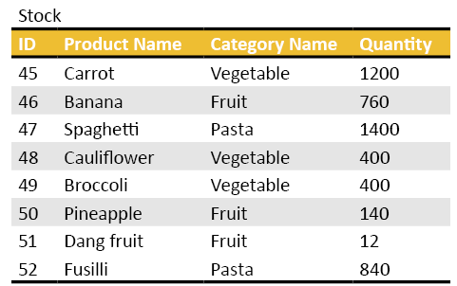
Figure 11- 1. The sample data which we are going to partition.

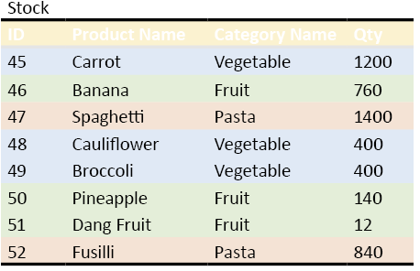
Figure 11- 2. The rows that will appear within each partition. The colours indicate one of three possible partitions a row can belong to based on the category name.

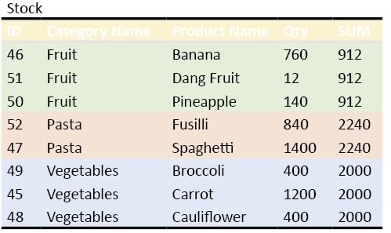
Figure 11- 3. The partitions with the final column indicating the result of the aggregation within that partition. The chosen aggregation function is SUM().

The OVER Clause

You will specify the partitioning you want using the OVER modifier. I refer to OVER as a modifier because you use it in the SELECT statement’s column list against one of the columns you want to display. OVER modifies the interpretation of the column telling SQL how to partition the rows using that column.
You can then ask SQL to order the data within the partition by either the same column or choose another. If my description is beginning to sound a bit abstract, I assure you, applying these concepts is straightforward.

Useful Functions that Come With Partitioning

When SQL 2005 introduced data partitioning capabilities into T-SQL, Microsoft added some useful new functions to supplement it. These new functions act as a handy tool to use to learn the basics of partitioning.

RANK()

RANK() allows you to rank the rows—label them as first, second, third, fourth, and so on—of a table based on a column’s content. For example, the query in Figure 11- 4 shows that you want to rank the products based on their list price. The DESC tells SQL to assign the rankings so that SQL ranks the highest valued product as 1.

RANK() implements a system called competition ranking (https://en.wikipedia.org/wiki/Ranking). To see what competition ranking is, look at the results in Figure 11- 5. Notice the five 1’s in the first five rows. The next different allocated rank is six because there are five rows ranked at number 1.

A few points to note:
The RANK() function has an OVER clause. OVER specifies what column to use to partition the data via the required ORDER BY.
The ORDER BY clause additionally tells SQL what values to rank as number 1. DESC shows SQL that you want the highest value in the given column ranked as 1. ASC (the default) does the opposite; SQL will rank the lowest value in the column as 1.
The ORDER BY clause is required. You cannot specify a column’s name on its own.

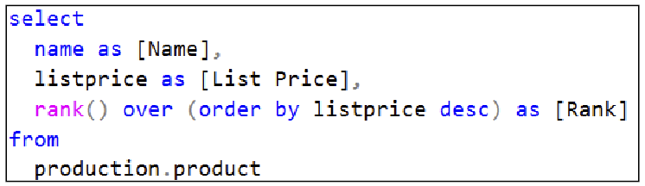
Figure 11- 4. Sample query showing a RANK() function

Name List Price Rank
----------------------------------- --------------- --------
Road-150 Red, 62 3578.27 1
Road-150 Red, 44 3578.27 1
Road-150 Red, 48 3578.27 1
Road-150 Red, 52 3578.27 1
Road-150 Red, 56 3578.27 1
Mountain-100 Silver, 38 3399.99 6
Mountain-100 Silver, 42 3399.99 6
Mountain-100 Silver, 44 3399.99 6
Mountain-100 Silver, 48 3399.99 6
Mountain-100 Black, 383374.99 10
Mountain-100 Black, 42 3374.99 10

Figure 11- 5. The results of the RANK() function.

DENSE_RANK()

This query in Figure 11- 6, is the same as that in Figure 11- 4 except I have substituted DENSE_RANK() for RANK(). This function counts out 1,2,2, 3… without skipping any numbers. This ranking is known as a dense ranking. This system of ranking is what most people intuitively regard as the way to rank data.

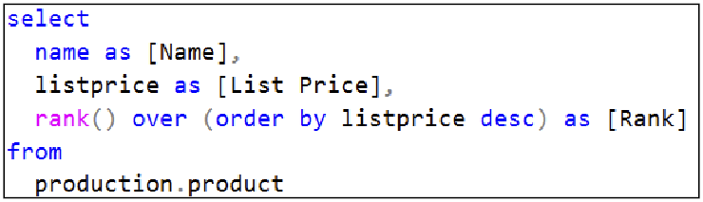
Figure 11- 6. The same query as Figure 11- 4 except it uses the DENSE_RANK() function rather than RANK().

Name List Price Rank
---------------------------------- ------------------ ---------
Road-150 Red, 62 3578.27 1
Road-150 Red, 44 3578.27 1
Road-150 Red, 48 3578.27 1
Road-150 Red, 52 3578.27 1
Road-150 Red, 56 3578.27 1
Mountain-100 Silver, 38 3399.99 2
Mountain-100 Silver, 42 3399.99 2
Mountain-100 Silver, 44 3399.99 2
Mountain-100 Silver, 48 3399.99 2
Mountain-100 Black, 38 3374.99 3
Mountain-100 Black, 42 3374.99 3
Mountain-100 Black, 44 3374.99 3
Mountain-100 Black, 48 3374.99 3
Road-250 Red, 44 2443.35 4
Road-250 Red, 48 2443.35 4
Road-250 Red, 52 2443.35 4

Figure 11- 7. The results of the DENSE_RANK() function.

ROW_NUMBER()

ROW_NUMBER() adds a column containing sequential numbers to a table. This function is useful if you need to choose specific row numbers using an IN clause, for example. It is convenient for labelling rows that are going to appear in a grid in a user interface. Figure 11- 8 shows you how to get a sequential row number, and Figure 11- 9 shows you the result.

Useful Hint: Do Not Use Identity Columns as Row Numbers

You cannot rely on an identity column’s value as a row number (your primary key column is often an identity column). The reason why identity columns don’t make good row numbers is that if you delete a row in a table, SQL will not reuse that identity value. Consequently, you will have gaps in the sequence of numbers in an identity column.

Useful Hint: Do Not Use Identity Columns as Row Numbers

If you want to select rows in a table by row number, take a look at the SELECT ... ORDER BY col1… OFFSET x ROWS FETCH NEXT y ROWS ONLY statement. This variation of the ORDER BY clause lets you specify a starting row number in a table and then retrieve a chosen number of rows. It does not need you to use the ROW_NUMBER) function. If this it appeals to you, you can find out more by going here: https://docs.microsoft.com/sql/t-sql/queries/select-order-by-clause-transact-sql

If you want to display a sequential row number as opposed to merely selecting a row by its row number, ROW_NUMBER() will generate a displayable row number for you.

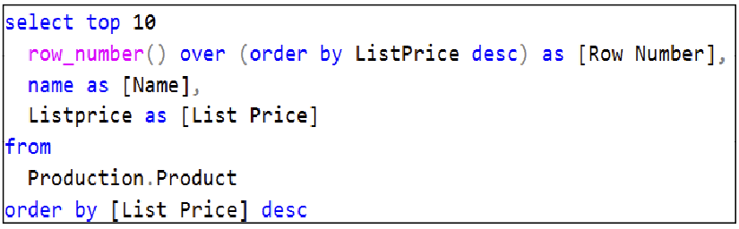
Figure 11- 8. An example of using ROW_NUMBER() to label each row sequentially.

Row Number Name List Price
------ ------------------------------------- ----------------
1 Road-150 Red, 62 3578.27
2 Road-150 Red, 44 3578.27
3 Road-150 Red, 48 3578.27
4 Road-150 Red, 52 3578.27
5 Road-150 Red, 56 3578.27
6 Mountain-100 Silver, 38 3399.99
7 Mountain-100 Silver, 42 3399.99
8 Mountain-100 Silver, 44 3399.99
9 Mountain-100 Silver, 48 3399.99
10 Mountain-100 Black, 38 3374.99
Figure 11- 9. The results of the ROW_NUMBER() query.
ROW_NUMBER() needs a column via the OVER clause so SQL can work out which row qualifies as row 1. In the example in Figure 11- 8, the highest value list price will be row number 1.

Let’s see how to use a combination of DENSE_RANK() and ROW_NUMBER() as per the query in Figure 11- 10. See if you can figure out what is happening using the result in Figure 11- 11 before reading the explanation.

This example introduces the PARTITION BY subclause. When you use PARTITION BY you are explicitly naming the column you want to use to partition the data. Without the PARTITION BY subclause, SQL partitions the data using the column in the ORDER BY subclause.

Using PARTITION BY, you can partition the data by a column’s content, then order the rows within that partition by a chosen column. In the example (Figure 11- 10), the column “ROW_NUMBER() OVER (PARTITION BY psc.ProducttSubCategoryID ORDER BY ListPrice DESC)” assigns a row number that starts at one for every subcategory. The highest list price within a subcategory will be row number 1.

For the “DENSE_RANK() OVER (PARTITION BY psc.ProductCategoryID ORDER BY ListPrice DESC)” SQL allocates a ranking that starts at 1 for each product category. SQL ranks the items from the most expensive item in a category to the least expensive.

For that reason, the last column does not show a sequentially ordered ranking. For instance, Mountain Bottle Cage is the most expensive item in its subcategory (Bottles and Cages), which is why it is row number 1 within that subcategory. Within its category, which is Accessories, it is the 17’th most expensive item. Rank in Category may appear randomly ordered until you realise that you have derived the ranking from the list price within a category, not a subcategory.

I hope you have concluded that the ORDER BY clause at the end of the SELECT statement is beneficial in reducing confusion caused by calculating row numbers and rankings by different criteria. The SELECT’s ORDER BY clause should match at least one partition criteria of one of the columns, or the order of the result’s rows will be very confusing.
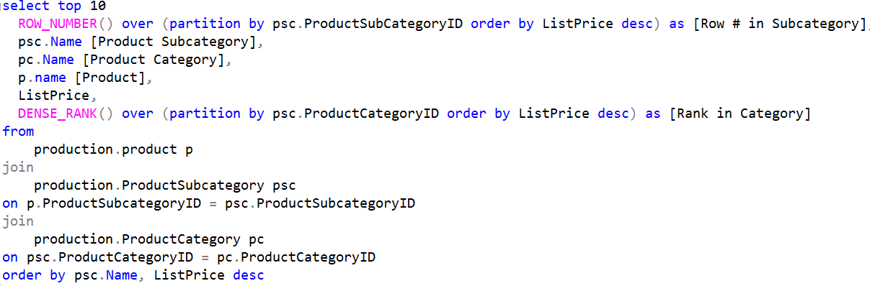
Figure 11- 10. Shows a query that calculates a row number that starts from one for each subcategory name and uses a dense rank to rank each list price within a category. The output is limited to 10 rows for practicalities sake.

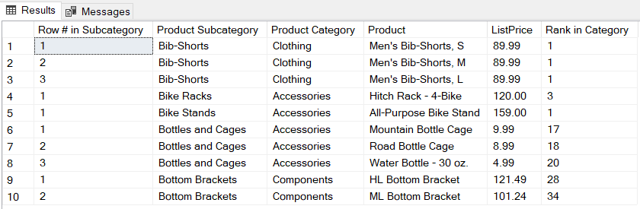
Figure 11- 11. The results of the query in Figure 11- 10.

Useful Tip: Read the PARTITION BY and All the ORDER BY’s Carefully

- Be sure to read each PARTITION BY…ORDER BY for each column carefully. Use a final ORDER BY in the SELECT statement to match the partition you have chosen for at least one of the partitioned columns.
- Name the columns that perform partitioning with meaningful aliases.

SQL will appear to order the rows chaotically if you do not align the SELECT statement’s ORDER BY with at least one column’s ORDER BY or use poorly named columns.

Using Data Partitioning with a CTE

The example in Figure 11- 11 shows you how to use a CTE to simplify what would otherwise be a bloated query. Begin reading a CTE by starting with the last SELECT statement.

Bear in mind that you cannot put a partitioning function into a WHERE clause. The latter restriction can “force” you to create a CTE as it does in this example. Which is a good thing, because it makes you write the query in a clear step-by-step style.

Have a look through the query first in your own time (Figure 11- 11) and match it to the results in Figure 11- 12.

Have you worked it out? The query displays up to five of the highest valued sold items in each subcategory.

An explanation follows if you need it.

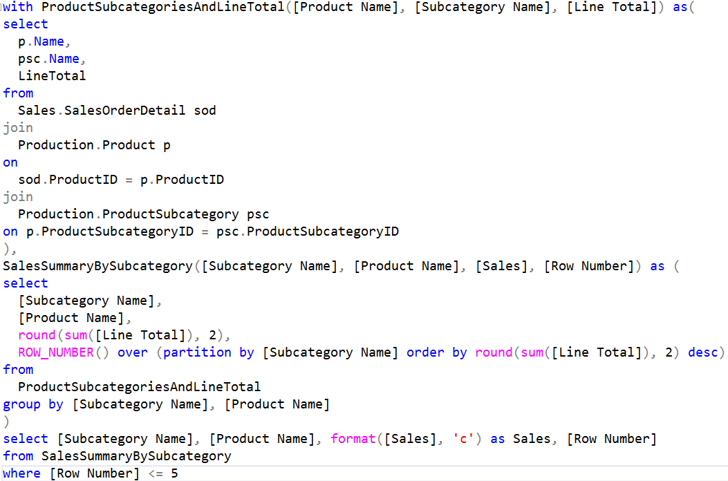
Figure 11- 12. Using a CTE to simplify what could have been an otherwise bloated and cluttered query. There are two subqueries in this script: ProductSubcategoriesAndLineTotal and SalesSummaryBySubcategory.

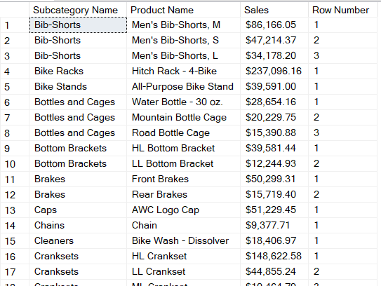
Figure 11- 13. Partial results of executing the CTE based query in Figure 11- 11.

Unpacking the Meaning of The CTE

The best place to start in unpacking a CTE is the last SELECT in the script.

Figure 11- 14. The last SELECT statement in Figure 11- 11.
Figure 11- 13 you see that we are using a “table” called SalesSummaryBySubcategory to give us the subcategory’s name, the product name, we are formatting a Sales value as a currency and each row has a row number. We are limiting the number of rows to 5 or less. Now you have a basic idea of what the CTE does. Yes, you don’t quite know what Sales means, and you don’t know entirely what Row Number is about, but you are starting to feel comfortable with the query.
Now find the meaning of SalesSummaryBySubcategory (Figure 11- 14).
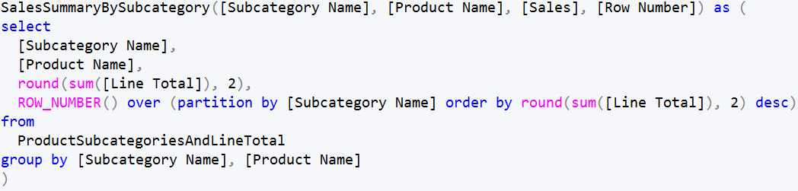
Figure 11- 15. The definition of the subquery SalesSummaryBySubcategory.
You can use the title of the subquery as an important clue: it is going to supply summarised sales information grouped by product subcategory. Next to the subquery’s name is the list of columns it is going to return. You can now see that Sales is the rounded sum of the line total. You can see that the query calculates the row number starting from 1 with each change of subcategory name. You can also see that the subquery arranges the row numbers so that the highest summed line total is going to be row number 1.
Now find the meaning of ProductSubcategoriesAndLineTotal (Figure 11- 15).
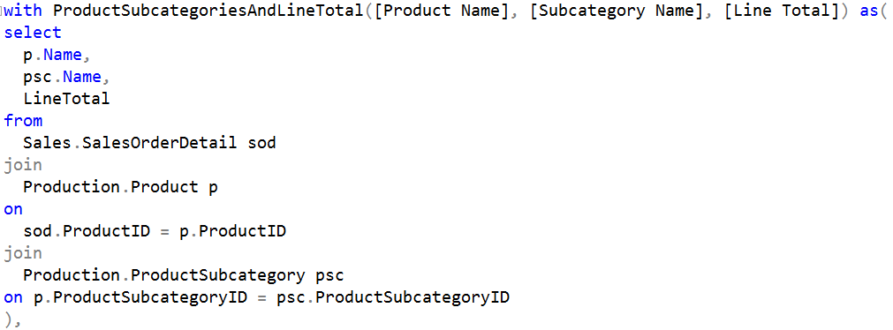
Figure 11- 16. The final subquery in the CTE: ProductSubcategoriesAndLineTotal.
In Figure 11- 15, you use the subquery’s name as a hint. You know you are going to get data related to a product’s subcategory and a line total related that subcategory. You can see the subquery will return a product’s name, the subcategory name and the line total. This query does not use an aggregation function, so you know this query is going to give you each sale’s information. SalesSummaryByCategory, as you have seen, will do the grouping to produce the subtotals for you.
This overall structure is a common one used in CTEs. The last query (the one directly after WITH) supplies the “raw” data, the other subqueries then group or format the data. The result is that the query at the very bottom is uncluttered and reads relatively simply. We can now tell that the last query displays the first 5 rows of sales for each subcategory. We have worked out that the query arranged the rows of each subcategory so that the most valuable products in each subcategory appear first, numbered from 1 up to at most 5.

11.9. Using Aggregate Functions with Data Partitioning

The last example in this section shows you how to use several different aggregate functions with partitioning. The query in Figure 11- 17 displays the lines of each sales order together with the value of the most expensive item bought, the cheapest item bought and the average value of the items in each order.

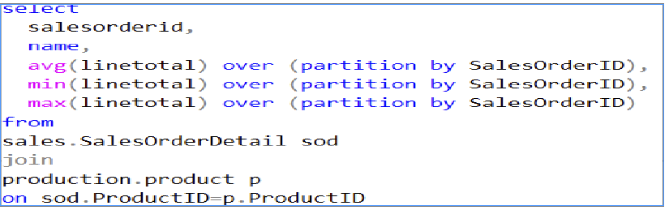
Figure 11- 17. An example of how to use aggregate functions with partitioning.
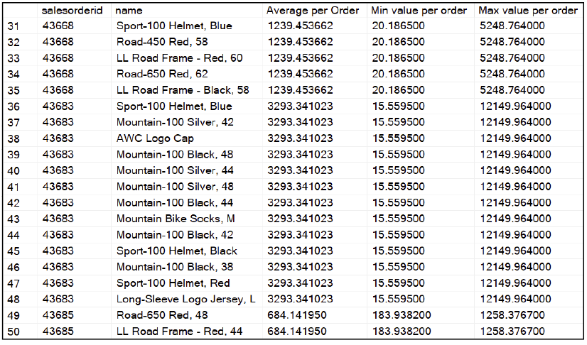
Figure 11- 18. The results of the query in Figure 11- 17.

If you didn’t access to the OVER clause, you would not be able to see the results of the aggregate functions and each order’s details simultaneously. Should you have used the GROUP BY clause to supply similar data, you would be able to see the results of the aggregation functions for each order id, but not the rows that make up those values.

11.10. More Functions To Explore

SQL 2012 added more functions that are specific to partitioning. If you are adventurous and want to try them, first dip your toes into what the NTILE() function does before you do. NTILE is a pre-2012 function which will help you understand what the purpose of the newer functions.

NTILE() divides the data into a chosen number of tiles. You can think of the tiles as ceramic bathroom tiles or even squares on a chessboard onto which you place the rows that NTILE is going distribute across them. SQL allocates each row, by the content of a chosen column, onto a tile. SQL does the distribution of the rows based on the number of tiles you have specified and the range of values in the column.

For example, if you divided the letters of the alphabet into two tiles (which would correspond to NTILE(2)), you would, mentally, create a pair of tiles “labelled” A to M and N to Z. If your chosen column had a word starting with ‘F’ it would go onto tile 1; if it began with ‘P’, it would go onto tile 2. Using NTILE() in a column list would display 1 or 2 against each row to let you know onto which tile the row falls.

In other words, NTILE() divides the rows equally into as many portions as you request.

You can read up on NTILE() here: https://docs.microsoft.com/sql/t-sql/functions/ntile-transact-sql?view=sql-server-ver15

The functions Microsoft added after SQL 2012 to further support row partitioning are known as the analytic functions–LEAD, LAG, CUME_DIST (cumulative distribution) and a few others. If you think you might need them or their names intrigue you, you can read up on them here https://docs.microsoft.com/sql/t-sql/functions/analytic-functions-transact-sql?view=sql-server-ver15.
If you are into statistics or any form of actuarial science, they will give you a small thrill.

11.11. The Exercise

How tricky could this possibly be? Only one way for you to find out .
Appendix F is there to help you with the answers.

Exercise 11. Data Partitioning Using OVER

Add a new query to your “My Class Queries” project and name it “Partitioning Functions”. Put a descriptive comment at the top of the script and follow it with a suitable USE clause that accesses the AdventureWorks2017 database.

Ex 11.1. The Starting Query

Write a query that displays a category name, each product that falls into that category and finally the total quantity of sales of each product in that category.

Ex 11.2. Convert the Query into a CTE

Use that query to define a CTE. The outer query should contain three non-aggregated columns: the category name, the product name and the total quantity. Do the aggregation in the subquery.

Ex 11.3. Add Two ROWNUMBER() Columns

Now add two columns to your query:
The first column must contain the numbers 1 to x where x is the total number of rows in the result.
The second column must list row numbers from 1 to y, where y is the maximum number of rows within a category. The number must start at one each time the category name changes.
Order the rows by the category name and then the product’s name.

UNION, INTERSECT and EXCEPT

UNION, INTERSECT, EXCEPT are known as the set operators. SQL is a set-based language; tables are sets from mathematics. You might have learned set theory at school. That was when you drew Venn diagrams (circles representing the sets) and put letters of the alphabet into them to represent apples (A) and pears (P) and such things into them. Then you wore asked by your school teacher to work out the intersection–overlap–of the items in the various sets. No? No worries, these set operators are easy to grasp and easy to use.
The most worthwhile to learn of the three operators is UNION; you can think of it as an operator that merges rows from several tables to form a single table. You can use INTERSECT, and EXCEPT to compare the contents of tables–usually as a step in the goal of synchronising the tables’ contents.
You are going to learn:

- How to merge table’s rows on the fly using UNION
- How UNION deals with duplicate rows
- What INTERSECT and EXCEPT do

UNION

You use UNION to merge two separate tables’ rows to form a single table. The result is output as a single table. UNION does not affect the original tables, nor does it create a permanent new table. If you want to permanently insert one table into another, see chapter 15, which is about the INSERT command.
As an example of using UNION take the table in Figure 12- 1 which you are going form a union with by using the contents of the table in Figure 12- 2.
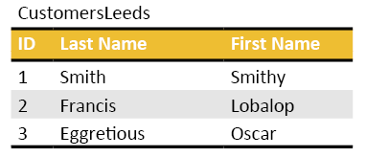
Figure 12- 1. A table of customers from Leeds.

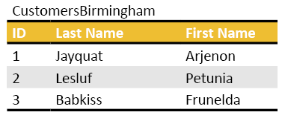
Figure 12- 2. A table of customers from Birmingham.
Their UNION will produce the table in Figure 12- 3.

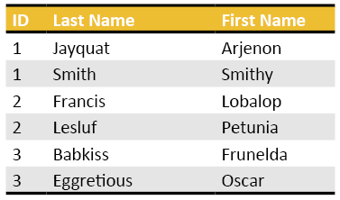
Figure 12- 3. The union of the tables in Figure 12- 1 and Figure 12- 2.
If you want to try the UNION statement out yourself, Figure 12- 4 shows you a script you can use to create the two tables.
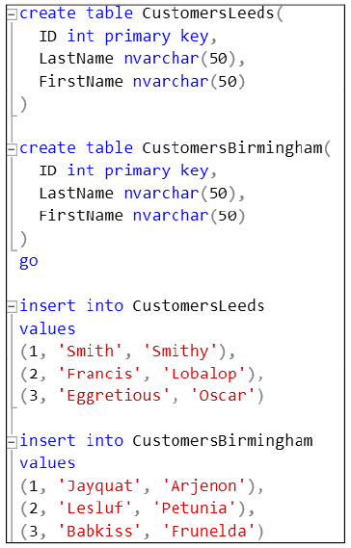
Figure 12- 4. If you type these commands into your SQL server, you will generate the tables used in this chapter.
Figure 12- 5 shows you the SQL that will create the union of the two tables. The resultant table is in Figure 12- 6.
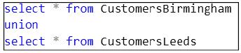
Figure 12- 5. The UNION of the CustomersBirmingham and CustomersLeeds tables expressed in SQL.
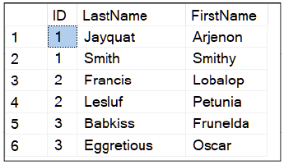
Figure 12- 6. The result of the union operation.
UNION requires you to supply two SELECT statements that choose the columns and rows you wish to merge. Each SELECT statement must function as a stand-alone query. You simply insert the keyword UNION between the queries. You can continue to use UNION to merge as many tables onto a previous union as you want.
There are rules you need to follow about the columns that the SELECT statements provide:
- You need to make sure the number of columns in both tables are the same.
- You must be sure the data types of each merged column match.
If the first column from the first query is an integer, the first column from the second query must be an integer. You can’t form the UNION of a numeric column with a column that is of a character type. All Is not lost; you can cast the numeric column in one of the queries to be of a text type or convert the text column to be of a numeric type, whichever option is appropriate for your data.
Let’s find out what happens if you have duplicate rows. Let’s perform a union of the CustomersLeeds table with the table in Figure 12- 7.

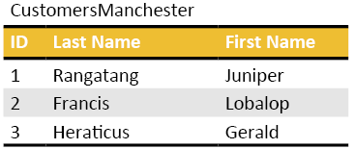
Figure 12- 7. Another table to use to experiment with UNION. This table contains a row that is a duplicate from CustomersLeeds (Francis Lobalop).
You will get the result in Figure 12- 8. The duplicate row of Francis Lobalop appears once in the result.
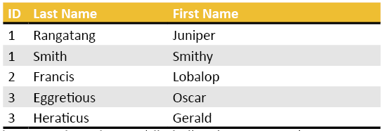
Figure 12- 8. The result of the UNION class. The duplicated row appears once.

UNION ALL

If you wish to see the duplicate row(s), use in UNION ALL rather than UNION; Francis will appear twice.
The script in Figure 12- 9 will create the CustomerManchester table if you would like to try UNION ALL for yourself.
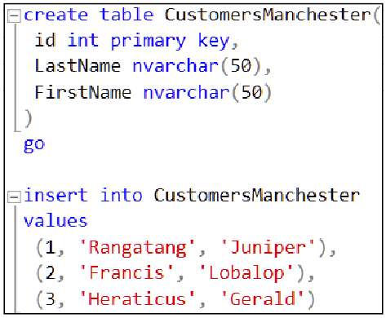
Figure 12- 9. A script to create the CustomersManchester table.

INTERSECT

Now that you know what UNION does, can you work out for yourself what INTERSECT does?
If you INTERSECT the CustomersLeeds table with the example CustomersManchester table, you will get the result in Figure 12- 10.


Figure 12- 10. The intersection of CustomersLeeds and CustomersManchester
Figure 12- 10 shows that INTERSECT calculates the duplicated rows in both tables.
And that can be done by typing in Figure 12- 11.

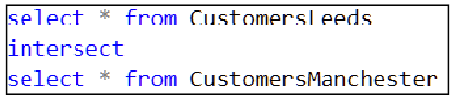
Figure 12- 11. A script to perform an INTERSECTion using SQL.
INTERSECT can be useful if you are about to import data into a table and you want to check if any of its rows are already in the destination table

EXCEPT

Do you think you have this one figured out too? If you run the script in Figure 12- 12, you will get the output in Figure 12- 13.
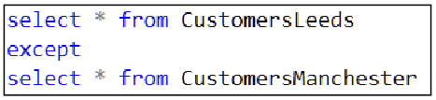
Figure 12- 12. A SQL script to calculate the result of EXCEPT.

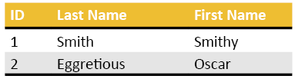
Figure 12- 13. The result of the script in Figure 12- 12.

EXCEPT displays the rows from the first table except for those that you have duplicated in the second. Any rows in the second table that are not in the first table will not display.
EXCEPT can catch you by surprise since; my intuition told me that it calculates the rows that the pair of tables do not have in common. It doesn’t do that.

The Exercise

After doing the exercise on CTE’s, this exercise will be a walk in the park. Or will it?
The answers are in Appendix F, and you can download them all from my website: https://www.Transference-UnLimited.com

Exercise 12. UNION, INTERSECT and EXCEPT

Add a new query to your “My Class Queries” project and name it “Union Intersect and Except”. Put a descriptive comment at the top of the script and follow it with a suitable USE clause that accesses the AdventureWorks2017 database.

Ex 12.1. Write the First Query

Write a query that displays all the columns and rows from Person.Person where the last name is ‘Smith’.

Ex 12.2. Write a Second Query

Write a query that displays all the columns and rows from Person.Person where the last name is ‘Rodriguez’.

Ex 12.3. Write the Union of the Above Queries

Blend the output of the first two queries into a single table using UNION. Did you struggle to get it to work?
Which column caused trouble? Why do you think it did? Über bonus points if you can work out why this column is a problem.
Hint: Try using UNION ALL instead of UNION. Text columns, varchar(max), image and varbinary(max) columns don’t work either.

Replace the column lists in your two select statements with the columns for first name and last name.
Check that your UNION works this time.

Ex 12.4. Write One Last Query

Write a query that displays all the rows except those that are not in the result set generated by Ex 12.3. Use the EXCEPT operator to do this.

Dealing With Dates

SQL has plenty of functions to manipulate dates and times. You can perform all sorts of interesting operations on them–add them, subtract them, extract components such as the day, month and more. A small number of the functions are Microsoft T-SQL specific but are well worth getting to know. You will mostly work with the standard date functions in this chapter.

What you will learn:

- The various types that SQL can use to represent dates and time
- Multiple ways to reformat dates
- How to “chop” dates up into their constituent components using DAY(), MONTH() and YEAR()
- How to use DATEPART() to extract even more elements of a date such as a year’s quarter
- How to format dates according to various cultures
- How to do arithmetic with dates
- How to use EOMONTH() to calculate the last day of a month

What Do Dates Look Like?

SQL traditionally stores dates in a field of type DateTime. This type has been around since the 70s. Since then (2008), Microsoft added a few other standard date and time related types. I have listed the types in Table 13- 1 below.

Type name: | Appearance: | Usage:
DateTime | yyyy-mm-dd hh:mm:ss.ttt | Standard types for dates (from the 70’s).
DateTime2 | yyyy-mm-dd hh:mm:ss.nnnnnnn | Used when you want to store time with a fraction of second accurate to 7 digits. You should think of this type as the modern replacement to DateTime. You should use it in future database designs.
DateTimeOffset | yyyy-mm-dd hh:mm:ss.nnnnnnn +hh:mm | Stores a time zone offset from UTC (UTC is independent of daylight savings time)
Date | yyyy-mm-dd | This type stores a date without storing a time part.
SmallDateTime | yyyy-mm-dd hh:mm:ss | Rarely used type from the 70s. The year part is limited to the range 1900 to 2079.
Time | hh:mm:ss.nnnnnnn | This stores time with fractions of a second accurate to 7 digits.
Table 13- 1. The date types supported by T-SQL. yyyy is a year, mm a month, dd a day. hh are the hours, mm minutes, ttt thousandths of a second, nnnnnnn is a seven-digit number representing a fraction of a second.
ANSI and the ISO decided the standard representation of SQL dates and times. Consequently, without modification, SQL always shows dates in this order:

yyyy-mm-dd hh:mm:ss.ttt (DateTime)
or
yyyy-mm-dd hh:mm:ss.nnnnnnn (the newer DateTime2)

If SQL presents dates differently, it is because the query has instructions that manipulate the output format of the date. You are better off sending the data to the client in the standard ISO format. Let the client application change the format. Leaving the format as per standard SQL as it is allows the client application to apply its local desktop operating system’s regional settings. Doing this means that dates appear as each user wants them based on their location.

How to Reformat Dates

You can, to some, degree reformat dates within a query. Unless you want to print or display the output from a SQL query directly, best leave the format alone.

SQL can be tolerant of entering dates such as ‘10-Aug-2005’, but it will turn them into its standard numeric format if it can work out the meaning of the month’s name. And who says the server is running on an English based machine? Even riskier is using a date similar to ‘04-02-1990’ and hoping that SQL interprets it correctly as 4th of February if you are in the UK. SQL won’t. According to the ISO rules, that date is the 2nd of April.

An Old Fashioned Way to Convert Dates

You can use the CONVERT() function to change the appearance of the date to a limited range of formats that SQL has pre-programmed as styles. You can find the possible values of the style parameter and the forms they map onto here https://docs.microsoft.com/sql/t-sql/functions/cast-and-convert-transact-sql

Let’s have a look at it:

Figure 13- 1. Using CONVERT() to display the date in style 105; the format used in Italy.
The output is: 019-09-22 10:39:15.250

Style 105 is, according to the web site given above, is the date and time format used in Italy.

You will see this next technique (and variations thereof) in older SQL code. This method relies on the language setting specified by your SQL login, which on my machine is “English – US_English” as you can see in Figure 13- 2.

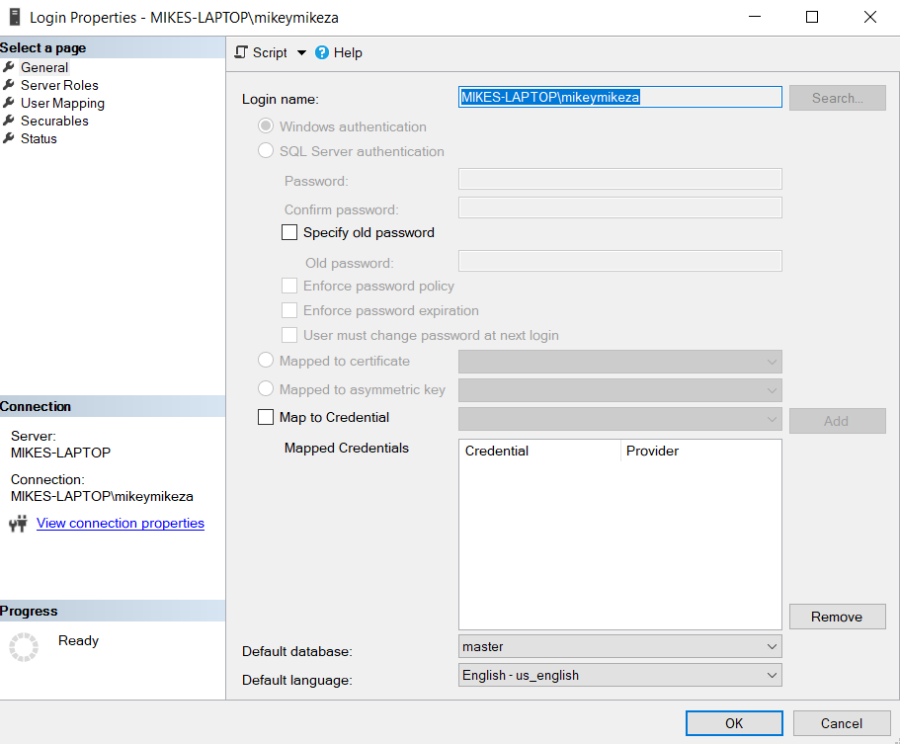
Figure 13- 2. This screenshot shows the properties of my SQL login account.
To get to the dialogue you see in Figure 13- 2, go to the Object Explorer=>your server’s name=>Security and then look at the properties of your login account (right-click your account’s name and click Properties).
The language setting is as good as unpredictable in a global organisation since you may not know the location or country in which the SQL server is. For that reason, I generally don’t recommend using the technique I am going to show you next.

Figure 13- 3. Using CONVERT() (or CAST() ) to convert a date without a style.
The output on my machine (UK) is: Sep 22 2019 10:53AM

If I change the language of the current session to Russian (Figure 13- 4), I get Figure 13- 5. If you try this, set the language back to your local language after, in my case, using the script in Figure 13- 6 or you can close the current tab in SSMS and open another.

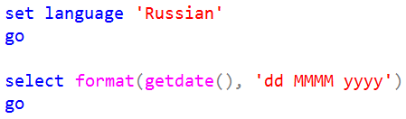
Figure 13- 4. A script to set the language to Russian then display the date using the format of ‘day fullmonth’sname year’.

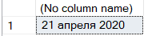
Figure 13- 5. The date displayed with the month’s name in Russian (April).

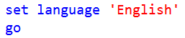
Figure 13- 6. The command to reset the login sessions’ language to English (US).

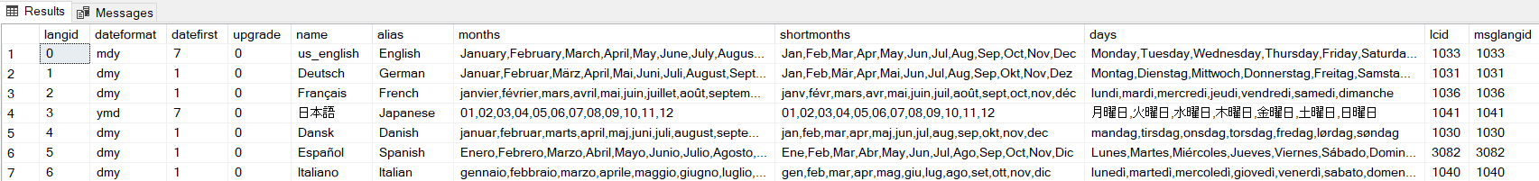
Figure 13- 7. A sample of the languages you can choose using SET LANGUAGE. Use the name under the alias column if you want to try out a language with symbols your keyboard doesn’t support.
Figure 13- 4 shows you the command that you can use to change the language SQL uses when it converts a date to a character field; SET LANGUAGE x. x is a name you can find in the sys.syslanguages table (Figure 13- 7). Careful, SQL will then display all your error messages in that language, which can be mildly amusing in the short term.

Extracting Parts of Date (Method 1)

You can extract parts of the date and then manually reconstruct the date from its pieces to create whatever format you like using a script similar to Figure 13- 8.

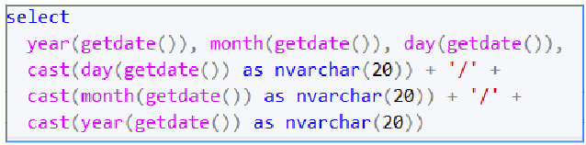
Figure 13- 8. This script shows how you can “mangle” date by breaking it up into its component pieces. You can then recombine the pieces to create a specific format.

Figure 13- 8 produces: 2019 9 22 22/9/2019. Formatting a date this way is asking for trouble in a multi-lingual system. Rather use the FORMAT() function described in section 13.6.

The DAY(), MONTH() and YEAR() functions are very useful in a WHERE clause when you want to specify a date accurately in its condition.

Extracting Parts of Date (Method 2)

Sometimes you will need to know the week number or the quarter number of a date. There are no analogues to the functions DAY(), MONTH() and YEAR() to do that. Instead, you can use a more general function called DATEPART().

DATEPART takes a character string that represents what you wish to extract from a date. You can find the list of character strings here https://docs.microsoft.com/sql/t-sql/functions/datepart-transact-sql

In Figure 13- 9, you can see examples of how to use it:

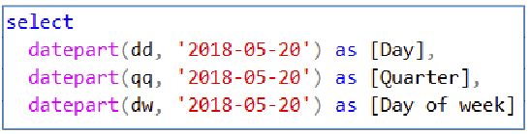
Figure 13- 9. Using DATEPART() to extract the day of the month, quarter number and day of the week from ‘2018-05-20’.
Day Quarter Day of week
----- ----------- -----------
20 2 1
Figure 13- 10. The result of executing the script in Figure 13- 9.
Figure 13- 9, “dd” gives the day of the month, “qq” gives the quarter of the year and “dw” gives the day of the week with Sunday being day 1.

Microsoft Specific Date Formatting Commands

You can use FORMAT() to format the parts of the date and time in a variety of custom ways. FORMAT() is available on SQL 2014 onwards. Some examples are using it in Figure 13- 11.

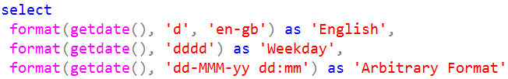
Figure 13- 11. Various examples of how to use FORMAT to display the date and time in various ways.
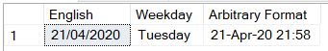
Figure 13- 12. The result of using the formats shown in Figure 13- 11.
FORMAT(GETDATE(), ‘d’, ‘en-gb’) formats the date using Great Britain’s English. FORMAT(GETDATE(), ‘dddd’) display the day of the week in long-form. FORMAT(GETDATE(), ‘dd-MMM-yy hh:mm’) shows the date using a three letter month name.

‘M’ is for months, ‘m’ Is for minutes. ‘en-gb’ is an example of an ISO language and country code. You can look up the country code you want to use here https://en.wikipedia.org/wiki/ISO_3166-1 and the language code you want here https://en.wikipedia.org/wiki/List_of_ISO_639-1_codes

FORMAT() supports the symbols shown in Table 13-2. FORMAT() uses symbols that Windows understands as part of its regional settings. These symbols are not the same as used by the other SQL date functions such as DATEPART().

Symbol: | Meaning:
dd | A two-digit day, for example, 03 for the 3rd of the month.
ddd | Three letters for the day: Mon
dddd | The full word for the day: Monday
MM | A two-digit month: 04
MMM | Three letters for the month: Apr
MMMM | The full word for the month: April
hh | Two-digit hour 12 digit clock
HH | Two-digit hour 24 digit clock
mm | Two-digit minute
tt | am/pm indicator

Table 13-2. Symbols that allow you to format dates and times arbitrarily.

You can find out more about the FORMAT function at https://docs.microsoft.com/sql/t-sql/functions/format-transact-sql?view=sql-server-ver15.

Arithmetic With Dates and Time

Doing arithmetic with dates can be tricky, especially if your calculation needs to cross from one month into another or you have to deal with leap years. SQL has functions to help you add units of time to dates rather than you risking doing the mathematics yourself. All these functions can operate on time as well as dates.

DATEADD()

DATEADD() lets you add or subtract a chosen number of units (days, quarters, weeks, etc.) to or from a given date. You represent the unit using the same set of symbols as used for DATEPART().

Figure 13- 13. This script shows you how to add 28 days onto the 16th of August 2019.
The result is: 2019-09-13 00:00:00.000

If you want to a subtraction operation, put a negative sign (“-“) in front of the quantity, for example, use -28 in Figure 13- 13 to subtract 28 days from the 16th of August 2019.

DATEDIFF()

You can use DATEDIFF() to measure the time difference between two dates(or times) and return the answer in a unit of your choosing. That means that you can calculate the difference between to dates or times in hours, days, months, quarters, and so on.

DATEDIFF() is not the function to use to subtract a unit of time from a date. DATEDIFF() works with two datetime quantities. Use DATEADD() to deduct a unit of time by specifying the amount of the chosen unit with a negative number.

Figure 13- 14. This script calculates the difference between the 20th of September 2020 and the 1st of January 2019 in days.
The result is 262 days.

EOMONTH ()

EOMONTH() (end of month) is a gem of a function. If you give it a date, it will tell you what the last day of that month will be. It is excellent for avoiding writing calculations that need to detect leap years.

EOMONTH() takes an offset as a second parameter. The offset is the number of months from the date you specified on which you want to calculate the last day. You can set the offset to 0 for the current month, a negative number to calculate the last day of the previous month (or further back) or a positive number for future months. Figure 13- 15 shows some examples of using EOMONTH().

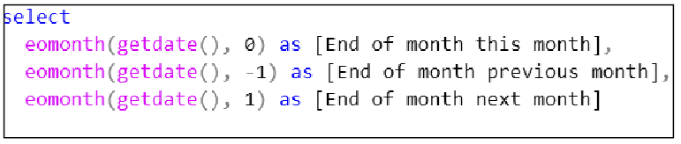
Figure 13- 15. This script shows some examples of using the EOMONTH() function to calculate the last day of several months relative to the current month, which was December 2019.

The Exercise

Some fun, short and informative exercises to try.

The answers are in Appendix F, or you can download my complete Solution from https://www.Transference-UnLimited.com.

Ex 13. Dealing With Dates

You will now try computations with columns containing dates. Add a new query to your “My Class Queries” project and name it “Dealing With Dates”. Put a descriptive comment at the top of the script and follow it with a suitable USE clause that accesses the AdventureWorks2017 database.

Ex 13.1. How many Days Until Your Birthday

Write a select statement that works out how many days until your next birthday. Use GETDATE() and DATEDIFF() to work it out.

Ex 13.2. Different Units

Repeat Ex 13.1 but use units of months and weeks rather than days.

Ex 13.3. How Long Did Adventure Works Stay In Business?

Write a query that works out the number of years between the earliest order and the last order in Adventure Works. I get three years.

Ex 13.4. List Orders Placed Close to the End of the Month

Write a query that lists how many orders customers placed within five days of the last day of each month in 2012.
Hints:
1. Begin by displaying the order date, the last day of the month and the difference in days between those two dates for the year of 2012.
2. Display those rows that show a difference in days of 5 or fewer.
3. Count the number of rows that fall on a given month.

Have a look at your figures.

When are the busiest periods of sales for Adventure Works?

They would appear to be around summer time (Northern hemisphere) and Christmas time.

The Fundamentals of Creating Tables

In this chapter, you are going to find out about the fundamentals of how to create tables.
The syntax I am going to use throughout this chapter is considered modern ANSI syntax. Variations of this syntax are possible.
I’ve aimed this chapter at beginners. This section will help you get a gentle feel for what is to be a SQL programmer.
You are going to find out:

- How to use the GUI to create tables (a brief description)
- How to create a primary key and identity column
- How to restrict the usage of NULL in a column
- How to implement a PK-FK constraint
- How to generate several demonstration tables that you will see referred to in the next three chapters of this course
- What default and check constraints are and how to create them

Generating Practice Tables

In this course, you will want some tables of your own with which you can play. I am going to show you how to create some demonstration tables using various scripts. However, you might want to experiment with SSMS’s GUI to create the table’s yourself.
I am not going to go into much detail about using SSMS’s GUI as it is best to get to know the SQL the GUI generates first. This knowledge will help you work with many makes of SQL, not just T-SQL. Bear in mind that you won’t always have access to a GUI interface to use to manage SQL.
If you want to experiment with the GUI to create tables and edit data, it is straightforward to get started: Go to SSMS’s Object Explorer, expand the database you want to use and right-click the Tables folder. Then take the option New=>Table. You will then see a grid using which you can define the column’s names, choose the column’s data types and set various properties such as nullability, the identity column and its settings.
If you want to edit an existing table’s column structure, right-click the table then choose Design.
If you want to edit data in a table using the GUI, SSMS restricts you to only editing the first 200 rows. To do the edit: right-click on the table’s name and select Edit Top 200 Rows. You cannot see the entire table because downloading or scrolling up and down through a table can unnecessarily slow down the server, the network and your client computer. All of this adds up to annoying other users working on the SQL server.

If you get yourself into “trouble” by accidentally editing a table’s design in a way you didn’t mean to, press the Esc key or close the relevant editor tab. If SSMS asks you to save anything, choose no. Rather lose the changes you might have made successfully and redo them after.
Be careful, SQL makes any changes you make to a row’s data permanent when you move the cursor off of the edited row.

The Primary Key Column

For a table to be useful in a relational database, it needs to have a primary key (there are rare exceptions). Refer to section 1.7 and 1.10 if you need a detailed reminder about what a primary key is. If you want to find a row in a table with precision, you need to use the primary key to do so.
The primary key may be a column added to the table for that purpose (a surrogate key) or a role nominated to an existing data column (a natural key). The primary key can consist of two or more columns (a compound key).
There are two types of tables: If a table does not have a primary key, it falls into the category of a heap. The name heap comes about because it implies you can visualise the table as a jumbled pile of data; each row is placed as good as randomly on top of the others. In SQL, this means that there is no formal ordering mechanism that governs the placing and consequent finding of rows in a heap. You can search the contents of a heap, but nowhere near as efficiently as you can compared to searching a table with a primary key.
You can insert data very rapidly into a heap which makes a heap good for rapidly logging status entries or for quickly recording auditing information.
If a table has a primary key, we categorise it as a clustered index. A clustered index is a combination of your data and a specialised index structure that allows you to search for a primary key value exceptionally rapidly. The primary key based index finds a row you need in the same way you would use an index in a book; you look up a keyword (the equivalent of the primary key), and the index tells you what page to go to in the book (where SQL keeps the row in the physical database files).
SQL automatically creates a clustered index enabled version of your data when you allocate that table a primary key. In a clustered index, entries in the index refer to a single row of data in the physical table. With a standard index (a non-clustered index) you base the index on an arbitrary column in the table. A standard index’s entries map a value from the chosen column to the corresponding table’s primary key. SQL then uses that primary key to look up the required row via the clustered index. In short, SQL uses a standard index to find primary keys.
When a DBA refers to an index, they are usually referring to a standard index. A standard index is a supplemental search tool manually added by the DBA at their judgement. It speeds up searching for data in specific columns. A standard index is a separate entity to the table. SQL uses it alongside the table, be that table a heap or clustered index. I have simplified this description slightly to avoid excessive detail. You can learn more about indexes and clustered indexes here: https://docs.microsoft.com/sql/relational-databases/indexes/clustered-and-nonclustered-indexes-described?view=sql-server-ver15

The Identity Column

You use an identity column to automatically assign a unique integer value to each newly inserted row. You can have one identity column per table. When you specify the chosen column’s identity settings, you must supply a starting value called the seed value. You then provide an increment value. SQL adds the increment to the last used identity value each time you add a new row.
You can set the increment to a negative value, in which case the numbers count downwards. An increment is a whole number of your choosing; you could set it to two to cause the assigned numbers to count up in two’s. The seed can be any valid integer you like.
You will frequently assign the identity column to be the primary key column as it guarantees a unique value for each row. This convenience saves you generating a number yourself. The current value of a table’s identity column doesn’t influence another table’s identity column’s value. If you require a number that is unique across several tables, you need to use a device called a sequence. You can find out more about sequences here: https://docs.microsoft.com/en-us/sql/t-sql/statements/create-sequence-transact-sql?view=sql-server-ver15.

Data Types

You must allocate each column in your table a data type. The type will determine the format and range of data that you can store in that column. To remind yourself of the wealth of available data types available to you, have a look at section 2.15.

NULL or NOT NULL

When you create a table, you can place NULL or NOT NULL next to a column’s definition. This option will determine if you can put NULL values into that column. If you choose the NOT NULL option, you won’t be able to put NULL into that column. Allowing NULLs is the default option.
You cannot put NULL into a primary key column. Since NULL translates to “unknown”, it makes no sense to do so.

Creating the Customer’s Table

Let’s begin learning how to create tables by executing the script in Figure 14- 1.

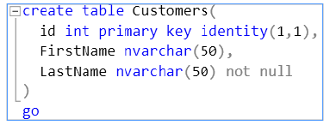
Figure 14- 1. A SQL script to create the Customers table.

The script demarcates the id column as both the primary key and an identity column. The identity column has a starting value of 1 (the first number in parenthesis) and will increment in 1’s (the second number in parenthesis).
The last two columns, FirstName and LastName can contain a maximum of 50 Unicode characters.
You will insert data into the table in the next chapter.

Creating the Products Table

Now let’s create the table in Figure 14- 2.
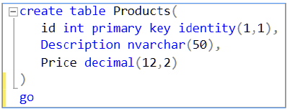

Figure 14- 2. A SQL script to create a products table. Optionally, see if you can modify the script so that Description and Price do not allow NULLs.
What differs in the Product’s table’s definition is the Price column. This column’s type specifies that it stores a number with two digits after the decimal point and ten digits in front of it. You will see this table used in later chapters.

Creating the Sales Table

Now create the Sales table in Figure 14- 3.
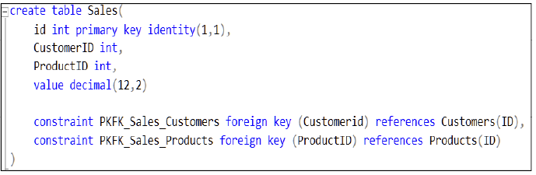
Figure 14- 3. The script to create the Sales table. This table features FOREIGN KEY constraint definitions.
The CONSTRAINT section describes two constraints, one named PKFK_Sales_Customers and the other PKFK_Sales_Products. The constraints are named so that you can edit them by using other SQL commands at a later time. If you don’t give your constraints a name, SQL will give them awkward “random names” instead.
When you break or violate a constraint SQL displays the name of the constraint in question. A well-chosen name will make it easier to diagnose the cause of an error. You will experiment with violating constraints later in the course.
The utility of the pair of constraints in Figure 14- 3 is that they put a limit on the range of data you can insert into the constrained column.
The first constraint–PKFK_Sales_Customers–applies to the CustomerId column. The constraint is of type FOREIGN KEY. There are other types of constraints, as I will show you later. The REFERENCES section tells you that this table’s CustomerId column must match an existing value in the ID column in the Customers table.
PKFK_Sales_Products applies to the ProductId column. It too is a constraint of type FOREIGN KEY. The REFERENCES section tell you that this table’s ProductId column must match a value in the ID column in the Products table.

Copying A Table

At some stage in your SQL journey, you will want to copy a table. You can do so in two ways: you can copy the source tables structure (the columns, their types and so on) together with the data or copy the structure without any rows to form an empty table with the same columns as the original. You can do either copy operation with the SELECT INTO command.
SELECT INTO allows you to choose which columns you want to copy as well as which rows (if any). You can create a copy of a table that comes from a different database to a destination table name with a different name.
You can see the SELECT INTO syntax in Figure 14- 4.
select col1, col2, col3,…
into
destinationTable
from
sourceTable
where conditionToSelectARow
Figure 14- 4. The general syntax of the SELECT INTO command.
To see how to use SELECT INTO, let’s create a new database and copy a table from Adventure Works into a table in this new database. I create a new database simply to make the demonstration a bit more informative. There is no need to create a new database to use SELECT INTO.
The script in Figure 14- 5 creates a database with the absolute minimum of fuss called TestDB. The command I have used creates TestDB by duplicating all the settings contained in a template system database called Model (you can find it under System Databases in the Object Explorer). You would not use this technique to create a production database.
It then creates a schema called Production. I chose that name to mimic the schema that Adventure Works uses for the Products table. I did this to keep the example “realistic” and make it more fun. You can use any schema name you like. If you decide to call your copied table dbo.Products rather than Production.Products, you don’t have to create a schema since the schema dbo will already exist in TestDB.
I then switched into the Adventure Work database. Doing so allows you to see how to use the notation databaseName.schemaName.tableName.
The SELECT INTO command then copies the rows from the Production.Product table that fall into the category Road Bikes. It places them into a table called Production.RoadBikes in the TestDB database. Finally, it displays the copied data.
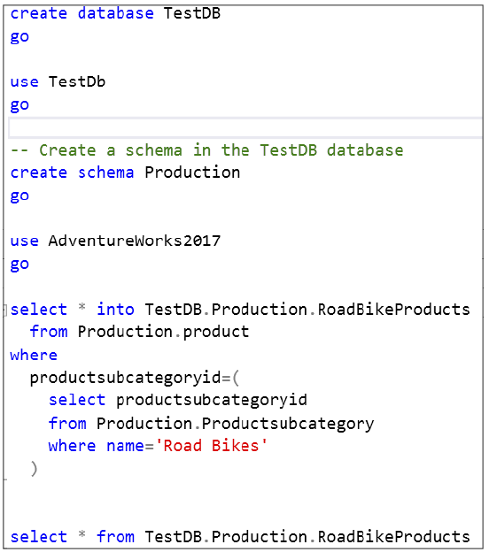
Figure 14- 5. A script that shows how to use SELECT INTO command to copy a table between two databases.
Figure 14- 6 shows you what is inside the Production.RoadBikeProducts table once the copy is successful.
Once you have studied and possibly executed this example for yourself, you may want to delete the TestDB database. You can do so by using “DROP DATABASE TestDB”. Be sure that you are not using TestDB as a database context nor have it in use in the Object Explorer or SQL will tell you that TestDB is currently in use.

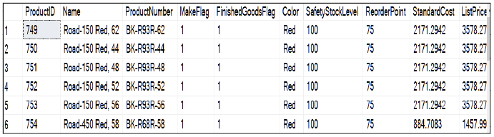
Figure 14- 6. The contents of the newly created table TestDB.Production.Product.

Copying The Structure of a Table

You can copy a table without taking any of its data. This usage of SELECT INTO allows you to copy the column names and types from the source table. You do this by writing a SELECT INTO statement with a WHERE clause that always evaluates to false. For instance, let’s copy the Category table’s structure to create an empty table called CopyOfCategories. The script in Figure 14- 7 will do that for you.

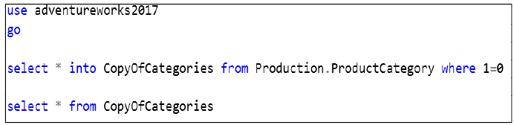
Figure 14- 7. This script shows you how to copy Production.ProductCategory’s structure (or metadata) into a new table called CopyOfCategories.

The WHERE clause in Figure 14- 7 will never be satisfied since 1 will never equal 0, and so the condition is always false. SELECT INTO will only copy a row if the WHERE clause for that row returns true. The result is that SQL copies the table’s columns without the data. This type of copy copies what is called the metadata; (the descriptive data about the data in a table.
However, SELECT INTO does not copy all the metadata contained in the source table. It does not copy which column(s) you have demarcated as the primary key. Neither does it copy any indexes. SQL copies the IDENTITY property but no constraints from the source table except the nullability constraint.
All the constraint and index details from the source table are left for you to apply to the copy. You do that once SQL has completed making the copy. That is so you can pick-and-choose what constraints and so on you want to apply to the copy yourself.
SELECT INTO cannot copy data into an existing table. I will show you how to do that in chapter 15.

DEFAULT and CHECK Constraints

This section will show you examples of other typical constraints you will find applied to tables. Although this isn’t a SQL programming course, because you will encounter the effects of these constraints when you manipulate data, why not try creating and experimenting with examples of them for yourself?
Figure 14- 8 creates a table that you will in the next chapter to test out various constraints.
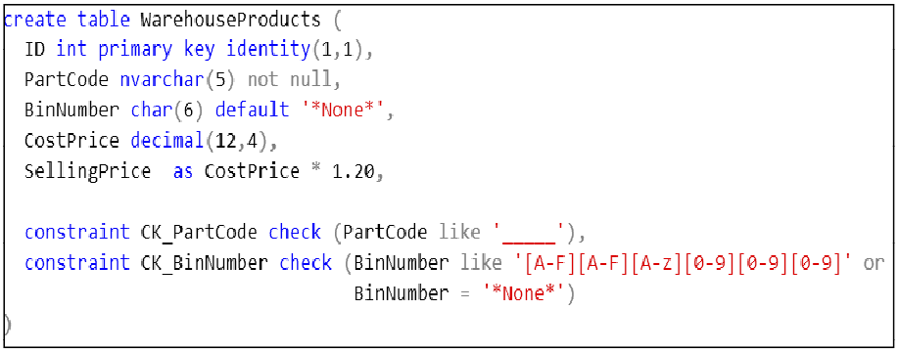
Figure 14- 8. A table you can use to show other types of constraints you will find on a real-world table. The constraint CK_PartCode contains five underscores.
The script in Figure 14- 8 creates three constraints: a default constraint, a NOT NULL constraint and a CHECK constraint.
The NOT NULL and the DEFAULT constraint are specified next to the affected column’s definition. You cannot specify these two constraints in the CONSTRAINTS section at the bottom of the CREATE TABLE statement.
SellingPrice is a computed column. It appears if you view the table’s contents, but SQL does not store the content in the database. A calculation generates its content instead.
You will insert data into this chapter in chapter 15.

What’s Coming Up In The Next 3 Chapters

In the next three chapters, you are going to explore what is involved in manipulating data. You are going to do so with the four tables you created in this chapter.

14.13. The Exercise

I would highly recommend doing the demonstrations in this chapter’s text yourself.
In the official exercise, you are going to create additional tables to those featured in this chapter.
Don’t forget to refer to Appendix F if you get stuck or you can download a complete SSMS Solution from my website: https://www.Transference-UnLimited.com

Exercise 14. The Fundamentals of Creating Tables

Add a new query to your “My Class Queries” project and name it “Creating Tables”. Put a descriptive comment at the top of the script and follow it with a suitable USE clause that accesses the AdventureWorks2017 database.

Ex 14.1. Create a Pair of Tables To Store Car Warehouse and Car Sales Information

Modify the example SQL commands in this chapter’s text to create the tables described in Table Ex 14- 1 and Table Ex 14- 2.
CarWarehouse
Column Name: | Characteristic: | Data Type:
ID | This column is the primary key.  It is an identity column (seed 1, increment 1) | integer
Description | The description must have a minimum of 10 characters.  This column must use Unicode. | nvarchar(50)
UnitsInStock |  | integer
Table Ex 14- 1. This table contains the metadata that you need to create CarWarehouse table.
CarSales
Column Name: | Characteristic: | Data Type:
ID | This column is the primary key.  It is an identity column (seed 1, increment 1) | Integer
CarModelID | This column contains a foreign key value that must reference the ID column in the Warehouse table. | Integer
Quantity |  | Integer
Table Ex 14- 2. This table contains the metadata that you need to create CarSales table.

Ex 14.2. Copy a Table

Copy the rows in the Sales.SalesOrderHeader and Sales.SalesOrderDetail table for the year 2011 into a pair of respective tables called Sales.DataForReportsSalesOrderHeader and Sales.DataForReportsOrderDetail.

Inserting Data

You are now going to learn the most commonly encountered forms of the INSERT command to puts rows into a table. This chapter’s examples depend on the tables described in chapter 14.
You will learn:

- How to insert a single row
- How to insert multiple rows with a single command
- What PK-FK constraints do
- What default and check constraints do
- How to copy rows from a table into an existing table

Inserting a Single Row

To insert a single row into the Customers table created in chapter 14, you can use the command in Figure 15- 1.
Figure 15- 1. This script shows a SQL command that inserts a single row of data into Customers.
You will then receive a confirmatory message, as shown in Figure 15- 2.

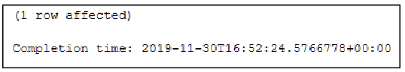
Figure 15- 2. SQL’s output in the messages pane, confirming that the insert in Figure 15- 1 worked.
You can then run a SELECT statement to see if the row is there.
Figure 15- 1 is an example of the most well-specified and reliable way that you can insert a row; that is because of the column list in parenthesis. This list makes sure you identify which of the columns into which you want to insert data. The ID column is missing from the list because SQL will generate its value automatically. If you try to insert a value into the ID column, you will get an error.
You can specify the columns in any order you think makes sense. The data given after VALUES must be in the same order as the list of named columns. You don’t have to list the columns in the order in which they appear in the table. After all, the DBA can change the table’s column order anytime they choose.
If you don’t put in a column’s name, it will take on a default value, usually NULL. That is unless you have placed a default constraint or NULL constraint onto that column. In that case, it will either take on the specified default value or report an error.
If you attempt to insert data into an identity column, you will incur minor wrath from the SQL server as I’ve shown in Figure 15- 3.
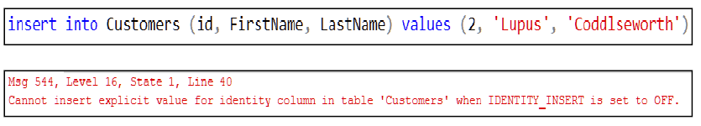
Figure 15- 3. This figure shows what happens if you attempt to insert data into an identity column.
The text of the error message implies that you can insert a value into an identity column with a “little bit of manipulation”. You can force an insert into an identity column using a command called “SET IDENTITY_INSERT”. If you want to learn more, you can read up on how to do so here: https://docs.microsoft.com/en-us/sql/t-sql/statements/set-identity-insert-transact-sql?view=sql-server-ver15. As this is not a recommended practice except in the case of data recovery I am not going to discuss inserting into identity columns further.

Implicitly Inserting a Default Value

Let’s insert a row using a default value for the first name (Figure 15- 4).
Figure 15- 4. This SQL INSERT statement ignores the first name column. FirstName will take on a default value.
The resultant table so far is shown in Figure 15- 5.

Id FirstName LastName
--- ------------- ---------------------
1 James McNugget
2 NULL Sigmafluff
Figure 15- 5. The second row shows the default value used for Sigmafluff’s first name (NULL represents unknown).

You can see that without an explicitly defined default constraint, SQL has put NULL into the first name column for Sigmafluff. NULL is how SQL expresses that the value is unknown.

Implicit Column Names

You can use a shorter syntax to insert a row if you are familiar with the order of the columns in the destination table and you are confident the column order has not and will not change. The latter is not a good assumption in a production system. This approach is okay for an ad-hoc “quick insert”.
Remember, the DBA can change the order of the columns in a table. Remember that other people will need to read your script. The best practice is to name the columns, which also has the advantage of providing some documentation about the table’s structure to the reader.
Figure 15- 6 shows a command that will insert a row while assuming the order of the columns in the Customers table.
Figure 15- 6. This command is an INSERT that assumes the order of the columns. ID is still missing from the list as it should be.

You can see that I have continued to skip over the identity column in the value list.

Explicitly Listing Default Values

You can make it clear to a reader (and yourself) that you wish to use a default value in a particular column by using the DEFAULT keyword as you can see in Figure 15- 7.
Figure 15- 7. How to make it clear to the reader that you are inserting a default value.

You can not use DEFAULT to refer to the value of the identity column. If you try, you will get an error.

What Your Customers Table Should Look Like

If you have been following along, your Customers table should look something like this Figure 15- 8.

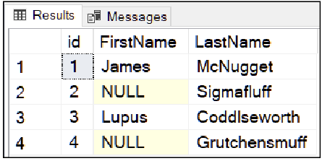
Figure 15- 8. This screenshot shows what you should have in your Customers table at this point in the chapter.
It isn’t serious if your Customers table doesn’t look quite like this, but you may have to modify future commands to suit what you have.

Inserting Multiple Rows With a Single INSERT

Figure 15- 9 shows a form of the INSERT command that inserts more than one row at a time. In this case, you are going to insert three rows into the Products table.
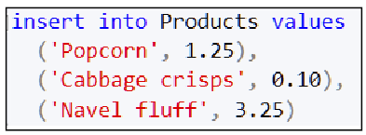
Figure 15- 9. This single INSERT command inserts three rows.
This version of INSERT is a convenient and visually pleasing way to avoid typing the keyword INSERT over and over in a script.

Inserting Faulty Data Into Sales: Testing the PK-FK Constraints

Can you work out how you would insert the following sales into the Sales table?
1. James buys 5 packets of popcorn and 2 bags of navel fluff.
2. Lupus buys 1 packet of cabbage crisps
3. Sigmafluff buys 4 bags of navel fluff
Did you come up with an INSERT that is similar to Figure 15- 10 or perhaps the slicker (but longer to type) Figure 15- 11?
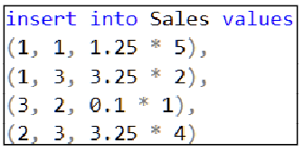
Figure 15- 10. One way to insert the sales data as given in the text. The multiplier is the quantity of an item sold.
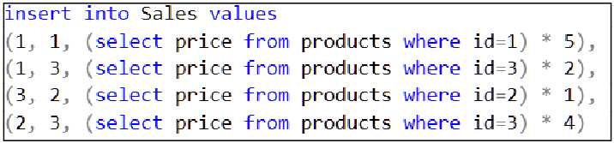
Figure 15- 11. Inserting data into Sales by avoiding having to look up the product’s price. You do need the products IDs though. The multiplier is the quantity of an item sold.
Using the script in Figure 15- 10 requires you to look up both the product’s primary key and its price. Figure 15- 11 looks the price up for a given product ID for you. Figure 15- 11’s script is longer to type in, but it is more robust in a production script that you intend keeping for a long time; all you need to supply to the script in Figure 15- 11 is the product ID.
There are a few side notes about my design of the sales table.
- I designed it for teaching purposes and not for real-life usage.
- The table could do with a quantity column which I left off for simplicity’s sake.
- A positive point about the design is that It stores the value of the goods when you enter the sale. Doing so avoids a potential time anomaly (section 1.12).
I made sure to highlight point 3 to show that you need to prevent a possible time anomaly (discussed in section 1.12). The last thing you want is to view your past sales figures sometime in the future and see old sales information that uses the most up-to-date prices.
The second set of inserts retrieve the current selling price of a given product, multiply it by the quantity, and then record the sale’s value at that time.

Violating the Constraints

Let’s try to insert a sale that refers to a customer that doesn’t exist (customer number 9). Figure 15- 12 shows the attempt, and Figure 15- 13 shows the result.
Figure 15- 12. An attempt to insert a sale for a non-existent customer number 9.
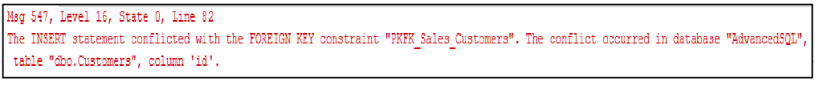
Figure 15- 13. This error is what you will see if you attempt to sell to a customer that you haven’t defined in the Customer’s table.
SQL is not terribly happy, is it? SQL will not let you sell to a non-existent customer. You must refer to a valid existing customer id when you insert a sale.
This PK-FK constraint saves you or an application from making silly errors. If you hadn’t programmed the PK-FK constraint into the Sales table, you would have been able to make such an error; the system would have stored the sale for customer number 9. Future INNER JOINS applied to the tables would not reveal the faulty data. You would have a mess, possibly a silent one, on your hands. I hope this also shows you that OUTER JOINS are usually the better, safer join type to use over an INNER JOIN.
If you are following along on your machine, try and make a sale of a none existent product. You will get a similar result. PK-FK constraints can be a lifesaver, but in reality, the programmer of the tables doesn’t always think to specify them.

Trying Out Computed Columns and DEFAULT, CHECK and NULL Constraints

Now let’s try out some other common constraint types that you will find in many tables. You will use the WarehouseProducts table from chapter 14 to find out what they do. I have repeated the script that creates the WarehouseProducts table inFigure 15- 14 for easy reference.

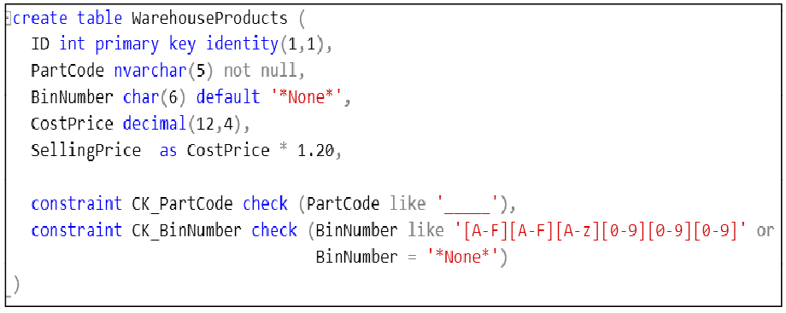
Figure 15- 14. The definition of the WarehouseProducts table reproduced from Chapter 14. The definition of CK_PartCode contains 5 underscores.
If you run the INSERT in Figure 15- 10, you will find a single row in your WarehouseProducts table (Figure 15- 11).

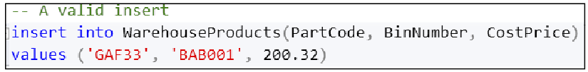
Figure 15- 15. Insert a valid row into the table.
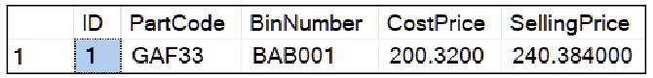
Figure 15- 16. This screenshot shows what the insert in Figure 15- 15 gives you.
Have a look at the SellingPrice column. SQL calculated this column’s content according to the formula assigned to the column’s definition (Figure 15- 14). SellingPrice is known as a computed column. SQL does not store the content of SellingPrice in the table. SQL calculates this column’s content for each row when you reference or display the column. SellingPrice’s content doesn’t use any disk space unless you index it or you request it to be PERSISTED (a keyword you can place next to the column’s definition). I like to think of computed columns as “synthetic columns” because they aren’t stored physically in the table. SQL only keeps the formula used to produce their contents in the table.

I put the SellingPrice column into WarehouseProducts table so that you can see the syntax if you want to create a computed column of your own. In reality, calculating the selling price this way is a bad idea since the markup will change with time. The practical way to calculate the selling price is to look the markup percentage up from a separate table.

Now run the INSERT in Figure 15- 17, which results in the WarehouseProducts table having the content in Figure 15- 18.

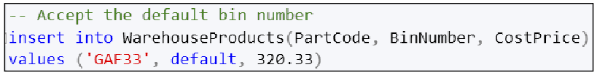
Figure 15- 17. An insert command that loads a default value into the BinNumber column.
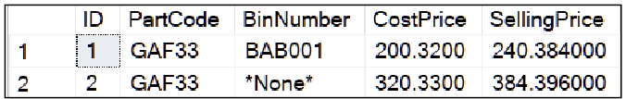
Figure 15- 18. Putting DEFAULT into the BinNumber column tells SQL to store the assigned default value of ‘*None*’.
Now try to put a NULL into the PartCode column as in Figure 15- 19. This column has a constraint specifying that it is to reject NULL values. You will see the output in Figure 15- 20.

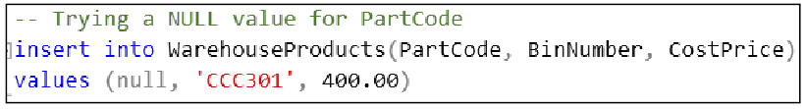
Figure 15- 19. An attempt to insert a NULL into a NOT NULL column.
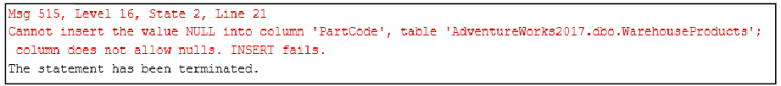
Figure 15- 20. The result of running the query in Figure 15- 19.
Now try to insert an invalid bin number as in Figure 15- 21, which will result in you seeing the output in Figure 15- 22.
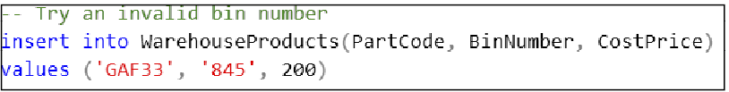
Figure 15- 21. This INSERT command INSERT uses a bin number that does not match the check constraints requirements.
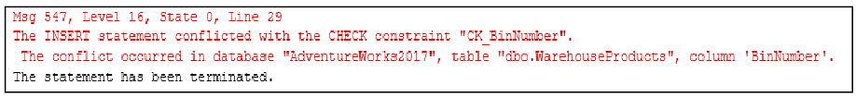
Figure 15- 22. The check constraint’s name makes it clear what you have done wrong trying to run the script in Figure 15- 21.
You receive the error in Figure 15- 22 because CK_BinNumber requires the part code to have 6 characters. You must set the first two characters to be the letters A-G, the next letter must be from A-Z, and then that must be followed by three digits of 0-9.

Let’s try inserting a part code that has too few characters by running the script in Figure 15- 23.

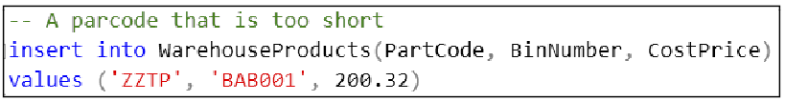
Figure 15- 23. An invalid part code. It should be five characters long.
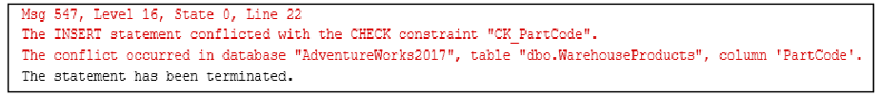
Figure 15- 24. This output shows the result of violating CK_PartCode by using the short part code given in Figure 15- 23.
Try various ways to both break and satisfy the various constraints. You can have hours of fun playing with them–okay, maybe 10 minutes worth tops. You want to convince yourself that you can preserve logical integrity; in other words, the data you store always makes sense.

Copying Rows Into An Existing Table

Sometimes you will need to copy rows from one table into another. Copying rows is a powerful ability to help you archive ageing data out from a busy table, copying data into an existing table from one database to another and for implementing row-based data recovery scenarios.

You do this with the INSERT SELECT command. This command lets you choose which rows you want to copy as well as which columns you want to copy. Furthermore, you can copy column data to destination columns with different names or even modify (transform) the data as SQL copies it from the source table.

The INSERT SELECT command is easy to understand. It is an INSERT statement that grabs the output of the SELECT statement that immediately follows and inserts it into the destination table and columns of your choice. The SELECT statement can reformat the source table’s columns and choose whichever rows you wish.

INSERT INTO destTable(destCol1, destCol2, destCol3,...)
SELECT srcCol1, srcCol2,s rcCol3, ... FROM srcTable
Figure 15- 25. The syntax of the INSERT INTO command.
If you look at the syntax (in Figure 15- 25) of the INSERT INTO statement carefully, you will realise that it uses an ordinary SELECT statement which chooses the source data you want, preceded by an ordinary INSERT statement into any suitable table with suitable columns. Give yourself a moment to think about how powerful that simple syntax is. INSERT SELECT is my favourite SQL statement because it is so clear in structure, powerful in functionality and visually pleasing.

You cannot use INSERT SELECT to copy the identity column’s value from one table into another. That is because the destination table must compute its own next available identity column value to ensure that it is unique for that destination table.

If you want to override this mechanism and insert identity column data, you can do so after researching about how to do that here: https://docs.microsoft.com/en-us/sql/t-sql/statements/set-identity-insert-transact-sql?view=sql-server-ver15 and https://docs.microsoft.com/en-us/sql/t-sql/database-console-commands/dbcc-checkident-transact-sql?view=sql-server-ver15. If you decide to try this, be sure to practice on sample data first. You can cause errors in the identity column that can take days if not weeks to reveal themselves.

An Example of INSERT SELECT

Figure 15- 26 shows an example of using INSERT SELECT. The example begins by creating an empty table to insert data into rather than inserting into an existing table. You can easily use a suitable existing table instead. I made this choice because I didn’t want to risk “damaging” any existing data in Adventure Works.
The INSERT part looks like a conventional INSERT statement except instead of using VALUES you follow it by a SELECT. The SELECT picks out the columns from Production.Product that match the columns in the CopyOfProducts table. The example shows a valuable feature with a simple example; the SELECT’s WHERE clause only returns the rows where the product name starts with the letter “P”. You can see the results in Figure 15- 27.
Don’t be put off by the length of the column lists in Figure 15- 26. I didn’t type the column names out; I produced the list by simply dragging the word “Columns” from under the Production.Products table in the Object Explorer onto the text editor and deleted the ProductID column from the list. If you haven’t tried this facility before, it is well worth remembering and possibly trying it.
“*” rarely works with an INSERT SELECT statement because you will very likely have to deal with an identity column in the source and destination tables. You will have to skip these columns in the column lists.

The SELECT part of the INSERT SELECT statement is a free-running SELECT statement. In other words, you can run it and test to see that it extracts the data you want without performing an INSERT. You can swipe the mouse over the SELECT, run it on its own, look at the output and then decide if you are ready to execute the INSERT prefix. That is so lovely and clever.

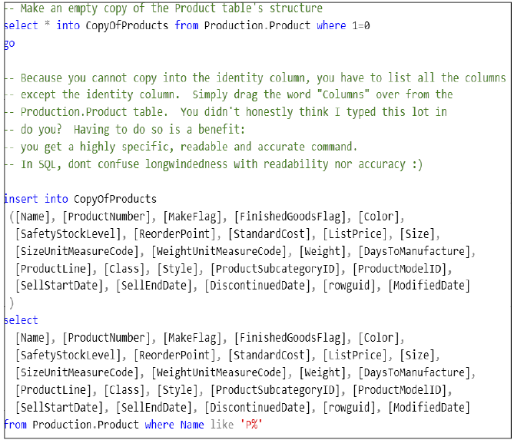
Figure 15- 26. Using INSERT SELECT to insert all products whose name starts with the letter P into an existing–albeit blank–table.

Figure 15- 27 shows what is in the CopyOfProducts table once the INSERT SELECT has executed.
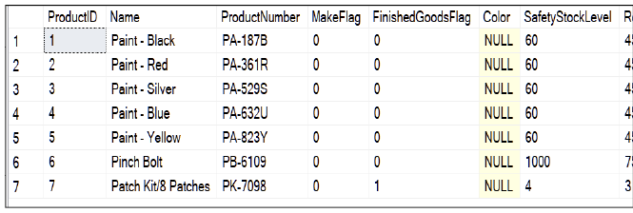
Figure 15- 27. The data copied into the CopyOfProducts table once the INSERT SELECT has completed.

  - An Example That Transforms the Data

Here is an example that transforms the data as SQL copies the rows into the destination table. “Transform” means that SQL will manipulate the rows in transit from the source to the destination table. Transforming the data is useful, for example, if you want to archive the results of a GROUP BY query in a table for future speedier future lookups.

Products such as Microsoft’s SSIS (SQL Server Integration Services, it comes with SQL) allow you to create stand-alone packages that implement this kind of work using a GUI interface. You will need a solid understanding of SQL to use SSIS. SSIS creates (amongst other things) ETL jobs. ETL stands for extract, transform and load, which represents the data selection process (extract) the transforming of the data and inserting the data into a destination (load).

The scenario behind the example in Figure 15- 28 is that you want to propose a new set of prices for Adventure Work’s products. You want to create a table that contains a list of the products’ names, their subcategory names and the new prices. The new prices will be 15% higher than the current prices.

Colleagues will look through, analyse or even edit the proposed prices as they wish without disturbing the actual products table. You don’t need to copy all the columns from the products’ table as they are irrelevant for the purpose.

In the SELECT statement in Figure 15- 28, you will see that I have multiplied the list price from Production.Product by 1.15 to add 15% to the price. The modified price is recorded permanently in the ProposedProductPrices table and so doesn’t need recalculating whenever you display that table. That step represents the transformation, albeit a minor one.

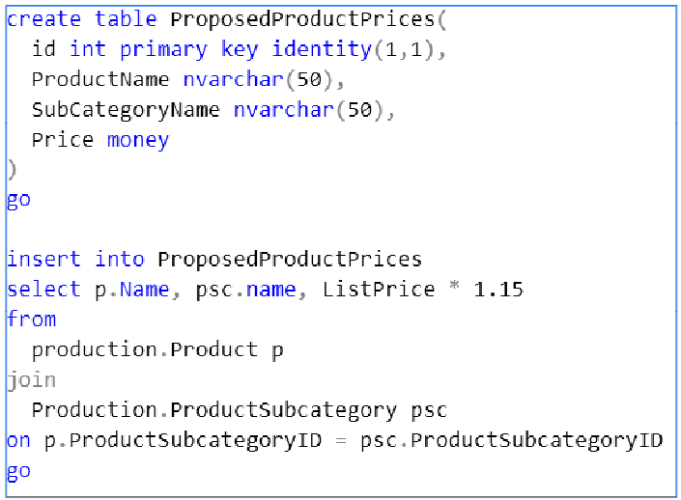
Figure 15- 28. The SQL to create a new table that will permanently store the updated prices. The second half of the script transfers the data from an existing table into the new table.

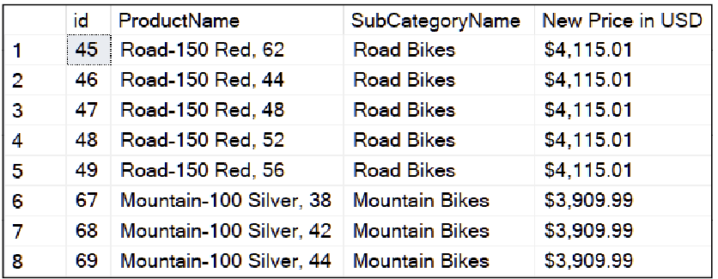
Figure 15- 29. The results from the content of the newly created ProposedProductPrices table.

Useful Tip: Data Types in the Destination

If you create the destination table yourself, arrange it so that you copy data from a source column to a destination column that has the same data type or one that has a higher capacity. Please don’t guess the data type for the destination columns; you might truncate character columns (shorten them by dropping characters), lose digits after the decimal point or cause overflow errors.

In my example, as much as I do not recommend using the money type for storing money (see 2.15.3), that is the type chosen by the table’s designer, and so I have kept it. For character fields, don’t guess their length, use the Object Explorer to see what they are in the source table.

I could have mapped the price column onto a suitably specified decimal column if I wanted to. I decided to be consistent instead.

A Comparison Between SELECT INTO and INSERT SELECT

Give yourself a chance to think about the differences and similarities between SELECT INTO and INSERT SELECT for a few seconds.

SELECT INTO creates a new table made up of existing column’s names and data types from another table. It does not copy such characteristics of which column(s) are the primary column(s), it does not copy constraints such as check and PK-FK constraints and neither does it implement indexes.

SELECT INTO does copy the identity attribute and NULL constraints. It converts the contents of a computed column into a physical column of equivalent type.

INSERT SELECT requires a valid existing table. SQL uses any constraints, indexes and so on as they are on the destination table. Don’t insert into a computed column on the destination; there should be no need.

INSERT SELECT copies data and nothing else because the destination table already exists. You would have created the destination table complete with constraints, computed columns, indexes and the like in advance.

The Exercise

I would highly recommend doing the example in this chapter’s text yourself.

The “official” exercise is going to insert data into the CarSales and CarWarehouse table from the previous exercise.

If you need assistance, consult Appendix F or my Solution that you can download from my web site (https://www.Transference-UnLimited.com).

Exercise 15. Inserting Data

Add a new query to your “My Class Queries” project and name it “Inserting Data”. Put a descriptive comment at the top of the script and follow it with a suitable USE clause that accesses the AdventureWorks2017 database.

Ex 15.1. Insert Data Into The Warehouse and Sales Table

To do this exercise, you will need to have created the tables in Exercise 14 or have run the script for Ex 14.1’s answers that are in Appendix F.
Use Table Ex 15- 1 to insert the car models and quantity of each model that you have in your warehouse into the CarWarehouse table.

Description: | Units in stock:
Green Three-Wheeled Spinner | 18
Orange Kneecruncher | 36
Big Car With Gadgets | 7
Pink Perambulator | 14
Table Ex 15- 1. The cars you have in your warehouse.
Now insert some sales data into CarSales according to Table Ex 15- 2.

Car Sold: | Quantity Sold:
Orange Kneecruncher | 4
Big Car With Gadgets | 2
Green Three-Wheeled Spinner | 7
Pink Perambulator | 3
Big Car With Gadgets | 1
Table Ex 15- 2. A record of sales of your cars.

Ex 15.2. Testing the Constraints

Try and see what happens if you attempt to insert a sale for a non-existent car ID. Read through the error so that you will recognise it in the future should this error occur when you work on your database in the office.
Try and insert a car into the warehouse that has a name that is fewer than ten characters long.

Ex 15.3. Insert Into

Insert rows from the Sales.SalesOrderHeader and Sales.SalesOrderDetail table for the year 2012 into the pair of tables you created in the previous exercise: Sales.DataForReportsSalesOrderHeader and Sales.DataForReportsOrderDetail.

Deleting Data

This chapter will show you how to delete rows of data. You must use the DELETE command with care because it is easy to delete rows you didn’t mean to delete. The DELETE command almost always has an attached WHERE clause that will select the rows you want removed.
I strongly suggest that you test the proposed WHERE clause’s condition by copying it into a SELECT statement and executing that first. That will allow you to make sure you will delete the rows you intend to.
Once you are happy with your WHERE clause, edit the SELECT statement to become a DELETE statement.
You are going to learn:
- How to use the DELETE command
- The difficulty of deleting rows on a table without a primary key
- What happens when you attempt to violate PK-FK relationships
- How to delete rows in a table determined by the contents of another table

The Delete Command’s Syntax

The general syntax of DELETE is in Figure 16- 1.

delete from table where conditionToSelectRows
Figure 16- 1. The general syntax of DELETE.
Let’s look at the syntax via some examples. I have shown the customers from the previous chapter in Figure 16- 2.
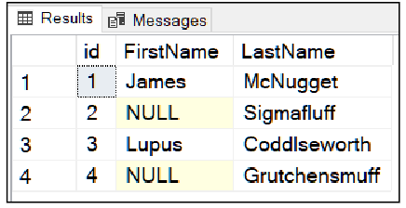
Figure 16- 2. What is currently in the Customers table, assuming you have followed the previous 2 chapter’s instructions. It doesn’t matter if your table doesn’t look exactly like this; edit my other queries to suit what you have.
If you type in the delete command in Figure 16- 3, you will remove Grutchensmuff’s row since the id for that row is 4.
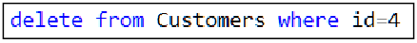
Figure 16- 3. A delete command to get rid of Grutchensmuff’s row in other words the customer whose id is 4.
You could use the command in Figure 16- 4 instead.

Figure 16- 4. Another way to rid Customers of Grutchensmuff.
If you run both delete commands, only one will do a delete; the other will complete without reporting an error, but SQL will tell you that 0 rows were affected. That information is worth remembering if you are looking to correct mistakes in a script in the future.
Note the IS NULL in the second example to make sure that you delete the correct Grutchensmuff. Is that reliable enough for real-world usage? Having two ways to delete a customer sounds like trouble to me, and I hope it does for you too. You are going to find out what that trouble could be.

An Easy Mistake To Make

The most accurate way to identify a row for deletion is to use the primary key value of that row. Compare that strategy to the one used in Figure 16- 5.

delete from Customers where LastName=’Howell’ and FirstName=’Michael’
Figure 16- 5. An example of an unreliable way to delete a row.
If you had two or more Michael Howell’s in your database, you have just wiped them all out. Oops!
The DELETE drama for removing Michael Howell should have played out like this:

First check that you have the correct Michael Howell:

select * from Customers where LastName=’Howell’ and FirstName=’Michael’

And you get:

1 Howell Michael 555-123 123
2 Howell Michael 555-444 999
3 Howell Michael 555-888 777

Oh, dear! You thought there was only one Michael Howell in the system. Thank goodness you followed the course author’s advice and checked that there was more than one matching row.

Several phone calls to three Michael Howells later, you discover that you want to erase the Michael with an id of 2:

delete from Customers where id=2

Success!

Useful Tip: Don’t Delete Data Without Considering the Consequences

In practice, you rarely delete a customer’s data from a database. Instead, you would have a column in the customer's table that serves as an indicator as to why you no longer contact this customer or why you don’t use this version of the customer’s information anymore. You do not necessarily have legal permission to destroy the old data.
For instance, a former residential address that you used at Amazon 15 years ago is still in their system, and you are free to go into their web server and look it up.
If you glibly delete rows rather than mark them as “disabled” be careful; Mr Receiver of Revenue or Mr GDRP may become curious about your data management techniques. Best to check what is legally required first.

Beware The Heaps of March

Okay, that was a bad Shakespeare joke. But the hyperbole does sound deliciously foreboding.
Heaps are the category of tables that don’t have a primary key. Because they don’t have a primary key, it can be tricky to delete single rows from them. In fact, it is impossible to distinguish between duplicate rows, and so you are only able to delete all the duplicated rows simultaneously. If you find yourself in such a situation, you have to add a surrogate primary key column to your heap and so convert your heap into a clustered index. You can then identify each row.

Violating Constraints Using Delete

When explicitly programmed, PK-FK relationships are extremely helpful in that they protect you from deleting data that could have unintended consequences.
The Sales table currently looks like Figure 16- 6.
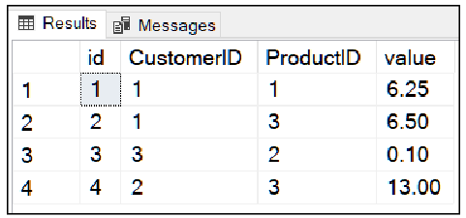
Figure 16- 6. The current contents of the Sales table.
We can see that customer id 3 has bought some number 2’s. If you try and remove customer number 3 from the system (Figure 16- 7), and you will see Figure 16- 8.
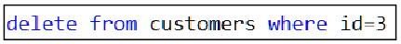
Figure 16- 7. A command that will attempt to delete a customer that has sales.
Figure 16- 8. The PK-FK relationship kicking in to stop you deleting customer 3. This error happens since the customer has sales in the Sales table.
You can infer from the name of the constraint that you have attempted to delete a customer that has sales. I also hope this reiterates to you the value of giving your constraints meaningful names.

Deleting Data Based on Data in A Different Table

SQL has an interesting version of the DELETE command called DELETE FROM FROM that lets you delete rows from one table based on the content of another. This command matches rows from one table against those of another using a boolean expression that links the two tables rows together. It deletes a row from the first table when it finds a row in the second table that causes the boolean expression to evaluate to true. Figure 16- 9 shows DELETE FROM FROM’s general syntax.

DELETE
FROM tableToDeleteFrom
FROM tableThatDecidesRows tableAlias
WHERE
conditionForRowTobeDeleted
Figure 16- 9.The general syntax of DELETE FROM FROM. This command deletes rows in one table based on data kept in another. You have to use a table alias for the second table, or you will cause a syntax error.

An Example Using DELETE FROM FROM

Let’s say that you receive orders from customers for products that you have to manufacture. You enter the request for its manufacture by inserting a row into a WorkInProgress table. At the end of each working day, when the manufacturing department has completed the product, they want to delete the completed product row from the WorkInProgress table.
As the manufacturing department completes a product, they enter a row for that product into a CompletedProducts table. At the end of every day, you want to use the CompletedProducts table to delete the finished items from WorkInProgress. You can look at the work in progress table to see what progress the manufacturing department is making.
Let's mimic this idea using SQL. Figure 16- 10 shows a script to create a pair of demonstration tables you can use to see the syntax of the DELETE FROM FROM. It then inserts some products to manufacture into the WorkInProgress table (Figure 16- 11).

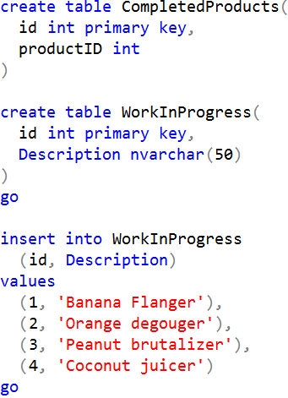
Figure 16- 10. This script mimics the manufacturing scenario I have described in the text.
If you execute the script in Figure 16- 11 you will record that the manufacturing department has completed a request to make an Orange degouger and Coconut juicer (not that I would buy these products myself mind you).
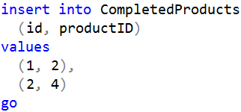
Figure 16- 11. A script to insert products that you manufactured during the day (the Orange degouger and coconut juicer).
Figure 16- 12 shows the WorkInProgress table before you update it using CompletedProducts.
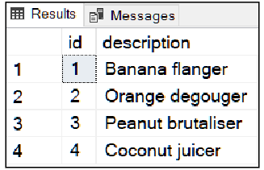
Figure 16- 12. What you should see in WorkInProgress table before the DELETE FROM FROM operation is applied.
If you run the command in Figure 16- 13, SQL will remove the rows from WorkInProgress that are in the CompletedProducts table based on the product id’s matching in both tables.

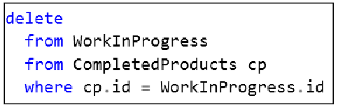
Figure 16- 13. The DELETE FROM FROM command that will remove items from WorkInProgress that are in CompletedProducts.
You will end up with a WorkInProgress table looking like Figure 16- 13:
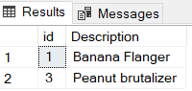
Figure 16- 14. The WorkInProgress table after the DELETE FROM FROM has occurred.
For SQL to realise that this is not a standard DELETE command, you can’t use a table alias for the first table. You must use one for the second, or you will receive an error.
The WHERE clause’s expression can contain any combination of operators and columns from either table, not just the primary key column. DELETE FROM FROM effectively joins the two tables together to work out which rows to erase.

The Exercise

I would recommend trying out the SQL scripts in this chapter for practice.
The official exercise requires you to have successfully done all the previous exercises from Chapter 14 onwards.
You can find the answers in Appendix F. My website can supply a complete SSMS Solution for all the chapters at https://www.Transference-UnLimited.com

Exercise 16. Deleting Data

Add a new query to your “My Class Queries” project and name it “Deleting Data”. Put a descriptive comment at the top of the script and follow it with a suitable USE clause that accesses the AdventureWorks2017 database.

Ex 16.1. A Dealership Returns a Car

The car dealership that ordered the second order of a Big Car With Gadgets has decided to return the car to you, the manufacturer, as their customer cancelled their order.
Please delete the row in CarSales that corresponds to that sale. Do not adjust the warehouse’s stock levels to reflect any changes. You will do so in the next chapter.
To check that you have identified the correct row, it would be a good idea to test your DELETE’s WHERE clause by displaying the row with a SELECT statement with a matching WHERE clause. Checking your WHERE clause before doing a DELETE is a recommended practice.

Updating Data

This chapter is going to explain ways to modify the contents of existing rows. Updating data does come with the same caveat as for deleting data: UPDATE has a WHERE clause and you will want to test your proposed conditions with a SELECT statement first. You don’t want to update the wrong rows.

In this chapter, you will learn:
- The syntax of the UPDATE statement
- What happens when you violate a PK-FK constraint with an UPDATE
- Updating in one table based on data in another

17.1. The Fundamentals of UPDATE

Figure 17- 1 is the current Sales table which I have joined onto the Customers and Products table. Figure 17- 2 shows the query that I used.

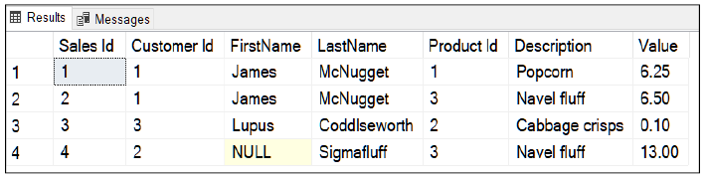
Figure 17- 1. The Sales table displayed after joining it to Products and Customers.

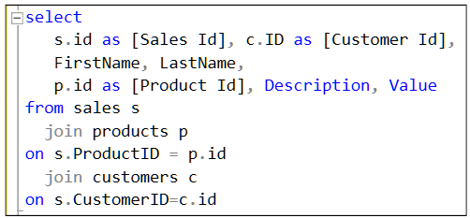
Figure 17- 2. The SELECT statement that displays the Sales table, as seen in Figure 17- 1.
Now let’s say Lupus (the third row) has decided he isn’t so keen on the cabbage crisps (I can’t imagine why) and wants to swap them for your super popular option of navel fluff. You can implement this change by typing in the script in Figure 17- 3.

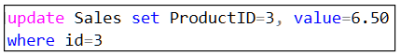
Figure 17- 3. The UPDATE statement to swap Lupus’s order of cabbage crisps for navel fluff.
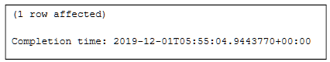
Figure 17- 4. SQL confirms the update.
Figure 17- 4 confirms 1 row was affected. If SQL showed 0 or a number higher than 1, you would know you have a faulty WHERE clause or you have misunderstood the data in your table. If the number of affected rows exceeded 1 and you intended only to edit a single row, I’m afraid you would have permanently damaged the data in your table. You would have to figure out how to reverse the update, very likely having to restore the database. However, you might find chapter 18 can help you control accidental updates in the future.

You type the keyword SET in once, and then a list of comma-separated equates between a column’s name and the new value. The value can contain mathematical expressions based on any of the columns in the current row in the table.

17.2. Updating To Test Violating a PK-FK Constraint

This time, let’s update the sale to Sigmafluff. His row (row 4) shows that he too has bought a bag of Naval fluff. Figure 17- 5 shows an UPDATE command that will change his sale to refer to a product we haven’t registered yet, product id 4. Figure 17- 6 shows the result.

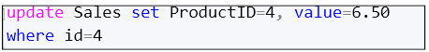
Figure 17- 5. An UPDATE statement to attempt to get Sigmafluff (id=4) to buy a product that doesn’t exist.

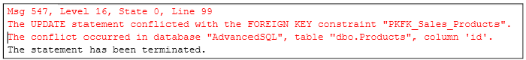
Figure 17- 6. The error confirms that you can’t sell a product that you haven’t entered into the Products table first
SQL tells you that such a sale isn’t going to happen. The constraint’s name given in the error explains that we have tried to break the relationship between sales and products. We would need to create product 4 first. Then we can update the row about the sale.

17.3. A Valid Update

Let’s create a new product by registering it in the products table (Figure 17- 7). You know the ID will be 4 because you have been paying attention to the previous section. In the real world, you would have to check the new ID allocated to the product. If you add the product and it gets an ID other than 4, take note of the ID number and adjust the following UPDATE statement accordingly. Figure 17- 8 confirms that the addition of the Scratchamazoo (you know you have always wanted one) was successful.
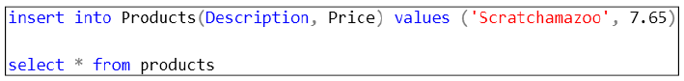
Figure 17- 7. An INSERT statement to put our new product, a Scratchamazoo, into the Products table.

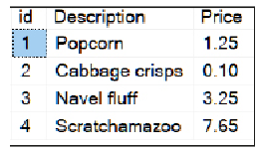
Figure 17- 8. Confirmation that the new product (id=4) is now ready to be sold.

Let’s redo our update to Sigmafluff’s order and see if it works. Figure 17- 9 shows the update statement to make the change, and Figure 17- 10 confirms that it works.

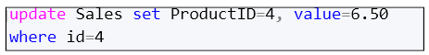
Figure 17- 9.An update that sells a Scratchamazoo to Sigmafluff.
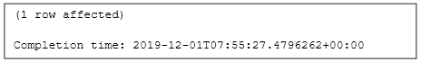
Figure 17- 10. Confirmation that Sigmafluff bought a Scratchamazoo.

17.4. Updating Data Based on Another Table

Let’s say that you need to replace the prices of certain items in your Products table. The marketing department supplies you with a table that contains the ID’s of the products to change and the new selling price of each product. You then use the UPDATE FROM statement to apply the changes.

UPDATE tableToUpdate
SET col1 = newCol1, col2 = newCol2...
FROM
tableThatContainsReplacementValues ttcrv
WHERE
conditionThatMatchesColumnValuesInTheTwoTables

Figure 17- 11. The general syntax of the UPDATE FROM command. The alias ttcrv stands for “table that contains replacement values”.
Let’s run some script that will create the scenario I have described for you. Firstly, let’s check what is in the Products table (Figure 17- 12).

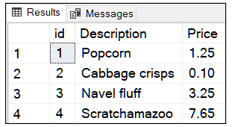
Figure 17- 12. The Products table after the UPDATE ready for the next example.

Figure 17- 13 is a script that will the table containing the new prices for products 2, 3 and 1.

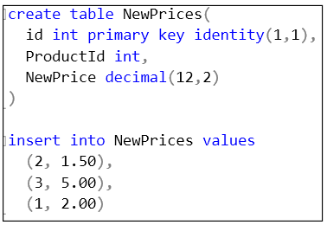
Figure 17- 13. A script that creates the table of new product prices.
Now apply the UPDATE command shown in Figure 17- 14. This query finds the products whose ID matches the NewPrices table’s ProductId column and replaces its price with a new one.

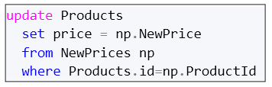
Figure 17- 14. The UPDATE FROM command that will replace some of the product’s current prices with new ones.

And now the Products table looks like Figure 17- 15.

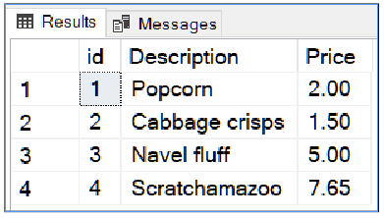
Figure 17- 15. The newly updated Products table after applying the script in Figure 17- 14.

Now you know how to prepare updates in advance before applying them to a table. This skill means you can check and edit the proposed updates, and when you are happy, you can apply those changes with a single command.

17.5. The Exercise

If you haven’t tried the examples in the chapter’s text, please give them a go so that you get the fundamentals of UPDATE firmly into your mind.
Once you have done that, there is an “official” exercise for you for this section. As always, Appendix F has all the answers.
If you prefer, you can download my SSMS Solution containing all the answers from my website https://www.transference-unlimited.com.

Exercise 17. Updating Data

Add a new query to your “My Class Queries” project and name it “Updating Data”. Put a descriptive comment at the top of the script and follow it with a suitable USE clause that accesses the AdventureWorks2017 database.

Ex 17.1. Make Stock Level Adjustments to The Inventory

Write a pair of update statements to adjust your stock levels of cars in the warehouse. The new stock levels appear below:

Description | Units In Stock
Green Three-Wheeled Spinner | 24
Big Car with Gadgets | 14
Table ex 17- 1. The two separate updates to make to the car warehouse table (CarWarehouse).

Ex 17.2. Update the Inventory Based on the Sales

Use the sales table to adjust the stock in the warehouse. Do this task with an INSERT FROM command.
Figure ex17- 1 shows my Warehouse table before the INSERT FROM was applied, and Figure ex17- 2 shows the results so you can check your results. The UnitsInStock column reflects the changes.

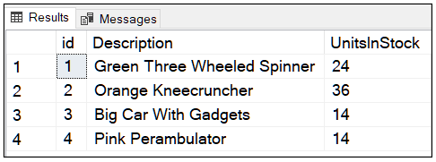
Figure ex17- 1. The starting stock figures if I look at my table as it currently stands. Look at what yours has before you start the exercise. That way, you can check if you have made the adjustments have correctly.

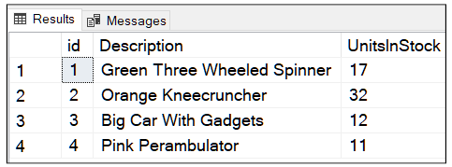
Figure ex17- 2. The stock levels after the adjustment using INSERT FROM.

Fundamentals of Explicit Transactions

In this chapter, you are going to find out precisely what transactions are they implicit or explicit. In short, you can use transactions to explicitly control the outcome of a group of SQL statements that all need to execute successfully, or if not, no trace of their partial execution must be detectable.

What you will learn in this chapter:

- How transactions protect your data
- How to create and control an explicit transaction
- How to use @@ERROR to exit failed transactional script gracefully
- How transactions affect other users: optimistic and pessimistic locking
- How to create a pessimistic locking situation–T-SQL’s default locking mode–and what happens when it occurs
- How to create a SELECT statement that ignores locks on data

18.1. A Transaction Begins

Let’s look at an example where explicit transaction control is useful. You want to move money between two of your bank accounts; you want to pay your credit card using your cheque account.

One account, your cheque account, is kept on a mainframe in Johannesburg. The other account, your credit card, is kept on a mainframe in Pretoria. Off you go and log into your bank’s web site and fill in the form to transfer the money. You click ‘okay’...

There are three machines involved: the bank’s web server and the two mainframes. You can discount the browser. A browser is little more than a conduit that triggers code running on a remote machine (the webserver) and displays the results as prompted by that remote machine. A user’s browser doesn’t directly come into this equation. The bank’s web server is in charge of the entire transaction, not the mainframes. Variations on this configuration are possible.

The web server tells the mainframe in Johannesburg that it is enlisting it into a transaction. The mainframe now knows that the webserver is the master that controls the transaction. We refer to the transaction as an ambient transaction. The term “ambient” highlights that the transaction is “in the atmosphere; it is available for anyone involved to see and to communicate with it. All future commands are going to be affected by the transaction’s state: successful or a failure. All the machines can discover the status of the transaction.

The bank’s web server sends the withdrawal instruction to the mainframe in Johannesburg. The mainframe acknowledges with a success message and that it is aware of it being in a transaction controlled by the webserver. The mainframe does not make permanent changes to its data; the changes are tentative. The mainframe is waiting for a signal from the ambient transaction to say that it must make these changes permanent. The webserver will let all the machines involved know, via the ambient transaction, if they must make their changes permanent.

An ambient transaction can timeout because it is taking too long to commit. This situation happens if the machines involved lose communication with each other. In that case, all the machines will assume the worst case and rollback any changes they began under the transaction’s control. All the machine’s involved enlisted in the transaction will record that the transaction aborted—this will be useful for humans and machines to reference in the future.

The web server then begins transmitting the deposit instruction to the mainframe in Pretoria. As luck would have it, someone steals the telecoms cable between the web server and the credit card company’s mainframe just before the deposit instructions get to their destination. Where is your money now?
Luckily, it hasn’t gone “poof!” and disappeared in a tear-inducing wisp of smoke. The communication between the webserver and the credit card mainframe times out. The webserver marks the ambient transaction as a failure and tells the first mainframe that it must roll back its changes. You money reappears in the source account. You live to repeat the transfer another day. In the meantime, your money is in a known safe place. A nuisance, yes, but your money is safe.

18.2. How Do Transactions Affect You?

Let’s practice using transactions so you can see what they involve. Create the tables in Figure 18- 1 in Adventure Works so that you can experiment with controlling transactions yourself. I have used “Transaction” as a table name prefix to avoid clashing with the Products and Sales table should you have one. You could create a schema called Transaction instead if you would like to try that approach.

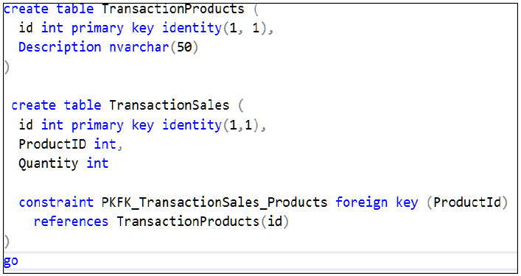
Figure 18- 1. A script to create tables we will use to learn about transaction control. Transaction prefixes the table names to avoid clashes with any existing table called Products or Sales.

Let’s insert some products to sell as I have done in Figure 18- 2.

Figure 18- 2. A script to insert three products into the TransactionProducts table.

If you look at the contents of TransactionProducts, you should see what is in Figure 18- 3. You are now ready to offer these items to the world.

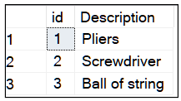
Figure 18- 3. A screenshot of what you should see in the TransactionProducts table.
Ask yourself what would happen to the TransactionSales table’s content if you issued the commands in Figure 18- 4. Once you have considered the output, try running the script and see if the result agrees with what you thought.

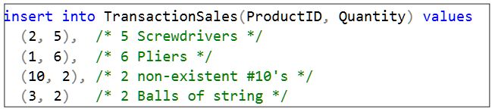
Figure 18- 4.This script is an insert which contains erroneous data; there is no product number 10.

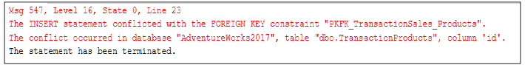
Figure 18- 5. The error you will get if you execute the insert command in Figure 18-4.
Since there isn’t a product with an id of 10, you will get the error in Figure 18- 5. What will you find in the TransactionSales table? Figure 18- 7 shows the results.

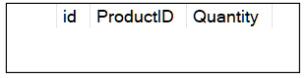
Figure 18- 6. The contents of the newly created TransactionSales table after applying the script in Figure 18- 4. Yes, there is nothing there.

Nothing. The command’s result could have gone in one of two directions: either sales of screwdrivers, pliers and balls of string could have appeared and the faulty row ignored or nothing could happen at all.
What you have discovered is that a single SQL command is a self-contained transaction. Even though the script would have affected four rows, the single command executes as a whole or fails as a whole. SQL regards a single command as an atomic unit. SQL makes this analogy because an atom is the smallest building block of matter. Yes, atoms are technically divisible into smaller particles, the analogy is more romantic than accurate.

18.3. Separate Transactions

Let’s try a different way of inserting as you can see in Figure 18- 8. If you are following along on your computer, be sure to highlight all the insert commands so that they execute as a single batch:
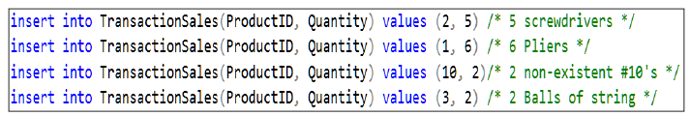
Figure 18- 7. The INSERT command of Figure 18-4 expressed as four separate INSERT statements compared to a single INSERT statement.

This time when you look inside TransactionSales, you get the output in Figure 18- 9.

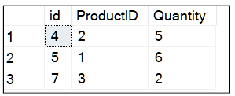
Figure 18- 8. The result of executing the four inserts as separate commands in a single batch. You can see that the attempted INSERT of product 10 has not affected the other inserts.
This result may or may not be what you want–you have the option to choose if this behaviour is what you want. For instance, if the script in Figure 18- 4 represented a single real-time sale to a customer, I would prefer the entire transaction to abort giving me the chance to look through the whole set of purchases just in case there were other errors I missed. An application could quickly resubmit the entire collection of inserts.
If these inserts were part of a batch of transactions done after hours, I might be happy to let some pass and some fail. The next day, I could look at the results, make corrections and apply re-inserts the next day. You must decide what works for you.

18.4. Controlling The Transaction Yourself

The TransactionSales table now rows that you don’t want anymore. Type in and execute the command in Figure 18- 9.

Figure 18- 9. A command to empty the TransactionSales table
TRUNCATE TABLE will empty the table. TRUNCATE TABLE is different to DELETE. Deleting rows would leave the identity counter set to the last value used. A new row will get the next identity value. TRUNCATE TABLE resets the identity counter back to its seed value. You can’t use TRUNCATE TABLE on tables that are lookup tables–tables that are referenced by foreign key constraints. Trying to do that will give you an error. Try and truncate TransactionProducts and see what happens.
Execute this set of commands in Figure 18- 10. You can type TRANSACTION rather than TRAN if you prefer.

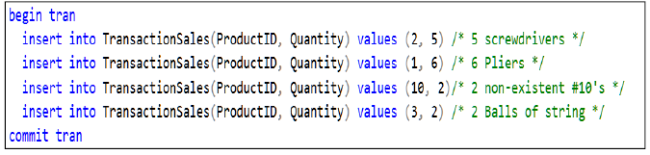
Figure 18- 10. This script shows how to demarcate where a transaction begins and ends with BEGIN TRAN and COMMIT TRAN.

Ignore the error amongst the success messages. Have a look at what is in the TransactionSales table (Figure 18- 11).

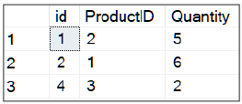
Figure 18- 11. The same rows are back again.
The BEGIN TRAN and COMIT TRAN don’t seem to have done much. What you see in Figure 18- 9 is the start of a mechanism that gives you complete control over how the machine will react to an error.

The COMMIT TRAN told the machine to finalise–make permanent–what happened. Even though there was an error, the COMMIT told the computer to accept the successful changes and ignore the error.

Let’s truncate the table again by running the script in Figure 18- 9 once more.

This time execute everything up to but NOT including the COMMIT TRAN as in Figure 18- 13.

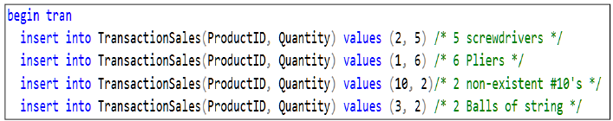
Figure 18- 12. Here you execute everything in Figure 18- 10 except the COMMIT TRAN.
Look at the TransactionSales table, and you will see what is in Figure 18- 14.

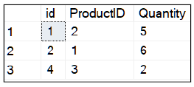
Figure 18- 13. The TransactionSales table while you have a transaction running in the background.
Type in the command in Figure 18- 15.


Figure 18- 14. A command to count the number of transactions you have running in your current session.

SQL will tell you that you have one transaction running in your current session (Figure 18- 16).
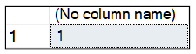
Figure 18- 15. A confirmation that you have one transaction running.

@@TRANCOUNT is a system variable that tells you how many transactions your current session (not the entire machine) has open, 1 in this case. You currently have the opportunity to look at the data and decide if you like it as is.

You can create a nested transaction by executing another BEGIN TRAN within a transaction. In that case, you must execute two COMMIT TRAN’s for SQL to permanently commit the transaction. Nested transaction happen in practice when a script executes another script–usually by calling a stored procedure or the like–and that second script contains a transaction.

Let's decide that we don’t like the results that we see, and so execute ROLLBACK TRAN. Check the transaction count and the results in the TransactionSales table (Figure 18- 17).

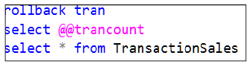
Figure 18- 16. The SQL statements to rollback (undo) the current transaction and confirms that by displaying the number of running transactions.
You will see the results in Figure 18- 18.
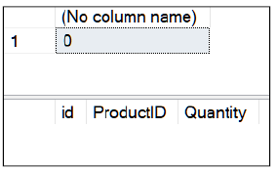
Figure 18- 17. The ROLLBACK TRAN command undoes everything up until the BEGIN TRAN.
ROLLBACK TRAN has told SQL to reject all of the changes. On the other hand, if you executed COMMIT TRAN, you would tell SQL that you want to accept the “partial” changes and you would see the same results that you saw in Figure 18- 14. Another way to look at it is that you can accept the results caused by an error if you choose to.

18.5. A More Graceful Approach

What you often want to achieve for a given script is that it should either run to completion or politely tell the user that the script failed and then terminate, ignoring any further instructions in the script. In my example, I would like the script to report the error under control of the script and then leave the Sales table as it was before the script began. The script should disclose the error details itself and not let SQL intervene with its error processing mechanism. After all, having red errors on the screen is not very elegant, neither is leaving a half updated table.
A demonstration script that solves these problems is in Figure 18- 19.

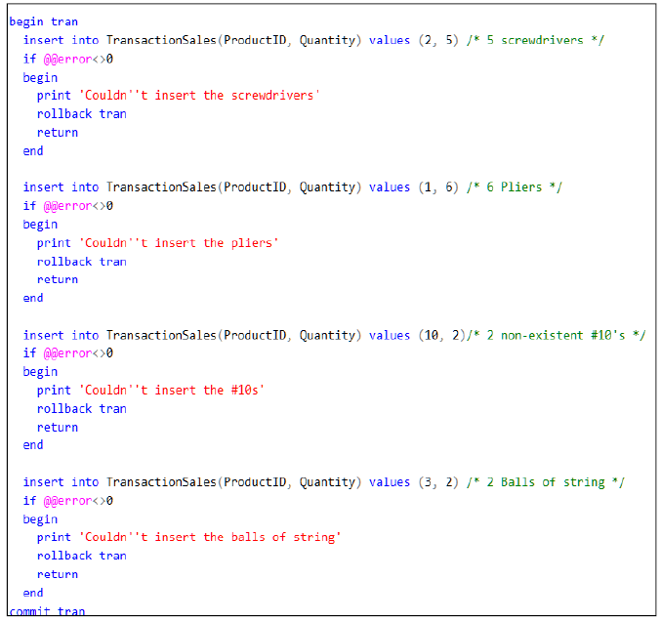
Figure 18- 18. A comprehensive and very repetitive way of making sure each INSERT command succeeds. If the script detects an error, it rolls back any changes and ends gracefully. Note the COMMIT TRAN at the very end which will execute if none of the RETURN commands execute.

Each INSERT comes with an IF statement that checks an integer system variable called @@ERROR. This variable contains an error number that matches the text of the error. If @@ERROR is 0, it means that no error has occurred.
If there is an error, the script will print a user-defined status message prints on the screen. The script then rolls back all the successful inserts up until that point. The RETURN keyword causes the batch/script to stop without any further notification. If the machine gets past the last INSERT command, the changes are made permanent by the COMMIT TRAN.
@@ERROR resets back to 0 as soon as you have read it. Since reading @@ERROR is itself a successful statement that process itself resets it to back to 0. If you want to refer to the error code several times, you must store @@ERROR in a variable ASAP and then continue by reading that variable instead.

Although this script (Figure 18- 19) may seem very long and repetitive, you will find many well-written scripts containing an implementation of the logic shown. In Chapter 19, I will show you how to shorten this script using a mechanism added to SQL called the TRY CATCH block.

How Transactions Affect Other Users

Explicit transactions can appear to be problematic in a system when viewed from the perspective of the other users. I am now going to scratch the surface of a very substantial topic. I will, never-the-less, show you some useful points and some “tricks” you might find handy around the office in both dealing with and helping you understand the nature of transactions.
Transactions cause rows in a table to become locked. Depending on the type of lock, it can mean that the locked rows are either readable but uneditable or not readable by other users. There are two broad kinds of locks: shared locks and exclusive locks.

A shared lock on a row means that other users can read that row, but not edit it. An exclusive lock means that other users can neither see nor edit that row.

Together with the types of lock, there are two broad locking management strategies that SQL can employ. These strategies are pessimistic locking (the default) and optimistic locking. Microsoft SQL uses pessimistic locking unless you explicitly enable and use optimistic locking. Out of interests sake, Oracle defaults to using optimistic locking.

These management strategies affect how other users are affected by the types of locks.

Pessimistic Locking

If you start a transaction and during that transaction, you edit data, you block other users from reading that data until you commit your transaction. That transaction may be created explicitly using BEGIN TRAN and COMMIT/ROLLBACK TRAN or implicitly which would be during the execution of a single command.
Blocking can be problematic if you are trying to read a table while other users are editing it. SQL defaults to this behaviour because it is programmed to make sure that a user sees the latest data. It pauses the user who is reading the data until the other user commits their changes, making sure that the user sees the data once the other has completed their edits.
Once a user has committed their changes, the user reading the data then sees the newly edited row and continues with their query. On a busy system, your command is potentially paused, released, paused and released over and over as you try to work your way through a table.
To summarise: When you start a query that spans reading many rows, you are hoping nobody else is editing the data you need, otherwise you repeatedly–and possibly for a long time–get put on hold. Since your ability to get through the table unhindered depends on luck, and when there is a hindrance you are “put on hold” this system is called pessimistic locking.

Optimistic Locking

If you start a transaction, you can read data that other people are editing. The data you see in your session is a copy–a snapshot–of the data before the other user began editing it.
If the other user commits their transaction, you will continue to see the data before they edited It; you continue to use the snapshot. That means you won’t get up-to-the-second “correct” data. If you think about it, you very likely don’t care if a report that you are running that spans some 10,000 rows and misreads a few rows here and there.

If you happen to edit a row, while your transaction is running, that another user has edited and they commit their changes back to the database first, you will receive an error when you try to commit your changes. As long as you edit data that someone else hasn’t edited, you can continue to read the snapshot version of the table and change its rows’ content until you are completely bored and the machine will not report an error when you commit your changes. SQL merges your changes from the snapshot into the table.
If you edit data, other users will not see your edits until you commit your changes and they have committed theirs. Other users running the same application are very likely using snapshots via optimistic locking mode too, but they don’t have to be. Some users can be using pessimistic locking while you are using optimistic locking.
To summarise: When you start a query, you are assuming that nobody else is going to edit data that is important to you. You are going to ignore their changes while you work on the data. If you make changes, you hope your changes don’t clash with theirs—contributing to the usage of the adjective optimistic.

The Purpose of Locking

Without locking, you would have chaos. Assuming there were other users on the machine making changes, at worst you run the risk of reading half updated rows. Can you imagine the damage and poor decisions that would cause? Locking exists to make sure you read meaningful, consistent data not only from a single table but all the tables you refer to in a query that someone else could be editing.

Be careful of dismissing locking as a nuisance, its the safety belt in your car. By the way, SQL will never let you read a half updated row.

Pessimistic locking is the type of locking that most of my clients are indirectly referring to when they ask me questions such as “how do I get around locking?”. You can bypass locking under the correct circumstances as I will show you later.

Trying Out Pessimistic Locking

Pessimistic locking is the mechanism where one user can block another from running their query. Bear in mind that there are a significant handful of adjustments that you can make to the level of locking in the database engine. Those adjustments can work for you and against you. You can find out more here https://docs.microsoft.com/sql/t-sql/statements/set-transaction-isolation-level-transact-sql?view=sql-server-ver15.

You can make changes to entire scripts of as well as individual SQL statements that can relieve locking related congestion provided doing so is justified, and you fully understand the consequences.

It is rarely one setting that fits all situations, even across all queries on the same server or database. Temper any knowledge with this rule: what works brilliantly today after you have applied your carefully chosen adjustments, may turn into curse a month later. Data changes in your tables over time both in the volume of rows and repetition of values in columns. Bear in mind that SQL has to apply locking to both indexes and tables.

An Example of Pessimistic Locking

To follow this example, you will need to keep track of two open editor tabs in SSMS. Create two queries by going to File=>New=>Query With Current Connection twice. Save each query file by going to each tab sequentially and push ctrl+S and naming them user1.sql and user2.sql as you save them.

Switch to the tab labelled User1. The tab header section at the top of SSMS should now look something like Figure 18- 20. The order of the two tabs in SSMS doesn’t matter, as long as you can find and switch between them easily.

Figure 18- 19. This screenshot shows how your tab list should appear. The order of the tabs and having other tabs open will not affect the results.

Make sure each tab is using the Adventure Works database. Under the User1 tab type in and execute the script in Figure 18- 21.

Figure 18- 20. An UPDATE statement that will cause SQL to hold a lock on the first row of the Product’s table.

Note that there is no COMMIT TRAN in the script. Not committing a transaction means that you will leave your transaction running, keeping the lock in place until you commit or rollback.

Now switch to the tab labelled User2 and type in and execute the script in Figure 18- 22. You will find yourself frozen with SSMS displaying an output similar to Figure 18- 23.

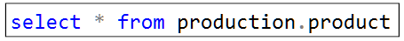
Figure 18- 21. The SELECT statement the second user types in once the first user has left a transaction running.

Figure 18- 22. The bottom section of SSMS after you start the above query. The “Executing query” cartwheel will keep spinning, and the execution timer (in the red circle) will keep counting upwards.

Your second User 2 has entered a “stasis field”. SQL has blocked User 2 from continuing unless they abort their query. P.S. if you talk about “a user in a stasis field” to your DBA they will either admire your Star Trek prowess or think you have gone slightly mad, that never stopped me though.

What user 2 is dealing with is the effect of trying to read data that another user has edited within a long-running transaction. Until the first user executes a COMMIT, that transaction is going to keep on running, and user 2 will wait “forever”. In real life, this can happen due to poorly written code in the client application. User 2 can set a timeout on how long they are willing to wait. You can find out more here: https://docs.microsoft.com/sql/t-sql/statements/set-lock-timeout-transact-sql?view=sql-server-ver15.

Any other user (User 3, 4 and so on) can work on the products table until they try to use the row with ProductID=1. If they do, they too will be put on hold. Our User 1’s session, the user who holds the lock, can do whatever they like to the product with id=1 since SQL has granted their session an exclusive lock on row 1.

If User 1 updated another row, they would hold an exclusive lock on that row as well until they committed their changes.

The locking in this example is working with pinpoint accuracy partially due to the statement locating a row via the primary key. If you need to find a row in a table, do so using the primary key directly or via an indexed column. That practice helps SQL manage locks more efficiently.

If you use none primary key columns and non-indexed columns to implement updates or deletes, you can cause excessive locking and slow running queries.

Switch over to the User1 tab and type in and execute the script in Figure 18- 23.


Figure 18- 23. Type in COMMIT TRAN to release user 2.
Switch over to User2 and lo; they will have a “Banana” on their hands as the first row of the Production.Product table will confirm. Receiving this output shows that User 1 has committed their change and that SQL has released the lock. The rest of the products table appears too.

Options for Using a Table Despite it Being Locked

Let’s say you want to use a busy table for a report and you don’t need to get up to the second accurate information.
For a quick fix to getting around the “unwanted” locking, you have two choices.
1. You can ignore the locks and read the edited uncommitted data. You do this with the understanding that the data in the table might change if you select the data a second time within the same script. If this is a once-off read, you probably don’t mind. In essence, the data is unstable meaning that repeated reads in quick succession are unreliable; reads can occur on uncommitted transactions.

You won’t ever read a partially updated row. In other words, you won’t read a row where some of the columns have begun changing while other columns are waiting to be changed. Locking occurs at row level.

You can let SQL skip over rows that users are editing as if they didn’t exist. SQL will hop right over them. They won’t appear in your query’s output and neither will any related rows from joined tables referenced by that row.
You have to choose which option is best for you. There are other options, including:

1. using snapshot isolation mode –Microsoft’s name for their implementation of optimistic locking.
2. you can release the blocked user by specifying a time limit for how long their SQL commands take before timing out.
3. You can adjust the transaction isolation level, which affects what conditions for locking you are prepared to tolerate or wish to enforce.

The trick is to work out a balance between the necessary level of data accuracy, time and machine resources to process a given set of simultaneously executing queries. You can begin your journey into transaction isolation levels here: https://docs.microsoft.com/sql/t-sql/statements/set-transaction-isolation-level-transact-sql

18.13. The NOLOCK Option

This option allows you to read the locked rows in a table. You will read other users uncommitted changes as well as the existing data in a table. To use this option, next to each table’s name in your query, append WITH (NOLOCK) as shown in Figure 18- 24.

Figure 18- 24. User 2 could have run this query instead of that in Figure 18- 21. This query will let you see rows even though if they have an exclusive lock on them.
If you try the query in Figure 18- 24 as User 2, you will see data with no blocks occurring. If you need to, rerun User 1’s query first (Figure 18- 20) to put a lock in place; it doesn’t matter if you set the product’s name to what it already is (a banana).

The READPAST Option

With WITH (READPAST) appended to a table’s name, SQL skips over the rows that are locked. It is as if the locked rows were not there. The read data is stable in-other-words, the read is repeatable; two reads of the table in quick succession will retrieve the same row values, but rows will be missing. Depending on the nature of the data, you may feel this is a better option than reading potentially changing data which is the risk you take WITH (NOLOCK).

Only you, who understands the data, can work out which option–LOCK or READPAST–is the better choice. Most of my clients use NOLOCK. Many of my clients are unaware that there is a READPAST option.

Consider a Staging Database or Data Warehouse in the Future

You can annoy yourself and other users if you regularly run reports with queries that span many rows against a live system. There could be updates occurring to the tables coming in from machinery on the production line, for example, that you don’t want to delay or block.
In situations like that–be it because of user frustration or risk to realtime physical production–it is time for you to consider either a staging database or even a data warehouse.
A staging database contains copies of relevant tables if not a copy of the entire database itself. The copy allows you to run your queries against it rather than against the live one. There are several ways you can implement a staging database or tables that I will explain below.

SQL has some fantastic fully automated options such as high availability groups that can automate the database duplication process for you, offering you near real-time synchronisation against a live database. You can read about them here https://docs.microsoft.com/sql/database-engine/availability-groups/windows/overview-of-always-on-availability-groups-sql-server?view=sql-server-ver15.
You can use less “exotic” options, especially with the older versions of MS SQL such as database mirroring configured so that you can read the mirrored copy even while it is synchronising.
You can find out more about mirroring here: https://docs.microsoft.com/en-us/sql/database-engine/database-mirroring/database-mirroring-sql-server?view=sql-server-ver15.

SQL’s High Availability options have superseded mirroring. If your version of SQL doesn’t support High Availability Groups and upgrading your server is not an option, never fear, I have clients who are very happy with a mirrored database solution.
You can copy selected tables as well as sections of a table using SQL Server Integration Services (SSIS) into a purpose-specific database. SSIS may prove efficient for your reporting purposes as you can specify what tables, columns and rows you want to copy from a source database as well as transform/summarise the data as opposed to making a copy of the entire database. The SSIS option also allows importing data from various SQL servers of all makes-and-shapes around the company into a more convenient central database. It is, however, even if implemented using SSMS’s Import/Export wizard, far more complicated to set up than an Availability Group or mirror.
Unless you have a traditional database replication structure in place already, I would advise against using database replication. I would strongly recommend that unless you need features specific to replication such as the sophistication of performing updates on a potentially/temporarily disconnected remote database servers, avoid replication as it can be and usually is difficult to maintain.
The options I am describing here vary in availability from one version of SQL to another. You will have to do some research as to what options are open to you, including possibly upgrading from SQL Standard Edition to Enterprise Edition

A Data Warehouse

A data warehouse is used mainly to archive data from an OLTP database. You keep a data warehouse on a SQL server in a conventional-looking database. That is because it is a specialised form of a relational database albeit constructed using different design principals. A warehouse stores the tables in a highly denormalised form for the convenience of querying. These tables are a combined way of archiving and summarising data; hence the name “warehouse”. Microsoft encourages you to use SSIS to keep the warehouse up-to-date.

To use a warehouse for reporting requires learning query techniques that are based on but not covered in this course. You design a Data warehouses to make querying for more directed/specific results simpler. They are not relational databases aimed at rapid transaction processing as taught in this material. Studying a data warehouse often leads down the path of Microsoft’s Analysis Services, a product to ease extracting meaning (trends and so on) from the data.

18.6. The Exercise

The exercise is a step-by-step guide showing you the point and value of explicit transactions.

As usual, the answers are in Appendix F. You can download an SSMS Solution with all the answers typed in for you from my web site (https://www.transference-unlimited.com).

Exercise 18. Transaction Fundamentals

Add three new query files to your “My Class Queries” project and name them:
1. Ex18 Transaction Fundamentals
2. Ex18.3 User 1
3. Ex18.3 User 2
Put a descriptive comment at the top of each script and follow them each with a suitable USE clause that accesses the AdventureWorks2017 database.

Ex 18.1. Create a Clothing Inventory Table and Load it With Data

Create a ClothingInventory table using the command in Figure ex 18- 1. Note that there is a check constraint on the list price to make sure you sell everything for over £20.

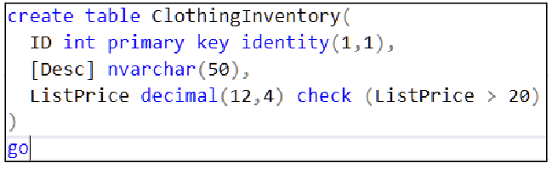
Figure ex 18- 1. The script to create the Clothing Inventory table you will use for the various transaction and locking experiments

And load it up with the inventory data shows in Figure ex 18- 2.

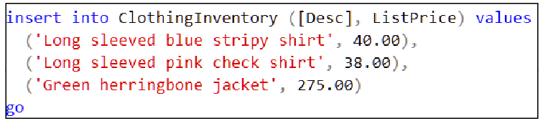
Figure ex 18- 2. The script to insert some clothes into the inventory table

Now run the “faulty” query in Figure ex 18- 3 which is within an explicit transaction.

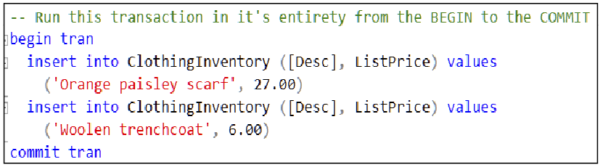
Figure ex 18- 3. A pair of inserts inside a transaction. The second insert will fail as the woollen trenchcoat has a list price below £20.
View the contents of the ClothingInventory table. You will find the Orange paisley scarf is in the table. In other words, you have accepted the changes that SQL was able to make.
Run the query in Figure ex 18- 4. There is no COMMIT instruction in the script. Do not add one.

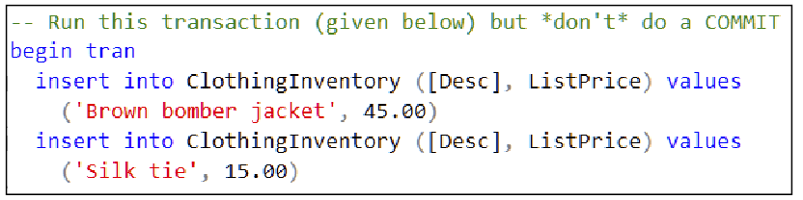
Figure ex 18- 4. This script is a query that you must run without a COMMIT. This time the silk tie will fail to insert.

The Silk tie will fail to insert; Brown bomber jacket’s insert will succeed. Check the contents of the table to prove this to yourself.

Since you are still in a transaction, execute a ROLLBACK and look at the ClothingInventory table now. Brown Bomber jacket will be gone from the table as you have now asked SQL to undo all changes to the table.

In summary, ROLLBACK will erase successful edits that are part of an explicit transaction. You have told SQL you want to reject the partially completed transaction.

Ex 18.2. Keeping Track of Your Transactions

Try to commit a transaction that doesn’t exist by running Figure ex 18- 5. The script will create a single transaction but commit twice. The second commit has no matching transaction, and you will get an error. The error you see is one you will become very familiar with the more you work with SQL, which is why I wanted you to see it.

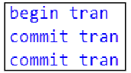
Figure ex 18- 5. A quick way to create a transaction–that does nothing–then try to commit it twice.
Execute the script in Figure ex 18- 6 to learn how to tell if you are in a transaction. It will tell you that you have one transaction in progress since BEGIN TRAN and ROLLBACK TRAN bracket SELECT @@TRANCOUNT.

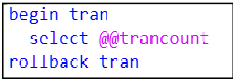
Figure ex 18- 6. @@TRANCOUNT will show you if you have a transaction running-an ambient transaction.
Now run the script in Figure ex 18- 7. You should get 0 to show that no transaction is currently executing. Bear in mind that @@TRANCOUNT reflects your current session. Other users can run transactions in other sessions which won’t influence what you see via @@TRANCOUNT.


Figure ex 18- 7. View @@TRANCOUNT without a transaction open. It will show 0.

Now try putting a transaction inside a transaction (called a nested transaction), as shown in Figure ex 18- 8.
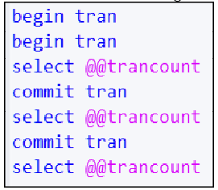
Figure ex 18- 8. Nested transaction. Watch how @@TRANCOUNT drops from 2 to 0 as you commit each transaction.
Now rerun the script but modify it so that you roll back the innermost transaction. In other words, replace the first COMMIT with a ROLLBACK. The first COMMIT belongs to the second (closest) BEGIN TRAN. The second COMMIT belongs to the first (outermost) BEGIN TRAN.

You will find @@TRANCOUNT jumps from 2 to 0 because when part of a nested transaction rolls back, the entire transaction becomes worthless and rolls back.

The nested transaction scenario that you explicitly created in Figure ex 18- 8 occurs implicitly in the real world. It happens when a script that starts a transaction runs another script (usually the script within a stored procedure or similar) which in turn begins a transaction. It is very unusual to see a single script start a transaction that explicitly begins another transaction.
In the real world, it is possible to lose track of your running transactions and end up making changes to data inside a transaction without realising you are in one. Later, your changes “magically” disappear when the unexpected transaction aborts at some stage, usually when you log off, or a poorly written application terminates.

Ex 18.3. Locking Between Users

You are now going to experiment with the effects of row locking, ways to “get around” locks and the side effects of doing so.

Go to the editor tab you have labelled “Ex 18.3 User 1”. Type in and execute Figure ex 18- 9.

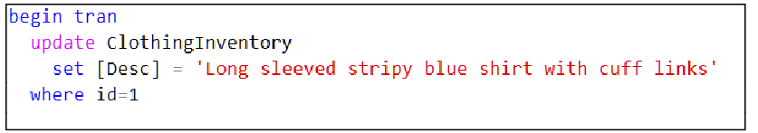
Figure ex 18- 9. An update that will cause a long-running lock to be held on the first row since there is no commit instruction.
Now switch to the “Ex 18.3 User 2” tab and attempt to view the entire ClothingInventory table.

Your User 2 session will “freeze” because you are waiting for User 1 to either commit or rollback their changes. Switch to User 1 and try to view ClothingInventory. You will be able to do so with no problems.

User 1 has no idea they are “bunging up the machine” as far as other users are concerned. Press the stop button () on User 2’s session. User 2 can now issue other instructions if they wish as long as they don’t try to read the locked row. You might want to try specifically viewing row 2 to prove this to yourself.

Now restart User 2’s attempt to reread the entire ClothingInventory table, so they are “frozen” once more. This time, go to User 1’s session and execute a ROLLBACK TRAN. Switch to User 2’s tab, and you will see the output they requested. This output appears because User 1 has decided to “throw their changes away” and so they have released any locks they held on the ClothingInventory table.

Now start User 1’s update again, leaving the transaction open, so it keeps the row locked as before. Switch to User 2’s tab and type in and run the script in Figure ex 18- 10.

Figure ex 18- 10. A SELECT statement that ignores the lock held by User 1.

You will see the inventory table, including the changes the other user has made. For a report generation scenario, this may not bother you. It is up to you to decide if this behaviour–that of reading uncommitted data-is acceptable.

To show the risk involved, go back to User 1’s tab and rollback their changes. Now go to User 2 and run the select statement in Figure ex 18- 10 again. The data will have changed from User 2’s perspective. This changing data is known as a non-repeatable read or inconsistent read. As mentioned, this may or may not be an issue for you. It depends on the overall purpose of your query.

Now start User 1’s blocking update again. Try the query in Figure ex 18- 11.

Figure ex 18- 11. Another SELECT statement that ignores the locked row.
This time, the row that is locked won’t appear in the output. This skipping of rows is known as a read past. This skipping of rows may be more acceptable to you compared to a NOLOCK. Only you will know what suits you and what doesn’t.

Error Control

This chapter will show you an efficient way to manage errors that occur during the execution of your scripts. These sorts of errors are known as runtime errors because you find them during script execution.
Compare this to an error that is caused by a syntactic fault; under such circumstances, you cannot run your script. These are known as compile-time errors, even if there is no obvious compiler or compilation processed involved.
There is another class of error known as a logic error. This sort of error occurs when your code executes to completion without error, but the outcome is not what you expected. The code’s author has given faulty yet executable instructions to the computer. Logic errors epitomise GIGO: Garbage In Garbage Out.
Logic errors can be challenging to find for two reasons: in your mind, you have convinced yourself that you have told the computer to perform a task, but in reality, you have told the computer to do something else. In SQL, logic errors are sometimes caused by you not fully understanding what a command does, or you have misunderstood the subtleties of the initial task in the first place. These errors can be frustrating, but they are an opportunity to learn detailed SQL skills.
You can find these logic errors by analysing the execution of the script’s code line-by-line and monitoring the effect of each instruction. SSMS offers a debugger to help you discover such errors. You can find out more here: https://docs.microsoft.com/sql/ssms/scripting/transact-sql-debugger?view=sql-server-ver15
I introduced an older form of run-time error management technique near the end of chapter 18. You may find it helpful to look over that chapter before beginning this one.
In SQL 2005, Microsoft offered more elegant means to express the control of errors. You no longer need to sprinkle your script with repetitive checks against @@ERROR as you saw in chapter 18. T-SQL bases the technique on a notation used in many programming languages: the TRY…CATCH block.
To fully follow along or do the demonstrations in this chapter’s text, you need to have at least read over the table definitions from the previous chapter.

Understanding What Is Inside A T-SQL Error

To control errors, you first need to understand what components make up a SQL error. I explain these components in Table 19- 1.

Component: | Meaning:
Number | This numeric code identifies the error definitively.  A numeric code is a reliable way to document the error compared to, say, someone trying to describe the text of an error message to you over the phone.  An ideally written application would write the error’s details into an external log table or file, together with the time of occurrence and the responsible user id. I would advise finding out if the applications you use do so and where they keep those logs. These logs will make diagnosing the cause of an error easier.
Severity | This number ranges from 11-24. This number is a rating of how likely you are to be able to correct the error.  Levels 11 to 16 imply that a user can fix the issue (spelling errors and the like).  Levels 17-19 require database administrator (DBO) privileges to correct.  Levels 20 to 24 reflects corrupted data on the hard drive to hardware failure. They require “specialised” knowledge to correct.  Severity levels below 11 do exist; SQL regards them as status messages. Messages such as “x number of rows affected” have a severity of 10. The PRINT command generates “errors” with a severity rating of 10. Such messages print in black and won’t stop a script from working.
State | The state is a numeric sub-error code. It is a code within the error number; a subcategory that defines the error more precisely. As you are someone who writes queries, you can mostly ignore this number.  A programmer can create customised errors and sub error codes using SQL’s RAISERROR or THROW command. You can discover more here should you want to create customised errors:  https://docs.microsoft.com/en-us/sql/t-sql/language-elements/raiserror-transact-sql?view=sql-server-ver15  and  https://docs.microsoft.com/en-us/sql/t-sql/language-elements/throw-transact-sql?view=sql-server-ver15.
Procedure | If an error occurs within the execution of a stored procedure, this component contains the procedure’s name. Otherwise, SQL returns NULL if the error occurred outside a stored procedure.
Line | This number is the physical line number in the script where the error occurred.  SQL statements are processed in their entirety rather than line by line. This processing technique means that you need to not only look at the quoted line number but the entire command to which that line belongs. You may need to extend your search to the preceding command, which might have triggered a knock-on effect that has caused the highlighted command to fail.  With earlier versions of SQL, SQL measured this number from the start of the executed batch. In-other-words, SQL regarded line 1 to be the first line of highlighted code in SSMS’s editor. In SQL 2017, SQL measures the line number from the first line of the script editor’s window.  When SQL reports an error, if you go to the message pane of SSMS, you can double-click the red error message. Doing this will cause the text editor to move the cursor to the location of the error. This technique is very convenient if you are locating errors in a lengthy script file.  The error summary pane is another useful way to track your compile-time errors. You can reveal it by clicking View=>Error List on the main SSMS menu.
Message | The message is a text-based human-readable description of the error.  Bear in mind that the error’s description is, on occasion, so accurate that it draws your attention away from the real failure or at least understanding it more clearly.  I would advise that you do your best to understand the context in which an error has happened. Ask yourself “what was I trying to achieve with this section of code?”.  You might like to view all the possible error codes and status messages that SQL can produce. There were 14 071 of them at the time I wrote this course. You can see them with this statement:  The language ID criterion shows you the English messages. You might enjoy amusing yourself by looking at the entire table and all the languages it contains.
Table 19- 1. The components of a SQL error.

Demarcating Potentially Hazardous Code: The TRY…CATCH Block

Let’s meet the TRY…CATCH syntax as used by SQL to trap and process errors. In SQL, you express the traditional TRY…CATCH block as a BEGIN TRY…END TRY and BEGIN CATCH…END CATCH pair of statements as shown in Figure 19- 1.
BEGIN TRY
Code that could go wrong
END TRY
BEGIN CATCH
Code that runs if there is an error in the above code
END CATCH
Figure 19- 1. The general syntax of the BEGIN TRY END TRY and BEGIN CATCH END CATCH statements.
If the code between the BEGIN TRY and END TRY fails, SQL will exit that entire block of code and begin running the code bracketed by the BEGIN CATCH and END CATCH. When the BEGIN TRY...END TRY code completes, SQL will run any remaining code in the script as it usually would. You can have as many BEGIN TRY...END TRY blocks in a script as you please.
For a demonstration, begin by truncating the TransactionSales table as in :
Figure 19- 2. A command to empty the TransactionSales table.
Let’s create a table to log errors that may occur during the script’s execution using the script in Figure 19- 3. Having such a log is a beneficial tool in the real-world.
Here is the code to create the table which will record errors:
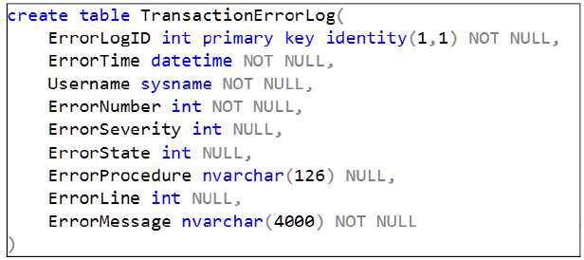
Figure 19- 3. The script to create an error logging table. The chosen columns map onto the components of an error message. Additional columns store the time the error occurred, and the name of the user who caused the error.
You will use the table in Figure 19- 3 to record each error. You will see in my sample code how to extract each of these elements of the error.
Figure 19- 4 is a complete script showing how to use the BEGIN TRY statement.
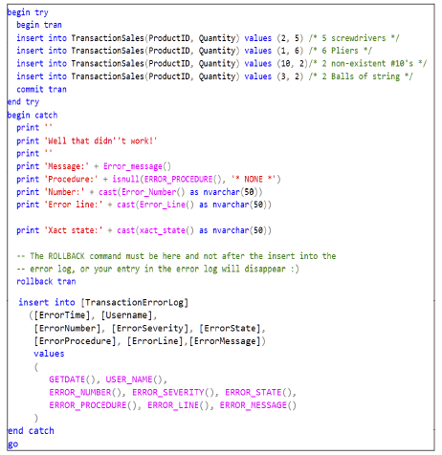
Figure 19- 4. A script that shows you an example of how to use the TRY…CATCH mechanism of SQL. When an error occurs, the error is logged into the TransactionErrorLog table for you to be able to read it any time you choose.
If Figure 19- 4, you can see that the BEGIN TRY statement prefixes code that is potentially able to fail. In our case, we are guarding ourselves against a set of INSERT commands that could contain erroneous data. One of those inserts, the third one, is faulty for sure; it tries to sell a non-existent product.
The protected code is bracketed at its end with an END TRY statement. Any code outside the BEGIN TRY…END TRY bracket is not protected and will generate errors as usual. Note the BEGIN TRAN and COMMIT TRAN are in the TRY block. The commit is part of the code you expect to run successfully, but it won’t execute if there is an error.
The code between BEGIN CATCH…END CATCH executes if an error has occurred. If an error occurs, SQL will ignore the remaining commands in the BEGIN TRY…END TRY block, including the COMMIT TRAN. Then SQL will execute the BEGIN CATCH code. The BEGIN CATCH block contains a ROLLBACK TRAN as the transaction will still be running even though an error has occurred. Chapter 18 will explain this to you.

The Error Handling Code in the BEGIN CATCH…END CATCH Block

Inside the BEGIN CATCH…END CATCH block, you typically report the error to the user in a manner of your choosing, printing it on the screen in this case. Then you can optionally log the error in a table for later retrieval. You know when you run the script that you are in control because the machine does not display any text from the error using a red coloured message. The messages produced by the script will appear in SSMS’s Messages pane.

SQL shows the error’s details in black coloured text. If the severity rating of an error is 20 or above (which is a severe error), SQL will take over from your script, abort it and display an error in red.
To access the components of the error, you can use several functions with self-evident names. I have listed them in Figure 19- 5. Refer back to Table 19- 1 for an explanation of the components of an error.

ERROR_MESSAGE()
ERROR_NUMBER()
ERROR_SEVERITY()
ERROR_STATE()
ERROR_LINE()
ERROR_PROCEDURE()
Figure 19- 5. A list of the functions you can use to retrieve the details of an error.
I have left a function out of Figure 19- 5, which I have used in my script: XACT_STATE(). XACT_STATE() has been around a lot longer than the TRY CATCH block. I discuss it a little later in this chapter. In the meantime, keep an eye on its output and see if you can work out what it does.

I have written the script so that it inserts the error’s details, along with the time and the database user name–via the function USER_NAME()– into the TransactionErrorLog table.

You still have to do either a ROLLBACK (a very likely choice) or a COMMIT (will keep the partial changes) in the CATCH block. Be aware of where you place a ROLLBACK TRAN command in such a script. A schoolboy error is to put the ROLLBACK instruction after the INSERT statement that puts an entry into the error logging table. In that case, not only will you undo the changes to the Sales table, but you will remove your freshly inserted row from the error log table. Not good! Especially if you spend ages wondering why your error table is blank when you could swear that you have logged the error.
If you execute the script in Figure 19- 4, you will see the output in Figure 19- 6.

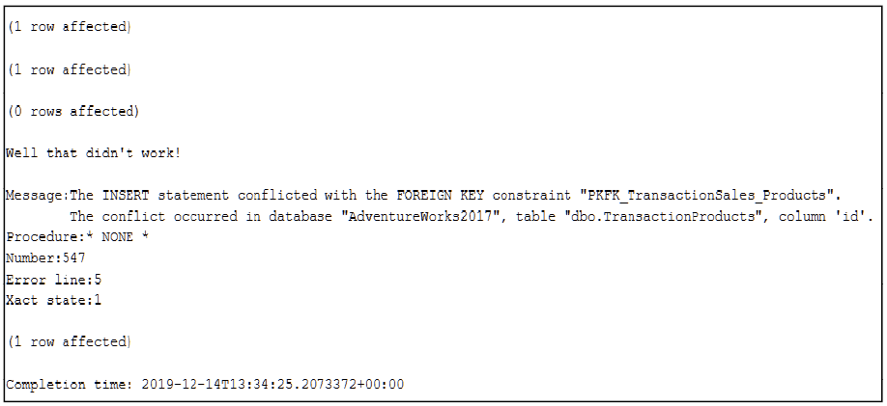
Figure 19- 6. The output of the script. There is no red text here. The error message is reported in black text because your script is in complete control of the error condition.
Now have a look at the contents of the two relevant tables (Figure 19- 7 and Figure 19- 8).

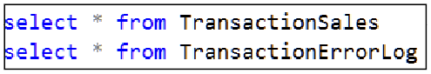
Figure 19- 7. A pair of SELECT statements you can use to view what is in the TransactionSales table and the TransactionErrorLog table.
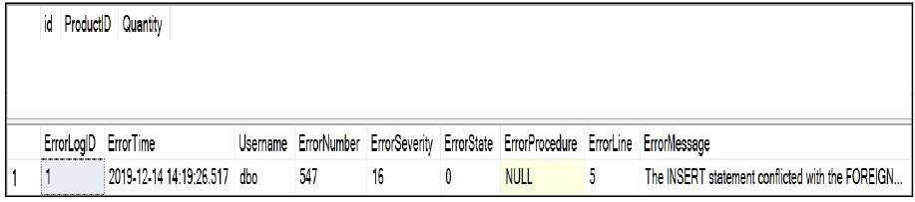
Figure 19- 8. This figure shows what is in the pair of tables, TransactionSales and TransacstionErrorLog. TransactionSales is empty since the CATCH block rolled all of the INSERTs back. The TransactionErrorLog table shows the reason why.
The TransactionErrorLog table stores and reveals the error in full detail. Note the user name is dbo. dbo is your user name in the current database. If you want to record your SQL server login ID rather than your database user ID, use SUSER_SNAME() instead. Perhaps you would like to edit the script and error table to record both?

Transaction State (XACT_STATE)

The script in Figure 19- 4 prints the output of a function called XACT_STATE() or transact(ion) state. XACT_STATE() is a tool used to monitor the status of a transaction. XACT_STATE() returns 1 to indicate that a transaction is currently running. A returned value of 0 indicates that you don’t have a transaction running.

XACT_STATE() continues to return 1 in the TRY…CATCH block; this confirms that the occurrence of the error does not automatically abort the transaction. That confirms that you must do a COMMIT or ROLLBACK, even in the CATCH block. A XACT_STATE() value of 0 would mean that no transaction is running; that may infer that you forgot to start one.

A value of 1 confirms that the ambient transaction is safe to commit or roll it back without causing further errors. That is so despite that a SQL error has occurred. An error does not affect the viability of committing a transaction. Please don’t think that the value of 1 indicates the occurrence of an error.
The behaviour of XACT_STATE() that I’ve described is one of two possible behaviours that it offers you. This first behaviour occurs when the SQL server has its automatic transaction abort mode switched off–this is the default configuration. If you turn transaction abort mode on, you will get a different response as I explain below.

XACT_ABORT Mode Outside a TRY CATCH Block

Transact abort mode is either on or off for a given session; some users can have it on, and others can have this mode turned off. It defaults to off. In the case of a TRY CATCH block, it changes the behaviour of the CATCH BLOCK concerning transaction management.

You turn transaction abort mode on for the current session by executing the command in Figure 19- 9.
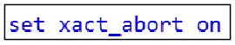
Figure 19- 9. The SQL command that turns automatic transaction abort mode on.
Likewise, you can substitute “on” for “off” to turn it off.
All the examples we have seen in chapter 18 and earlier have run with transaction abort mode turned off.
Let’s look at the situation when you have turned this mode on, and you are not using a TRY CATCH block. If you issue a BEGIN TRAN, XACT_STATE() will return 1 to show a transaction has started. If you then cause a SQL error to occur, an implicit ROLLBACK TRAN executes before you receive the error message. If you hadn’t started a transaction, SQL behaves as it normally does.

In this implicitly aborted state, XACT_STATE() will return 0 to let you know that SQL has automatically terminated your transaction. Traditionally, you would have checked @@ERROR to discover that an error has occurred.

This mode of operation means that after an error, you don’t have to call the ROLLBACK instruction yourself. If you refer back to the volume of IF statements and the repetitive code in the example script from Figure 18- 10, you can see that this mode helps reduce the amount of code in each IF @@ERROR block.

Table 19- 2 summarises XACT_STATE()’s behaviour outside a TRY…CATCH block with transaction abort mode turned on.

Value: | Meaning (No TRY…CATCH block):
0 | The transaction has aborted and rolled back.  or  The session never started a transaction as you possibly forgot to start one.
1 | A transaction is running, and so far, everything SQL has done can be committed.  Errors will cause an automatic rollback, and the value will switch to 0.  A commit instruction will set the value back to 0.
Table 19- 2. The meaning of XACT_STATE when you are not using a TRY…CATCH block.

XACT_ABORT Mode On in a TRY…CATCH Block

If you are working inside a BEGIN TRY…END TRY block with transaction abort mode on, XACT_STATE’s meaning changes as you can see in Table 19- 3.

Value: | Meaning (Using a TRY…CATCH block):
0 | The session is not running a transaction in the BEGIN TRY block.  If you intended to have a transaction, you need to check if you have executed the BEGIN TRAN statement.
1 | A transaction is running, and so far, you can commit without worry.
-1 | The transaction is in an aborted state.  The transaction has not automatically rolled back even though an error has occurred.  This means:  You cannot write any further data to any tables. You will get an error if you try to do so.  You cannot COMMIT any changes without causing an error. COMMIT is effectively disabled until you acknowledge the error. Arguably, this is the main benefit of running in this mode.  To go back to state 0, which you need to do, you must issue an explicit ROLLBACK TRAN which will undo all changes done started by the transaction (as usual).  Once you have rolled back, you can write to an error log table or any other table.
Table 19- 3. The meaning of XACT_STATE when you are using a TRY…CATCH block.
In a TRY…CATCH block scenario; transaction abort mode makes sure you can’t edit data until you have knowingly rectified the situation with a ROLLBACK. Transaction abort mode is arguably more protective of the database’s contents than it would be outside a TRY…CATCH block.

This mode of usage no longer rolls the transaction back automatically. I prefer not to use automatic transaction rollback in general; I’m not a big fan of assumptive behaviour in a computer, let alone inside SQL. Using automatic rollback in this way is up to you.

You might wonder why I have shown this mode to you. Some people like to use it, and so I feel it best that you know about it. It is a topic that has been known to appear in the Microsoft SQL exams.

Summary of the TRY…CATCH Error Handling Technique

You can use the TRY…CATCH notation to clearly demarcate the error handling code in a script. The TRY…CATCH notation reduces the clutter of error detection code from SQL scripts of the past.
If you are going to use explicit transactions, you need to exercise some care. You need to practice error management technique and test any error management code thoroughly, with both successful and failed transaction states. Doing so will help you to create robust, reliable SQL code.
If the use of XACT_ABORT appeals to you, you need to become familiar with its dual nature: it has one set of behaviours in a TRY…CATCH block and a different set of behaviours in older code that does not use such blocks.

The Exercises

These will give you opportunities to experiment with the BEGIN TRY and BEGIN CATCH statements.
Consult Appendix F if you need a guide or download the answers from my website at https://www.transference-unlimited.com.

Exercise 19. Error Control Basics

Add a new query to your “My Class Queries” project and name it “Ex19 Error Control Basics”.
Put a descriptive comment at the top of the script and follow it with a suitable USE clause that accesses the AdventureWorks2017 database.
This exercise uses the tables created in Exercise 18.

Ex 19.1. Create a Set of Inserts

Type in the script in Figure ex 19- 1. This script contains an invalid product row for Pocket squares; we are attempting to sell them too cheaply.

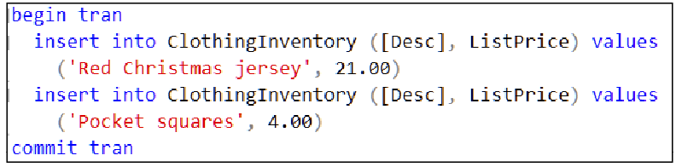
Figure ex 19- 1. A script that will cause an error when it tries to insert Pocket squares. Note that you want to COMMIT regardless of their being an error.
Check the contents of the ClothingInventory table and confirm that the behaviour you see matches what you have learned in the previous chapter.
Do you see that you lost control of the SQL server and your script when the error occurred? Your script didn’t detect the error. Any SQL that executes after an error occurs runs or fails on blind luck. You don’t want that situation; you want to control what happens when there is a failure.
Get rid of the Red Christmas jersey by executing the script in Figure ex 19- 2. I would like you to keep your eye on the jersey’s id as this row appears and disappears as the exercise progresses.

Figure ex 19- 2. We want to remove the jersey. I have not mentioned the primary key value in the WHERE clause for a reason. I would like you to keep track of the id of the jersey as the exercise continues.

Ex 19.2. Controlling the Error

Now type in the script in Figure ex 19- 3, which detects and controls precisely what happens when an error occurs.

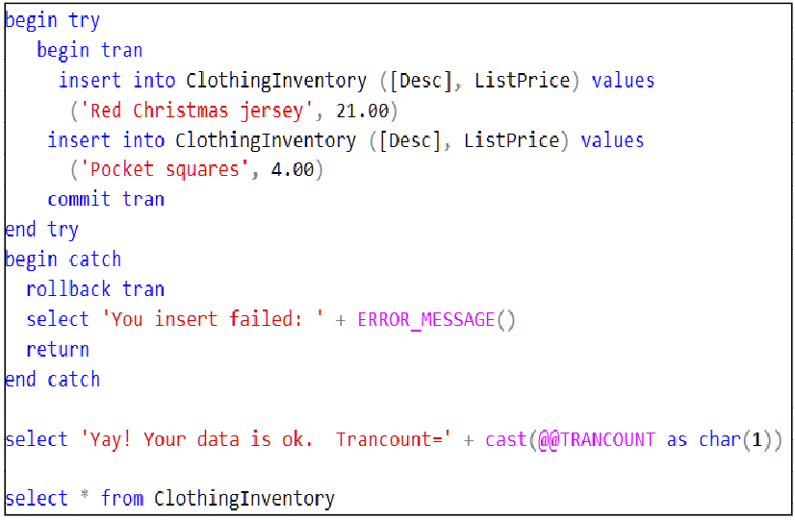
Figure ex 19- 3. This figure is a script that will neatly abort and report an error.
Run the script, and you will see that the transaction rolls back, removing the jersey, it does not execute the part of the script that tells you that all is okay neither does it display the ClothingInventory table. The script terminated because of the RETURN command embedded in the BEGIN CATCH section.
It is a good idea to check @@Trancount in general after such a script as mine to test that you haven’t left a transaction running. If @@TRANCOUNT weren’t 0, it would mean that you have skipped either the ROLLBACK or COMMIT instruction somewhere in the execution of your code.
Now try the script in Figure ex 19- 4. This script is the same as Figure ex 19- 3’s above but with a valid price for the Pocket squares. You can simply modify your existing script or copy and paste what you currently have for reference.

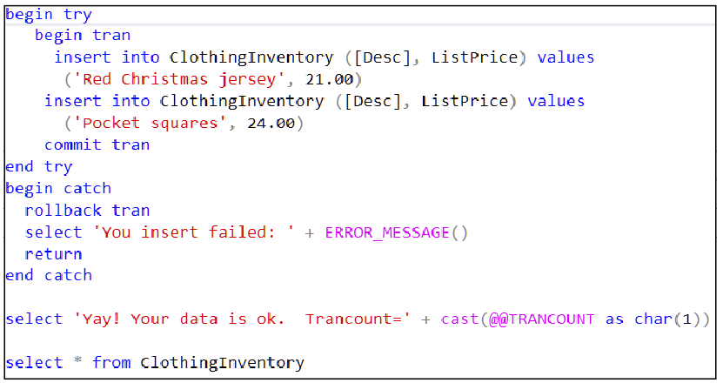
Figure ex 19- 4. A variation of the previous script that has a valid pair of INSERT instructions.
Execute the code, and this time you will be told all is well as the script runs to the end of the last two SELECT statements.

Have a look at the IDs for the Red Christmas jersey and the Pocket Squares. You will see that they don’t follow on sequentially from the first four rows. This jump in the identity column’s value is an indicator that rows were removed either via a DELETE or from an aborted transaction. Yes, aborted transactions do not stop an identity column’s current value from incrementing. Knowing that is a handy troubleshooting tool.

The reason why I emphasized that you check @@TRANCOUNT once the script is finished is that it would be a disaster if your script ended with a transaction open and you didn’t realise it. You could find yourself in that scenario, make other changes to your data, and at some stage do a commit or rollback and “magically” a whole lot of changes happen that you weren’t expecting. Those unexpected changes happened because you ended a transaction you didn’t know was running.

This situation happens more often in real life than you would like to think. They occur especially with transactions that are nested and complex and are even more likely to occur in multi-server transactions. Poorly programmed web services using cached/pooled connections are notorious for leaving dangling transactions running. Such an error can take days to surface and diagnose, but lucky you now has a heads-up on what to check.

Writing Queries Using SSMS’s GUI

SSMS has a GUI tool to help you write basic yet long queries. The tool can create queries up to the level of sophistication of joins and grouping. It cannot cope with CTEs nor can it understand OVER clauses. It has severe limitations in dealing with nested queries.
The tool allows you to construct a query using a combination of clicking on GUI elements such as table names and editing the SQL directly. The editor is available on the context menu you get by right-clicking a blank region of the SQL text editor surface or by highlighting an existing query and right-clicking it.
The quality of the resultant GUI engineered query can leave something to be desired. Table aliases are something you will have to put in and deal with yourself.
As a beginner, you may find the GUI editor is a useful tool to help you get up to speed with SQL’s syntax for joining, grouping etc. For the experienced query writer, the GUI editor is a handy way to create a long query that contains many joins rapidly. You can then go in after and manually “clean up” the editor’s resultant output by adding table aliases, reformatting, and so on. The best is to practice using it and discover its quirks for yourself.
As a bonus topic, I will show you SSMS’s SQL scripting template tool. This tool can provide a layout for a SQL command that you then edit with the text editor to supply the necessary missing details.
A template allows you to forget the detailed syntax of a T-SQL command as it provides a “skeleton” of a SQL command. You can then flesh out the template using a semi-automated search-and-replace facility.

20.1. The Elements of the GUI Editor

In Figure ex 20- 1, you can see the GUI interface in the process of editing a query. Table 20- 1 discusses the various components of the interface, most of which you can see in the figure.
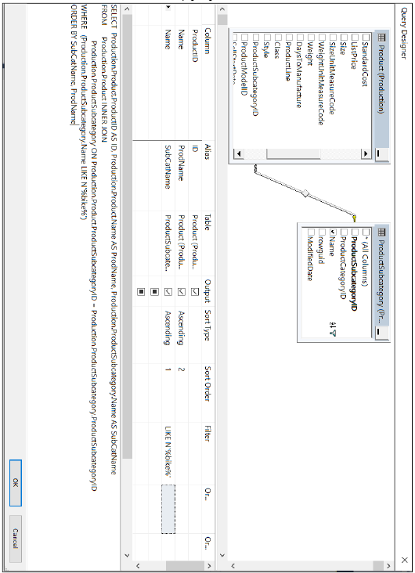
Figure 20- 1. The query editor’s GUI interface in SSMS.

Feature: | Ability:
Graphical representation of the table(s) | This top pane allows you to see the tables and columns as graphical representations on a design surface.  The table’s columns appear in an easy to read vertical format, similar to the way a database diagram represents them.  Each table’s column list has a check-box next to it. If you click the box, you insert or remove a column into the resulting SELECT statement.
Lines drawn between tables to represent the columns in an ON clause | You can easily see the sequence of tables that are joined together by following the lines that the GUI draws between the tables. Again, very much like the database diagram.  The GUI will attempt to automate working out what columns to put into the ON clause of a join. It can’t always work out/guess which columns it should link.  For that reason, understanding the symbols used is important:  indicates that SSMS has taken the two tables and linked their columns together where the column in the left-hand table is a primary key column, and the column in the right-hand is a foreign key column. SSMS has deduced this by discovering an explicitly programmed PK-FK constraint between the tables.  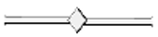 indicates that SSMS has linked the two table’s columns by matching their names. There is no explicitly programmed PK-FK constraint involved in the assessment. This “guess” can require manual correction of the SQL statement in the SQL pane as linking to two in this way may result in linking two columns that have different purposes, they simply happen to have the same names. Arguably, guessing which columns to link by using matching names is not an entirely reliable method, but better than nothing.  indicates that SSMS has taken a foreign key column in the left-hand table and linked it with a column in the right-hand table via an explicit PK-FK constraint.  For whatever reason, SSMS does not show the right-hand column with a golden key symbol even if it is a primary key column.  The symbol to keep an eye on is the middle one. If it appears in your GUI, check that the link SSMS created makes logical sense. The other two symbols seem to indicate reliably deduced ON clauses.  If you attempt to add a table that has no apparent relationship with the existing tables you have chosen, the editor will show a CROSS JOIN. That means that SSMS will join tables together by fair means or foul. In that case, remove the CROSS JOINed table and check that you have selected the existing tables you need to form a meaningful set of PK-FK relationships with the new one. You will find that you are either missing one or more tables that you need to specify first or that linking the table you want is simply impossible because of a design limitation in the database.
Drop-down table list and column list | If you like, you can use these drop-down boxes to choose columns and tables you want in your query.  You cannot select tables unless you have added them to the topmost design surface first.
Filter column | This column is where you place an expression that you want in the WHERE clause.  Each column has a row of OR filters.  Each row’s expression is ANDed with the others.  There are OR labelled columns in the grid that run horizontally. Each expression that you fill into one of these cells is OR’ed with the others.  The GUI is tolerant of you using variables in your expressions.
Replace a column name with an expression | You can type in a mathematical expression instead of a column’s name in the centre grid. SSMS will propose an alias name (usually Expr1) which you can change to a more meaningful name.
Sort column | You can use a drop-down box to choose if you want a column to appear in the ORDER BY clause as well as its position in the ORDER BY’s column list.
Group by | You can use a drop-down to choose the aggregation function you want to apply to a column.  All non-aggregate columns must have the entry “group by” in them to make sure they are listed in the GROUP BY clause.  You have to turn the grouping facility on. To get the GROUP BY column in the query builder, you must right-click the top-most design surface and then select Add Group By from the menu
Output column | If you check this box, the editor puts the column into the SELECT’s column list.  You leave this box blank when you want the column to be available in the WHERE clause, but you don’t want to display it in the output.
Alias column | You can rename a column by filling in an alternative name here. Feel free to use spaces and so on in the new name.
Variables in the filter | You can use the @ symbol to prefix variable names in your query.
Table 20- 1. A list of the features the query builder offers to you.
A few significant points to note before you start using the builder:
- The builder tool is conservative and will use full qualified column names. It will insist on putting a table name in front of each column’s name. This practice is harmless but does make the query tricky to read or edit manually.
- The builder does not directly use table aliases. Don’t be surprised if you put them in and the editor removes them and replaces them with the full table name. Rather finish your query and when you are happy with it, add in aliases outside the editor. You can apply the designer to an existing query that uses table aliases, but even small edits will cause the editor to replace them with full names. An alternative approach is to simply not use table aliases at all.
- The builder doesn’t cope directly with “fancy” queries that use OVER clauses or CTEs. One does get the feeling that if your SQL skills are at the level of using OVER clauses and CTE’s you don’t need the builder to use the builder at all.
- Do not be surprised if the builder occasionally repeats the same expression multiple times in the ON clause of a JOIN. If you see something with a pattern such as “…ON table1.column1=table2.column4 AND table1.column1=table2.column4” SQL’s optimiser will ignore these redundant expressions. They look awkward, but they do not do any harm. If you remove them and re-edit the query, the editor will often put them straight back.
- As noted in Table 20- 1, watch out for CROSS JOINS appearing if you select tables that neither SSMS nor you can work out how to join together.
The builder is a bit quirky if you haven’t already realised by now. It frequently generates perfectly functional yet slightly odd-looking SQL. If you try to correct the “oddness”, it will reward you by resetting whatever you’ve edited back to what it “prefers”. Best not to argue with it. Perhaps you are better off not using it at all once you are past the basics of SQL.

20.2. Why Did I Leave Using the GUI Until Now?

You might wonder why I have left this topic to this chapter and effectively encouraged you to use SQL explicitly. To start, please reread points 1 to 5 above. Realistically, you need to meet SQL face to face to understand what GUI builder tools do. Code generator tools, in general, aren’t perfect and SSMS’s query builder is no exception. Please don’t think the quirks I have listed are a problem specific to Microsoft’s products, that I can promise you.
I cannot recommend the SSMS query builder as a way to learn SQL from first principles. The SQL it generates can be pointlessly complicated. Using it can help speed up creating lengthy SQL statements that are “full of joins” as long as you stick to editing the query with the GUI editor rather than refine it manually after.

The builder is helpful when you already know what you are doing using the SELECT statement. It is useful when you are working in an unfamiliar database with unfamiliar tables because of its visual nature and which makes it easy to navigate the database’s tables.
Once you get to know a database’s content with time and practice, you will probably find yourself questioning whether a GUI builder is actually of any value. Use it as an aid when necessary. Don’t take my opinions as facts, experiment with it, keep an open mind and see if it suits you.

20.3. How to Activate The Query Editor Tool

Set your database context to the one for which you want to write a query so that SSMS will offer you the correct list of tables. If you like, you can edit an existing query by highlighting it with the mouse then open the editor. Otherwise, click on a blank area in the SQL text editor then right-click and select Design Query in Editor. You can see the query editor option highlighted in the context menu in Figure 20- 2.

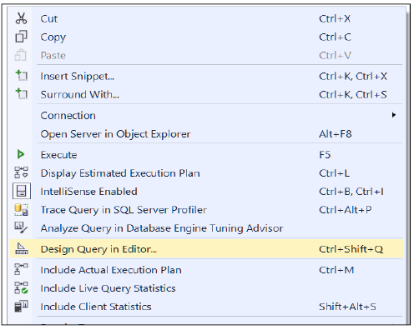
Figure 20- 2. The context menu you will see when you right-click the SQL text editor’s surface. Design Query in Editor is what you want.

SSMS will either offer you a list of tables you can choose from or show you the tables in the query you highlighted before you opened the editor. Use the usual ctrl + click to pick a collection of table names that you want, shift + click to select a range of tables or add them one by one. You can always right-click the top pane to add tables whenever you want. Use Figure 20-3 as a guide.

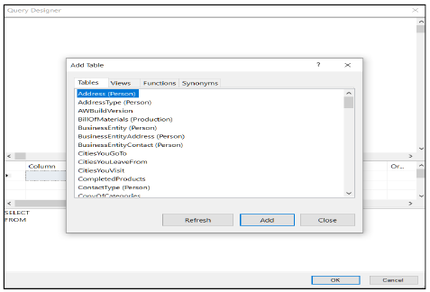
Figure 20- 3. The query editor’s initial surface. You can choose as many tables as you want. If you select multiple tables at once, SSMS will figure out how to join them all in one go, assuming that SSMS can join your choice meaningfully. Watch for CROSS JOINS.
Have a go at mimicking the query in Figure 20- 3. There are many ways you can go about it. The GUI is very tolerant of the order in which you do things, within reason.
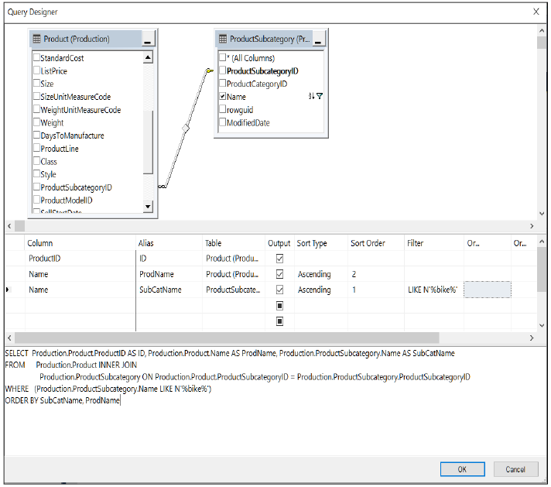
Figure 20- 4. A fully constructed query for you to try. Create the query by first adding the tables then select the columns and finally edit the specifics with using the grid in the middle. You can edit the SQL directly, and the UI will adjust to reflect your edits.
Try reproducing Figure 20-4 yourself if you have the opportunity. When you click OK, SSMS will insert the query’s text into the text editor ready for you to execute.

20.4. The Template Tool

This facility offers you a library of SQL command templates. You view the library by taking the main menu’s options View=>Template Explorer (Figure 20- 5).

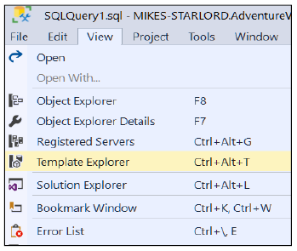
Figure 20- 5. This screenshot shows the menu item that opens the Template Explorer.
The Template Browser (Figure 20- 6) will then appear on the far right-hand side of SSMS’s interface. It is a tab you can click on next to the Solution Explorer’s tab. If you want to see the Solution Explorer again; you must click its tab at the bottom of the pain and likewise for the Template Browser.

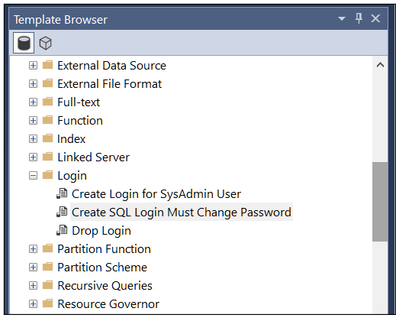
.
Figure 20- 6. The Template Browser. It offers you folders containing various preprogrammed templates. These templates represent common syntax variations of a fairly extensive set of SQL commands.

If you select the template I have chosen (Login=>Create SQL Login…) by double-clicking it, SSMS will show you the T-SQL command to create a SQL login. You can see it in Figure 20- 7.

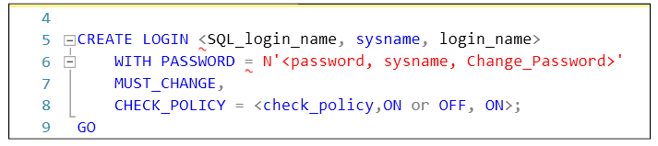
Figure 20- 7. A template to create a SQL login. The items in <…> are going to be substituted with real-world values.
Find and click the button in Figure 20- 8 in SSMS’s toolbar or press ctrl+shift+m, SSMS will present you with Figure 20- 9.


Figure 20- 8. The toolbar button to click to begin substituting the <…> in the template with your chosen values.
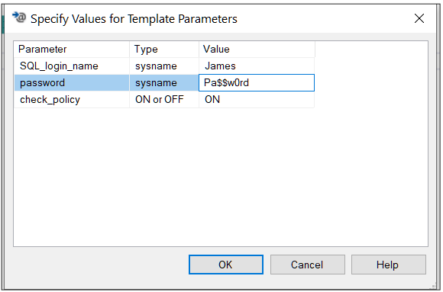
Figure 20- 9. SSMS’s value substitution dialogue that you use to replace the various <…> in the template with real values. Fill them in as I have shown here.
If you fill in the values as I have done in Figure 20- 9 and click OK, SSMS will leave you with the completed script shown in Figure 20- 10. If you have permissions to create SQL logins, the script will run otherwise you will get an error. The error will confirm if you don’t have the privileges to execute the command versus a syntax error. A permission denied error is proof enough you have done a successful job of using a template.

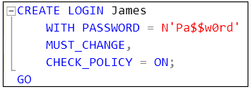
Figure 20- 10. The final executable script that the template produces.

These templates will become valuable to you as you broaden your knowledge of SQL and SQL Server administration. You might want to spend some time looking through what the templates can offer you.

20.5. The Exercise

Please follow along and do the demonstrations as described in the text.
The official exercise includes trying out the SSMS template tool, and in turn, you will learn the basics of how to create a stored procedure. Exciting stuff.
As usual, you can see the answers in Appendix F, or you can download a complete solution from my web site (https://www.Transference-UnLimited.com).

Exercise 20. Querying Using SSMS’s GUI

Since this is the last exercise in the course, I thought it might be fun to show you what you may pursue in your SQL future: how to write a stored procedure. Or at least, the beginnings of how to write one.
A stored procedure allows you to load a SQL script into a database and save it under a meaningful name. When you want to run it, you type in exec storedProcedure’sName. A stored procedure can take parameters; SQL passes them into the procedure’s script as variables. These parameters can be read anywhere in the script and make its functionality more flexible.

Ex 20.1. Opening a Template to Write a Stored Procedure

You are going to use the template that SSMS provides to create a stored procedure that will search product names for a keyword. Once you have finished the exercise, you will be able to type in and execute:

EXEC uspSearchForProducts ‘bike’

And you will get a table that lists all products that have “bike” somewhere in their names.

Go to View=>Template Explorer as in Figure ex 20- 1.

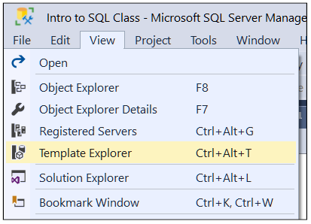
Figure ex 20- 1. The Template Explorer option on the View menu.

On the far right of your screen, you should see the Template Browser. Your Solution Explorer may seem to have disappeared; you can bring it back later by clicking the Solution Explorer tab at the bottom of the pane. Scroll down through the templates until you find Create Stored Procedure (New Menu) and double-click on it. It doesn’t matter if you can’t find an entry with the “new menu” suffix.

Now go to File=>Save As and save the file under the name “Ex20 Querying Using SSMS’s GUI”.

Feel free to look through the template. Focus on entries such as “<Procedure_Name, sysname, ProcedureName>”. These entries are place-holders. The template is expecting you to replace these entries with valid text.

Go to the menu option you see in Figure ex 20- 2–you can find the same option on the toolbar if you click on the icon . Fill in the parameter grid using the values in Figure ex 20- 3.

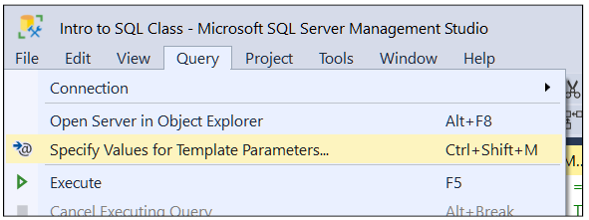
Figure ex 20- 2. The option to replace placeholders in the template with text.

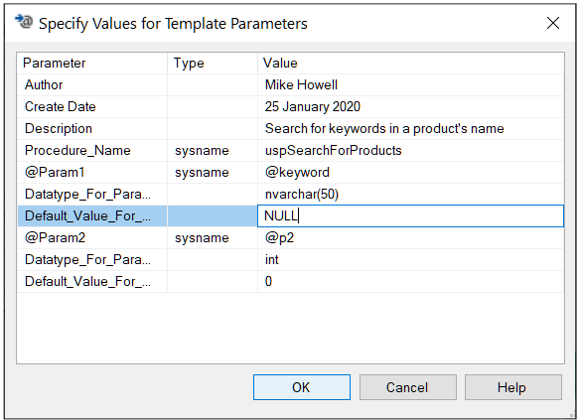
Figure ex 20- 3. The values to put into the parameters grid. Put your name in, not mine. For the parameters that you aren’t going to use (@p2), leave them set as they are.

Clean up the script by removing the bits-and-bobs we don’t need. Be sure to remove the comma after the NULL. Replace the code between the BEGIN and END with the custom SQL statement you see in Figure ex 20- 4.

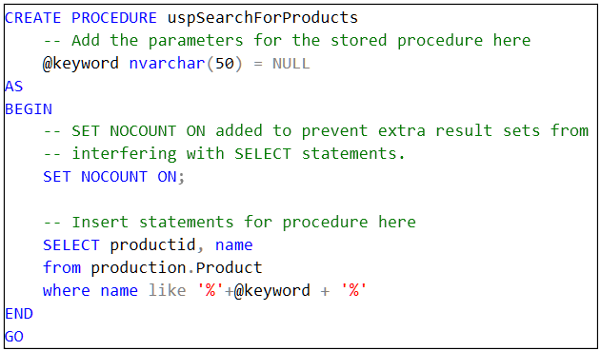
Figure ex 20- 4. What your script should look like when you are finished. Leave the upper part of the file as it is.

You are welcome to explore what SET ANSI_NULLS ON, SET QUOTED_IDENTIFIER ON and SET NOCOUNT ON and so do via the online documentation. SET NOCOUNT ON is particularly interesting as it prevents the procedure from displaying status messages causing your stored procedure to run silently.

Execute the script, and SQL will tell you the “Commands completed successfully”.

Now, move the cursor to just below the GO in your script. Type in and execute the script in Figure ex 20- 5.

Figure ex 20- 5. The command to execute your stored procedure.
You will get the output shown in Figure ex 20- 6.

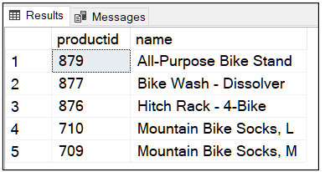
Figure ex 20- 6. What the stored procedure will return if you execute it via the script in Figure ex 20- 5.
If you do not supply a parameter value, the stored procedure will show all the products.

If you make an error in your stored procedure’s script and SQL accepted the faulty code, replace CREATE PROCEDURE with ALTER PROCEDURE and rerun the script.

21. Conclusion

Have you worked your way here by going through every single chapter? Well done you. If not, well, I hope you have picked up a tip or two or a hundred.
I hope you are approaching SQL in your office more confidently now, and you are ready to start teaching and helping others to achieve the same–be the office genius you’ve always wanted to be. And please tell others about how useful this course has been to you and how this material can help them.
Possibly you have experienced the odd bump in the road to SQL success here-and-there. You can email me to get help for that “little bit of SQL” that simply refuses to make sense; no matter how hard you look at it.
I am open to offering virtual on-line classroom should you want personal tuition at negotiable rates.

21.1. Exploring More
Maybe you are a budding or closeted DBA? During the course, did you find yourself drawn to knobs and dials on SQL that intrigue you and they don’t make any sense just yet? If so, I would recommend that you follow this course with one on database administration.

21.2. Spreading the Good Word

If you enjoyed this course, I would appreciate reviews posted online to show to others that you have successfully learned from this material. It would encourage others to take the same learning path that you enjoyed. I want to reach as much of an audience as possible to help them achieve a meaningful, practical understanding of the SQL language.
All the best, and thank you for following this course to the very end.
Mike Howell
Mike.Howell@Transference-UnLimited.com
https://www.Transference-UnLimited.com

Exercise 21. Conclusion

Find a bath.
Pour some fragrant bubble bath into the said bath.
Fill the bath with hot water.
Soak yourself in it for 30 minutes.

Appendix A. Installing Microsoft SQL and Adventure Works 2017

This appendix will show you how to install SQL on your computer. It will show you what hyperlinks to follow to find MS SQL, the Adventure Works sample database, and SQL Server Management Studio. If you want to install the software on your work computer instead of your home machine, you will need to have the necessary administrator rights and your IT administrator’s permission.

If you want to use an existing SQL server in your office, you will need to install the Adventure Works sample database onto it. You will use this database throughout the course. You will need database owner rights (full access rights) on this sample database. Be sure to ask the company’s DBA for permission and possibly to help you.

You will need database owner rights on the Adventure Works database or in other words, complete control over the database. Having dbo rights on the sample database will not affect your privileges on any other database on your server.

If you install MS SQL and the sample database on a private computer, you will automatically have full control over the SQL server and any databases you put onto it.

If you have a private SQL server, you will be able to do the exercises at the end of each chapter as well as perform the demonstrations in each chapter’s text whenever and wherever suits you.

A.1. Introducing the Sample Database: Adventure Works

This course uses one of Microsoft’s free sample databases. The database I have used is the Adventure Works 2017 OLTP database (also known as a relational database). This database represents a fictitious bicycle and bicycle component manufacturer and distributor known as Adventure Works. The database comes in a variety of versions to suit your particular version of MS SQL.

All of the versions of the Adventure Works OLTP database will work with this course, choose the one whose year matches your SQL server installation (Adventure Works 2014, 2016, they are all good).

This course does not use the Adventure Works data warehouse (DW) or the Analysis Services related Adventure Works files. These are separate databases for demonstrating components of SQL that you are not going to use in this course. You may install them if you are curious to play with them. To install non-relational components of Adventure Works will require installation instructions that go beyond this course material’s purpose, and you will have to research how to do so on your own.

A.2. General Notes on Installing SQL Server 2017

I am going to explain how to download and install the SQL 2017 product. At the time of writing, SQL 2019 has become available. You are welcome to use SQL 2019 instead, simply download it rather than 2017. The installation instructions are the same as given here.

You can use an existing MS SQL server if you prefer, but you will need to ask for permission from the owner before you do so.

A.2.1. What To Do If You Already Have MS SQL On Your Machine

If you already have an MS SQL server installed on your machine, you can very likely use that installation as is. You will need to check the version, specifically the year number, the edition (SQLExpress, Standard, Enterprise, Developer) and know both your computer’s network name as well as your MS SQL server’s name.

Once you have this information, do make sure you have SSMS installed. If not go to the section on installing SQL Server Management Studio (SSMS) later in the appendix (section A.15).
After installing SSMS if you need to, you can download a suitable version of Adventure Works by skipping to the section on downloading the sample database A.16.

A.2.2. What To Do If You Don’t Have an MS SQL Server Installation On Your Machine

Please install MS SQL 2017 or later as I will describe to you. I recommend installing the Developer Edition. The Developer Edition is the full enterprise scale capable version of MS SQL. It has all the features on offer that MS SQL can offer anyone. It is free to use for testing and development purposes. You are not permitted to put a live user load onto this edition of the server. Please check the Microsoft licence agreement if you are in doubt concerning your situation.

You can use SQL Express. Microsoft restricts SQL Express to use limited amounts of memory, database size and CPU capacity. It can accept a small user load free of cost. If you have a choice, I would suggest using the Developer version instead; it will let you learn all the features of MS SQL that might interest you in the future.

You can install SQL 2017 on a machine that already has a version of MS SQL installed. It doesn’t matter what the existing version of that MS SQL installation is. Doing so creates what is called an additional instance of MS SQL. A new installation will not interfere with an existing installation in any way.

You can install MS SQL together with other brands of SQL. My machine runs PostgreSQL, MongoDB and MySQL simultaneously together with MS SQL 2017 and various version variations without problems.

A.2.3. Using a Virtual Machine

If you know how to set up a virtual machine using Hyper-V or Oracle VirtualBox, feel free to do so. A virtual machine (VM) will allow you to create a “machine in your machine”. The VM will in not affect your current windows installation or its settings. I will not give instructions on how to set up a VM here. To set up a virtual machine requires knowledge of OS installation, network and general hardware configuration. It is the least intrusive option in that it operates entirely independently of the host machine and makes no changes to the existing OS installation.

A.3. Hardware Required

MS SQL runs on a vast array of hardware configurations. The instructions I am giving you assume Windows 10 and SQL 2017. You can use earlier operating systems and earlier versions of MS SQL, but you will have to modify my instructions to suit.

The exact hardware and host operating system you have determines which version of SQL you can install. The amount of memory and the age and speed of your central processor will determine how fast SQL will run. You can always remove SQL if you find your machine becomes too slow. In which case, you could consider using a SQL Server machine in the cloud such as on Azure or Amazon Web Services. If you do, you will have to find out how to set up a cloud-based MS SQL server or independent VM running MS SQL yourself. Cloud services are not free, although you can find various promotional offers to get you started.

Your current operating system may require service packs (OS updates) to be applied. The SQL installation process will tell you what changes you need to perform to your machine first should you have to make them. At worst, the setup process will tell you that your OS or machine’s hardware is utterly unsuitable without causing any harm to your computer.

You can read Microsoft’s MS SQL 2017 official minimum specification, but you can’t take it seriously: 1GB RAM, 1.5GB disk space. In Table A- 1, I provide the hardware specification of the machine I run MS SQL on daily. I have moderated the table with comments to assist you since you don’t need to have a multi-purpose configuration like mine. My machine is way over specified to run SQL 2017 for this course’s needs; I give its specification as a guide. You can run SQL 2017 on Linux if you feel so inclined. You cannot use SSMS directly on Linux, but you can make use of Azure Data Studio instead (https://docs.microsoft.com/sql/azure-data-studio/what-is?view=sql-server-ver15). If you are new to MS SQL, I would recommend running it on Windows to start with and try the Linux version when you have more experience.

Component: | My Laptop: | My Recommended Minimum: | Commentary:
CPU | i7-2GHz  4 cores  8 threads | i5 or Ryzen 5 (2nd or 3rd Generation) | You don’t need a high powered processor for MS SQL for this course.  I have run it on an i3 processor with an SSD drive for teaching purposes.
RAM | 32GB | 8GB | You can get away with less RAM than 8GB if you must.  Running other applications on a machine with insufficient RAM can be done, but they will run slower than “normal”. SQL will run slowly as well.
Disk space used in program files folder for SQL | 1.6GB | 10GB free space. | Preferably have 10GB free if you plan to start playing with SQL’s extra tools (I do not cover them here) and other databases.
Disk space used for SSMS | 1.5GB |  | SSMS is the client I will use throughout this course. SSMS issues SQL commands and displays their output in a friendly GUI environment.  SSMS can connect to an MS SQL instance over a network.
OS | Windows 10 Pro | Windows 8 minimum. | I know many still love Windows 7.  If you run Windows 7, you will have to install an earlier version of MS SQL such as 2014.
Table A- 1. A list of hardware suggestions for MS SQL to run on.

A.4. Understanding The MS SQL Naming System

To refer to your MS SQL server from within a client program such as SSMS, you need to know two names: your computer’s OS name and your MS SQL server’s name.

A.4.1. Identifying Your Computer’s Network Name

Your machine has an OS (or network) name which you need to know. People refer to It colloquially as “your machine’s name”. This name is the one other users would type or browse for to access your file shares and printer over a network. You can find your machine’s name by opening File Explorer (browse your computer or press windows key + e)=>right click This PC=>Properties. You can read your computer’s name from the section highlighted shown in Figure A-1.

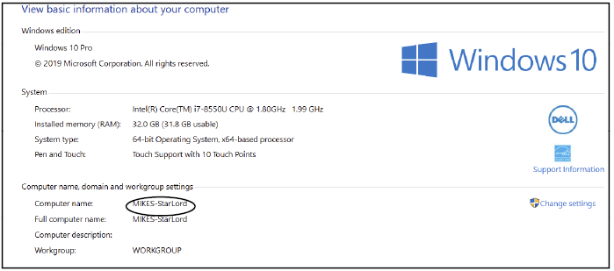
Figure A- 1. The Windows screen that shows your computer’s name.
From reading Figure A- 1, my machine’s name is MIKES-StarLord (named after the internal project name for the Dell Inspiron 7773).

A.4.1. Choosing an MS SQL Server Name

You will need to give your SQL server a name. You choose this name in addition to your computer’s name.

If you use the default SQL server name, you will have a slightly easier time of it. That is because any SQL client software (which includes SSMS) will let you type in the computer’s name and then assume to use the default SQL server’s name. The default server name is MSSQLSERVER. The SQL installation tool will attempt to offer this name to you if it is unused on your computer.

If you choose a name other than MSSQLSERVER, to connect a client application to it, you will have to type both the computer’s name and the SQL server’s name into the client. You do this using the format: MyComputer\SQLServerName. For example, if my SQL server’s name is SQLTest, I would connect to the SQL server using SSMS by typing in the name MIKES-StarLord\SQLTest.

Another example: You will almost always use this two-part name when using Microsoft’s popular SQL Express edition. SQL Express uses the default name of SQLEXPRESS. If I had SQL Express installed, I would type in the name MIKES-StarLord\SQLEXPRESS to access SQL.

The names are not case sensitive. They are each limited to 15 characters in length.

TIP: A Short Cut Computer Name Trick

If you are running a client application physically on the computer that is running the SQL Server, you can type in a “.” (a period or full stop) instead of the computer name. In my example, I could type in .\SQLTest rather than MIKES-StarLord\SQLTest.
If you are connecting to a SQL server via a network, you must type in the SQL Server’s host computer’s name.
Either way, be sure that you have connected to the correct SQL server before issuing commands to it.

A.5. Downloading the SQL Server Files

My suggested installation method is to download the SQL Developer Edition from the web site https://www.microsoft.com/sql-server/sql-server-downloads. The site’s address may change, if the link no longer functions, it is best to google for Microsoft SQL Server’s current home page. Please make sure you are downloading the files from Microsoft’s web site for safety’s sake.

The web page as of September 2019 looked as in Figure A- 2. The SQL 2019 page is identical except for obvious changes. Please scroll down the web page to find the button that downloads the Developer Edition, which you can see highlighted in Figure A- 3. The “Download Free Trial” button is not the button you want as this will download a time-limited evaluation edition.

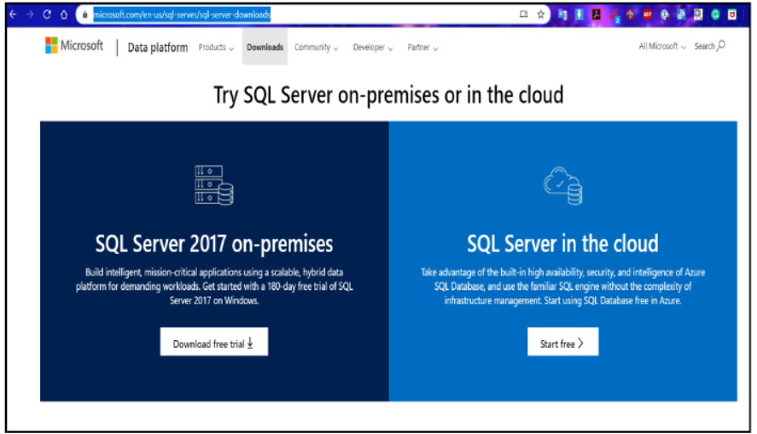

Figure A- 2. The opening web page where you can find the download for MS SQL Developer Edition. Scroll down further to find the link for the Developer Edition download. Do not click on the “Download free trial” button as this will download an evaluation version.

The first file you will download from Microsoft’s MS SQL site—SQLServer2017-SSEI-Dev.exe in my case—is a downloader application. Run the file you have downloaded, and the downloader will greet you with Figure A- 4. Take the “download media” option and proceed to download the suggested .iso file to a location of your choice.

Once the .iso file has downloaded, double-click it, and it will open to reveal what appears to be a DVD (Figure A- 5). Click on the setup.exe file, and the initial install dialogue will appear (Figure A- 6). The result of this process is shown below in Figure A- 5.

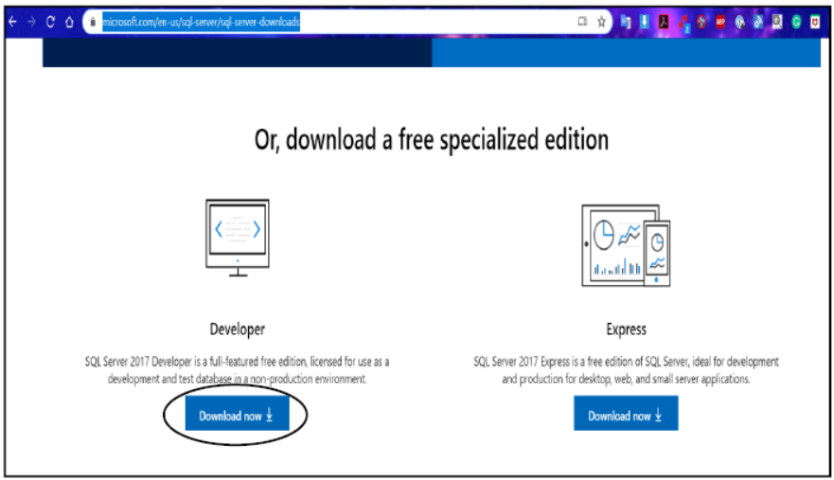
Figure A- 3. The section of the web page that exposes the download for the Developer version.

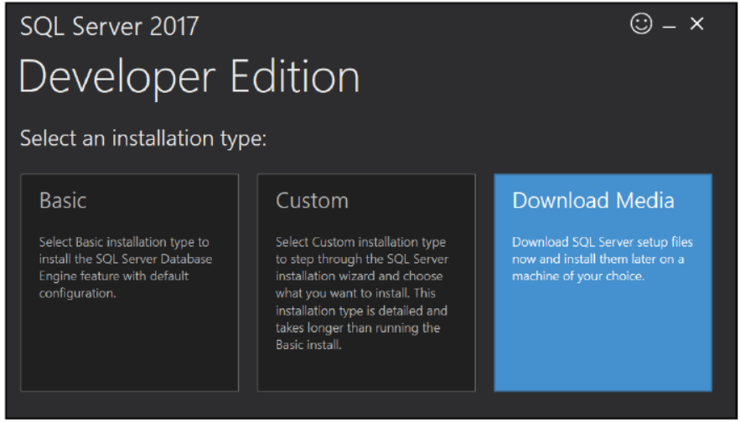
Figure A- 4. The initial screen displayed by the SQL downloader. The tile highlighted in blue is the one you want to take.

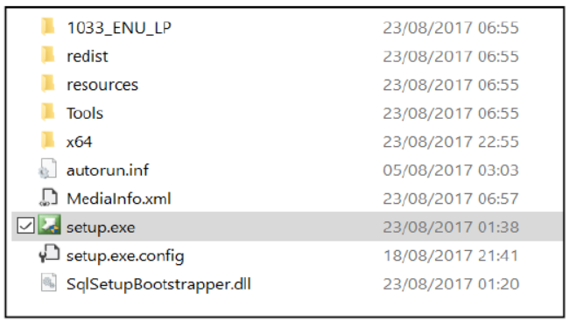
Figure A- 5. Double click the downloaded ISO file, and you will see the above files. Double click the setup.exe to start the Installation Center.

A.6. Installation Centre Options

Once the installation centre is open (Figure A- 6), choose the Installation blade. Then take the New SQL Server stand-alone Installation… option. Proceed by following the screenshots that I describe below.

If you want to change the options that I have taken and you know what you are doing, please feel free to. The options explained in the text will install a SQL Server with the minimum options you will need to get going with this course. They are safe options.

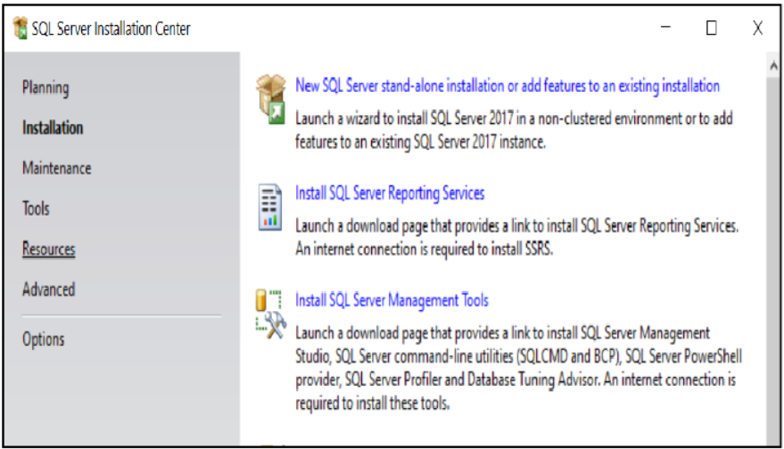
Figure A- 6. The opening SQL installation centre. I have selected the Installation blade down the left-hand side.
Here is the confusing part: The first few screens I explain below, don’t always appear, or if they do, they don’t always show in the same order I have listed them. That is because their appearance and order depend on previous MS SQL installations you may have done or attempted on your machine.

As you see them on your screen, match the screenshot in the text up to the caption and instructions for each figure.

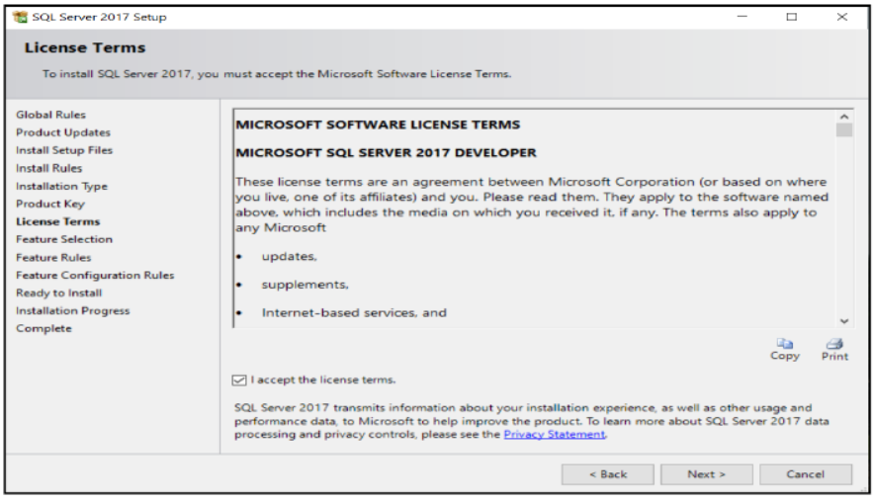
Figure A- 7. Accept the Licence Terms as usual.

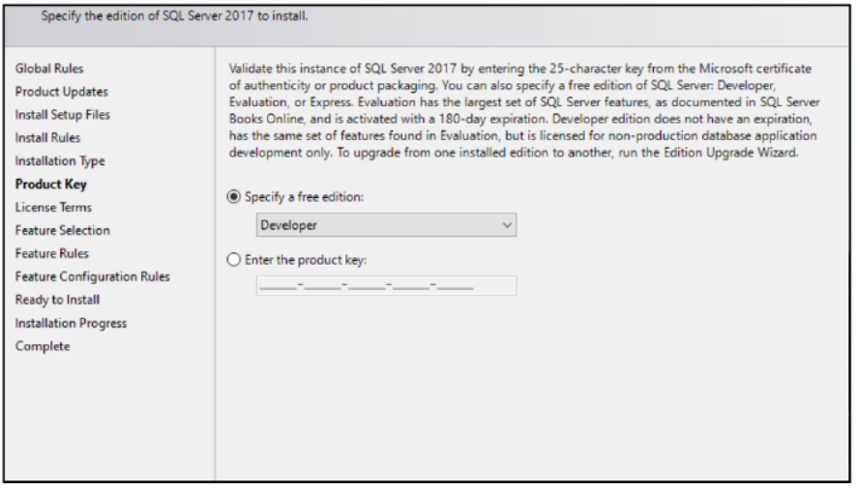
Figure A- 8. Select the Developer Edition option from the drop-down.

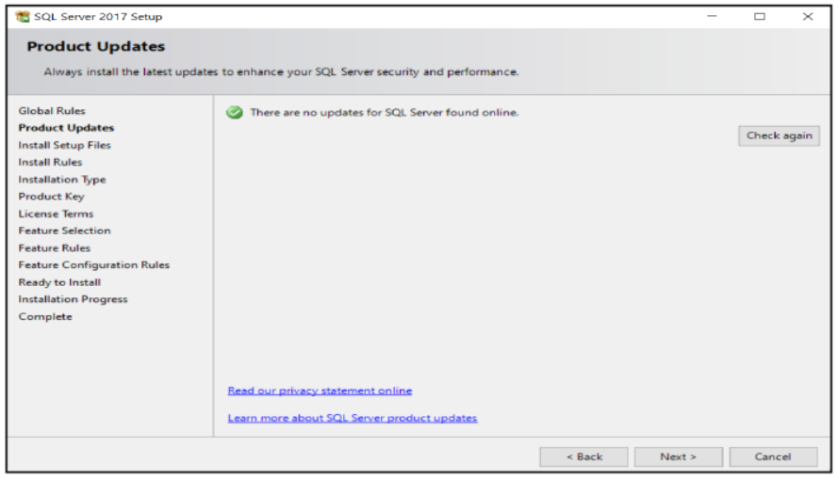
Figure A- 9. This variation of the Product Updates screen doesn’t always appear. If it does, there is nothing to do here except click Next.

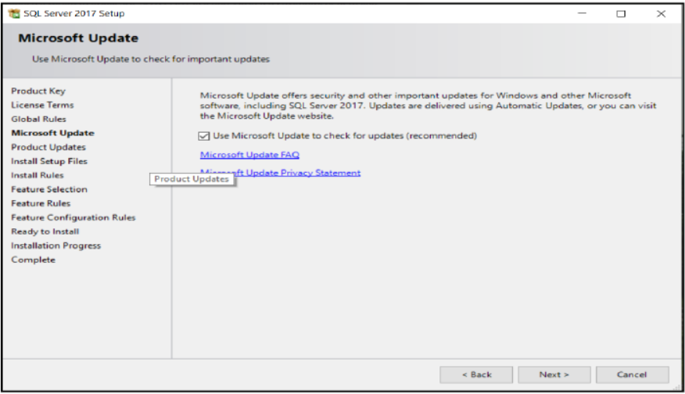
Figure A- 10. This screen may appear to ask if the installer can download any “last minute” updates from Microsoft.
For Figure A- 10, the installer is offering to let you install the latest updates Microsoft may have made to MS-SQL. They are non-essential for this course. Tick the box if you want to download them. These updates are usually recent updates from Microsoft. Tick the box and agree to download the updates. If you can’t install them for whatever reason (for example, should you not have configured an Internet connection while installing inside a virtual machine), skip them, the installation of SQL will proceed anyway.

A.7. The Install Rules Screen

If you have the correct privileges to install SQL, you will see Figure A-11. If you see red lights, please read the description SQL will give you about what is wrong. An error is very likely to be caused by:

- Your OS version which isn’t supported by the release of SQL you are trying to install.
- Your machine is missing a service pack or a version of the .NET Framework. The error will tell you what to install.
- Your windows user account does not have adequate permissions on your machine to allow you to install SQL.

Figure A-11 is what you should see if all is okay. The warning triangle next to “Windows Firewall” is to let you know that if you want to connect to your machine over a network, you will have to configure any intermediary firewalls. That includes checking and configuring Window’s built-in firewall (Windows Defender) to allow external connections from other client machines.

If you follow my instructions, you are going to connect a client application to a SQL server which are both installed on the same computer. That means that there is nothing to alter on a firewall. If you are going to connect via a network to the SQL server, check the footnote for help.

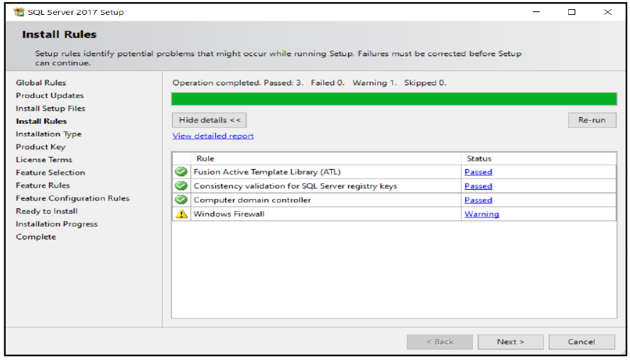
Figure A- 11. The Install Rules screen.

A.8. The Feature Selection Screen

When you reach Figure A- 12, please select the components listed below in Table A- 2. These are the minimum required options for the course to work. If you select additional components, you may encounter additional configuration screens later in the installation process that I have not described.

If you decide to add any extra components and are then unable to answer the questions in any resultant dialogues, you can use the Back button to return to this screen and remove the extra option(s). You are welcome to add extra options, but you will have to research how yourself.

You can rerun the setup and add options another time.

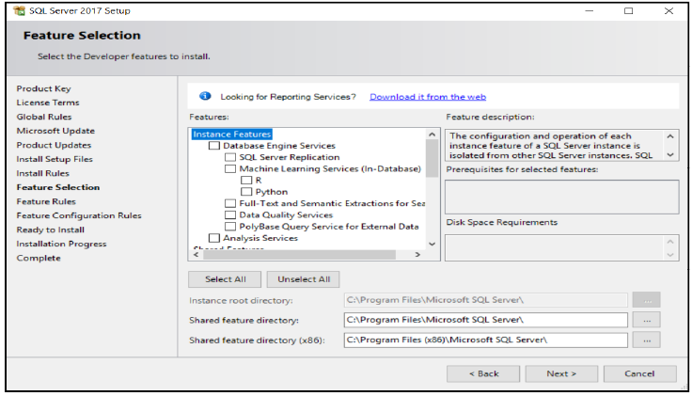
Figure A- 12. Feature Selection is the screen where you have to choose the components of SQL that you want to install. The text will tell you which options you need.
It is best to leave the folders listed as they are. You traditionally install SQL on the C drive. You can install the databases on any drive you like provided the SQL service account (described later) has full read-write access to them. I would suggest leaving the folder locations set to the default values seen in Figure A-12.

The components you need to choose at a minimum are in Table A- 2.

Component: | Purpose:
Database Engine Services | Database Engine Services are the core of the SQL Server engine.
Client Tools Connectivity  Client Tools SDK | These tools are needed to support your machine connecting to the SQL server.  This option includes a command-line tool to issue SQL commands called SQLCMD. We won’t be using SQLCMD, but you might want to try it from the command prompt one day. Especially so if you are working on a machine that doesn’t have SSMS installed on it (or a GUI for that matter).
SQL Client Connectivity SDK | This component installs providers (you can relate them to hardware device drivers) for OLE DB and ODBC, which allow connectivity to both none-SQL data sources and none-Microsoft data sources.  This component is useful if you want to use or write an application that needs to talk to not only MS SQL but other database systems as well. These components include the ability to read and create Excel files (using OLE DB).  SSMS uses these components within its data import/export wizards. They also allow connectivity to non-Microsoft SQL servers such as DB2 on mainframes/minicomputers, MySQL and the like either via a native provider or using ODBC.
Table A- 2. List of components you need to install a working SQL installation suitable for the course.

A.9. Instance Configuration or Installation Type

If you don’t have an existing installation of SQL, you will get a screen as you see in Figure A-13. If you do have an existing installation, you will see a screen similar to Figure A-14. The difference between the two figures is the content of the grid at the bottom. The grid shows you the names of the SQL servers you already have on your computer. The names are listed to help you make sure you don’t choose an existing name.

If you see Figure A-13, I recommend that you leave the instance ID set to the default of MSSQLSERVER. You can click next; your SQL server will take on the default SQL server name.

Later, to connect to the server, you will only need to type your computer name into the client software. Client software (such as SSMS) will assume the SQL server’s name is MSSQLSERVER. Do not try to connect to a default instance by typing MyComputerName\MSSQLSERVER. Interestingly, It won’t work.

Otherwise, if you see Figure A- 14, take the Perform a new installation of SQL 2017 option and click Next, which will lead you to Figure A- 13. Now change the Instance ID to a 15 character name of your choosing, perhaps using a name such as CourseServer. This name will become what you type in after MyComputerName\ such as Mikes-Starlord\CourseServer. Check the grid at the bottom to make sure you don’t choose a name that a SQL instance is already using.

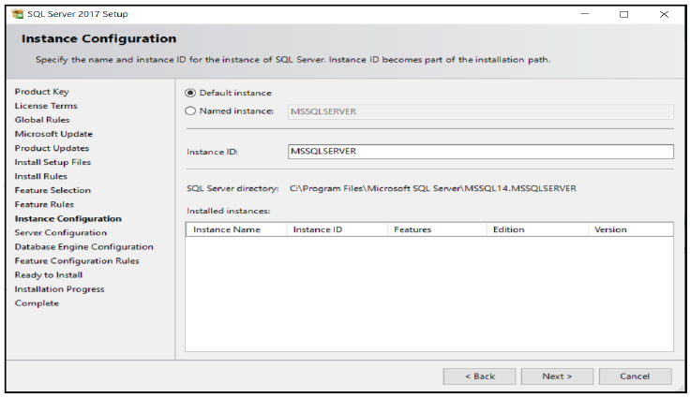
Figure A- 13. The Instance Configuration screen that appears if you don’t have MS SQL installed already. SQL is suggesting that you use the default name MSSQLSERVER.

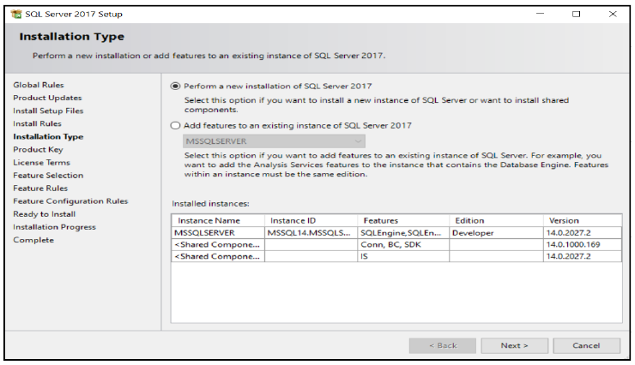
Figure A- 14. This Installation Type screen appears if you have an existing MS SQL Server installed. The grid at the bottom identifies the names of the MS SQL server(s) (amongst other components) that are already on your machine.

A.10. The Server Configuration Screen

When you see Figure A-15, the machine is asking you for the user accounts that it will use for the SQL Server Agent the SQL Database Engine and the SQL Browser service. Each of these services within SQL needs a user account. They use their accounts to log into the host OS so that they can run without you having to manually login in and start them. These services have a Startup Type of automatic.

The SQL Agent is used to execute jobs, such as backups or data imports/exports at a scheduled time. If you would like to try the Agent on your own, set the Startup Type for it to automatic. SQL Express does not come with a working agent.

The SQL Browser is used to identify which TCP/IP port a given instance of SQL is using. The default instance (MSSQLSERVER) defaults to using port 1433. Other instances default to using a randomly chosen (and changing) port number. A client application needing to connect to a named instance over a network discovers the port number given to that instance by “asking” the SQL Browser service what that number is. We don’t need this service in our configuration scenario. Leave it set to disabled unless you wish to connect to your non-default SQL instances via a network, in which case set it to automatic.

If you see a Launchpad service (SQL 2019), SQL uses it to pass queries from MS SQL to an external third party query language called R. We won’t use that service in this course so leave its settings alone.
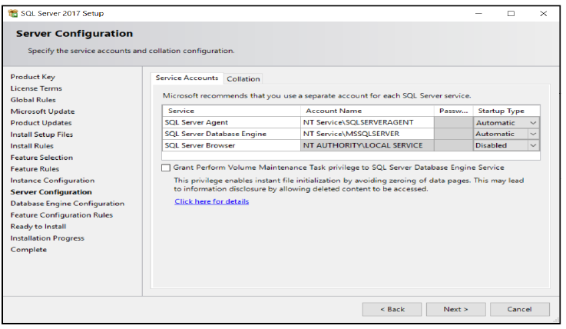
Figure A- 15. This screen is where you allocate a user ID and password to each SQL server service. A service needs to log in to the OS independently of a human user. The Startup Type column dictates if the service logs in when the OS is in its start-up stages (automatic) when it is started by another service or application (manual) or unable to be started at all (disabled).
You will see the installation application has chosen some default accounts for you. Windows categorises these accounts as virtual accounts. They don’t exist in a user list that you can find using Window’s standard tools such as User Manager or Active Directory Users and Computers. These virtual accounts are okay for you to use as-is.

In general, virtual accounts automatically change their very long passwords at regular intervals. It is impossible to log in physically with them because doing so is actively blocked by the OS itself. That is one of their benefits over using a standard user account for one of SQL’s services. You will use a standard user account if your SQL server needs to access files on the local hard drive or via a network file share under strict permission control. You are not going to do that in this course. You can change the service accounts, SQL users, at a later time.

If you use the suggested virtual accounts, you will see that the option to type in a password is disabled. That is because the machine controls them itself.

Please leave the Collation tab set to its current default options. That is unless you know you have to change the collation settings. You can confirm if you need to by asking your DBA. You will have to change it if you need to change the default human language and consequent character set used by SQL. SQL additionally uses this setting to determine how to sort the symbols of the character set you have chosen.

SQL defaults to a character set known as Code Page 1252 (in the UK and USA) which is inferred by the default collation name SQL_Latin1_General CP1_CI_AS. SQL supports languages such as English, Spanish, French and German via this character set. Unless you need to change these settings, please leave them alone, or you risk having to reinstall the entire server.

I do encourage you to look through the collation sequences if you are curious, but please don’t change it unnecessarily. You will learn more about code pages and collation sequences in section 1.9.

A.11. Database Engine Configuration

In Figure A- 16, the installer is asking you to decide if you want to activate the SQL server’s internal login list of users (combined with using Windows user accounts) versus using only Windows ID’s to log in.

SQL accounts cannot log into a workstation but can be used to log into the SQL server via a client application. Administrators use such accounts to allow the usage of application-specific user IDs. For example, let’s say you have a particular account that you use to log into your company’s finance application such as FinUser3 after having logged into your Windows workstation using a Windows account such as Simon. The first account (FinUser3) is a SQL login and the second (Simon) is a Windows user account.

These SQL accounts are also used by non-Windows machines to connect to MS SQL. For example, I have a Linux machine that needs to connect to MS SQL running on a Windows 2019 server. Since Linux doesn’t natively log into Windows accounts, you use a separately defined SQL login to allow a Linux client to connect.

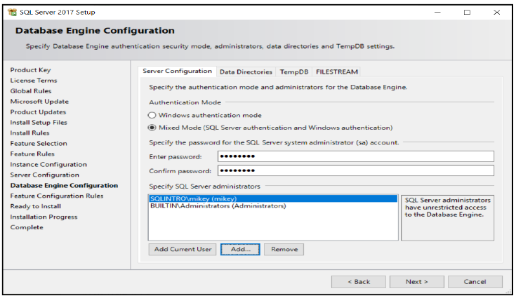
Figure A- 16. Here you can configure which user databases you wish to allow access to your SQL server. You also get to choose the SA (system administrator) account password if you have activated the internal user database. You get to decide

For the sake of flexibility, I suggest turning on Mixed Mode, which allows both window’s users and internal SQL logins to connect. The other mode is Windows authentication mode which allows only Windows accounts to connect. The Mixed Mode setting allows more room for you to experiment with your server in the future.

If you enable mixed mode, as I have done in the diagram, you will need to choose a password for the System Administrator (SA) account. The SA account has total power over the server. I have assigned it the password Pa$$w0rd. The password must contain alphanumeric characters (upper-case and lower-case, numbers are an option too), as well as symbols for SQL to accept it.

In the bottom section of Figure A-16 (Specify SQL Server administrators), click Add Current User so that your current windows ID has full control over the SQL server. Doing so will give your windows account SQL system administrator (known as SA) privileges. In practice, you would use this option to restrict administrative control of the server to a specific user or a small handful of users.

This facility is valuable in situations where the machine contains very sensitive information that not even the network administrator, unsupervised, can access. This option does accept Windows groups. Be aware that other tools can add users to a chosen Windows group that may defeat the purpose of this facility.

Since you are installing a private machine, you can enable the windows group administrators to have full control. You can do this by clicking Add and then type in administrators. This step means that any user who is an administrator of the local machine has full control over the server, just in case you need to log in with a different administrator capable account in case of an emergency.

Bear in mind that it is possible to lock yourself out of a SQL server if you only have one account listed and you can’t remember the password and are unable to reset that password. I have had this happen with a client. Luckily I could fix the problem by reinstalling the SQL server.

You may not be so lucky if you have encrypted databases, depending on how you have configured and stored the encryption keys. The long-and-the-short of it is if you want tight security, you have it, but don’t shoot yourself in the foot either.

A.12. The Ready to Install Screen

You will get a confirmation screen listing all the options you have chosen (Figure A- 17). Check through the list then click Install. Excellent! Go and grab yourself a nice cup of tea/coffee etc. and a biscuit or two. It will take a while for the SQL server to install.

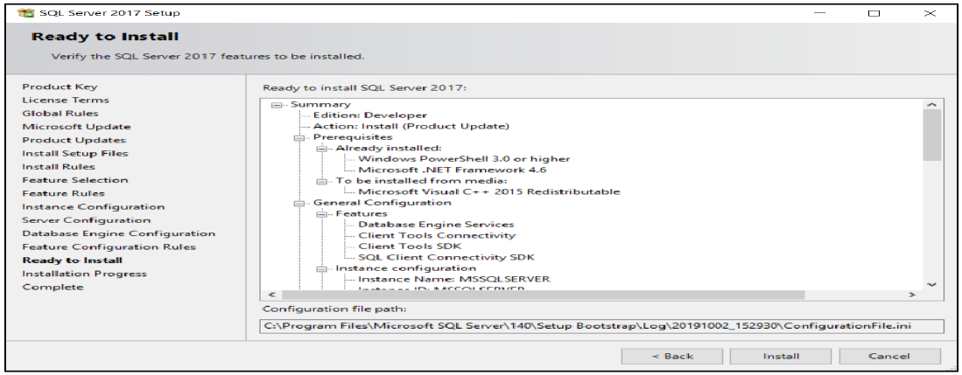
Figure A- 17. This screen summarises all the options you have selected before the installation proceeds.

A.13. The Installation Progress Screen

Once you click Install, you will see Figure A- 18 as the installation proceeds. You will see Figure A- 19 when the installation is complete.
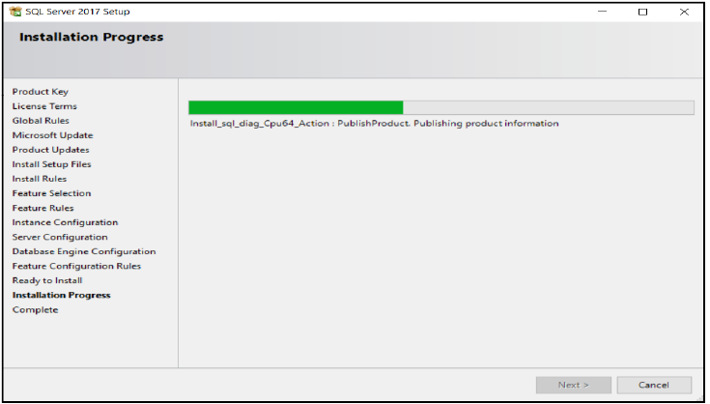
Figure A- 18. As the progress bar moves across, your installation is proceeding nicely.

If you get an error, look at the diagnostic message carefully and google its content if necessary. Write the error down if you need to. Once the error has vanished off the screen, it can be tricky to recall.

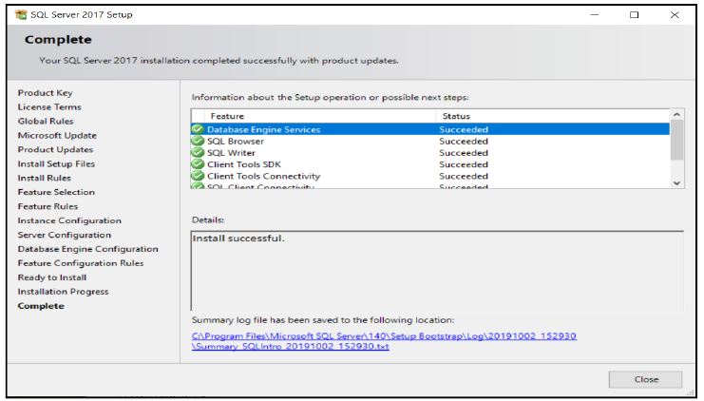
Figure A- 19. The screen of success. All green lights, all done!
You are now ready to go to section A.15 unless you have encountered errors.

A.14. Finding the Install Logs

If you encounter an error, you may find it helpful to look at the installation log files. You can find them in the path shown in Figure A- 20. I will explain the path so that you can find it. Once you have navigated to c:\program files\sql server the next folder’s name to choose matches the version number of MS SQL you have installed. For instance, SQL 2017 is version 14. SQL 2014 is version 12 and so on. The easiest is to open the highest numbered folder. In there you should see a Setup Bootstrap folder. If not, try the next lowest numbered folder and repeat this until you find it. Go into the Setup Bootstrap folder and then the Log folder.

Look through the summary.txt file for your initial log data. If that file doesn’t help you, go into the most recently dated folder. The folders are named using the format of year month day - hours minutes seconds. Go into each and read through the various text files looking for clues searching for information as to what went wrong during the installation.
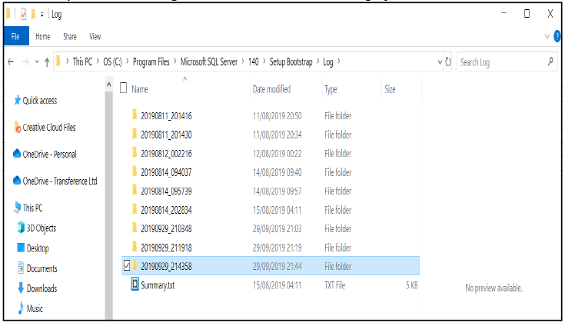
Figure A- 20. The folder where you can find the considerable collections of installation log files.

You can go into the Windows Event Viewer as a guide to the error (Figure A- 21). You can find the Event Viewer by typing Windows key=>type event viewer=>Enter. The Event Viewer will list multiple logs that are by-and-large system installation-specific. Start searching in Windows Logs=>System and have a look through for messages related to SQL. You can try the other logs folders as well.

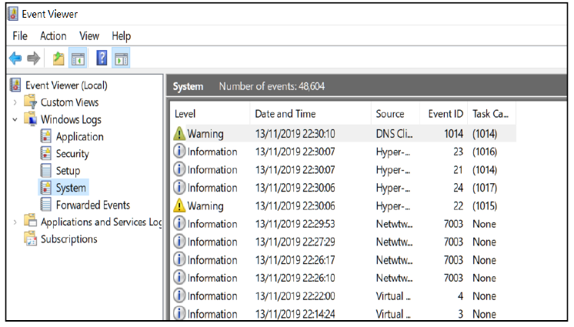
Figure A- 21. The event viewer tool.

A.15. Installing SQL Server Management Studio (SSMS)

An easy way to get access to the download link for SSMS is to restart the SQL setup program (setup.exe). Once you have done so select the Installation blade and click on Install SQL Server Management Tools (Figure A- 22).

The installer will take you to a web page (Figure A- 23) that has a download link for the latest SSMS version. Please download the file. At the time of writing, the filename was SMS-Setup-ENU.exe for the English version.

Once it has downloaded, run the executable, and you will see Figure A- 24. Click Install (unless you want to change the destination location first) and wait as the interface takes you through Figure A- 25 and then finally Figure A- 26.

You will test your installation of SSMS in the next section when you restore the Adventure Works database.

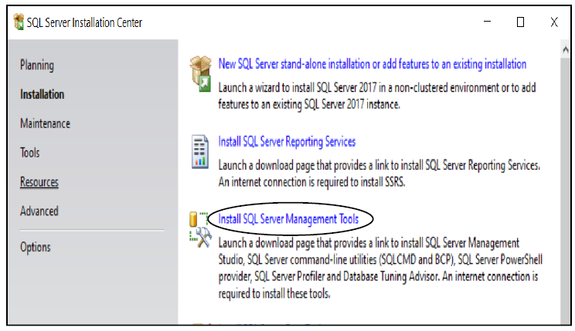
Figure A- 22. The link to click on to access SSMS’s download web page.

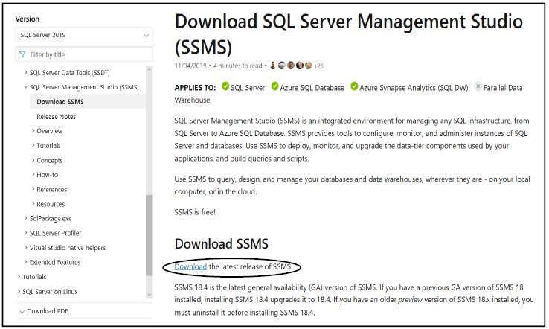
Figure A- 23. The download page for SSMS. I have highlighted the link to click with an ellipse. Bear in mind, this page’s content could change as time goes by.

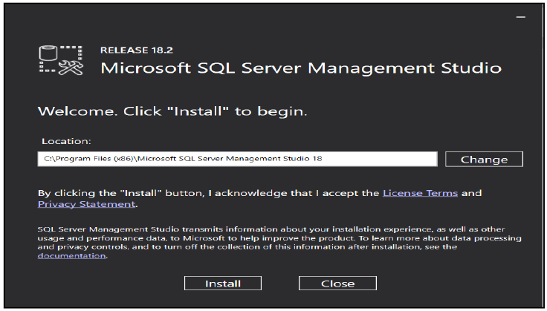
Figure A- 24. The first screen of the SSMS installer.

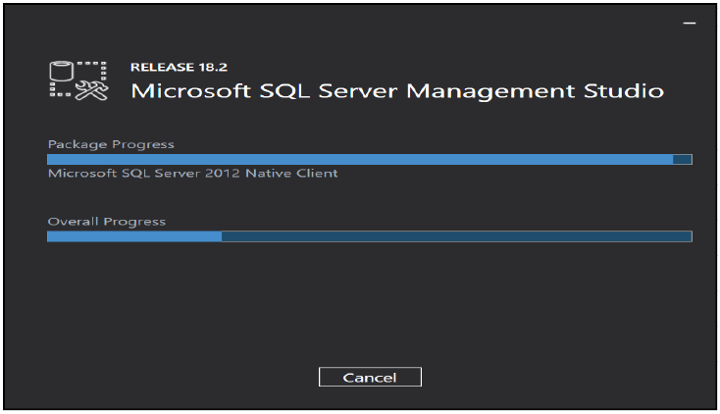
Figure A- 25. The installation progress screen of SSMS’s installer.

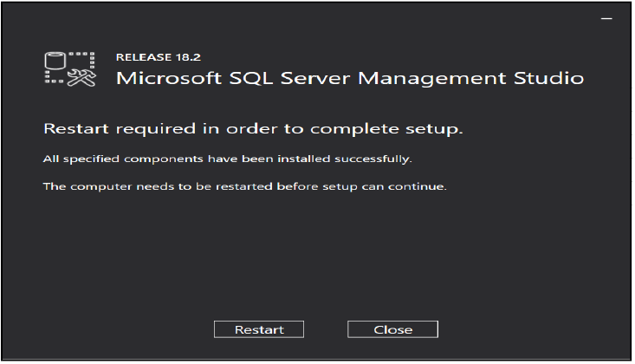
Figure A- 26. The final installation screen that you will see when installing SSMS. Note the request for a Windows restart.

A.16. Installing Adventure Works 2017

To download the Adventure Works 2017, or an earlier backup file, visit the site: https://github.com/Microsoft/sql-server-samples/releases/tag/adventureworks.

You should see Figure A- 27 (as of September 2019).

You can google for the terms Adventureworks 2017 sample database if you prefer to find the database that way. GitHub is a reliable source for the file you need.

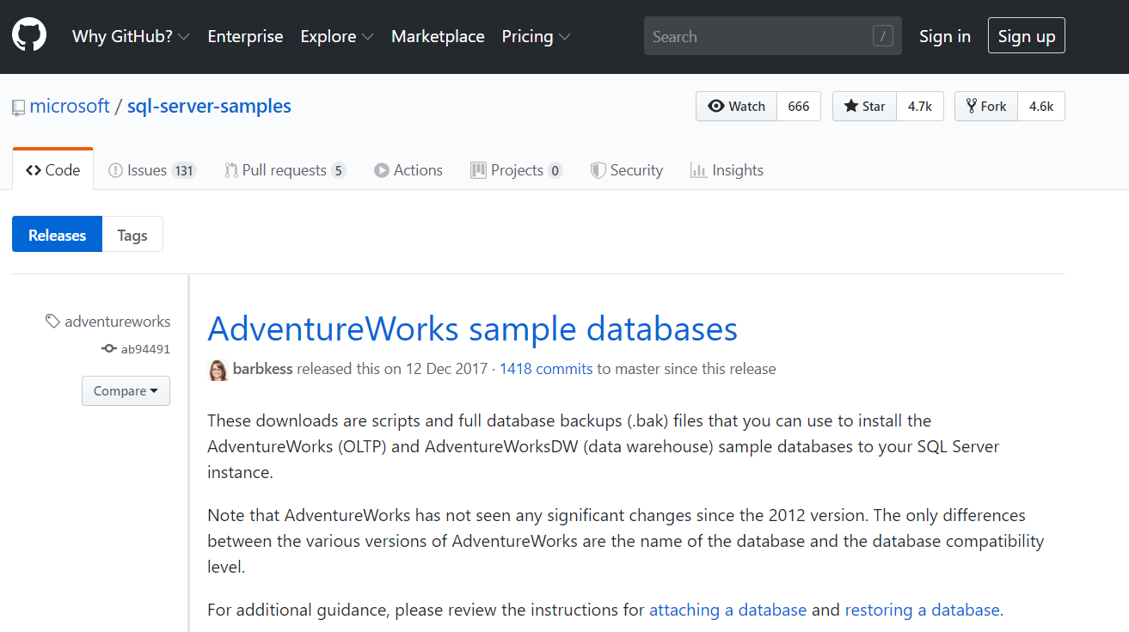
Figure A- 27. This screenshot is of the official web page on GitHub where you can find the Adventure Works database backup file: AdventureWorks2017.bak
Scroll down till you see the section of the page that looks like Figure A-28. Download the .bak file that matches AdventureWorks2017 or an earlier version as you need.
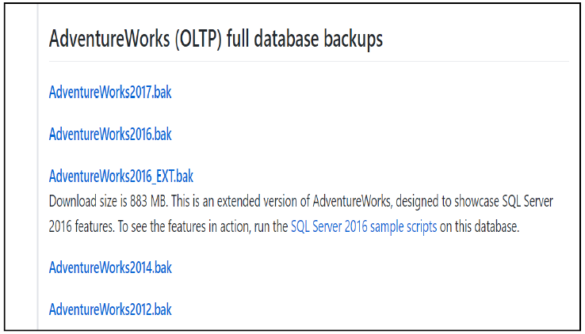
Figure A- 28. The set of links on GitHub that will allow you to download the AdventureWorks OLTP database. For SQL 2017 you want AdventureWorks2017.bak

Once you have the file, move it from where you have downloaded it to the folder in Figure A- 29. The destination folder is the Backup folder which is itself located in the folder where you have installed MS SQL. In my case, this path is:

c:\Program Files\Microsoft SQL Server\MSSQL14.MSSQLSERVER\MSSQL\Backup

Your destination path might differ from mine by the SQL version number (MSSQL14) and instance name (MSSQLSERVER).

During your moving of the file, Windows will very likely ask you to elevate your permissions to let you enter the Backup folder (Figure A- 30). It is safe for you to do so click Continue.

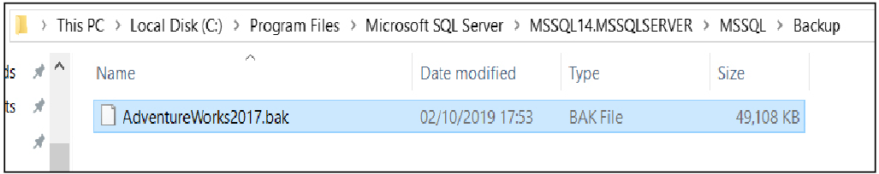
Figure A- 29. The location where you want to deposit the file. My path is c:\Program Files\Microsoft SQL Server\MSSQL14.MSSQLSERVER\MSSQL\Backup. Your path may vary slightly; please read the text.

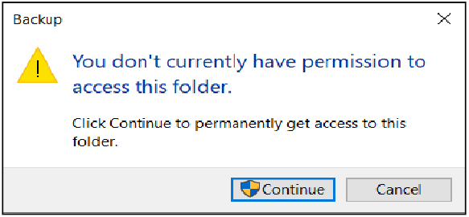
Figure A- 30. You may see this screen when you attempt to go into the Backup folder. Click Continue if you do.

A.17. Performing the Restore Operation

To restore the Adventure Works database, you are going to use SSMS. Press the Windows key and type in SSMS and then press “Enter” (Figure A- 31).

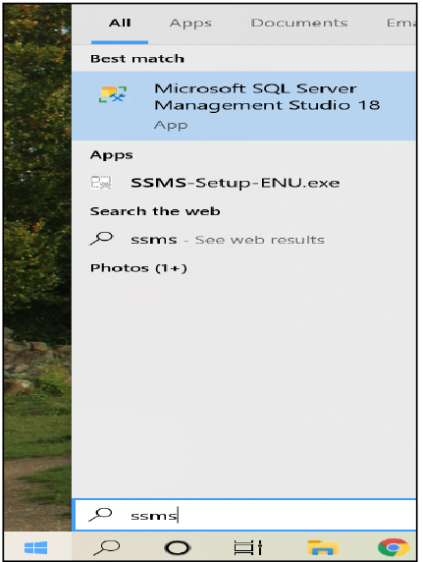
Figure A- 31. The Start menu when about to launch SSMS.

When SSMS finishes starting up, you will find Figure A- 32 in the centre of the screen. Unless you need to change the server/instance name, click Connect, and you will see Figure A- 33. See section A.4 if you are not sure how to work out your server’s name.

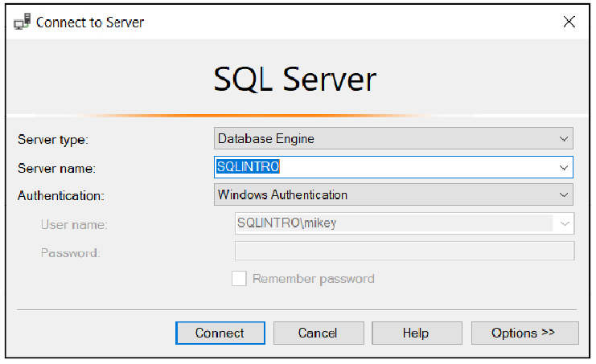
Figure A- 32. The Connect To Server log in dialogue. In this case, the computer’s name is SQLINTRO. The SQL server name is assumed to be MSSQLSERVER.

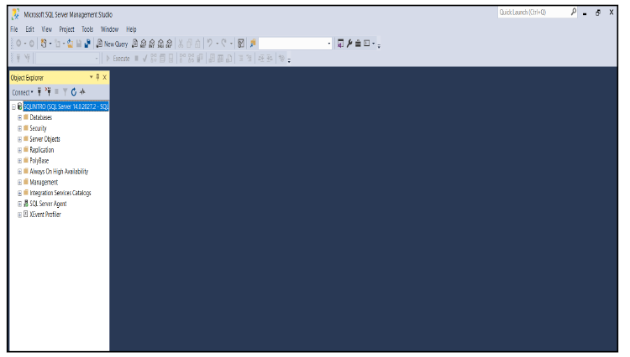
Figure A- 33. SSMS once you have logged in to your SQL server successfully. Your logging in has caused the Object Explorer to appear down the left-hand side. It is browsing the SQL server with your current credentials.

Down the left-hand side, you should see the Object Explorer as in Figure A- 34. Please right-click Databases and take the Restore Database option as in Figure A- 35.

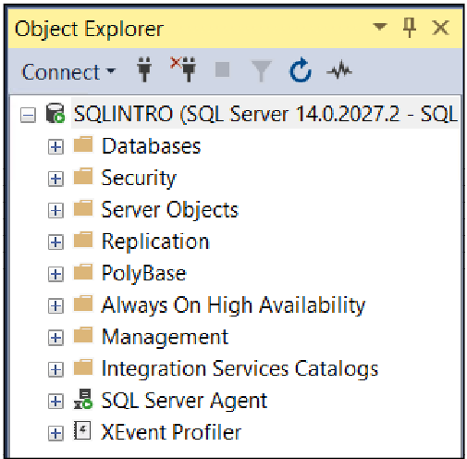
Figure A- 34. The Object Explorer which you will find on the left-hand side of SSMS.

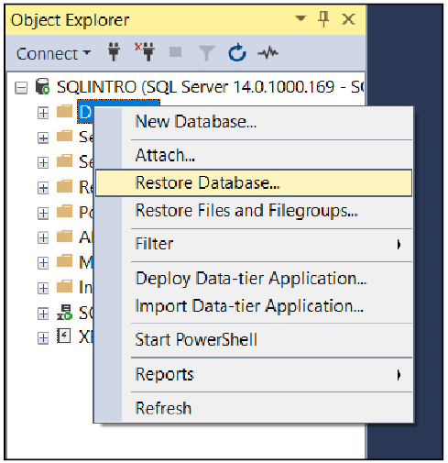
Figure A- 35. The Restore Database option in Object Explorer that you want to use.
When the restore screen appears, click the radio button next to Device. Then click the ellipses (…), and you will see what is in Figure A- 36.

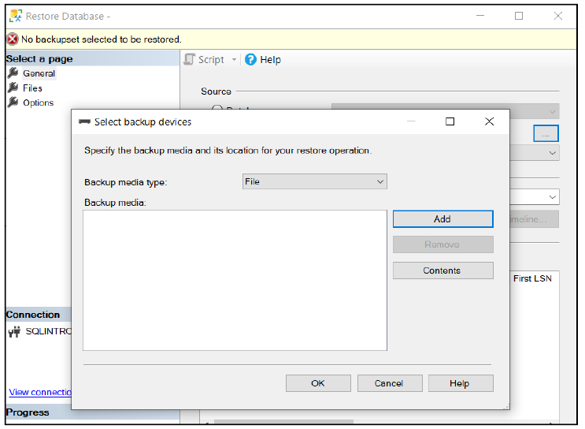
Figure A- 36. Click the ellipses (…) to access the Select Backup Devices dialogue.

Choose the Add button, and you will see Figure A- 37.

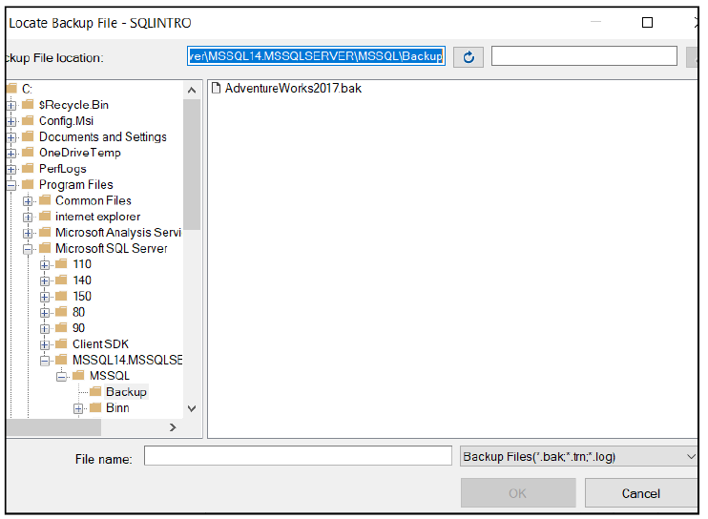
Figure A- 37. Clicking Add in Figure A-36 will cause this dialogue to appear.

The dialogue in Figure A- 37 assumes to use the Backup folder where you moved the .bak file earlier.
Choose the relevant Adventure Works backup file that you moved into the Backup folder;

Click OK twice. A green cartwheel should appear and spin for a short while. SQL will then tell you that the restore was successful (Figure A- 38).

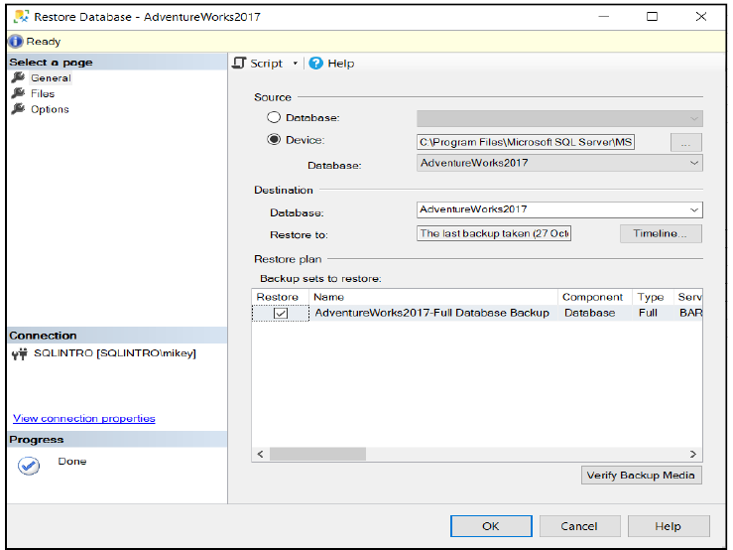
Figure A- 38. This screenshot shows the final restore screen of a completed restore.
You can store the .bak file in other folders besides the suggested Backup folder. For this to work, you may have to adjust permissions on the .bak file manually. If the restore dialogue does not show you your .bak file, give the Everyone Windows account full control over it or the folder which contains the file. Otherwise, move the .bak file to the Backup folder.

Once the restoration process is complete, expand Databases on the Object Explorer, and you will find your newly restored database as seen in Figure A- 39.

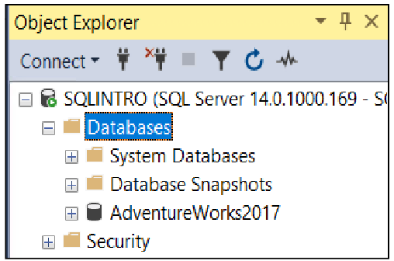
Figure A- 39. The proof that you have done a successful restore.

Well done! You are now ready to do the exercises at the end of each chapter in the book.

Appendix B. SSMS Tips and Keys

B.1. Useful Shortcut Keys

Key(s): | Effect:
F5 | If no text is selected, this key executes the entire script in the script editor pane.  If text is selected, pressing F5 executes the contents of the selected text.  Make sure you have highlighted meaningful SQL first.
Ctrl + s | Save the current file in the current script editor pane.  Watch for little ‘*’s next to the label on each tab. The ‘*’ means that you haven’t saved that tab’s content since you last edited it.
Ctrl + shift + s | This combination of keys saves all the files that you currently have open in the various tabs of the script editor pane. It does so by going through each tab in succession and saving it.  SSMS will ask you to rename any query files that you have not explicitly named.  This facility is very useful to make sure you have saved all your scripts in the various editor tabs.
Ctrl + shift + r | Refresh the Intellisense cache.  This function is handy when SSMS’s IntelliSense tells you an object doesn’t exist (with a red squiggle underlining it) when you know that it does. This situation happens because it takes time for Intellisense to regularly refresh the list of new objects that are in the database.  SSMS delays keeping the Intellisense cache up to date done to save processor cycles on the server.
Ctrl + kd | Reformat the SQL commands in the editor pane.
ctrl + t | SSMS will show the results of your query in text mode.
ctrl + d | SSMS will show the results of your query in grid mode.
shift + end | Highlight the text from the cursor’s current position to the end of the line. Then moves the cursor to the end of that line.
shift + home | Highlight the text from the start of the current line to the cursor’s position. Then moves the cursor to the beginning of the current line.
ctrl + ← | Move left one word.
ctrl + → | Move right one word.
shift + ← | Move left one character and highlight as you go.
shift + → | Move right one character and highlight as you go.
ctrl + alt + L | Put the Solution Explorer on the screen.
F8 | Put the Object Explorer onto the screen.
F4 | Put the property editor grid onto the screen.
shift + alt + enter | Toggle the text editor’s full-screen mode.

Table B- 1. A list of shortcut keys you will find useful when using SSMS.

B.2. What to Do if You Have Lost a Window or a Pane

If you have closed a window/pane and want to bring it back onto the screen, Microsoft’s SSMS has a three-step pattern that you can follow to get it back:

- Have a look for the missing window’s title listed under SSMS’s main menu’s View option.
- Have a look for the window’s title under View=>Other Windows.
- Open the menu item that is related to the theme of the lost window, and you may find the window listed under a Windows option on the menu. For example, open Debug and then look for an option labelled Debug Windows.

If you have entirely dislodged too many windows and panes and want to put them back; go to Window=>Reset Window Layout=>Yes. This option will put all the windows and panes back as when SSMS first started. You might have to re-open the Solution Explorer after doing this reset (see the above steps for how to find it).

B.3. How to Find Out What the Capabilities of an Icon/Heading Are

If you aren’t sure what an icon/heading can do in SSMS, right-click it. SSMS will usually tell you via a context menu what you can do to that icon or items that fall under that heading (an example heading would be Databases). If you right-click Databases in the Object Explorer, you will see all the things you can do to a database in general. Right-click a specific database and a menu will tell you what you can do to that particular database, likewise, for a table and so on. The right-click facility in Windows is very helpful. I often joke with my students “when in doubt, right-click it”.

Appendix C. Useful Options

C.1. Line Numbers

If you go to SSMS’s Tools->Options->Text Editor->All Languages->General (Figure C- 1) you can switch on line numbers that will appear down the left-hand column of the script editor pane.

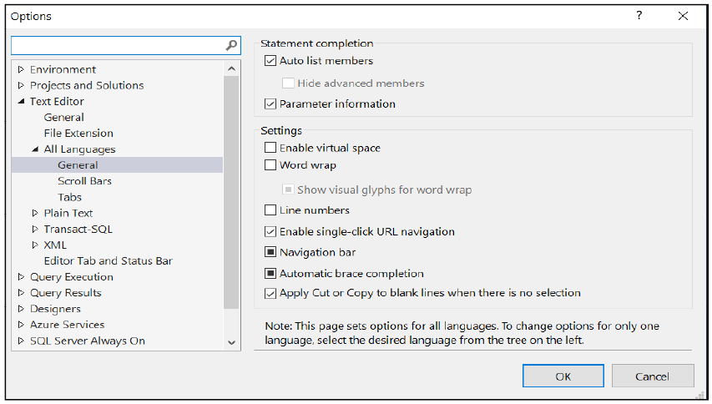
Figure C- 1. The dialogue that allows you to turn line numbers in the text editor off and on.

C.2. Text Size

If you find that the text in the editor pane or the results grid is too small to read comfortably, you can adjust this by going to Tools->Options->Environment->Fonts and colours. Check that the “Show settings for:” drop-down reads Text Editor if you want to change the standard editor font details.

If you choose the Grid Results option amongst the items in the drop-down, you can change the result grid’s text size. Unlike the text editor’s font settings, you will need to restart SSMS for the grid font’s settings to cause an effect.

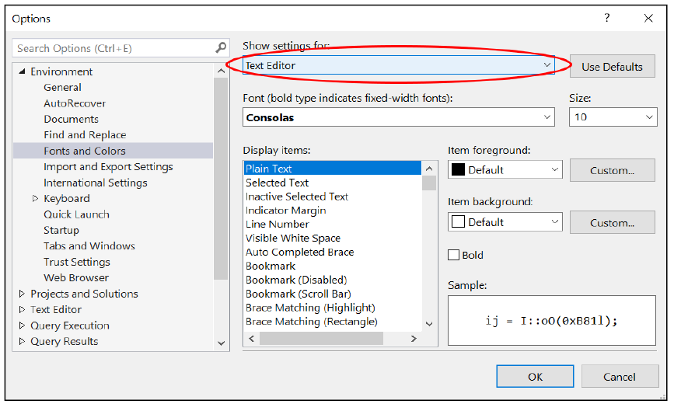
Figure C- 2. This screenshot shows where to go to change the font settings for the text editor.

Appendix D. Data Type Precedence and Implicit Type Conversions

What happens if you type in a value that could belong to multiple types? For instance, if I type in 7, is that an integer (a whole number) or do I really mean a number that you want to treat as part of a calculation that needs six digits of accuracy after the decimal point? An incorrect assumption could cause severe rounding errors to occur. If I type in ‘2010-04-01’, do I intend for those symbols to be taken literally or do you want SQL to see that set of symbols as a date?

The SQL needs to know what you mean. SQL is more flexible than many languages and will attempt to “guess” your intended meaning. It does so by applying a data type hierarchy to your ambiguously typed data. In other words, SQL will assume an ambiguous type is more likely to be one type than another. Some programming languages would generate an error should there be any ambiguity in interpreting your symbols. SQL tries to be more “tolerant” and not always successfully, as you will see.

D.1. Data Type Precedence

I have listed the precedence hierarchy of data types in Table E- 1 below. What this table is concerned about is resolving what happens when you mix data types in a calculation. The returned data type will be that of the data type with the highest precedence used in the calculation.

Precedence: | Type name:
1 | User-defined data types
2 | sql_variant
3 | xml
4 | datetimeoffset
5 | datetime2
6 | datetime
7 | smalldatetime
8 | date
9 | time
10 | float
11 | real
12 | decimal
13 | money
14 | smallmoney
15 | bigint
16 | int
17 | smallint
18 | tinyint
19 | bit
20 | ntext
21 | text
22 | image
23 | timestamp
24 | uniqueidentifier
25 | nvarchar (and nvarchar(max))
26 | nchar
27 | varchar
28 | char
29 | varbinary
30 | binary

Table E- 1. A table listing the data types of SQL in the order in which it will try to match a data type. SQL will try to match a datum’s type to the bottom-most type first (binary), then SQL will work its way up the table until it finds a suitable matching data type.
Let’s use some examples to explain how this works. In Figure E- 1, you can see a calculation that, taken literally, doesn’t make much sense. You are taking the character 7 (not the number 7) and trying to divide it by the integer 2.

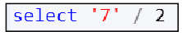
Figure E- 1. An example of a meaningless expression. Or at least, it is meaningless on the surface.
If you look at Table E- 1, you will find that the character type is 28th in the list and the integer type is 16th. Since integers are higher up in the precedence table, SQL will force the calculation’s return type to be an integer value. If the character type were higher in the list, the answer would be a character string.

This ordering of the types means that SQL must try to convert the ‘7’ into an integer value. Since SQL knows how to do this, you get the answer in Figure E- 2.
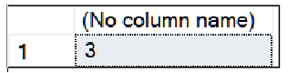
Figure E- 2. The answer from the script in Figure E- 1. The correct answer is 3.5, isn’t it?
As the integer type is the higher precedence type in the expression, the answer is an integer.

Let’s try the script in Figure E- 3.
Figure E- 3. An attempt to convert the potential decimal value of ‘7.0’.
This result that SQL will tell you is in Figure E- 4.
Figure E- 4. The expression in Figure E- 4 won’t convert as hoped.
With the help of Table E- 1, you can work out why. The data type with the highest level of precedence in the expression (Figure E- 3) is an integer. Therefore the result must be an integer. ‘7.0’ is strictly speaking not an integer, the conversion of ‘7.0’ to an integer cannot occur, and the result is an error.
You could get around this by using an explicit cast as in Figure E- 5.
Figure E- 5. How to explicitly cause the output to be a decimal value.
The result is Figure E- 6.
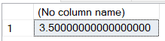
Figure E- 6. The conversion attempt in Figure E- 5 is successful. SQL has maxed out the possible scale used in the return decimal type.
In Figure E- 5, the data type in the calculation with the highest precedence is a decimal. SQL can convert ‘7.0’ to a decimal type without problems.
You could have solved the issue another way, as shown in Figure E- 7:
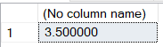
Figure E- 7. By using 2.0 rather than 2 the highest precedence data type in the expression is decimal, providing an acceptable answer of 3.5.
P.S. Show this trick to your friends at your next party. They’ll think you are a genius.

If you wanted more control over the type conversion process, you would be much better off being explicit as in
Figure E- 8. An explicit type cast is the best way to control type conversions.

D.2. Type Coercion

Figure E- 9 shows a script that adds 1 day onto the 1st of January 2020. Why does SQL assume that ‘2020-1-1’ is a date when it could be literal character data?

Figure E- 9. Adding a day onto the 1st of January 2020.
The answer lies in the definition of the data type of the third parameter of DATEADD().

Let’s look at the parameters of DATEADD() as shown in the Object Explorer (Figure E- 10). You can see this same information yourself by going to Adventureworks2017=>Programmability=>System Functions=>Date and Time Functions=>Dateadd()=>Parameters.

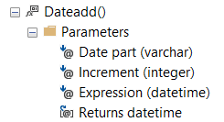
Figure E- 10. The data types of the parameters of the DATEADD() function as shown by the Object Explorer. Note that the third parameter is of type datetime.
The third parameter is of type datetime. This parameter’s type indirectly tells SQL to convert ‘2020-1-1’ to a date. This effect has nothing to do with Table E- 1. DATEADD() has told SQL that it will interpret the third parameter as a date regardless of the type used to express the parameter, in this case, a set of characters. And so the character data is implicitly converted to a date. This type of implicit type conversion is called type coercion.

You can, perhaps amusingly, think of a computer doing typecasting the same way as you would typecast an actor into a role (“you might be a string of characters, but I will always think of you as a date”). For instance, the late great Leonard Nimoy became typecast as a cold “logical” character like Spock. In reality, after watching a few interviews with him, you quickly realise that he was a highly spiritual open-minded hippie type in real life.

Let’s try another example as in Figure E- 11. This statement is an attempt to add 1 to a meaningless date.
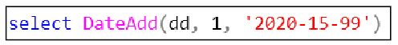
Figure E- 11. An attempt to add one day to a meaningless “date”.

And the result:
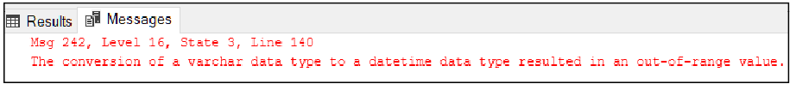
Figure E- 12. The script in Figure E- 4 causes this error.

The error explains to us that DATEADD() told SQL that it wants a datetime and SQL, obligingly, tried to forcefully convert the character string into SQL’s internal date format which failed.

Appendix E. Backus-Naur Form

Backus Naur Form (BNF) is a notation that allows you to express the syntax of a SQL statement in a popularly understood and consistent way. You can use it to describe any programming language’s command’s syntax. BNF is used extensively throughout the IT programming world. It is easy to understand, has been around for a very long time, and it will serve you well to learn it.

I am explaining it to you because you will find it used extensively in Microsoft’s SQL documentation. As you explore SQL’s online manuals, you will need to be able to read BNF so that you can type in any SQL command correctly.

I have not used BNF in my course’s text as I wanted to keep the explanations of SQL’s syntax as simple as possible for someone starting with SQL. Once you explore SQL’s commands on your own, you will find BNF very useful.

BNF consists of symbols with special meanings interspersed between the sections of a command. First, get to know the symbols and then I will explain how to use them. The symbols are:

Symbol: | Meaning:
| | Option separator.
{...} | Choose one of the options in the braces. BNF demarcates each option with a |.
[...] | The entire contents of the square brackets are optional.
[,...n] | You can supply an optional comma-separated list of values. Note that a comma, which you type in literally between the items in the list, appears before the ellipses (…).
<x> | x is described using BNF that appears further down the definition.  The ‘<>’ symbols allow you to break a long definition into smaller digestible pieces.
<x> ::= | The definition of x follows the ::=.  You replace the <x> which you saw earlier in the BNF with the definition of <x> that you are now reading.
(...) | BNF uses parenthesis literally.  They don’t have a special meaning in BNF. Type them in as you see them.  In SQL, ‘()’ usually surround a list of column names.
lower-case letters | You substitute the word in lower-case with a relevant value of your choice.
UPPER-CASE letters | You type the in uppercase as you see it. The case of the text that you type in doesn’t matter.
Table F- 1. The BNF symbols used in Microsoft’s T-SQL documentation. You type in parentheses as they appear in the definition. All other symbols are taken as annotations to explain the syntax of the command.

E.1. A Practical Example of Using BNF: Attaching a Database

Let’s learn BNF by using an example. The CREATE DATABASE command can attach an existing database by referring to its constituent files (the .mdf, optional .ndf and .ldf files). Attaching a database is the process whereby if someone gives you the files that make up a database–an .mdf file at the very least–you can use attachment commands to bring the database online and make it usable. Of course, CREATE DATABASE can be used to create a new database. I am not going to use it for that purpose here.

I have copied the BNF in Figure F- 1 from Microsoft’s online manual. You can see the original text here: https://docs.microsoft.com/sql/t-sql/statements/create-database-transact-sql?view=sql-server-ver15 .
You will have to look fairly far down the manual’s web page to find the relevant excerpt of BNF you see here.

CREATE DATABASE database_name
ON <filespec> [ ,...n ]
FOR { { ATTACH [ WITH <attach_database_option> [ , ...n ] ] }
| ATTACH_REBUILD_LOG }
[;]

<attach_database_option> ::=
{
<service_broker_option>
| RESTRICTED_USER
| FILESTREAM ( DIRECTORY_NAME = { ‘directory_name’ | NULL } )
}

<filespec> ::=
{
(
NAME = logical_file_name ,
FILENAME = { ‘os_file_name’ | ‘filestream_path’ }
[ , SIZE = size [ KB | MB | GB | TB ] ]
[ , MAXSIZE = { max_size [ KB | MB | GB | TB ] | UNLIMITED } ]
[ , FILEGROWTH = growth_increment [ KB | MB | GB | TB | % ] ]
)
}
Figure F- 1. The BNF describing the CREATE DATABASE command when used for attaching a set of existing database files.

E.2. Before You Try These Examples

If you are going to try out the examples, you will have to detach the Adventure Works’s database first to take it offline. Do not delete the physical database’s files after you have detached the database.

You might find it useful to know that you can copy a detached database's files with a straightforward copy and paste operation. You can’t do that when the database is attached and online. If you like, try copying the files that makeup Adventure Works when it is online and see what happens.

E.3. Finding Where The Adventure Work’s Files Are

An important detail you will need is the path to the Adventure Works database files. You can find where they are by executing the script in Figure F- 1.

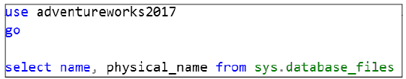
Figure F- 2. A script that will display the files that make up the current database. Be sure to have Adventure Works set as the current database context before running it.
And you will see:
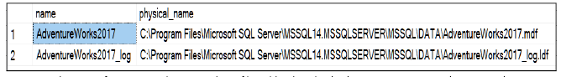
Figure F- 3. The output from viewing the sys.database_files table. Be sure to note the paths to the physical files as you will need this information to attach the database.
Make sure you record the physical paths and filenames, you might want to open another tab in SSMS and leave the results behind in the other. Once the database is detached, you can’t rerun this query.

E.4. What you are About to See is Not a Backup Technique

This a critical side note: please do not use the detach and attach process as a means of doing a backup. If you do so, you will lose out on too many valuable options such as online backups, compressed backups, differential backups and incremental backup. The latter two options allow backing up changes to the database rather than the entire database.

You can get these benefits, and others, by using the official BACKUP command. You can read up on it here: https://docs.microsoft.com/sql/t-sql/statements/backup-transact-sql?view=sql-server-ver15.

Performing sensibly designed backup operations is the subject of a database administration course.

E.5. Detach Adventure Works

Make sure none of the tabs you have open in SSMS are using Adventure Works as a database context. Make sure you have not selected anything to do with AdventureWorks2017 in the Object Explorer. If you are in any way using AdventureWorks2017, the next command will fail with a “database in use” error.

Detach Adventure Works by executing the script in Figure F- 4.

Figure F- 4. The SQL command to detach Adventure Works.
Alternatively, you may want to try right-clicking AdventureWorks2017 under Databases in the Object Explorer. You can then go to Tasks=>Detach. The GUI has a checkbox to log out any current users of the database forcefully which I advise you to check.
Now right-click the Databases folder in Object Explorer and click Refresh. Adventure Works will disappear.

E.6. Using BNF to Construct the CREATE DATABASE Command

Using the BNF notation in Figure F- 1, you should come up with something very similar to Figure F- 5.

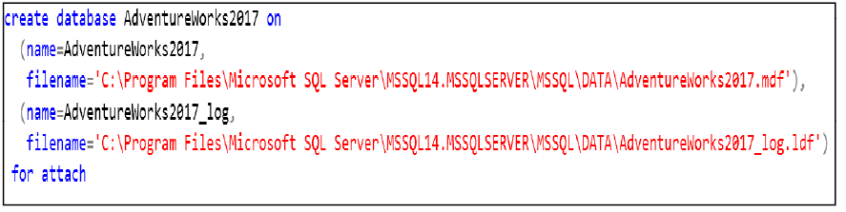
Figure F- 5. Attaching the database as straightforwardly as possible. If your file paths are different from those shown, change the ones in the figure to match yours.
In Figure F- 5, the lower-case letters in the BNF (Figure F- 1) have been substituted with the necessary real values. <filespec> has been expanded as per its definition. <filespec> can be repeated after a comma for each file to be attached as explained by the [,…n]. In the figure, I have repeated <filespec>, once for the .mdf file and once for the .ldf file. I have used the parenthesis literally.

The logical_file_name (such as name=AdventureWorks2017) is a shortcut name used to refer to the long physical name (filename=’c:…’). Various SQL command and tools use the logical_file_name to save having to type in a long physical name. The logical_file_names shown in Figure F- 5 are the same as the originals seen in Figure F- 3. The logical names can be changed, but it makes sense to keep them the same.

In the BNF (Figure F- 1) the SIZE and MAXSIZE options are shown surrounded by []. That means that if you don’t need these options, you can leave them out. For using CREATE DATABASE to attach an existing database, SQL will ignore these settings even if you specify them.

BNF notation has no direct way to show you that SIZE and MAXSIZE aren’t of use when attaching a database. Arguably Microsoft should have created a separate definition of filespec for attaching a database. Microsoft’s description of filespec is a general-purpose definition that works with CREATE DATABASE for creating a new database. I highlight this to show that BNF isn’t always used perfectly for the sake of simplifying the documentation.

The word FOR is required. The {} in Figure F- 1 indicates you must choose between ATTACH or ATTACH_REBUILD_LOG. If you use ATTACH, you can optionally follow it with the word WITH. If you use WITH, then you must follow it with a list of <attach_database_option>’s separated with commas.

The <attach_database_option> can be a <service_broker_option>, RESTRICTED_USER or FILESTREAM. You can only choose one of the <attach_database_option>’s as is indicated by use of the {}.

Before you try the next example, you must detach the database as described earlier. You can’t attach an attached dataset, and you are about to re-attach Adventure Works differently.

Figure F- 6 will attach the database in such a way that only a user with DBO privileges can use the database. I’m showing you this example so that you can compare it with one of the variations the BNF in Figure F- 1 offers you.

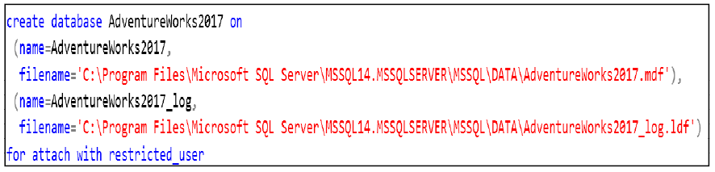
Figure F- 6. This command will attach the database so that only a DBO can use it. The database is now in Restricted User mode.

Object Explorer, once refreshed, will show that you have attached Adventure Works in restricted user mode (Figure F- 7).
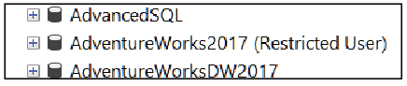
Figure F- 7. This screenshot shows what the Object Explorer will show you when AdventureWorks2017 is in restricted user mode.
In this mode, only users with DBO privileges can use Adventure Works. You would do this so that you can test if the database is okay before putting it into normal multi-user mode.
Detach the database again.
Try the script in In Figure F- 8, another variation of the CREATE DATABASE command deduced from the BNF. It shows you a script for attaching a database without using its log file. You can do this with a single file database, one that consists of only a .mdf file, since the log file isn’t needed. This technique won’t work with all databases. It works with databases made up of a .mdf file only versus one that uses additional .ndf file(s). You can find out about the files that make up a database here: https://docs.microsoft.com/sql/relational-databases/databases/database-files-and-filegroups?view=sql-server-ver15
You might wonder what the log file is for if you can recreate one so seemingly easily. SQL uses log files to protect the database against system failure during the day-to-day running of a database. A database administration course covering database backup and restore procedures will explain how to control and use log files.
You do have to have a log file for a single file database to be attachable. Figure F- 8’s script creates a new log file for you while attaching the database at the same time.

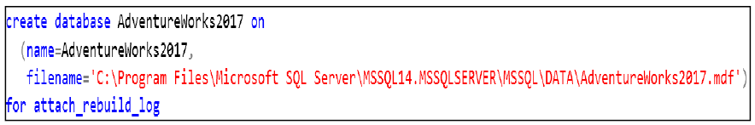
Figure F- 8. This command will attach the database if you don’t have the log file. This approach won’t work with all databases; the text explains the required conditions.

Be sure to leave Adventure Works attached and online to do any of the other exercises. Best use it in multi-user mode. Figure F- 5 will attach the database in multi-user mode, which is the standard mode in which a database operates. If your Adventure Works is running in one of the other modes, detach it and use the script in Figure F- 5 to get it back to normal. You may want to experiment with the GUI’s attach dialogue which you can access by right-clicking databases=>attach

Appendix F. Answers To The Exercises

Exercise 1. Getting Started With SQL

Answer to question 5

Production.Product

Answer to question 6

Person.Person

Answer to question 7

You could have chosen any of the following 4 columns and data types.

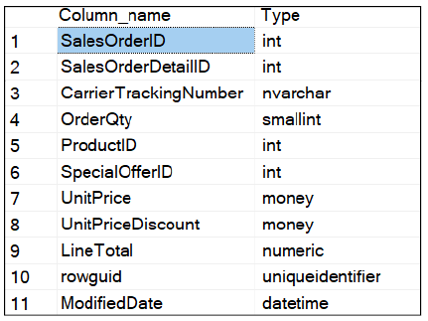

I obtained the above output by entering the command below. Be sure that you have selected Adventurework2017 in the Available Databases drop-drop box before trying it.

Answer to question 14

The select command assumes that you have set the correct database context first. If you type in a select statement that has a table name directly after the from clause, SQL will search for the table in the currently selected database. If you have the wrong database selected in the Available Databases drop-down box, the server will report that it can’t find the table.

If you need to query tables across multiple databases, you can do this by typing the database name in front of the table name. For example:

Answer to 2.2.1

C:\Users\xxx\Documents\SQL Server Management Studio

The xxx represents your user id which is a folder name within the users folder.

You need to take option File=>Open=>File

A common error is to try to open a .sql file using File=>Open=>Project/Solution. This option is for opening a Solution file. A Solution file has the extension .ssmssln.

Answer to 2.2.3

C:\Users\xxx\Documents\SQL Server Management Studio\Intro To SQL Class\Intro To SQL Class.ssmssln

Exercise 2 - Finding Your Way Around a Database

-- Exercise 2: Finding Your Way Around A Database --
--
-- Michael Howell, January 2020

use AdventureWorks2017
go

-- Exercise 2.1
--
-- Set @Length to the number of asterisks you want
-- displayed in a vertical column.

declare @Length int = 10

while (@Length > 0)
begin
print ‘*’
-- @Length -= 1 is the same writing @length = @length - 1
set @Length -= 1
end
go

-- Exercise 2.2
-- Same as Exercise 1.1 but draw a horizontal line instead.
-- The line is constructed in a temporary variable, @line, before
-- being displayed.

declare @Length int = 5
declare @Line nvarchar(80) = ‘’

while (@Length > 0)
begin
set @Line += ‘*’
set @Length -= 1
end

print @Line
go

-- Exercise 2.3
-- Take a variable, @Numbers, loaded with a string of comma seperated
-- integers and then plot each number as a horizontal line.
--
-- ‘5, 20, 8, 10’ produces:
--
-- 5 :*****
-- 20 :********************
-- 8 :********
-- 10 :**********

declare @Numbers nvarchar(80) = ‘5,20,8,10’

-- Each number will be stored in @num
declare @num nvarchar(8)
-- @LocCom is the position of the comma (LocCom = LocationOfTheComma)
-- CHARINDEX() will tell you what character position contains the comma
declare @loccom int = charindex(‘,’, @numbers, 0)
-- @line is used to build the horizontal row of ‘*’s
declare @line nvarchar(80)
-- @count is a variable that counts down as ‘*’s are added to @line
declare @count int

-- Go around in a loop until there are no comma’s in @numbers
-- This will be when CHARINDEX() can’t find a comma so @loccom will be 0
while (@loccom <> 0)
begin
-- Set @num to the characters to the first number in @numbers.
set @num = SUBSTRING(@numbers, 0, @loccom)
-- Chop the first number (and ‘,’) off of @numbers,
-- leaving whatever numbers remain.
set @numbers =substring(@numbers, @loccom+1, len(@numbers)-@loccom)

-- Prepare a blank string which will contain the ‘*’s
set @line=’’
-- Prepare the counter of ‘*’s
set @count=@num
-- Append the ‘*’s onto @line
while (@count > 0)
begin
set @line += ‘*’
set @count -= 1
end

-- Print @num in a field that is 3 characters wide.
-- This makes sure that all the ‘:’s line up.
-- Then print the ‘*’ in @line.
print cast(@num as char(3)) + ‘:’ + @line

-- Find the next ‘,’ in @numbers
set @loccom = charindex(‘,’, @numbers, 0)
end

-- The last number in the string won’t be processed by the WHILE
-- loop. This is because the test for repeating the loop has to be
-- done first before the loop’s content is executed.
--
-- If there is only one number in the string, the WHILE loop won’t execute.
--
-- This is why the code in the loop has to be repeated outside
-- the WHILE loop in order to solve the problem of only one number left in
-- @numbers.
--
-- Ideally, you would like that the loop’s content executes at least once
-- and then you can check if it must repeat. T-SQL does not have a loop
-- syntax/command that supports at least one iteration of the body of the loop.
--
-- SQL is truly NOT a programming language such as Python or C#
-- The scripting commands, although helpful, are too simplistic to write a
-- full-scale application.
-- SQL is brilliant at manipulating two-dimensional sets of data.
-- In SQL, those sets are called tables.
set @num = @numbers
set @line=’’
set @count=@num

while (@count > 0)
begin
set @line += ‘*’
set @count -= 1
end
print cast(@num as char(3)) + ‘:’ + @line
go

-- I would not recommend putting comments of this length in actual
-- code. I have done so here because I know my audience is new to the
-- ideas expressed by this code.
--
-- In practice, a few comments here-and-there are usually all you need.

-- I have repeated Exercise 2.3’s code below without any comments so you can see the
-- see the difference in legibility.
-- If you are an experienced SQL scriptwriter, the volume of
-- comments in the code above will annoy you.
-- As an exercise, you might like to sprinkle a few comments into the
-- code below, that way you can experiment and judge the acceptable volume of
-- comments yourself.

declare @Numbers nvarchar(80) = ‘5,20,8,10’
declare @num nvarchar(8)
declare @loccom int = charindex(‘,’, @numbers, 0)
declare @line nvarchar(80)
declare @count int

while (@loccom <> 0)
begin
set @num = SUBSTRING(@numbers, 0, @loccom)
set @numbers =substring(@numbers, @loccom+1, len(@numbers)-@loccom)

set @line=’’
set @count=@num
while (@count > 0)
begin
set @line += ‘*’
set @count -= 1
end

print cast(@num as char(3)) + ‘:’ + @line

set @loccom = charindex(‘,’, @numbers, 0)
end

set @num = @numbers
set @line=’’
set @count=@num

while (@count > 0)
begin
set @line += ‘*’
set @count -= 1
end
print cast(@num as char(3)) + ‘:’ + @line
go

-- Exercise 2.4

-- Create 4 variables. Their data type comes from the matching
-- column definitions in the Person.Person table.
-- I looked the types up using the Object Explorer.
declare @title nvarchar(8)
declare @firstName nvarchar(50)
declare @MiddleName nvarchar(50)
declare @lastName nvarchar(50)

select
@title=Title,
@firstName = FirstName,
@middleName = MiddleName,
@lastName = LastName
from
Person.Person
where BusinessEntityID = 5

print ‘Title:’ + @title
print ‘First name:’ + @firstName
print ‘Middle name:’ + @middleName
print ‘Last name:’ + @lastName
go

Exercise 3 - The Select Statement

/*
These are my SELECT statement exercises.

Michael Howell, January 2020
*/

use AdventureWorks2017
go

-- Exercise 3.2
select
ProductID, Name, ListPrice
from
Production.Product

-- Exercise 3.3
-- Display the first ten rows of the product table
select top 10
ProductID, Name, ListPrice
from
Production.Product

-- Exercise 3.4
--
-- Using WITH TIES to discover when the effect of WITH TIES
-- kicks in.
-- SPOILER ALERT: if you start at 5 it kicks in when you put 6 and
-- then again at 10 in the TOP clause :)

select top 10 with ties
ProductID, Name, ListPrice
from
Production.Product
order by ListPrice desc

-- Exercise 3.5
--
-- I dragged the names over from Object Explorer hence “all the brackets”.
-- See if you can work out which []’s are necessary and which you can remove.

select top 10
[SalesOrderID] as [Sales Order ID],
[OrderDate] as [Order Date],
[TotalDue] as [Total Due]
from
[Sales].[SalesOrderHeader]

Exercise 4 - The Order By Clause

-- Exercise 4: The WHERE clause
--
-- Michael Howell, January 2020

use AdventureWorks2017
go

-- Exercise 4.1 solved in two ways

select
OrderDate,
SalesOrderID
from
Sales.SalesOrderHeader
where
Year(OrderDate) = 2012 and Month(OrderDate) = 7

select
OrderDate,
SalesOrderID
from
Sales.SalesOrderHeader
where
OrderDate >= ‘2012-07-01’ and OrderDate < ‘2012-08-01’

-- Exercise 4.2
--
-- Removing duplicates with DISTINCT and proof that it is working

select distinct
SalesOrderID
from
Sales.SalesOrderDetail

-- If you check the row count in the bottom part of SSMS’s results pane
-- you should get the same number of rows
select
SalesOrderID
from
Sales.SalesOrderHeader

-- Adding an extra column to the query using Sales.SalesOrderDetail
-- requires that both columns be unique simultaneously.
select distinct
SalesOrderID, ProductID
from
Sales.SalesOrderDetail

-- Exercise 4.3
--
select
ProductID,
Name,
Color
from
Production.Product
where Color in (‘Red’, ‘Black’, ‘Yellow’)

-- Exercise 4.4
--
-- The same as the above using ORs
-- You will see why IN is so much nicer to use.
select
ProductID,
Name,
Color
from
Production.Product
where Color = ‘Red’ or Color = ‘Black’ or color = ‘Yellow’

-- Exercise 4.5
--
select
ProductID,
Name
from
Production.Product
where
Name like ‘%ball%’

-- Exercise 4.6
--
select
ProductID,
Name,
case Color
when ‘yellow’ then ‘Limited stock’
when ‘silver’ then ‘In demand’
when ‘black’ then ‘Plenty of stock’
else ‘* NA *’
end as [Stock Status]
from
Production.Product

Exercise 5 - The Where Clause

-- Exercise 5: The ORDER BY clause
--
-- Michael Howell, January 2020

use AdventureWorks2017
go

-- Exercise 5.1
--

select
ProductSubcategoryID, Name
from
production.Product
order by
ProductSubcategoryID

-- Exercise 5.2
--
select
ProductSubcategoryID, Name
from
production.Product
order by
ProductSubcategoryID

-- Exercise 5.3
--
select
ProductSubcategoryID, Name
from
production.Product
order by
ProductSubcategoryID, Name

-- Exercise 5.4
--
select
ProductSubcategoryID as [Subcategory ID],
Name as [Product Name]
from
production.Product
order by
[Subcategory ID], [Product Name]

-- Exercise 5.5
--
select
ProductSubcategoryID as [Subcategory ID],
Name as [Product Name]
from
production.Product
order by
1, 2

Exercise 6 - Joining Tables

-- Exercise 6: Joining tables.
--
-- Michael Howell, January 2020

use AdventureWorks2017
go

-- Exercise 6.1
--

select top 50
SalesOrderID,
Name,
OrderQty,
LineTotal
from
Sales.SalesOrderDetail sod
join
Production.Product p
on
sod.ProductID = p.ProductID

-- Exercise 6.2
--

select top 50
SalesOrderID,
psc.Name,
p.Name,
OrderQty,
LineTotal
from
Sales.SalesOrderDetail sod
join
Production.Product p
on
sod.ProductID = p.ProductID
join
Production.ProductSubcategory psc
on
p.ProductSubcategoryID = psc.ProductSubcategoryID

-- Exercise 6.3
--
-- Do bear in mind that you don’t have to write your query
-- over as many lines as I have. You could write the list of
-- columns in a single line if you preferred. I’m sure you
-- can come up with other improvements.
--
select top 50
SalesOrderID,
pc.Name,
psc.Name,
p.Name,
OrderQty,
LineTotal
from
Sales.SalesOrderDetail sod
join
Production.Product p
on
sod.ProductID = p.ProductID
join
Production.ProductSubcategory psc
on
p.ProductSubcategoryID = psc.ProductSubcategoryID
join
Production.ProductCategory pc
on
psc.ProductCategoryID = pc.ProductCategoryID

-- Exercise 6.4
--
-- You can write LEFT OUTER JOIN rather than LEFT JOIN if you prefer.
-- Note the IS NULL in the WHERE clause.
--
select
p.productid, p.name
from
Production.Product p
left join
Sales.SalesOrderDetail sod
on
sod.ProductID = p.ProductID
where sod.ProductID is null and p.ListPrice <> 0

-- Exercise 6.5
--
-- How not to use an ON clause. Or at least, how to write one and
-- compute a completely different answer to what you might think.

select
p.productid, p.name
from
Production.Product p
left join
Sales.SalesOrderDetail sod
on
sod.ProductID = p.ProductID
and
sod.ProductID is null and p.ListPrice <> 0

-- Read through the theory notes again if you aren’t sure what is
-- going on. Hint: An outer join always displays rows that don’t
-- match. ‘Match’ is defined by the ON clause’s expression.

Exercise 7 - Grouping Data

-- Exercise 7: Grouping Data
--
-- Michael Howell, January 2020

use AdventureWorks2017
go

-- Exercise 7.1
--
-- This SELECT statement will provide the fundamental query you
-- need to complete the exercise.
--
-- First you are going to write a query that extracts all the data
-- before you even think of grouping.
-- I have added column aliases because it makes the output easier to read.
select
SalesOrderID,
p.Name,
pc.Name as [Category Name],
psc.Name as [Subcategory Name],
orderqty as [Qty]
from
Sales.SalesOrderDetail sod
join
Production.Product p
on sod.productid = p.productid
join
Production.ProductSubcategory psc
on p.productsubcategoryid = psc.productsubcategoryid
join
Production.ProductCategory pc
on psc.Productcategoryid = pc.productcategoryid

-- Exercise 7.2
--
-- Remove the columns that won’t appear in the output.
-- They were there to reassure you that your fundamental
-- query is sensible.
--
-- For example: if you somehow managed to get ‘bikes’ under the category
-- ‘clothing’ you would know your input data to the grouping will be rubbish.
-- It is best to check for those sorts of errors as early on as you can,
-- rather than diagnosing the final statement.

select
pc.Name as [Category Name],
psc.Name as [Subcategory Name],
orderqty as [Qty]
from
Sales.SalesOrderDetail sod
join
Production.Product p
on sod.productid = p.productid
join
Production.ProductSubcategory psc
on p.productsubcategoryid = psc.productsubcategoryid
join
Production.ProductCategory pc
on psc.Productcategoryid = pc.productcategoryid

-- Exercise 7.3
--
-- Now you are ready to add the aggregation function into the query,
-- the GROUP BY clause and a suitable ORDER BY clause
--
-- You might want to look at the result if you don’t execute the
-- ORDER BY clause. The result will be correct, but the order of the
-- rows will be incomprehensible to a human.

select
pc.Name as [Category Name],
psc.Name as [Subcategory Name],
sum(orderqty) as [Qty]
from
Sales.SalesOrderDetail sod
join
Production.Product p
on sod.productid = p.productid
join
Production.ProductSubcategory psc
on p.productsubcategoryid = psc.productsubcategoryid
join
Production.ProductCategory pc
on psc.Productcategoryid = pc.productcategoryid
group by
pc.name, psc.name
order by pc.name, psc.name, qty desc

-- Exercise 7.4
--
select
pc.Name as [Category Name],
psc.Name as [Subcategory Name],
sum(orderqty) as [Qty]
from
Sales.SalesOrderDetail sod
join
Production.Product p
on sod.productid = p.productid
join
Production.ProductSubcategory psc
on p.productsubcategoryid = psc.productsubcategoryid
join
Production.ProductCategory pc
on psc.Productcategoryid = pc.productcategoryid
group by
pc.name, psc.name
having sum(orderqty) < 1000
order by pc.name, psc.name, qty desc

Exercise 8 - Subtleties of Aggregations

-- Exercise 8: Subtleties of Aggregations
--
-- Michael Howell, January 2020

use AdventureWorks2017
go

-- Exercise 8.1
--
-- Display the tax rate and company that meet one of two
-- criteria: the max and min tax rate.
-- The problem is solved by putting two queries in the WHERE
-- clause, one that finds the lowest rate and one that finds the highest.

select
taxrate, Name from Sales.SalesTaxRate
where
taxrate=(select max(taxrate) from Sales.SalesTaxRate) or
taxrate=(select min(taxrate) from Sales.SalesTaxRate)
order by taxrate desc

-- A variation that uses IN.
--
-- The brackets around the SELECT statements in the IN
-- clause are needed. That way SQL can isolate each MAX/MIN
-- query and calculate each number without SQL misinterpreting
-- the SELECT as being part of the IN operator itself.
select
taxrate, Name from Sales.SalesTaxRate
where taxrate in ((select max(taxrate) from Sales.SalesTaxRate),
(select min(taxrate) from Sales.SalesTaxRate))
order by taxrate desc

Exercise 9 - Conversion Functions

-- Exercise 9: Conversion Functions
--
-- Michael Howell, January 2020

use AdventureWorks2017
go

-- Exercise 9.1
--

-- The basic query
select top 20
FirstName, MiddleName, LastName
from Person.Person

-- Add in the Name column
select top 20
FirstName, MiddleName, LastName,
FirstName + ‘ ‘ + MiddleName + ‘ ‘ + LastName as Name
from Person.Person

select top 20
FirstName, MiddleName, LastName,
FirstName + ‘ ‘ + isnull(MiddleName + ‘ ‘, ‘’) + LastName as Name
from Person.Person

select top 20
FirstName, MiddleName, LastName,
FirstName + ‘ ‘ + coalesce(MiddleName + ‘ ‘, ‘’) + LastName as Name
from Person.Person

-- Bonus example
-- Inline if: IIF(test, output if test is true, output if test is false)
select top 20
FirstName, MiddleName, LastName,
FirstName + ‘ ‘ + iif(MiddleName is null, ‘’, MiddleName + ‘ ‘) + LastName as Name
from Person.Person

-- Exercise 9.2
--
-- char(50) will buffer the name with spaces so that it fits
-- into a physical column of 50 characters.
-- Use varchar on the price to make it flush left against the
-- dollar sign.
select
cast(name as char(50)) + ‘$’ + cast(ListPrice as varchar(20))
from
Production.Product

Exercise 10 - Subqueries and CTE’s

-- Exercise 10: Subqueries and CTE’s
--
-- Michael Howell, January 2020

use AdventureWorks2017
go

-- Exercise 10.1
--

select
SalesOrderID
from
Sales.SalesOrderDetail
where
ProductID = (
select ProductID from Production.Product
where Name=’Road-450 Red, 58’
)
go

-- Exercise 10.2
--

with SalesDataIncludingCategoriesAndSubcategories (ProdCatName, ProdSubcatName, Price)
as (
select
pc.Name,
psc.Name,
p.ListPrice
from
Sales.SalesOrderDetail sod
join
Production.Product p
on sod.ProductID = p.ProductID
join
Production.ProductSubcategory psc
on p.ProductSubcategoryID = psc.ProductSubcategoryID
join
Production.ProductCategory pc
on psc.ProductCategoryID = pc.ProductCategoryID
)
select ProdCatName, ProdSubcatName, avg(Price) as [Average Price]
from SalesDataIncludingCategoriesAndSubcategories
group by ProdCatName, ProdSubcatName
order by ProdCatName, ProdSubcatName
go

-- Exercise 10.3
--

with SalesDataIncludingCategoriesAndSubcategories (ProdCatName, ProdSubcatName, Price) as
(
select
pc.Name, psc.Name, p.ListPrice
from
Sales.SalesOrderDetail sod
join
Production.Product p
on sod.ProductID = p.ProductID
join
Production.ProductSubcategory psc
on p.ProductSubcategoryID = psc.ProductSubcategoryID
join
Production.ProductCategory pc
on psc.ProductCategoryID = pc.ProductCategoryID
),
CategoryAndSubcategorySales([Category Name],[Subcategory Name], [Average Price]) as
(
select
ProdCatName, ProdSubcatName, avg(Price) as [Average Price]
from SalesDataIncludingCategoriesAndSubcategories
group by ProdCatName, ProdSubcatName
)
select
[Category Name],
[Subcategory Name],
format([Average price],’c’, ‘en-za’) as [Average $ Price]
from
CategoryAndSubcategorySales
go

-- Exercise 10.4
--
-- SQL has trouble telling where the DECLARE statement ends.
-- You will need the statement separator (which is the semicolon ;) to help SQL
-- tell where the DECLARE statement ends, and the WITH statement starts.
--
declare @Culture char(5) = ‘en-GB’ -- Display the currency in Pounds
declare @ExchangeRate decimal(8, 4) = 1.31; -- At the time of writing £1 = $1.31

with SalesDataIncludingCategoriesAndSubcategories (ProdCatName, ProdSubcatName, Price) as
(
select
pc.Name, psc.Name, p.ListPrice
from
Sales.SalesOrderDetail sod
join
Production.Product p
on sod.ProductID = p.ProductID
join
Production.ProductSubcategory psc
on p.ProductSubcategoryID = psc.ProductSubcategoryID
join
Production.ProductCategory pc
on psc.ProductCategoryID = pc.ProductCategoryID
),
CategoryAndSubcategorySales([Category Name],[Subcategory Name], [Average Price]) as
(
select
ProdCatName, ProdSubcatName, avg(Price) as [Average Price]
from SalesDataIncludingCategoriesAndSubcategories
group by ProdCatName, ProdSubcatName
)
select
[Category Name],
[Subcategory Name],
format([Average price] / @ExchangeRate ,’c’, @Culture) as [Average $ Price]
from
CategoryAndSubcategorySales

Exercise 11 - Partitioning Functions

-- Exercise 11: Partitioning Functions
--
-- Michael Howell, January 2020

use AdventureWorks2017
go

-- Exercise 11.1
--

select
pc.Name,
p.name,
sum(sod.OrderQty) as [Total Quantity]
from
Sales.SalesOrderDetail sod
join
Production.Product p
on sod.ProductID = p.ProductID
join
Production.ProductSubcategory psc
on p.ProductSubcategoryID = psc.ProductSubcategoryID
join
Production.ProductCategory pc
on
pc.ProductCategoryID = psc.ProductCategoryID
group by
pc.Name, p.Name
order by
pc.name, p.Name

-- Exercise 11.2
--

with CategoriesProductsAndQuantities (CategoryName, ProductName, TotalQuantity) as (
select
pc.Name,
p.name,
sum(sod.OrderQty) as [Total Quantity]
from
Sales.SalesOrderDetail sod
join
Production.Product p
on sod.ProductID = p.ProductID
join
Production.ProductSubcategory psc
on p.ProductSubcategoryID = psc.ProductSubcategoryID
join
Production.ProductCategory pc
on
pc.ProductCategoryID = psc.ProductCategoryID
group by
pc.Name, p.Name
)
select
CategoryName, ProductName, TotalQuantity
from
CategoriesProductsAndQuantities
order by
CategoryName, ProductName

-- Exercise 11.3
--

with CategoriesProductsAndQuantities (CategoryName, ProductName, TotalQuantity) as (
select
pc.Name,
p.name,
sum(sod.OrderQty) as [Total Quantity]
from
Sales.SalesOrderDetail sod
join
Production.Product p
on sod.ProductID = p.ProductID
join
Production.ProductSubcategory psc
on p.ProductSubcategoryID = psc.ProductSubcategoryID
join
Production.ProductCategory pc
on
pc.ProductCategoryID = psc.ProductCategoryID
group by
pc.Name, p.Name
)
select
row_number() over (partition by null order by CategoryName) as [Number],
row_number() over (partition by CategoryName order by CategoryName) as [Number Within Catagory],
CategoryName, ProductName, TotalQuantity
from
CategoriesProductsAndQuantities
order by
CategoryName, ProductName

Exercise 12 - UNION, INTERSECT and EXCEPT

-- Exercise 12: Union, Intersect and Except
--
-- Michael Howell, January 2020

use AdventureWorks2017
go

-- Exercise 12.1
--

select * from person.person where lastname = ‘Smith’

-- Exercise 12.2
--

select * from person.person where lastname = ‘Rodriguez’

-- Exercise 12.3
--
-- This won’t work.
--
-- SQL is not prepared to waste CPU time comparing the contents of two columns
-- that could be up to 4GB in size, so it refuses to do so.
--
-- Why is it comparing them? To see if two rows can be merged into one row.
-- If you use UNION ALL the query will run because SQL no longer cares about
-- duplicated rows.
--
select * from person.person where lastname = ‘Smith’
union
select * from person.person where lastname = ‘Rodriguez’

-- This will work since we have ditched the XML column
select firstname, lastname from person.person where lastname = ‘Smith’
union
select firstname, lastname from person.person where lastname = ‘Rodriguez’

-- Exercise 12.4
--
-- Find everyone except Smith and Rodriguez
-- Using EXCEPT is more flexible than specifying a WHERE clause because you can
-- follow except by any query you like that produces the rows you want to remove.
-- Using EXCEPT is useful for eliminating rows based on data from other tables.
-- Those tables could come from other databases or be generated from a file import
-- operation.

select firstname, lastname from person.person
except (
select firstname, lastname from person.person where lastname = ‘Smith’
union
select firstname, lastname from person.person where lastname = ‘Rodriguez’
)

Exercise 13 - Dealing With Dates

-- Exercise 13. Dealing With Dates
--
-- Michael Howell, January 2020

use AdventureWorks2017
go

-- Exercise 13.1
--

select datediff(d, getdate(), ‘2020-08-10’) as [Days until my birthday]

-- Exercise 13.2
--

select
datediff(d, getdate(), ‘2020-08-10’) as [Days until my birthday],
datediff(ww, getdate(), ‘2020-08-10’) as [Weeks until my birthday],
datediff(m, getdate(), ‘2020-08-10’) as [Months until my birthday]

-- Exercise 13.3
--

select
datediff(
yy,
(select min(orderdate) from sales.SalesOrderHeader),
(select max(orderdate) from Sales.SalesOrderHeader)
)

-- Exercise 13.4
--
-- Step 1: See if you can correctly calculate the difference in days
-- between the order dates and the end of the month.

select top 200
orderdate, eomonth(orderdate), datediff(d, orderdate, eomonth(orderdate))
from
sales.SalesOrderHeader
where year(orderdate)=2012

-- Only show rows near the end of the month.
select top 200
orderdate, eomonth(orderdate), datediff(d, orderdate, eomonth(orderdate))
from
sales.SalesOrderHeader
where year(orderdate)=2012 and datediff(d, orderdate, eomonth(orderdate)) <= 5

-- Count the number of orders near the end of each month
select top 200
count(*) as [Order Qty], month(orderdate) as Month
from
sales.SalesOrderHeader
where year(orderdate)=2012 and datediff(d, orderdate, eomonth(orderdate)) <= 5
group by month(orderdate)
order by Month

Exercise 14 - Creating Tables

-- Exercise 14: Creating Tables
--
-- Michael Howell, January 2020

use AdventureWorks2017
go

-- Exercise 14.1
--

-- You must create the Warehouse table first since CarSales refers to it.
create table CarWarehouse(
id int primary key identity(1,1),
Description nvarchar(50),
UnitsInStock integer,

-- A compact way to express the check constraint
constraint ck_Description check (len(Description) >= 10)
-- or, using 10 _’s
-- constraint ck_Description check (Description like ‘_________%’)
)
go

create table CarSales(
id int primary key identity(1,1),
CarModelID int,
Quantity int

constraint PKFK_CarSales_Warehouse foreign key (CarModelID) references CarWarehouse(id)
)
go

/*
drop table CarSales
drop table CarWarehouse
*/

-- Exercise 14.2
--

select *
into
Sales.DataForReportsSalesOrderHeader
from
Sales.SalesOrderHeader soh
where year(soh.OrderDate) = 2011
go

-- You don’t have to explicitly name each column in SalesOrderDetail
select sod.*
into
Sales.DataForReportsSalesOrderDetail
from
-- You will need to do a join to figure out of a row in SalesOrderDetail
-- should be copied into SalesOrderHeader
Sales.SalesOrderHeader soh
join
Sales.SalesOrderDetail sod
on soh.SalesOrderID = sod.SalesOrderDetailID
where year(soh.OrderDate) = 2011

select * from sales.DataForReportsSalesOrderHeader
select * from sales.DataForReportsSalesOrderDetail

/*
drop table Sales.DataForReportsSalesOrderHeader
drop table sales.DataForReportsSalesOrderDetail
*/

Exercise 15 - Inserting Data

-- Exercise 15: Inserting Data
--
-- Michael Howell, January 2020

use AdventureWorks2017
go

-- Exercise 15.1
insert into CarWarehouse (Description, UnitsInStock)
values
(‘Green Three-Wheeled Spinner’, 18),
(‘Orange Kneecruncher’, 36),
(‘Big Car With Gadgets’, 7),
(‘Pink Perambulator’, 14)

insert into CarSales (CarModelID, Quantity)
values
((select id from CarWarehouse where Description=’Orange Kneecruncher’), 4),
((select id from CarWarehouse where Description=’Big Car With Gadgets’), 2),
((select id from CarWarehouse where Description=’Green Three-Wheeled Spinner’), 7),
((select id from CarWarehouse where Description=’Pink Perambulator’), 3),
((select id from CarWarehouse where Description=’Big Car With Gadgets’), 1)

select * from CarWarehouse
select * from CarSales

-- Exercise 15.2
--
insert into CarSales (CarModelID, Quantity) values (10, 2)
insert into CarWarehouse (Description, UnitsInStock) values (‘ABC’, 99)

-- Exercise 15.3
--

-- You cannot insert into an identity column hence the
-- column list.
insert into Sales.DataForReportsSalesOrderHeader
select
[RevisionNumber], [OrderDate], [DueDate],
[ShipDate], [Status], [OnlineOrderFlag],
[SalesOrderNumber], [PurchaseOrderNumber],
[AccountNumber], [CustomerID], [SalesPersonID],
[TerritoryID], [BillToAddressID], [ShipToAddressID],
[ShipMethodID], [CreditCardID], [CreditCardApprovalCode],
[CurrencyRateID], [SubTotal], [TaxAmt], [Freight], [TotalDue],
[Comment], [rowguid], [ModifiedDate]
from
Sales.SalesOrderHeader soh
where year(soh.OrderDate) = 2012
go

-- You don’t have to explicitly name each column in SalesOrderDetail.
-- Luckily the compound primary key doesn’t include an identity column
-- so you can get away with sod.*
insert into
Sales.DataForReportsSalesOrderDetail
select
sod.*
from
-- You will need to do a join to figure out of a row in SalesOrderDetail
-- should be copied into SalesOrderHeader
Sales.SalesOrderHeader soh
join
Sales.SalesOrderDetail sod
on soh.SalesOrderID = sod.SalesOrderID
where year(soh.OrderDate) = 2012
go

select * from Sales.DataForReportsSalesOrderHeader
select * from Sales.DataForReportsSalesOrderDetail
go

Exercise 16 - Deleting Data

-- Exercise 16: Deleting data.
--
-- Michael Howell, January 2020

-- Exercise 16.1
--

use AdventureWorks2017
go

-- Check that you are about to delete the correct row.
select * from carsales where id=5

delete from CarSales where id=5

Exercise 17 - Updating Data

-- Exercise 17: Updating data.
--
-- Michael Howell, January 2020

-- Exercise 17.1
--
use AdventureWorks2017
go

update CarWarehouse
set UnitsInStock = 24
where
id=1

update CarWarehouse
set UnitsInStock = 14
where
id=3
go

-- Exercise 17.2
--
update CarWarehouse
set UnitsInStock -= s.Quantity
from CarSales s
where CarWarehouse.id = s.CarModelID

select * from carsales
select * from carwarehouse

Exercise 18 - Transaction Fundamentals

-- Exercise 18: Transaction fundamentals.
--
-- Michael Howell, January 2020

-- Exercise 18.1
--

use AdventureWorks2017
go

create table ClothingInventory(
ID int primary key identity(1,1),
[Desc] nvarchar(50),
ListPrice decimal(12,4) check (ListPrice > 20)
)
go

insert into ClothingInventory ([Desc], ListPrice) values
(‘Long sleeved blue stripy shirt’, 40.00),
(‘Long sleeved pink check shirt’, 38.00),
(‘Green herringbone jacket’, 275.00)
go

-- Run this transaction in it’s entirety from the BEGIN to the COMMIT
begin tran
insert into ClothingInventory ([Desc], ListPrice) values
(‘Orange paisley scarf’, 27.00)
insert into ClothingInventory ([Desc], ListPrice) values
(‘Woolen trenchcoat’, 6.00)
commit tran

-- View the inventory and observe which rows if any, were inserted
select * from ClothingInventory

-- Run this transaction (given below) but *don’t* do a COMMIT
begin tran
insert into ClothingInventory ([Desc], ListPrice) values
(‘Brown bomber jacket’, 45.00)
insert into ClothingInventory ([Desc], ListPrice) values
(‘Silk tie’, 15.00)

-- View the inventory and observe which rows if any, were inserted
select * from ClothingInventory

-- You can now decide in your code if you want to keep
-- the partial changes or not

-- We don’t want these changes so execute:
rollback tran

-- View the inventory and observe what the ROLLBACK has done.
-- The Brown bomber jacket should have ‘disappeared’.
select * from ClothingInventory

-- Exercise 18.2
--
-- It is not unusual to lose track of your transaction in the
-- application creation/testing phase.
-- Let’s simulate that by trying to COMMIT twice for a single transaction.
-- The second COMMIT will tell you that you don’t have a transaction running.
begin tran
commit tran
commit tran

-- Let’s see how to tell if you are in a transaction--maybe you forgot you are
-- Run the script from the BEGIN TRAN to the ROLLBACK TRAN and see what happens.
begin tran
select @@trancount
rollback tran

-- Now ask SQL if a transaction is running
select @@trancount

-- Experiment by nesting BEGIN TRAN’s inside each other.
-- This happens when a script that begins a transaction calls
-- another script that begins a transaction.
-- You can run this script line by line or all at once, up to you.

begin tran
begin tran
select @@trancount
commit tran
select @@trancount
commit tran
select @@trancount

-- Now try and run this entire script. It may blow your mind for a
-- few seconds but SQL’s reaction makes perfect sense.
-- Be sure to check the Results pane for the output to make sense.
-- The errors alone don’t give the full picture.

begin tran
begin tran
select @@trancount
rollback tran
select @@trancount
commit tran
select @@trancount

-- The conclusion is that if a transaction starts a transaction and the
-- inner/second transaction aborts, the entire transaction must abort.

/*
You will need ClothingInventory to do the exercises in the next Chapter.
But if you want to drop it and recreate it, simply highlight the command below
even though it is in a comment, and push F5.

drop table ClothingInventory
*/
--
-- Exercise 18.3: A session script for “User 1”.
--
-- Michael Howell, January 2020

-- Exercise 18.3
--
use AdventureWorks2017
go

begin tran
update ClothingInventory
set [Desc] = ‘Long sleeved stripy blue shirt with cuff links’
where id=1

-- Do *not* do a commit at this point
-- Run a SELECT statement from within the transaction.
-- Remember the point of a transaction is that the data must appear
-- consistent to the user running the transaction.
select * from ClothingInventory

-- Switch to User 2 and run a select statement on their behalf to view the
-- ClothingInventory table as described in the comments in User 2.sql

rollback tran

Exercise 19 - Error Control Basics

-- Exercise 19: Error Control Basics
--
-- Michael Howell, January 2020

-- To remind you, let's insert some faulty data using a transaction.

use AdventureWorks2017
go

-- Ex 19.1
--

begin tran
insert into ClothingInventory ([Desc], ListPrice) values
(‘Red Christmas jersey’, 21.00)
insert into ClothingInventory ([Desc], ListPrice) values
(‘Pocket squares’, 4.00)
commit tran

-- Look at the ClothingInventory table
select * from ClothingInventory

-- Look at the output as a whole.
-- You as the script’s author lost control when the red error appeared.
-- After that, what the outcome from a script is, is basically luck (good or bad).

-- You should now have a Red Christmas Jumper but no pocket square
-- Get rid of the jersey.

-- I have intentionally *not* used the primary key. You will see why later.
-- This is not good practice, but I have done so to make a point.
delete from ClothingInventory where [Desc] = ‘Red Christmas jersey’

-- Control the way the error is processed
begin try
begin tran
insert into ClothingInventory ([Desc], ListPrice) values
(‘Red Christmas jersey’, 21.00)
insert into ClothingInventory ([Desc], ListPrice) values
(‘Pocket squares’, 4.00)
commit tran
end try
begin catch
rollback tran
select ‘You insert failed: ‘ + ERROR_MESSAGE()
return
end catch

select ‘Yay! Your data is ok. Trancount=’ + cast(@@TRANCOUNT as char(1))

select * from ClothingInventory

-- Notice how the final SELECT statement does not have to be protected
-- against being executed if there is an error.
-- The RETURN statement in the CATCH block aborts the script which means
-- that you will always run the final SELECT.

-- Run this script which is identical except that the ‘Pocket squares’
-- entry now has a valid price.
begin try
begin tran
insert into ClothingInventory ([Desc], ListPrice) values
(‘Red Christmas jersey’, 21.00)
insert into ClothingInventory ([Desc], ListPrice) values
(‘Pocket squares’, 24.00)
commit tran
end try

Exercise 20 - Querying Using SSMS’s GUI

-- ================================================
-- Template generated from Template Explorer using:
-- Create Procedure (New Menu).SQL
--
-- Use the Specify Values for Template Parameters
-- command (Ctrl-Shift-M) to fill in the parameter
-- values below.
--
-- This block of comments will not be included in
-- the definition of the procedure.
-- ================================================
SET ANSI_NULLS ON
GO
SET QUOTED_IDENTIFIER ON
GO
-- =============================================
-- Author: Mike Howell
-- Create date: 25 January 2020
-- Description: Search for keywords in a product’s name
-- =============================================
CREATE PROCEDURE uspSearchForProducts
-- Add the parameters for the stored procedure here
@keyword nvarchar(50) = NULL
AS
BEGIN
-- SET NOCOUNT ON added to prevent extra result sets from
-- interfering with SELECT statements.
SET NOCOUNT ON;

-- Insert statements for procedure here
SELECT productid, name
from production.Product
where name like ‘%’+@keyword + ‘%’ or @keyword is null
END
GO

exec uspSearchForProducts ‘bike’

Bear in mind that the SQL language does not offer commands that take advantage of complex administrative tasks such as replication, mirroring and sophisticated backup facilities needed in a real-world system. These are left to a SQL implementer to provide as extensions to the core SQL language.
Social Security Number if your country uses that number instead.
I made that number up. On very rare occasions, T-SQL needs you to use a ; to clarify ambiguities in certain SQL statement’s structure.
Field in this case implies variable or column.
Why two bytes? Two bytes of storage offers enough capacity to store a number in the range from 0 to 65535. One byte would only allow you to store 0 to 255. You are limited to 8000 bytes per character string in SQL because of a restriction on something known as the maximum size of a page. You can look up how database page affect row design if you are curious on the Internet.
Boolean algebra was created by George Boole. You can find out more here https://en.wikipedia.org/wiki/George_Boole
For those of you reading this who live in the UK, Adventure Works is referring to Leeds in Alabama. The addresses in the database are largely based in the United States. Interestingly, Birmingham Alabama is right next to Leeds Alabama if you study a map of the United States. Both cities are named after the origins of the immigrants that moved to those cities.
Adventure Works don’t sell the products that don’t have a subcategory. That demarcation indicates that they are kept in stock but assembled into an entire bike. Since I have no idea myself what these parts are, feel free to send me a new Ridley, Pinarello or a Cannondale road bike so that I can learn about these things first hand. Joking.
The type name of Numeric is an alias for the type name Decimal. I am curious to know why the Numeric type (from the 70’s) was renamed to Decimal. I know Decimal is the accepted IEEE name for the equivalent data type used in floating point co-processors, maybe ANSI changed the original type name to match the IEEE name.
You will get an arithmetic overflow error.
You may be intrigued to find out what a recursive query is and how a CTE can express them more clearly for you. You would use one when you have hierarchies within a table, such as the self join example you studied in”Self Joins”. A recursive query will work its way through the entire hierarchy to reveal the entire management chain under each employee. The example in the self-join section only showed you an employee’s immediate manager. I will leave you to google recursive CTE’s should they intrigue you and you want to find out more.
To see details of the date and time types go to https:/docs.microsoft.com/sql/t-sql/data-types/data-types-transact-sql
A statis field is a concept from science fiction. If you are caught in such a field, time stands still for you. In this case, you can do nothing but either wait or abort the query. https://en.wikipedia.org/wiki/Stasis_(fiction)
The term “ambient transaction” refers to the transaction or nested transactions that are currently in progress for your session. “Ambient” imples that the transaction is “floating in the atmosphere” waiting for you to communicate with it.
I have chosen this example because it shows a template that is easy to use. You may not have the privileges necessary to run the result.
The term “host” used here refers to the computer that will run MS SQL server.
You can see the specification here: https://docs.microsoft.com/sql/sql-server/install/hardware-and-software-requirements-for-installing-sql-server
An .iso file is an image of a DVD i.e. it contains the content in a format that would be copied onto a DVD. When you double click on an .iso file, Windows 10 then mounts this file and allocates it a drive letter as if it where a real DVD in a fictitious DVD drive.
In Windows “speak”, the terms Red Light, Yellow Light and Green Light refer to the red ‘X’ failure symbol, the yellow warning triangle and the green tick of success respectively.
If you need to configure the firewall (either Window’s or a general network firewall) you will need to expose port 1433 (at least) on the server assuming. That is assuming you are using the MSSQLSERVER default instance without any network configuration changes. If you need to connect to a non-default instance over a network, please read https://docs.microsoft.com/sql/sql-server/install/configure-the-windows-firewall-to-allow-sql-server-access
A service is an application that runs in the background. These applications do not have a GUI but instead receive their communications through a client application, such as SSMS.
If you want to know more about what characters code page 1252 offers you, examine: https://en.wikipedia.org/wiki/Windows-1252
Windows user accounts come from two sources: either from the user account database defined within the host’s operating system or from a central user database called Active Directory. Active Directory, very likely, stores your user account you use to log into any workstation in your company. The host’s local user database can only be used to log into the physical computer on which the SQL Server is installed.
This key sequence is performed as the following steps: a) Hold down the ctrl key and then press k then d in sequence. Keep the ctrl key pressed while you sequentially press k and d. The k stands for command (kommand) and comes from early word-processing applications.

